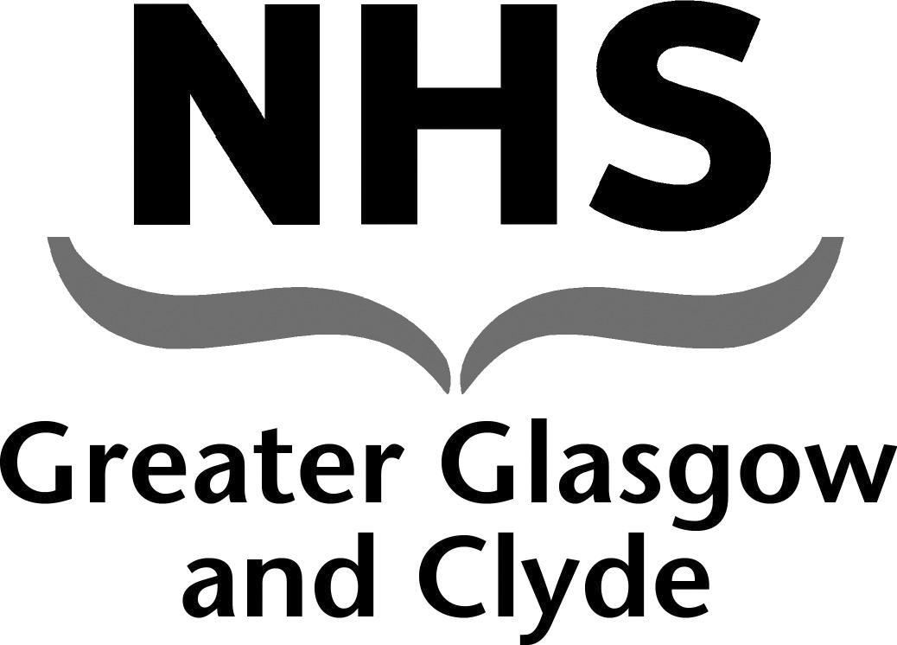
NEWSLETTER

Platinum Jubilee Public Holiday Friday 3rd June 2022 Pay Arrangements

NHS GGC Nursing and Midwifery Staff Bank

This newsletter contains important information regarding changes to the payroll cut off dates for the signing off of shifts on the BankStaff system over the Platinum Jubilee Public Holiday .

Changes to Bank Shifts Pay Arrangements

Date of Shifts Worked | Timesheets MUST be completely signed off by: | Date Paid
27th May to 1st June 22 | 12pm on Thursday 2nd June 2022 | 10th June 2022
2nd June to 9th June 22 | 12pm on Friday 10th June 2022 | 17th June 2022

Tel 0141 278 2555
Email staff.bank@ggc.scot.nhs.uk

