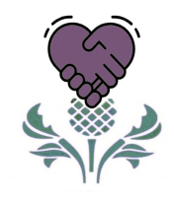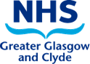
Civility Saves Lives
Civility Saves Lives – Setting the Scene for Civility

As part of NHSGGC intention to broaden awareness and application of the Civility Saves Lives (CSL) approach, we will be offering CSL Setting the Scene Sessions in May.

The sessions are aimed at those with an interest who would potentially advocate and help embed the CSL approach within their own Directorate or Service. The approach applies in all work settings, not just clinical.

There will be 40 places available on each session, allocated on a first come first served basis (please note, the same session will be run on both dates). They will be held online via MS Teams, and the registration link is available below.

CSL Engagement Session Dates:

Thursday 5th May ’22 9.30am – 12noon
Wednesday 25th May ’22 1.30pm - 4.00pm
The Aims of the Session:

- Introduce Civility Saves Lives and the impact of incivility on patient safety as well as day to day performance and culture in the workplace.
- To introduce how we aim to grow a CSL approach in NHSGGC.
- To discuss the principles that will apply to CSL, the role of 'Civility Leads' and explore the nature of their informal one-to-one 'calling it out with compassion' conversations, aimed at reducing rude and damaging behaviour in the workplace and clarifying the wider processes in which these conversations sit.
- How to engage, discuss and get commitment to the approach in your own service.
- How to identify, develop and support Civility Leads in your own service and the support that will be provided to help you with this.
- To explore and surface any risks in the approach.

Please follow this link to book your place in one of the sessions:
NHSGGC : Civility Saves Lives
This other link to the CSL UK website provides useful background for your further information:

Home | Civility Saves Lives | England

