OPAS G2
Management Referrals
March 2020

Contents

Management Referrals 3
Creating a Referral 3

Management Referrals
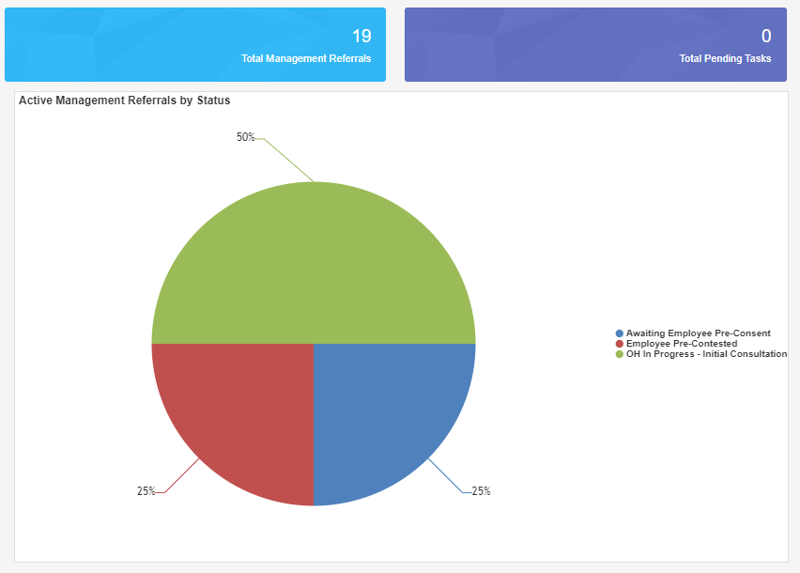

Log in as a Manager

Upon logging in, the Homepage will chart the Active Management Referrals you have open and their corresponding status

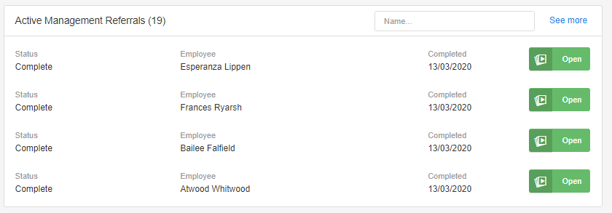
The right-hand side of the screen will show recent management Referrals. Select the Referrals from here or select the ‘Total Management Referrals’ blue panel at the top of the screen to show all of your referrals.

Creating a Referral

From the Referrals Menu on the left-hand side select ‘Management Referral’
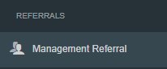

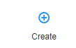
Select ‘Create’ from the top right-hand side.

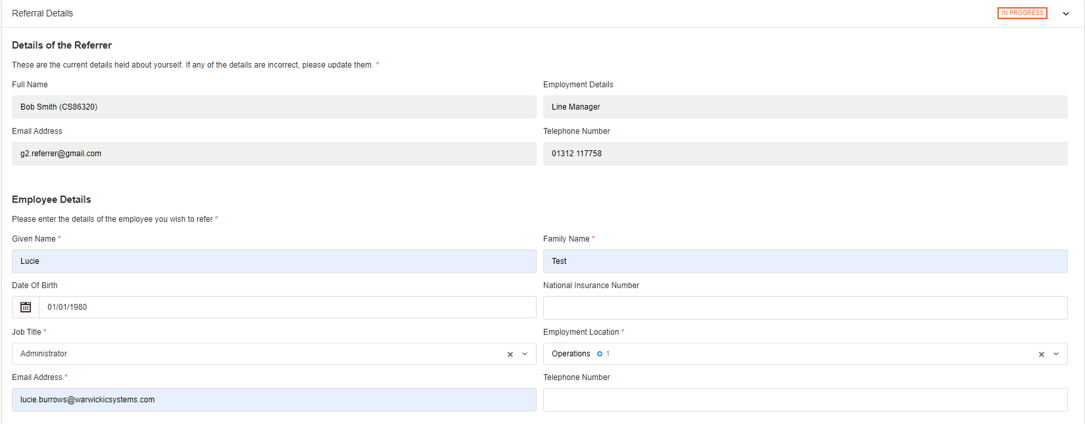
Complete all of the ‘Referral Details’

The first section will ask about the referrer and then the employee being referred.
Mandatory questions are signified with a red Asterix *

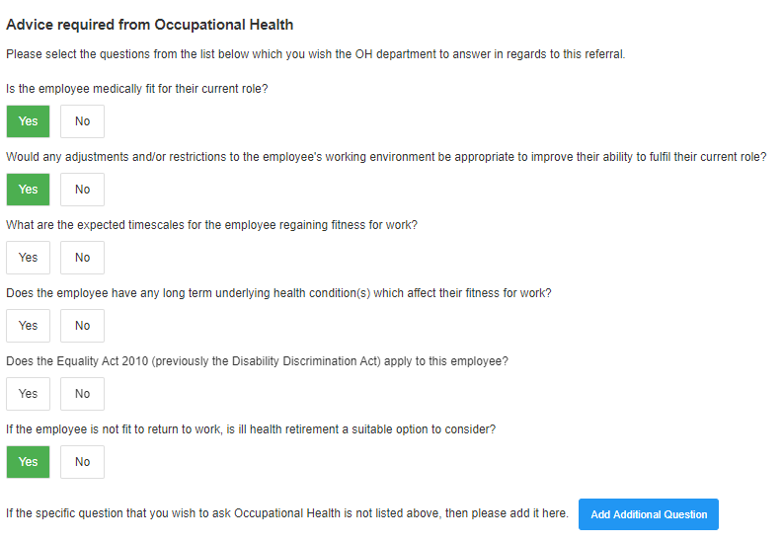
Scroll down and complete all sections relevant to the referral, working environment, absence details and Job Role Specifications.

Finally complete the ‘Advice required from Occupational Health’, attach any required documents and complete the declaration.

The user does not have to select all of the questions but just select yes to those which require an answer to.
Additional questions can also be submitted using the ‘Add Additional Questions’ button.

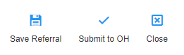
Once all sections are complete select ‘Submit to OH’ from the top right.
Note – the referral can be saved at any point using the save icon here.

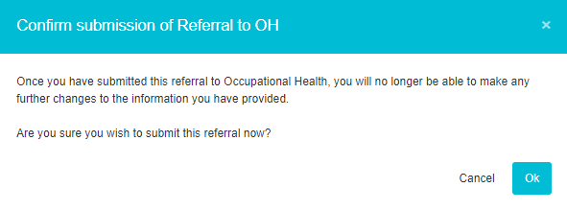
Confirm submission of the Referral by selecting ‘OK’

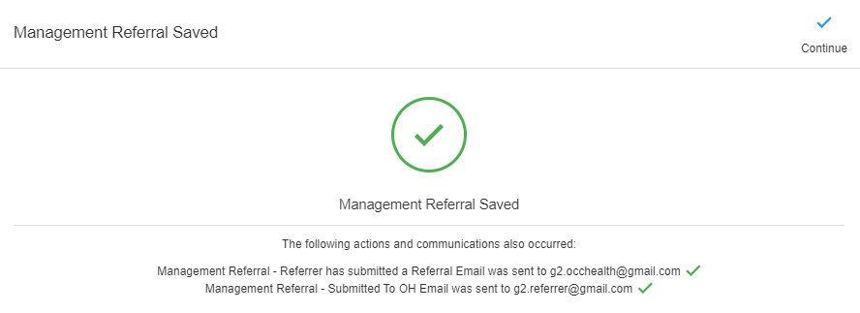
Confirmation that the Management referral has saved will display.
The confirmation will also detail any automated communications that have been sent.
Select ‘Continue’

The Management Referral Dashboard will display
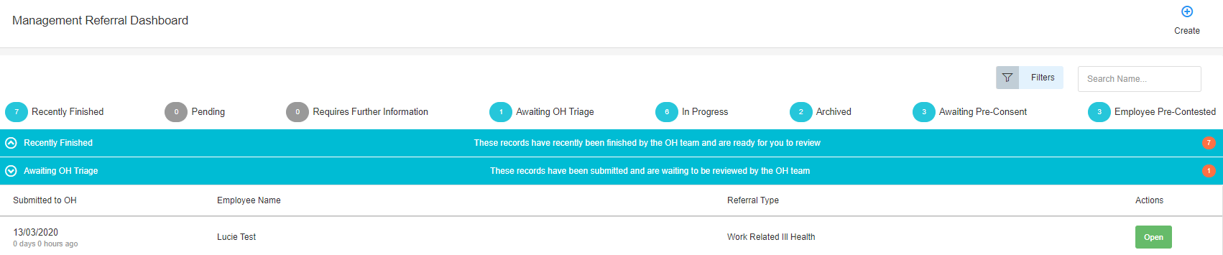

The submitted Referral will now display under ‘Awaiting OH Triage’.
The progress of the submission can be monitored using the blue bars
Management Referrals can be deleted after submission. However, they cannot be deleted once OH triage the submission.

