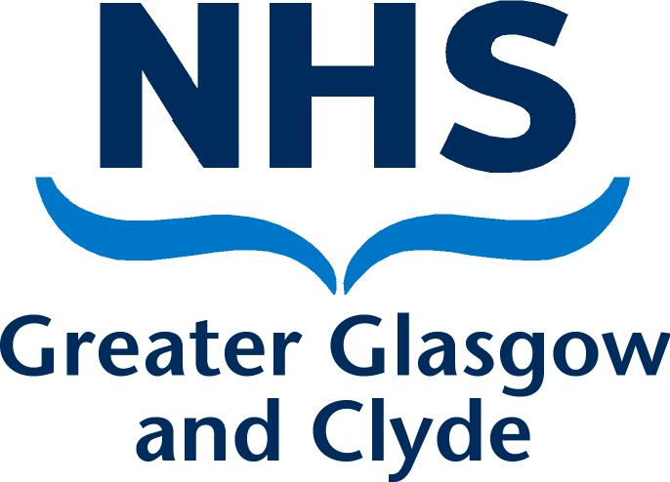

NHS Greater Glasgow and Clyde Healthy Minds Network

Mental Health Anti-Stigma small bids invite

1. Context
Despite supportive policy within Scotland, the experience of people with mental health issues in our communities remains poor. Mental health-related stigma and discrimination does not only occur within health and social care, but also within financial inclusion, employability, and education. This is in the context of the social determinants of health and equality issues predominantly amongst those with protected characteristics.

In Scotland, 35% of people have said that they, or someone close to them, have experienced stigma and discrimination due to their mental health. In addition, 1 in 3 young people in every classroom will experience a mental health problem, and 3 in 4 say that they fear the reaction of their friends.

The impact of stigma and discrimination can be wide-ranging, including making someone’s mental health problems worse and stopping them from getting support. Recently, the impact of COVID-19 on the mental health of our communities has raised awareness of these issues, and provided momentum for innovative action.

2. Bid Specification
The NHS Greater Glasgow and Clyde Healthy Minds Network have a membership that includes a wide range of partners across Statutory and Third sectors, and is supported by the Mental Health Improvement Team. The Network would like to invite creative bids from organisations to help address some of the issues that surround mental health stigma and discrimination. This year, we particularly welcome bids that look at reducing the stigma and discrimination around suicide issues, or reducing stigma and discrimination related to children and young people’s mental health.

The themes of interest and types of approaches that we have received in the past are provided below for information. Please note, this list is not exhaustive and we welcome other approaches that are not included. We particularly encourage bids that demonstrate innovative thinking.

Theme | Selected approaches
1. General Mental Health Anti-stigma and Discrimination Work | Examples of previous approaches:  - Training  - Research  - Awareness raising work  - Resource development  - Face-to-face activities
2. Reducing Stigma and Discrimination around
Suicide Issues
3. Reducing Stigma and Discrimination related to
Children and Young People’s Mental Health

We welcome bids from statutory or voluntary sector organisations. Funding of up to £5,000 can be applied for.

Decisions of the scoring panel will be final and correspondence will not be entered into in relation to unsuccessful bids.

3. Deliverables
Organisations must submit an application by the closing date of Friday 8th October, 2021. Applicants will be notified of the outcome of their submission by Friday 22nd October, 2021.

We require the work to be delivered by Thursday 31st March 2022. A summary report describing the work delivered and any recommendations for future practice should be delivered within a timeframe agreed with NHS Greater Glasgow and Clyde. Funding will be paid upon completion of the project within the agreed timeframes.

Successful organisations must follow the below terms of reference:
- Have User Involvement - Organisations must develop a methodology that meaningfully engages users throughout the course of their project.
- Maintain Open and Honest Communication - Successful organisations must maintain open and honest communication channels with NHS Greater Glasgow and Clyde. This includes around any potential delays to deliverables.
- Be Equalities-focused – Successful organisations must ensure that equality is at the heart of their project. This includes ensuring that those with protected characteristics are not knowingly or unknowingly discriminated against at any stage.
- Produce High Quality Reporting and Evidence - Organisations should ensure robust methodology and provision of evidence throughout the project.

4. Support throughout the process

Pre-application
We will be holding an online Q&A before the submission is due. The Q&A will be facilitated by the Mental Health Improvement Team at NHS Greater Glasgow and Clyde, and will run from 12.30 – 2.00 pm on Tuesday 21st September, 2021. It will be available to anyone who is interested in submitting an application. During the Q&A, we will provide an overview of what we are looking for, and provide a space to answer any questions ahead of the full submission. To join the session, please email the Mental Health Improvement team on ggc.mhead@ggc.scot.nhs.uk.

Post-application
Where relevant, successful applicants will have access to resources and training that support them in the development and completion of their project.

Successful applicants will also have access to a Learning Set with the Mental Health Improvement team and See Me, Scotland’s national anti-stigma and discrimination programme. The aims of the Learning Sets are to support organisations to produce better evidence from their projects, and to build capacity for the future. This includes activities that focus on topics such as evaluation approaches, research ethics, brief decision-making, project health checks, live problem solving, and involving people with lived experience.

5. Application

Please complete the details below and return to the Mental Health Improvement team by email at ggc.mhead@ggc.scot.nhs.uk no later than noon on Friday 8th October, 2021.

- Contact details
Please include email address and telephone number.
- Description of proposal, including which theme is covered, main aims and objectives.

- Outline what the intervention is hoping to achieve from the perspective of tackling the stigma of mental health.
(e.g. specific outputs)
- Describe the specific target group(s) that this initiative would be aimed at and brief justification for their inclusion. This could be a specific neighbourhood / geographical focus/ communities of interest/protected. characteristic.
- Outline the Equalities / Tackling Inequalities dimensions considered within the proposal.
- Outline the ways in which the proposal demonstrates innovative thinking in the area of mental health stigma.
- What is your timescale?
(When will the project start and what is the completion date?)
- Briefly, breakdown the costs envisaged for this proposal.
(Include details regarding any match funding and in-kind support)
- Describe how you will evaluate the initiative?
(Include detail around specific methodologies and timeframes)

- NHS Greater Glasgow and Clyde should be clearly acknowledged as the funder and copyright owner of any resources produced by this funding and in communications about the project, such as summary reports, and resources should be made available for open use via a Creative Commons Licence or similar.

Anti-Stigma Project Proposal prepared by Laura Andre on behalf of the NHS Greater Glasgow and Clyde Mental Health Improvement Team.

