Committee/Forum: | Jen Rodgers, Chief Nurse and professional lead for person centred care
Report Title: | What Matters to You Day? 2020 Legacy – ask, listen, and do what matters
Report Author: | Rachel Killick, Lead Clinical Improvement Coordinator – Person Centred Care
Report Date: | Wednesday 21 April 2021

Situation: | The purpose of this paper is to summarise activity undertaken for ‘What Matters to You?’ (WMTY) Day 2020; to ask, listen, and do what matters.
Background: | WMTY is an international person centred care movement. The underlying principle – ask, listen and do what matters – is intended to shift power to the person who knows best about the help or support they need. WMTY conversations help healthcare teams understand what is most important to patients, leading to better care partnerships and improved care experience.  WMTY day is an opportunity for NHSGGC to build on its national and international profile, shining a light on what matters most and demonstrating continued commitment to person-centred care in line with the Healthcare Quality Strategy.  Ask what matters:  In NHSGGC we asked people what mattered to them in a variety of ways for WMTY 20:  - patients shared their experiences with us on Care Opinion  - family members who have previously expressed an interest in hearing from us were invited to share their story with us via the Involving People Network and social media (approximately 45,000 recipients)  - staff members across the board area told us ‘what mattered to them now’ in the main R&R hubs, some hospital atriums, promotion via core brief, ward areas, on social media, on videos and via the person centred email inbox.  - People filled in pledges, wore stickers, displayed posters, completed trees, stood under balloon arches, and made cakes to mark the day.
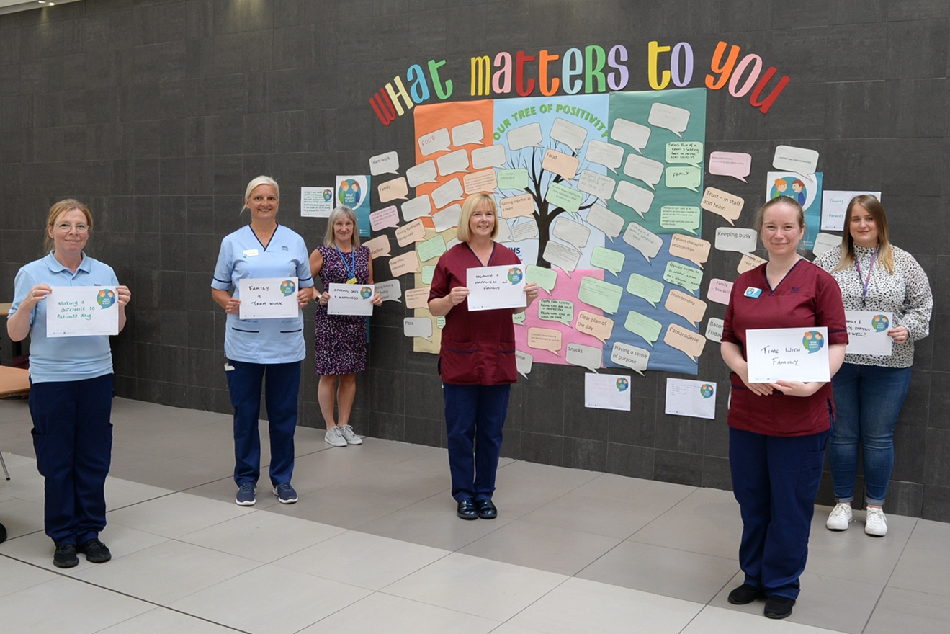
Figure 1: South Sector staff encouraged patients and staff to complete statements about what matters to them for a display in the QEUH atrium
Assessment: | We heard from:  - 959 staff  - 22 patients  - 4 family members.  The most popular ways for people to tell us what mattered to them were:  - R&R hubs (850 completed WMTY statements)  - Social media (124 tweets)  - Local activity (for example, we were told of activity in the Beatson (Appendix A), QEUH, RHC and Leverndale)  - Care Opinion (6 stories shared online)  The main themes of what people told us mattered to them was:  - Relationships (307 comments) - people value their family, and positive working relationships with colleagues; “missing my partner and sons who I’ve not seen since March”  - Wellbeing (299 comments) - people value good food, time away from work, and knowing they are doing a good job; “holidays in Scotland – looking forward to returning to Nairn beach with my dog Toby and the family”  - Human behaviour/ interaction (112 comments) - people talked about the importance of being mutually respectful and kind, and showing compassion to all; “Just making someone’s day by either smiling, saying hello or a quick chat”  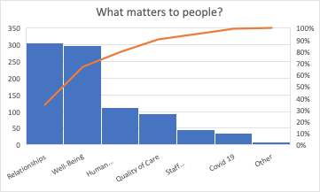  Figure 2: What people told us matters to them as part of activity for WMTY day
Do what matters: | Some people had suggestions for how we could act on what mattered to them:  - Relationships - many commented on the renewed sense of camaraderie brought about by the pandemic, and the importance of not losing this; “What matters to me is making sure we all remember the generosity the local community has shown to us during the pandemic - thanks Inverclyde!”  - Wellbeing - perhaps influenced by the fact that much of the WMTY activity took place in the R&R hubs, people wanted to tell us about the positive impact these have had during this time; “I feel the Active Zone is a great help and helps you to de-stress before going home after a hard day. I feel so disappointed and let down by the management as it is being closed down. I also really like relaxing in the R&R Hub.”  - Human behaviour/ interaction - maintaining a sense of a human connection with patients, family members and staff matters to people; “being able to communicate with patients’ families as best we can under these circumstances. The use of iPads have been great”  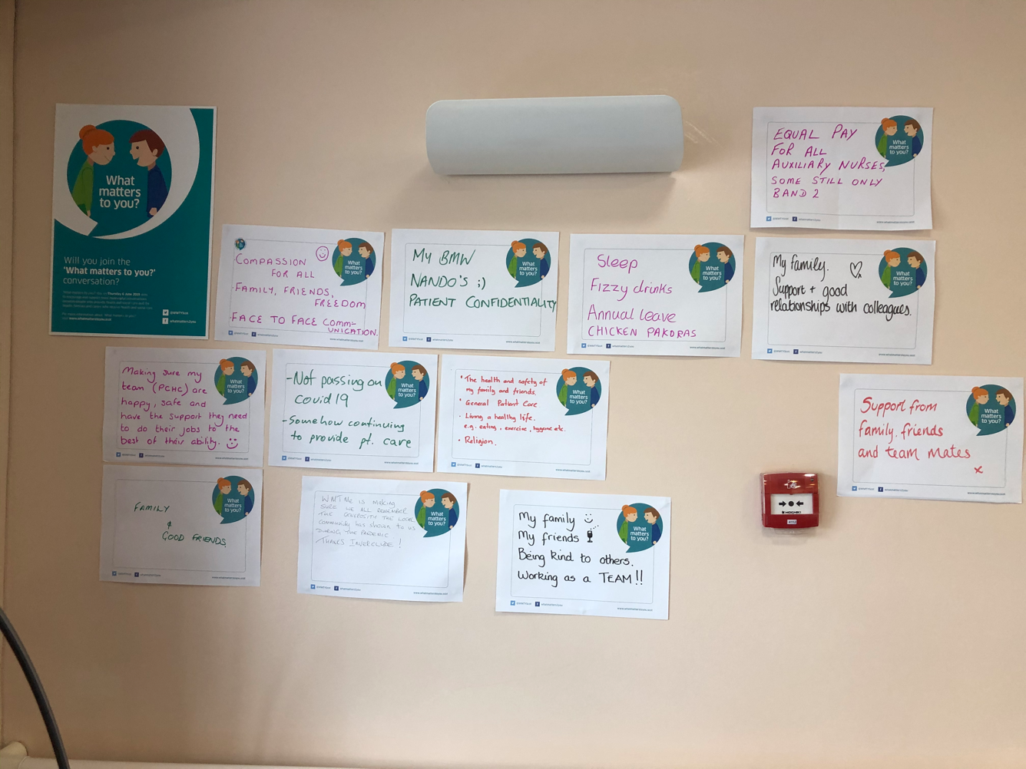Figure 3: Selection of completed WMTY statements in the IRH R&R hub
Evaluation | Feedback from those who participated in this year included:  - The vast majority of people wanted to engage in reflective conversation about what mattered to them most during this time; it was felt that a WMTY conversation during the COVID-19 pandemic was particularly appropriate  - The majority of feedback shared was from staff - we were not told as much about what matters to patients and their families.  - Some engagement in R&R hubs was very busy, with people happy to talk. Others preferred not to be interrupted in their breaks.  - There were some hospital sites who did not have resources, who got in touch the day before to say they would like them.  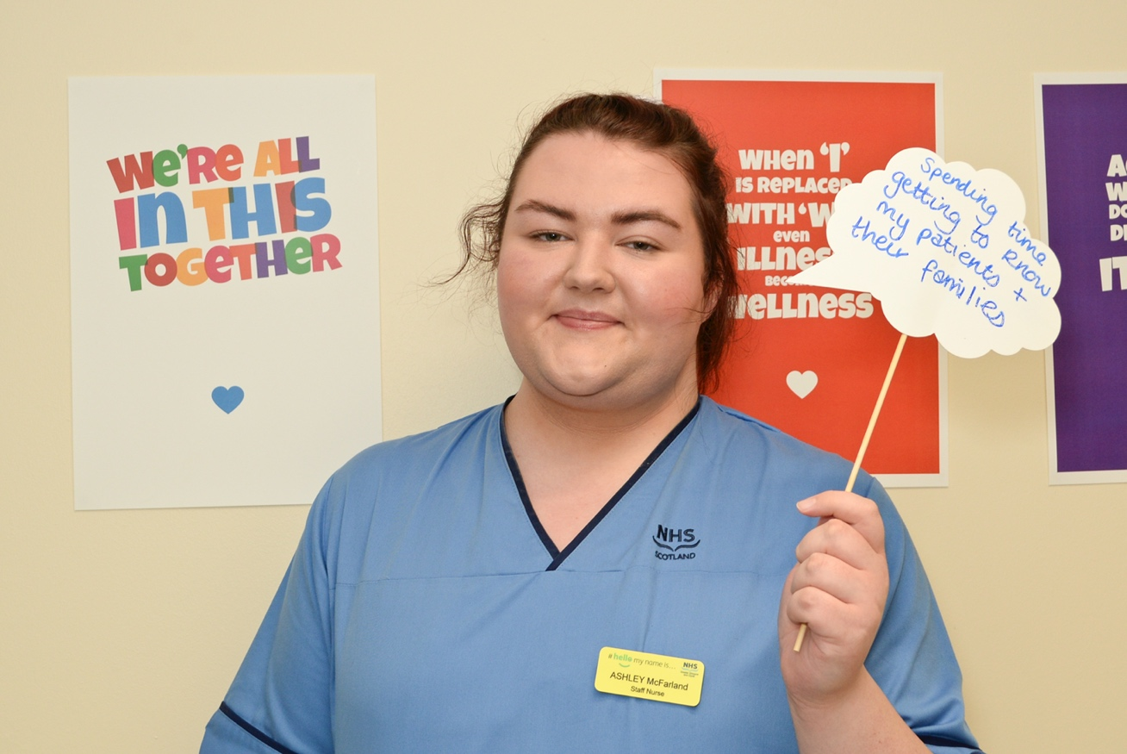  Figure 4: Ashley, a staff nurse from the GRI, shares what matters to her
Recommendations | WMTY Day 2020 provided the opportunity to hold meaningful conversations with staff to listen to what is important to them to maintain their wellbeing, safety and security when at work and in their personal life and understand what enables them to maintain and remain resilient even in the midst of a worldwide pandemic.  It is recommended WMTY conversations with staff, if carried out regularly can provide a useful means to identify what is going well and what contributes to making this happen as well as helping to uncover what are the pebbles in their shoes and inform where improvement is necessary.

Appendix A – Local activity report example, BWoSCC

