 cid:image002.jpg@01D43A07.B25E17C0

Manager Manual

NHS Greater Glasgow and Clyde

December 2020 – Version 2

Z:\STAFF EXPERIENCE ROADMAP\1. Employee Experience Roadmap\GoGC_for email.jpg

**Distribution run process**

**Chloe and Diana send on list of Directorate/HSCP teams to local leads as at 8 weeks before line manager confirmation**

**Local leads liaise and discuss with line managers to determine any changes to the team or manager names**

**Updates to the teams are submitted back to Chloe and Diana, by 2 weeks before line manager confirmation**

**Local administrators make the updates to the Hierarchy within User Management, in preparation for the distribution run. Changes to be made in User Management by 2 weeks before line manager confirmation begins**

**Line Manager Confirmation Stage**

**First Monday of line manager confirmation stage, managers in the system are emailed a link, confirming they can go into the system and review, edit and confirm their team**

**During 4 week line manager confirmation, managers can: Edit, remove and add team respondents**

**Should managers confirm team in error and need to make further amendments, those with admin access can reset team confirmation**

**Questionnaire Stage**

**First Monday of questionnaire stage, staff will be sent links via the email or SMS number supplied to fill in their questionnaires and managers should log in and print off paper copies for those required**

**If a manager has confirmed an incorrect email address or SMS number for a staff member, or if a staff member has been missed or added in error, local administrators can add/remove or exclude staff from the team without having to reset team confirmation**

**2 weeks (or next day) after the questionnaire closes\*, report links will be emailed out to staff to view the team report which managers can access by logging in to their iMatter account. A discussion between the manager and the team should take place, and the action plan should be populated within the manager’s account**

**Action Planning Stage**

**A progress update should be input approximately 3-4 months after filling in the team action plan within the system**

\*reports are produced the next day if a Directorate/HSCP has no paper copies

**Step By Step iMatter Guide for Managers**

Before line manager confirmation stage begins, local leads within each area will be in touch to discuss any changes to the hierarchy structure. At this point, managers should highlight

1. The team name and manager are to remain the same or provide updates
2. If any of the teams have to be archived/removed if they are no longer required
3. If any additional teams are required

This information will then be passed to local administrators to action any changes.

1. **Line Manager Team Confirmation Stage**

Managers are required to log in to their iMatter account and amend any **staff** details within their teams and confirm before the Friday deadline (the week prior to the questionnaire going live). You will be sent an email from Webropol containing the login link.If you are already registered on the system you will be able to login via <https://nhsscotland-sep.webropol.com/Account/Login> using your email address and password that you set up previously. If you are a new manager, you will receive an email containing a link for you to set up a password for your account. Should you need to reset your password, you can do this by following the login link and using the ‘forgot password’ function – you will then be sent a link to your email address to change your password.

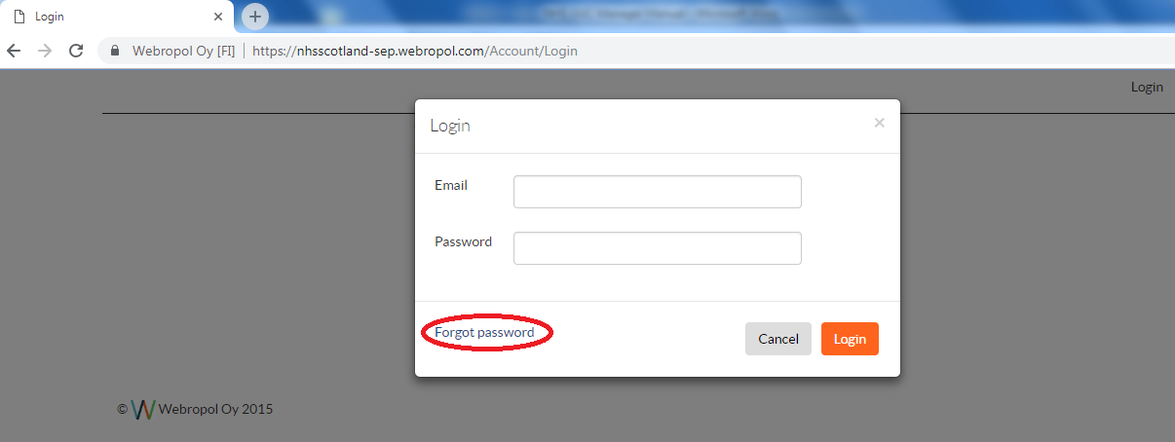

Once logged in to your account, you can access your team details via the homepage by clicking ‘iMatter Questionnaire’ followed by the team that you wish to amend and confirm, and then ‘Manage Team’ which will open the staff list within the chosen team (if you have more than one) - as shown below

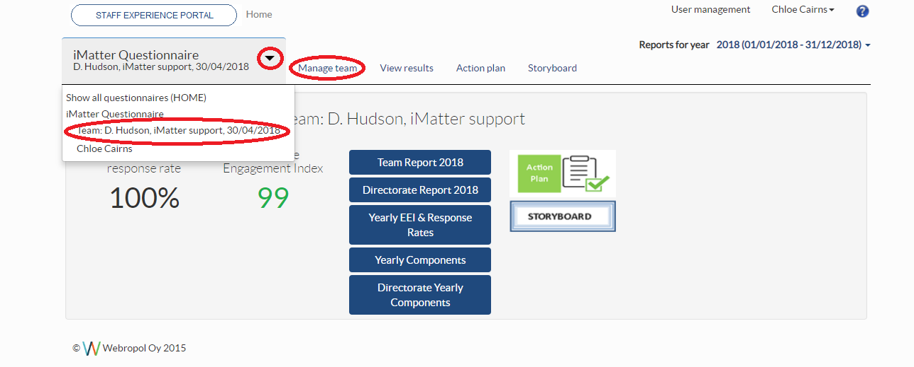

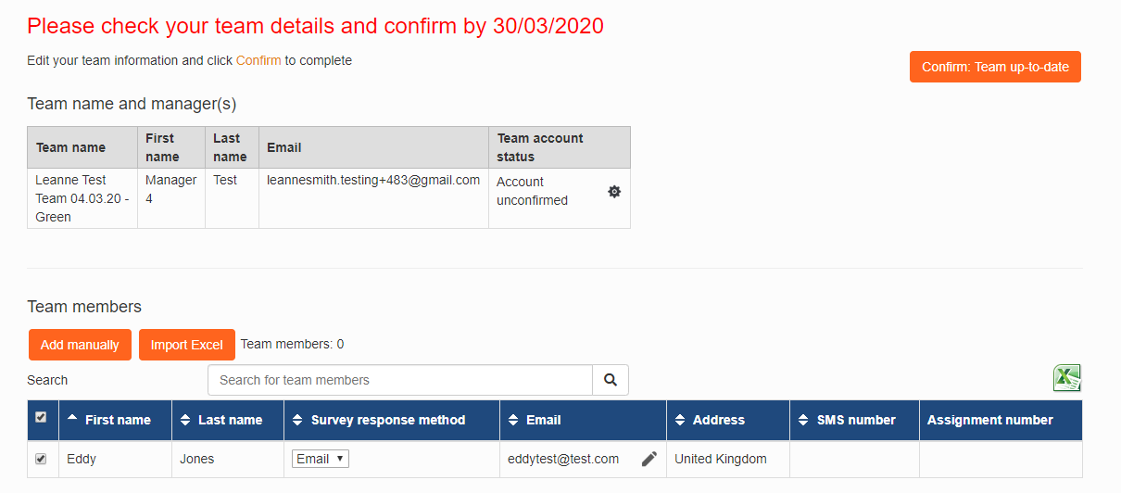

Upon opening the team list, you will be able to add, exclude and remove staff members in order to ensure your staff list is up to date. To add staff to your list you should use the ‘add manually’ button at the top left corner of the list and enter their details correctly.

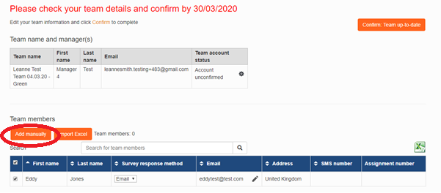

If the staff member has an email address, click the drop down menu and select ‘electronic’ as their response method – this will ensure they receive a link with their questionnaire. If the staff member does not have an email address then select ‘paper’ and leave the address blank – the manager is required to print off the paper copies and distribute to staff the day the questionnaire launches. **Paper copies will not be sent out to any addresses entered.**

For staff who previously received a paper copy, but have a work mobile and would like to participate via SMS, please select the ‘SMS’ option from the survey response method drop down list and ensure their mobile number is entered in the correct format. All mobile numbers should be formatted as **‘+4412345678900’** and will require internet access in order to complete the questionnaire.

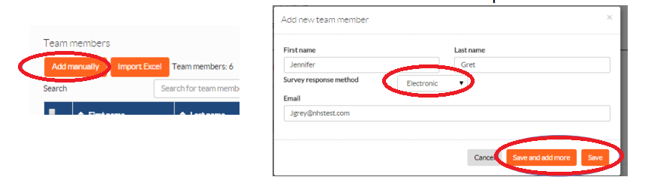

If a member of staff is off on leave such as maternity leave/long term sick, and will not be participating in the survey – it may be appropriate to **exclude** them as it will affect your response rate if they are left on the team. Excluding them means they will automatically be included again next year. Please ensure you have a discussion, if appropriate, with such staff members before excluding, as they may still want to participate whilst not at work.

If a staff member has left, or is no longer in your team you should remove them. The check box down the left hand side of the name of the staff member’s name to be removed or excluded should be ticked followed by either ‘exclude’ or ‘remove’ at the bottom of the list as shown –

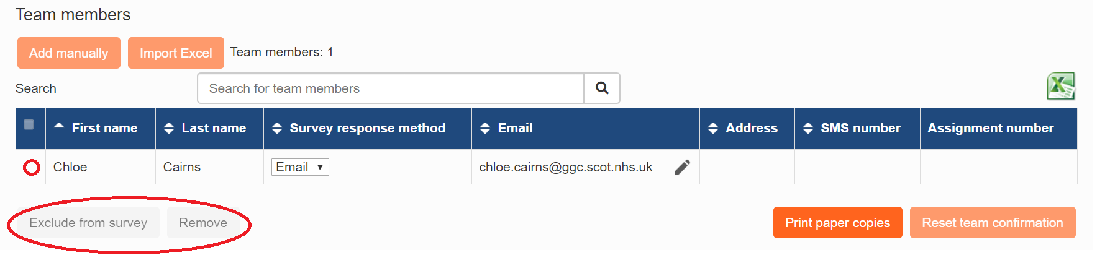

Once your team details are up to date, you should click the ‘Confirm: Team up to date’ button on the right hand side of the page.

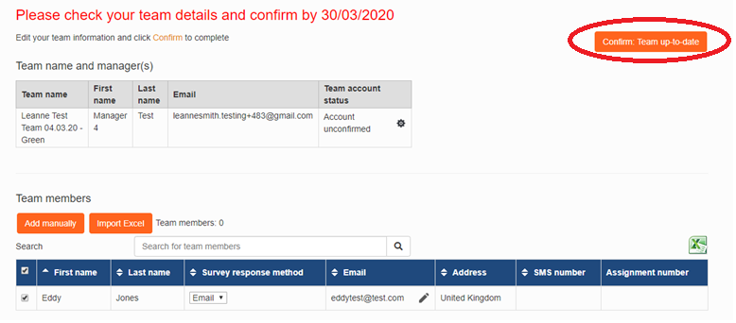

If you log in and have changes to make to the structure of your team set up (disaggregating or aggregating your team), contact [iMatter@ggc.scot.nhs.uk](mailto:iMatter@ggc.scot.nhs.uk) as soon as possible as this can only be done prior to the questionnaire launching.

Please note that if you log in and confirm your team with 0 staff listed, team this will be considered as a ‘live’ team and will still show in reports, therefore if you end up with no staff listed whether they have been moved to another team or have left etc then please email the iMatter inbox as ask us to remove your team.

1. **Questionnaire Stage**

On the Monday that the questionnaire is live for staff, managers should log in and print off the paper questionnaires for any staff that are listed as paper – this should be done via the ‘Manage Team’ page (as above). You can print individually by using the printer icon next to the staff member’s name, or by using the ‘print paper copies’ button at the bottom of the staff list. The paper copies will download as a PDF to print off and hand out to staff along with the pre-paid envelopes which will be supplied by local leads. This should be done during the first week of the questionnaire launching in order to give staff time to complete and return to Webropol.

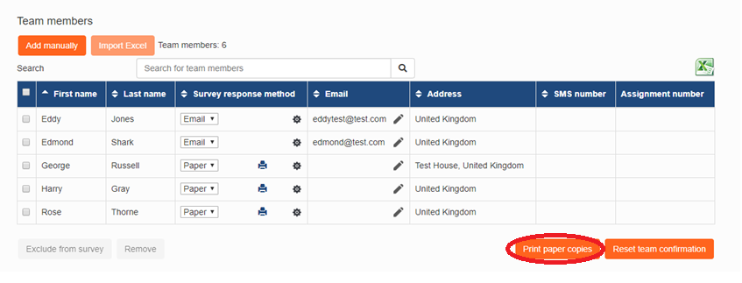

Although the questionnaire is anonymous, and therefore you will not be able to see which staff members have completed or not, you can check your response rate on the home page during the questionnaire stage and encourage all staff to complete. In order to generate a full team report for a team of less than 5, all staff must complete as a 100% response rate is required for small teams. For teams of 5 or more, 60% is required in order for a full report to be automatically generated.

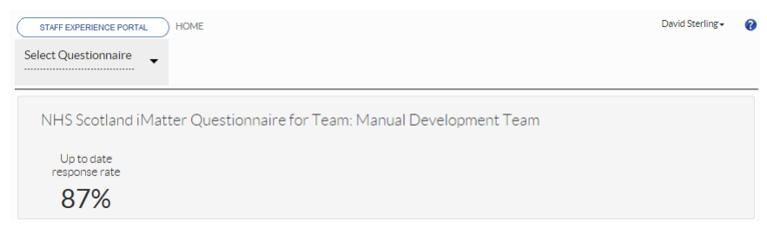

1. **Reports and Action Planning**

If there are paper copies within your team, the response rate can still change up until the reports are distributed – which is 2 weeks (or the day after the questionnaire closes if you work in a Directorate/HSCP which has no paper responses). Your staff members will automatically receive the team report via email / SMS on the Monday which reports are available if they are assigned as such on the system. You will also receive an email from Webropol to view the team report for the team which you participated in as a respondent under your own line manager, however to view your team report for the team you manage, you will need to log in to your account. If your team has generated a report (depending on the required response rate for the size of your team) you will be able to access the report via the homepage of your account

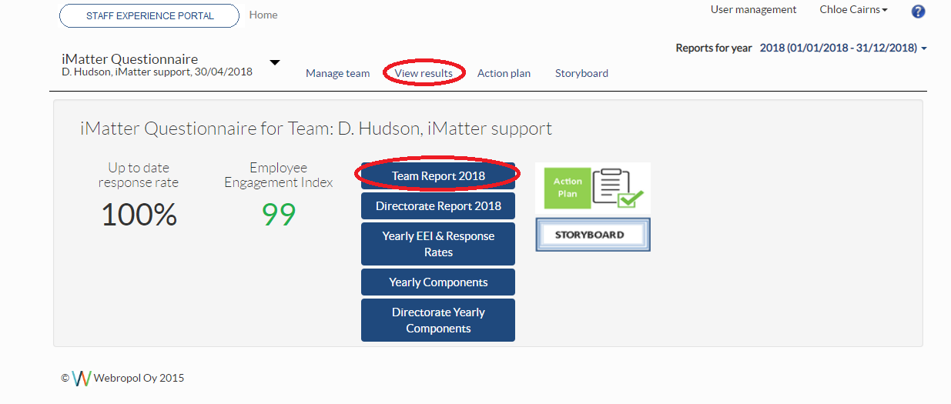

You can also download a PDF copy for the staff who do not have an email address by using the PDF function at the top left hand side of the report –

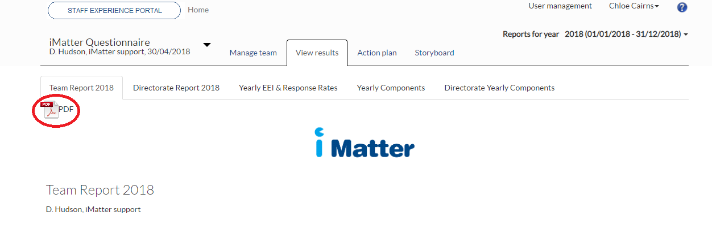

Following the reports being distributed, you have 8 weeks to arrange a discussion with your staff around the questionnaire results to create an action plan with your staff members whichever way is convenient for you and your staff (this can be included in meetings that you already have planned in with your staff i.e. weekly huddles etc). You should discuss your team report (if your team has generated one) and agree on 1 thing that the team does well, and up to 3 things that you hope to improve on as a team which should then be entered in to the template on your iMatter account. If your team has not received a report, you should use either the Directorate report, or the components report which are available on your account to discuss and develop your action plan.

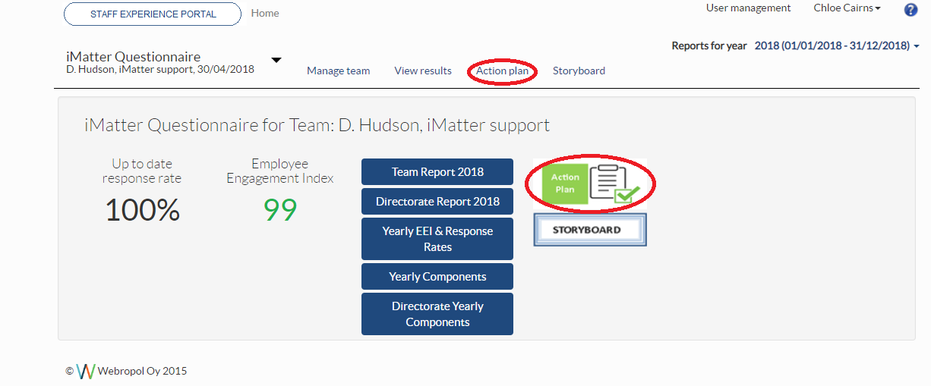

Action plans are required to be entered on the system by midnight on the 8 week Monday deadline given for your area.

When filling in your action plan, the ‘What we do well’ should be filled in as shown below in the green box, and the 1-3 improvements within the team should be entered in the table with all 4 columns populated before trying to save. If you wish to add to the plan at one point during the 8 weeks then use the ‘Save and continue’ button which will allow you to go back in at another time to edit further, otherwise click ‘Complete action plan & create storyboard’ which will lock your action plan and automatically create the storyboard. Step 3 of the action plan ‘Record of Progress’ should be filled in throughout the year.



The storyboard is automatically sent out to staff with email addresses allowing them to view the action plan summary. This should be downloaded by the manager for staff who do not have email access and can be done using the PDF icon in the top left hand corner of the storyboard.

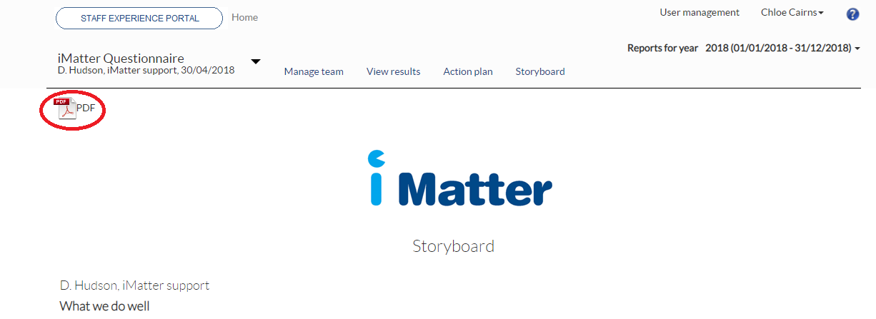

1. **Progress Update**

Over the next few months once the team have successfully fulfilled the areas of improvement that were agreed, managers should log in and enter a progress update which is ‘Step 3: Record of Progress’ within the action plan. If you are updating one area at a time, the ‘save changes’ button should be used until all areas have been recorded on the progress update, then the ‘complete and lock’ button should be pressed.

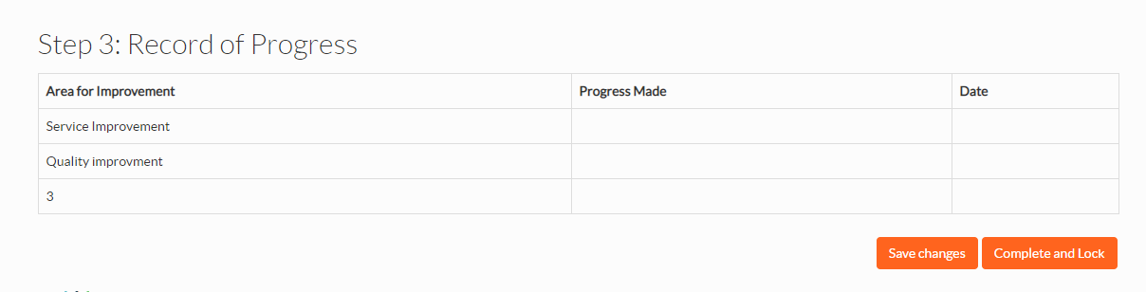

Following this there are no further requirements from managers for the iMatter process for the year.

There is also a help function within the system where managers can access videos and additional manuals should you need them -

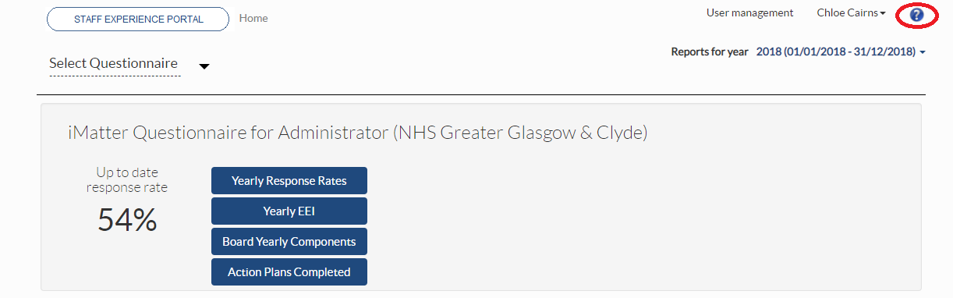

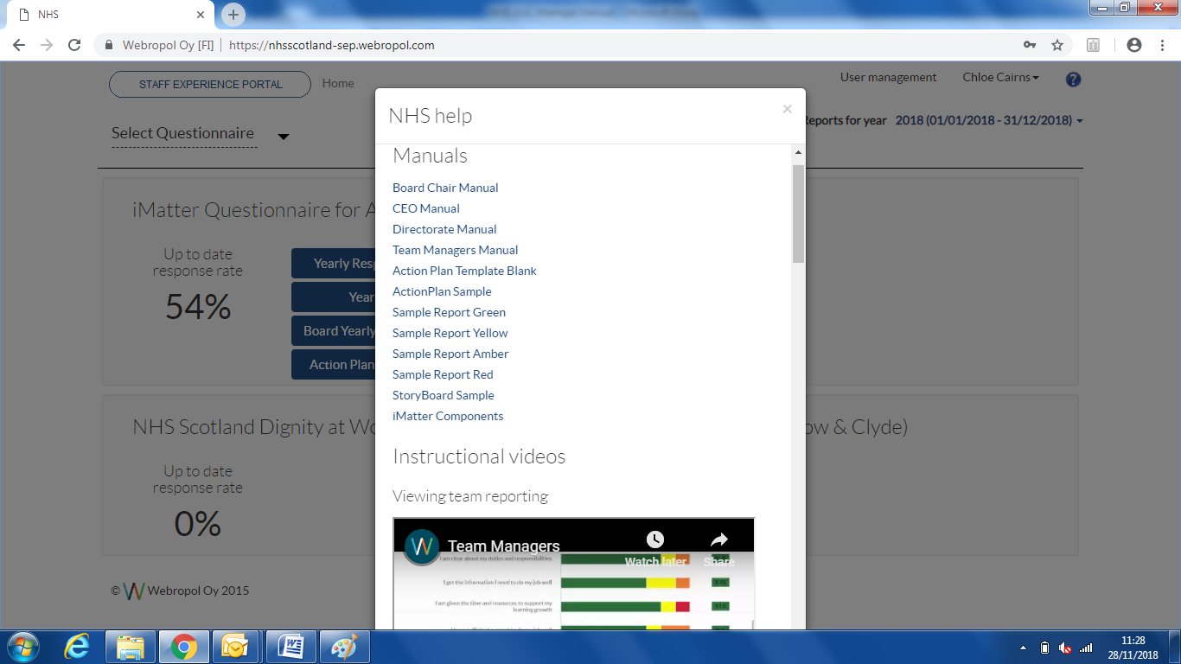

Should you have any trouble with anything that you cannot find in the steps above, please contact your local administrator if there is one assigned in your area; otherwise please contact the NHSGGC Mailbox at - [iMatter@ggc.scot.nhs.uk](mailto:iMatter@ggc.scot.nhs.uk)