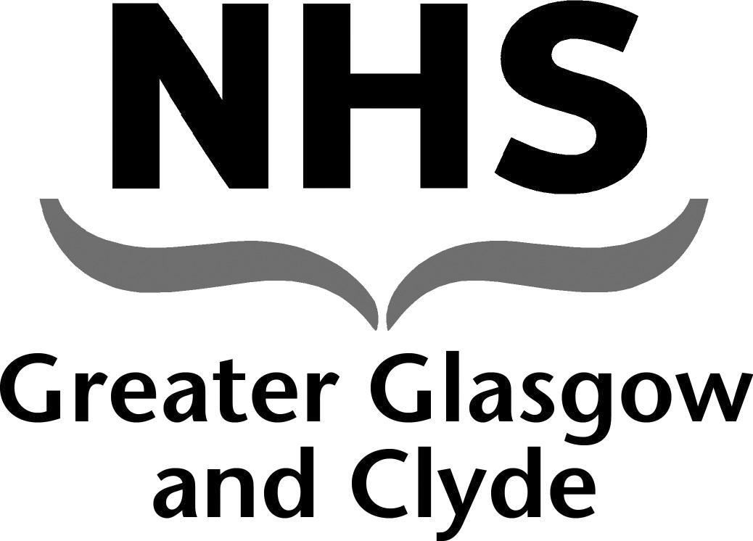
NEWSLETTER

May Day Public Holiday Monday 3rd May 2021 Pay Arrangements

NHS GGC Nursing and Midwifery Staff Bank

This newsletter contains important information regarding changes to the payroll cut off dates for the signing off of shifts on the BankStaff system over the May Day Public Holiday .

Please note there will be early cut offs and Early pay dates.

Changes to Bank Shifts Pay Arrangements

Date of Shifts Worked | Timesheets MUST be completely signed off by: | Date Paid
16th April – 22nd April 2021 | 12pm on Friday 23rd April 2021 | Friday  30th April 2021
23rd April – 28th April 2021 | 12pm on Thursday 29th April 2021 | Friday  7th May 2021
29th April – 6th May 2021 | 12pm on Friday 7th May 2020 | Friday  14th May 2020

Tel 0141 278 2555
Email staff.bank@ggc.scot.nhs.uk

