Important Payroll Information Reminder
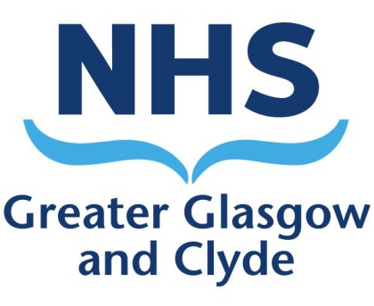

Festive Pay Arrangements

West of Scotland Regional, NHSGGC Medical Staff Bank

This briefing note contains important information regarding changes to the payroll cut off dates for the authorising of Medical Staff Bank shifts on the BankStaff system, and payment dates over the Christmas and New Year period for 2020/21.

Changes to Medical Bank Shift Pay Arrangements

Date Shift Worked | Timesheets MUST be authorised/finalised by: | Date Paid
Fri 11th Dec – Wed 16th Dec 20 | 0900 on Thursday 17th Dec 20 | Thursday  24th Dec 20
Thurs 17th Dec - Mon 21st Dec 20 | 0900 on Tuesday 22nd Dec 20 | Thursday  31st Dec 20
Tues 22nd Dec – Mon 28th Dec 20 | 0900 on Tuesday 29th Dec 20 | Friday  8th Jan 21

MedicalStaffBank@ggc.scot.nhs.uk
: 0141 278 2671

