Scottish Koilocyte Identification Project (SKIP)
Funded by Edinburgh and Lothians Health Foundation
Fiona McQueen, Scottish Cytology Training School Manager
One of the aims of the SKIP Project was to assemble a reference set of validated examples of koilocytes and their mimics. The Scottish Training Officers (TOs) group agreed that a set of images, accessible through the Scottish Cytology Training School (SCTS) web pages, would be a useful teaching resource.
Background
Each laboratory in Scotland was asked to collect 10 samples (and prepared slides) from the following categories

- Category 1 – Cases that contain unequivocal koilocytes
- Category 2 – Cases that contain cells that are probably koilocytes but do not show all their canonical features
- Category 3 – Cases that contain cells mimicking koilocytes

219 slides were received and reviewed by the TOs. The corresponding residual samples were sent to the Scottish HPV Reference Laboratory (SHPVRL) for HPV testing with Abbott rtHPV and Optiplex HPV Genotyping Test.
Cases where TO consensus ≥80% for each category were submitted for more detailed morphological analysis and categorisation.
Morphological criteria assessed

Presence of

- Large, clear perinuclear haloes
- Ring of condensed cytoplasm
- Enlarged nuclei (binucleation, multinucleation)
- Abnormal chromatin pattern (coarse, hyperchromatic)

Results
HPV distribution in cases with ≥80% consensus

Category 1 Category 2 Category 3
Category 1 - example 1

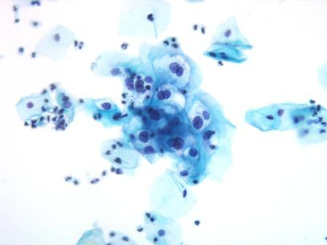
100% consensus category 1
HPV - HPV56 (high risk) present

X200

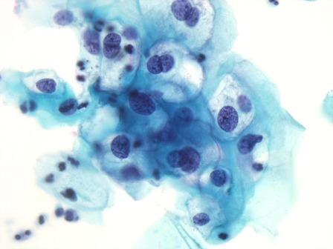
Koilocytes with large, clear perinuclear clearings and thickened cytoplasm. Nuclei are enlarged, hyperchromatic with a coarse chromatin pattern. Binucleation is present.

X400
Category 1 - example 2

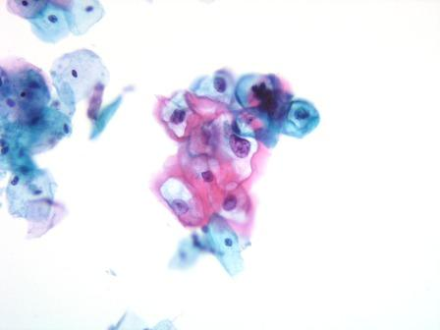
100% consensus category 1
HPV - HPV52 (high risk) and HPV66 (intermediate risk) present

X200

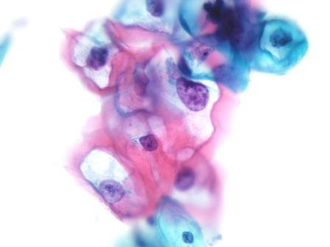
Koilocytes with enlarged variable nuclei and coarse chromatin. Large well defined haloes and thickened cytoplasm

X400
Category 1 - example 3

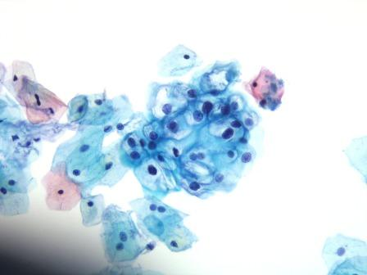
100% consensus category 1
HPV - HPV53 (intermediate risk) present

X200

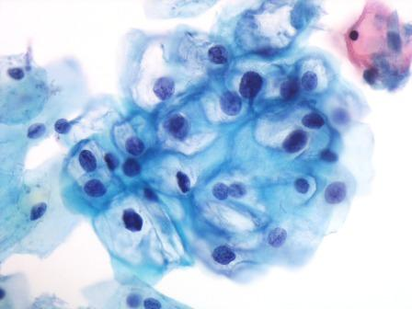
Koilocytes with hyperchromatic, enlarged nuclei and large clear perinuclear haloes. Binucleation is present. Abnormal chromatin pattern

X400
Category 1 - example 4

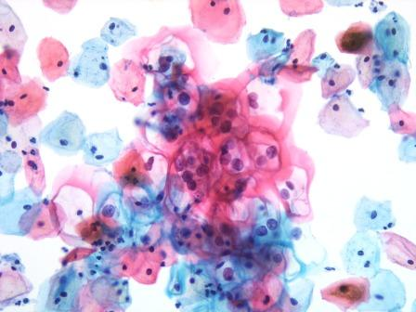
100% consensus category 1
HPV - HPV16, HPV52 (high risk) and HPV66 (intermediate risk) present

X200

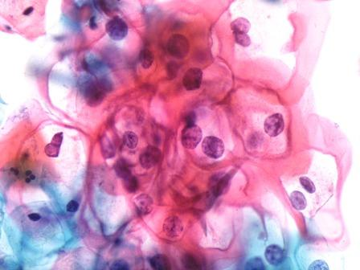
Koilocytes with hyperchromatic, enlarged nuclei. Binucleation is present. Large, well defined perinuclear haloes and thickened cytoplasm

X400
Category 2 - example 1

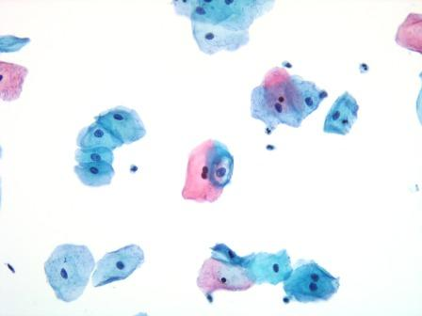
X200
80% consensus category 2
HPV - HPV 16, HPV56 (high risk) HPV 42 (low risk) present

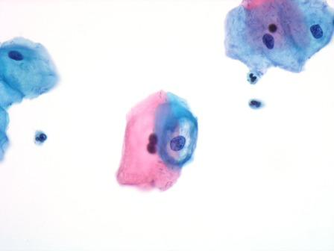
X400
Cell with thickened rim of cytoplasm and perinuclear halo. Nucleus shows minimal enlargement and chromatin is regular

Category 2 - example 2

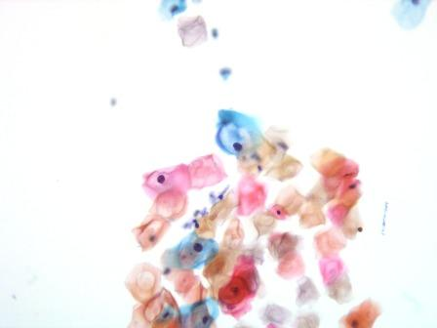
X200
89% consensus category 2
hrHPV - HPV 18 (high risk) and HPV42 (low risk) present

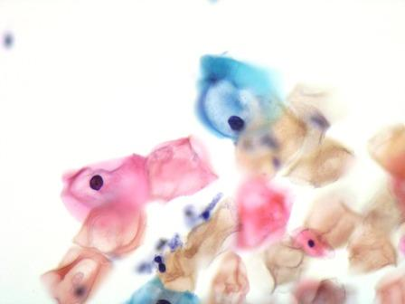
Cell with thickened rim of cytoplasm and perinuclear halo but no nuclear enlargement or abnormality present

X400
Category 2 - example 3

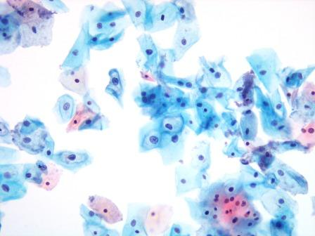
X200
89% consensus category 2
No HPV types present

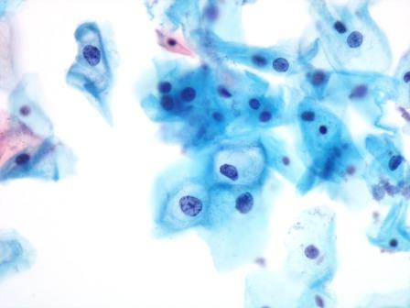
Cells with thickened rim of cytoplasm (on the inner aspect only) and perinuclear haloes (not well defined). Mild degree of nuclear enlargement. Compare with category 1, examples 1 and 3 images

X400
Category 2 - example 4

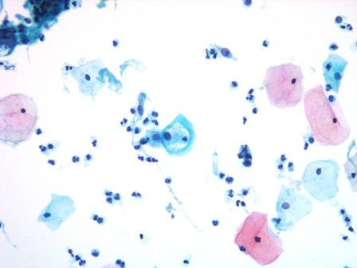
80% consensus category 2
hrHPV – HPV44 (low risk) and HPV66 (intermediate risk) present

X200

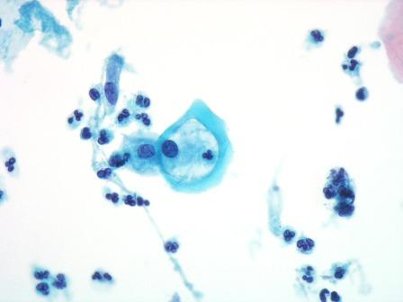
Cells with thickened rim of cytoplasm and perinuclear halo. Normal nucleus

X400
Category 3 - example 1

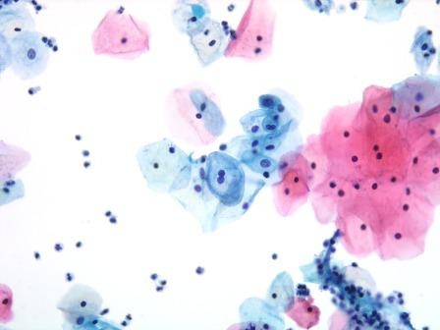
X200
100% consensus category 3
No HPV types present

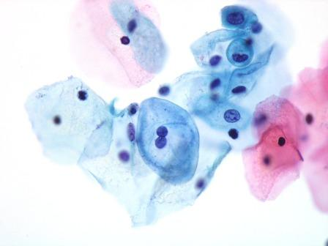
Cell showing binucleation only. No distinct halo or cytoplasmic thickening

X400
Category 3 - example 2

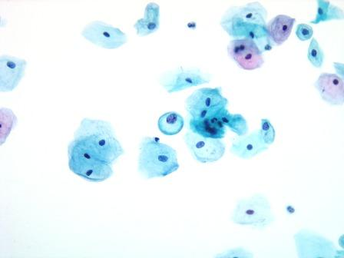
X200
100% consensus category 3
No HPV types present

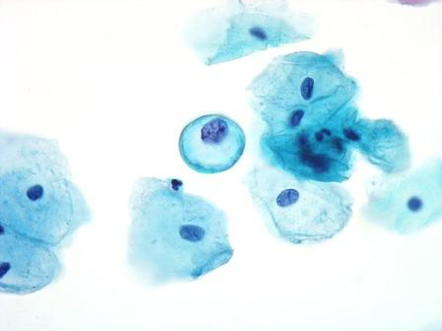
Enlarged nucleus but normal chromatin pattern. Appearance of perinuclear halo but no distinct clearing or thickened cytoplasm

X400
Category 3 - example 3

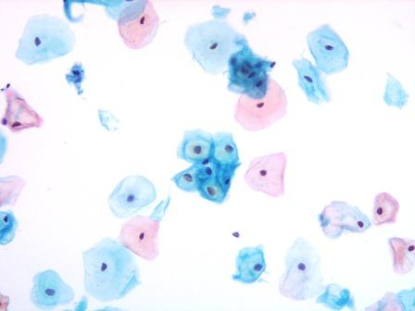
X200
100% consensus category 3
No HPV types present

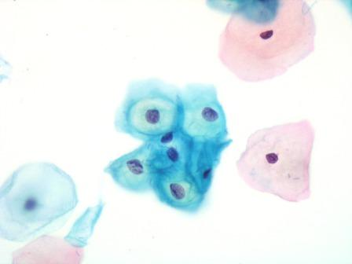
Cluster of cells with yellow stained glycogen filled cytoplasm.

X400
Category 3 - example 4

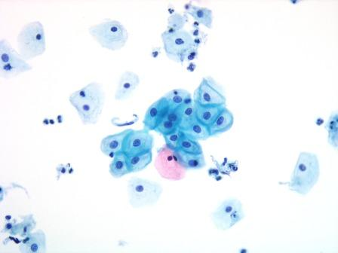
X200
100% consensus category 3
No HPV types present

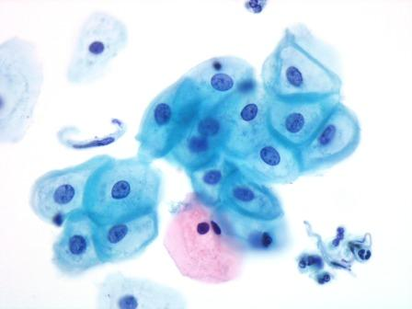
Group of cells with normal nuclei and no distinct perinuclear clearing.

X400

