Click the ‘**Allow access**’ tab to register your personal details, provide permissions and create a password.

It is best if you open this email and the website using your phone or tablet.

**During your appointment**

Once your appointment has opened, you will be sent another email asking you to log in and submit information and pictures of your skin through the website.

Your appointment will remain open for 5 days, allowing you to submit your information at a convenient time.

**What is a virtual appointment?**

A virtual appointment is a replacement for a face-to-face appointment at a clinic. It involves sending images and text remotely using a smartphone, tablet or computer.

The aim is to make appointments more convenient for patients, so that their skin can be assessed without the need to attend hospital.

**What do I need to be able to participate?**

To be able to use a virtual appointment you need to have:

* A smartphone or tablet with a camera
* An email account (**which must be your own)** which you can access from your smartphone or tablet

You can ask a friend or relative to help you, but you must use your own email address, not theirs and submit the **patients** name and details.

**How does it work?**

**Before your appointment**

We’ll check you are a suitable candidate for the service and ask for your email address. You’ll then be sent an email with a link to allow you to register– clicking on this link will take you to the consultation website. The registration email looks like this:

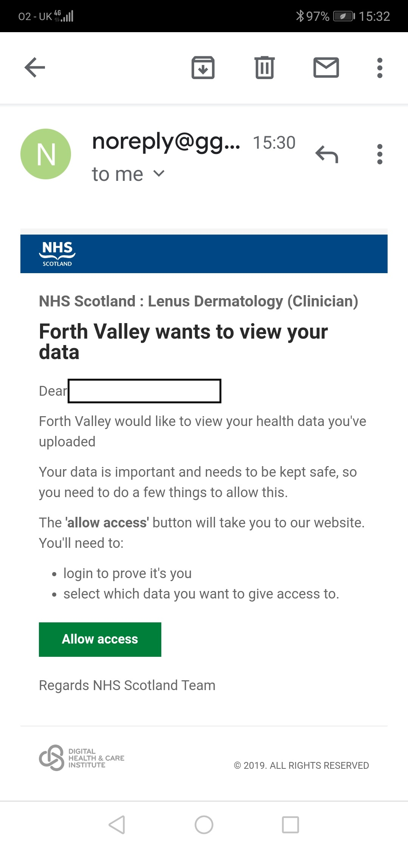

**NHS Greater Glasgow and Clyde**

**Dermatology Virtual Appointments**

**Patient Information**

**Frequently asked questions**

**Question:** What devices can I use?

**Answer:** You can use any internet-connected smartphone, tablet or computer. However the system works best from a smartphone or tablet as you can use this device to take pictures and upload them into the app.

**Question**: Can my relative upload data on my behalf?

**Answer:** Yes, they will need to do so via *your* email address and details not their own.

**Question:** What should I do if I am unable to upload my data during the appointment window?

**Answer:** Please contact the appointments team and we will be able to change your appointment period. If you do not contact us your appointment will be recorded as a ‘did not attend’.

**Question:** How do I reset my password?

**Answer:** You can reset your password from the login screen.

**Question:** Who should I contact if I have any technical issues with the system?

**Answer:** Call GGC Referral Management Team on : 0141 452 3493 (not for clinical advice)

**Question:** Can I have both virtual and face-to-face appointments?

**Answer:** For each appointment you and the team will choose whether you have a virtual or face to face appointment. If you are attending dermatology long term then you will probably be offered a mixture of virtual and face-to-face consultations.

**How do I get in contact?**

If you experience difficulties using this service then please call us at:

0141 452 3493

Note: This information leaflet is Version 1 for Pilot Phase of service.

**After your appointment**

Once you have sent the information and pictures, one of the doctors or nurse specialists will review this and will make an appropriate treatment plan. You can see their response through the website and you will be sent an email letting you know when they have responded. You should receive a response within 2 weeks although it may be considerably quicker than this.

Your GP will receive a summary of the consultation and can then prescribe any new treatments that the team have recommended. You should contact your GP regarding prescriptions.

If you haven’t submitted any information at the end of the 5 days, then you will be removed from the waiting list just as you would after failing to attend a face to face appointment.

**Is my data safe?**

Your data is kept safe in NHS Scotland’s data storage systems. It will be managed according to GDPR standards, ensuring your data is securely shared between you and your clinical team. Your clinical team can only access your data when you provide explicit permission for them to do so.