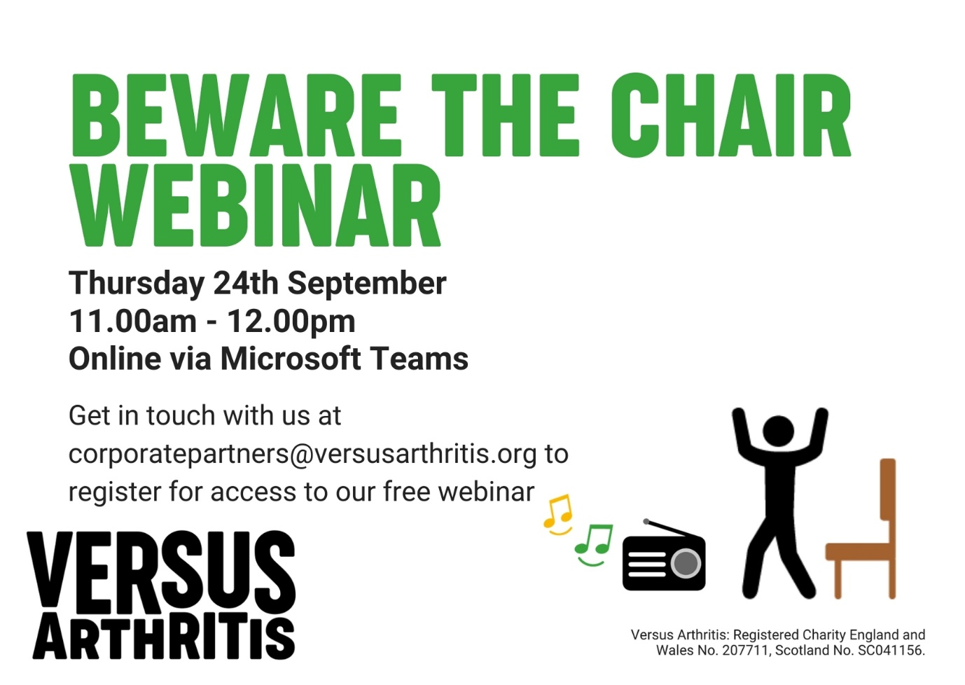
As part of our ongoing 'Beware the Chair' campaign, we will be hosting a webinar focussing on musculoskeletal health in the workplace and how taking small actions each day can help to prevent the risk of developing new aches and pains.

During the ongoing COVID-19 pandemic, for many of us, working or volunteering from home has become the new norm – and it is set to continue for the foreseeable future.
But it can be a pain in our neck, back and shoulders, especially if we are sitting more than usual.
In fact, according to the Institute for Employment Studies, there has been a significant rise is musculoskeletal complaints since the start of the COVID-19 pandemic.

We will be joined by three expert speakers:
- Cherry White: Wellbeing Manager, Versus Arthritis
- Ben Wilkins: CEO of Good Boost, Osteopath and Versus Arthritis MSK Champion
- Karen Walker-Bone: Professor in Occupational Rheumatology and Director of the Versus Arthritis Research Centre for Musculoskeletal Health and Work.

The session will run for 45 minutes, with 15 minutes for questions. It will be held on the Microsoft Teams platform, once we receive your request to attend you will be sent a joining link shortly before the webinar begins.

We really hope you can join us and please do share with any colleagues that you feel may be interested!
Please RSVP to corporatepartners@versusarthritis.org so that we can send you the link to join the webinar.

