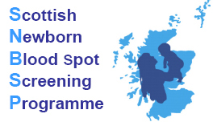 |  | 

Newborn Blood Spot Screening Service
Information for Users



Contents
Laboratory Information 3
The Service 3
Laboratory Mission Statement 3
Address 3
Laboratory Hours 3
Request forms – Bloodspot Screening Card 5
Completing the blood spot card 5
EDTA 8
Sample collection 8
Sample Dispatch and Transport 8
Danger of infection 9
Service information leaflets 9
Parental consent 9
Confidentiality 10
Complaints 10
Improvements to the service 10
Scottish Newborn Screening Laboratory 11
Clinical Information 12
Phenylketonuria 12
Medium-Chain Acyl-coA Dehydrogenase Deficiency (MCADD) 12
Maple Syrup Urine Disease (MSUD) 12
Homocystinuria (HCU) 12
Isovaleric Acidaemia (IVA) 12
Glutaric Aciduria type 1 (GA1) 13
Congenital hypothyroidism 13
Sickle cell disease 13
Cystic fibrosis 13
Will screening for these conditions show anything else? 13
Offer of screening 14
Reporting of results 14
Turnaround times of results 15
Recording of results 15
Repeat samples 15
Storage of cards 16

Laboratory Information

The Service
The Scottish Newborn Screening Laboratory provides a national screening service to
Scotland. The laboratory is situated on level 2B of the Laboratory Medicine Building at the Queen Elizabeth university Hospital campus. The screening services provided are funded by National Services Division of NHS Scotland and accredited by UK Accreditation Service (UKAS) Reference No. 9352.

Laboratory Mission Statement
To provide and further develop a high quality newborn screening services for those disorders where there is demand, using the most effective technological approaches whilst working within national and professional guidelines. To securely and confidentially store blood spot samples and information from individuals using this service, and to ensure the best possible use of the available resources and expertise in the testing of these patients

Address
Scottish Newborn Screening Laboratory
Level 2, Laboratory Medicine
Queen Elizabeth University Hospital
1345 Govan Road
Glasgow
G51 4TF
Tel: Newborn Screening Office: 0141 354 9277/9278
Email: GG-UHB.NewbornScreeningLaboratory@nhs.net
Web: https://www.nhsggc.org.uk/about-us/professional-support-sites/laboratory-medicine/laboratory-disciplines/scottish-newborn-screening-laboratory/

Laboratory Hours
 | Normal Working Hours  Mon-Fri | Out of Hours arrangements
 | Normal Working Hours  Mon-Fri | Saturday | Other
 | 08.30-16.30 | ~ 09.00-12:00 | Public holiday cover available
Routine analysis, results, as well as a clinical advice and interpretation service is available during routine working hours and public holidays. Saturday cover is provided for the inherited metabolic disorders screen.

Head of Service for Biochemistry

Dr Maurizio Panarelli
E-mail Maurizio.Panarelli@ggc.scot.nhs.uk

Director of Newborn Screening

Ms Sarah Smith
Principal Healthcare Scientist
Tel: 0141 354 9275
Email: sarah.smith2@ggc.scot.nhs.uk
Laboratory Manager/Quality Manager

Ms Tara Tchehrazi
Principle Healthcare Scientist
Tel: 0141 354 9270
E-mail tara.tchehrazi@ggc.scot.nhs.uk

Request forms – Bloodspot Screening Card

It is vital that every section of the blood spot card is completed accurately. The information supplied is entered onto the Scottish Newborn Screening Laboratory’s (SNSL) Laboratory Information Management System (LIMS) and is used for:

- the identification of the infant – to ensure that the correct result is issued to the correct baby
- the determination of results – certain parameters have to be fulfilled before results can be interpreted
- ensuring the correct protocol is followed – different protocols are applied in particular tests

Completing the blood spot card

Check the expiry date before completing the blood spot card. Expired cards should not be used, they should be returned to the SNSL.

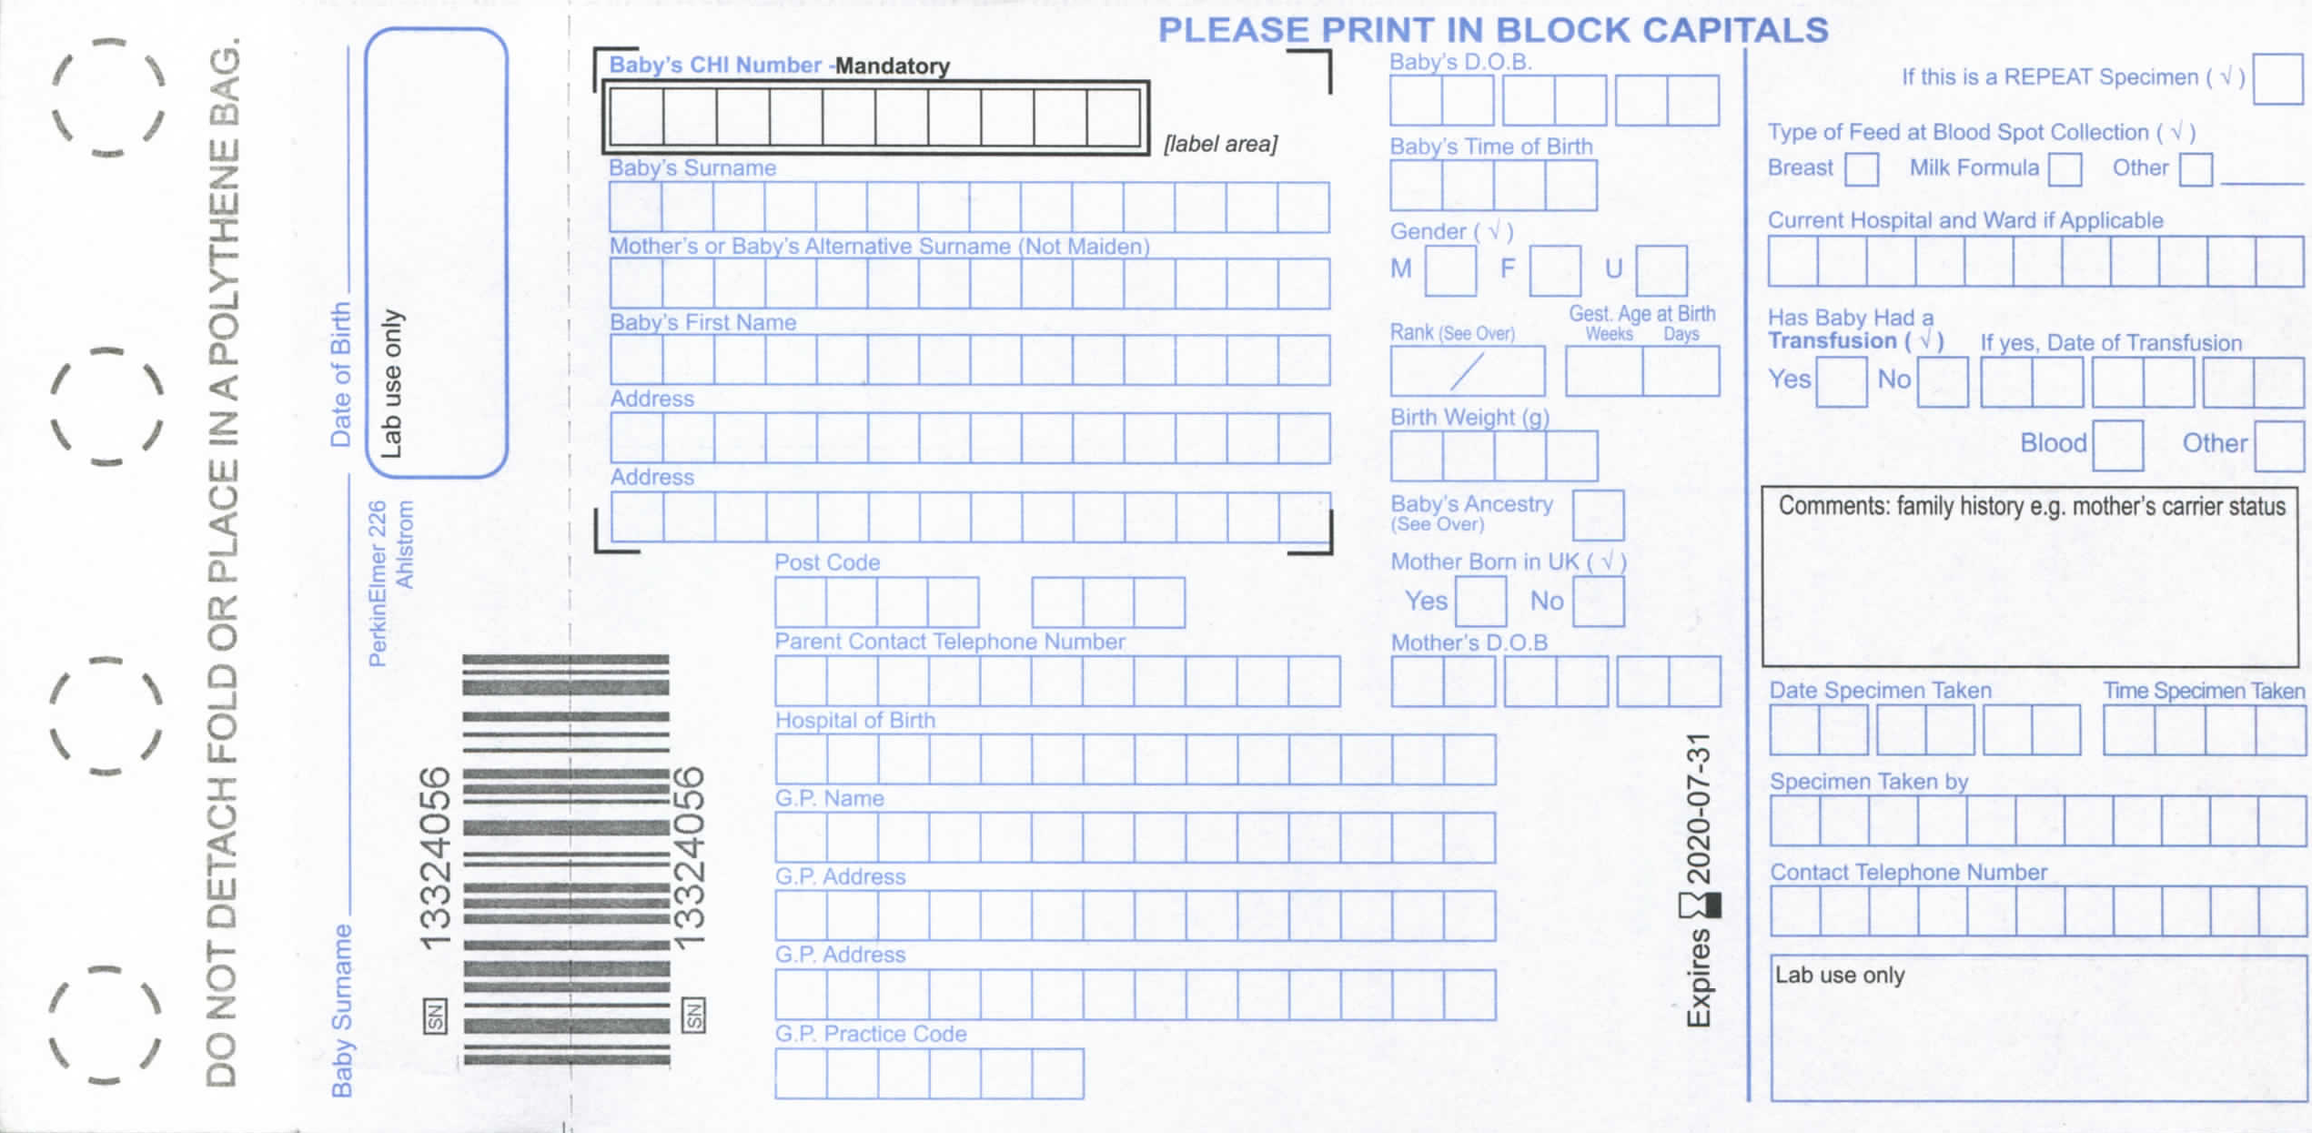

The middle section of the front of the card contains demographic details

It is best practice to use labels for this section if available. Always ensure that it is the baby’s label and not mother’s

CHI number | The use of the CHI number is a mandatory requirement and should always be noted in full
Mother’s or Baby’s Alternative Surname | If more than one name is known please document both
Address | This is the home address of the baby at the time of birth
Post code | This should be in full
Parent contact telephone number | This is important as immediate contact with parents may be required
Hospital of birth | Name of hospital that the baby is delivered in. Home should be stated if not associated with a hospital
GP | General Practitioner with whom the baby will be registered
GP address | Name of surgery and address
Baby’s DOB | This must be accurate as the interpretation of results for some tests is dependent on the age of the child. If the sample is taken too early, i.e. before 4 days of age, this can invalidate the results
Gender | Tick box; M-Male F-Female U-Unknown or Uncertain
Rank | This is important to indicate whether baby is a twin etc as shown on the back of the card egg 1/1 1/2. This will avoid the specimen being treated as a duplicate specimen of another baby
Gestation | This is the gestation that the baby was born at and is important for some of the tests. Mark in weeks and days
Baby’s Ancestry | Choose from one of the family origin codes, as detailed on the back of the card
Mother born in the UK | This is in relation to Sickle Cell Screening
Mothers DOB | Used as another link to the baby if details differ from those held by Child Health Information System

The right hand side of the front of the card is information used by the laboratory:

Type of feed | If more than one type applies tick both i.e. breast and bottle. ‘Other’ is for total parenteral nutrition (TPN) in cases of sick babies
Is this baby: In hospital / Premature | Indicate the status of the baby. If ‘in hospital’ is ticked then the SNSL would contact the hospital if a repeat specimen is required.
Has baby had a transfusion | Date of transfusion must be included. This is an indicator of whose blood the laboratory will be testing, which is important for some tests.
Comments | Such as relevant antenatal screening results, refusal for testing, parent carriers of haemoglobin variants/CF, Meconium ileus, family history. This box should also state ‘No Storage’ or ‘No Research’ if parents have requested this.
Date and time of birth and Specimen Taken | This is essential. The SNSL uses this to determine age of baby when sample was taken. Cards without this date will not be issued with a result until this has been established.
Specimen Taken By | Name of healthcare professional
Contact Telephone Number of Health Professional | Will allow immediate contact in the event that the laboratory or clinical service needs to make direct contact with the healthcare professional
Lab use only | Must be left blank. This will be used for the laboratory’s unique numbering system

The left hand side of the front of the card is for the specimen collection

- Baby’s Surname and DOB/CHI number must also be completed on this portion of the card

The reverse side describes the following:

- Family origins – This information is important for CF and SCD testing
- Rank – This gives birth order in multiple pregnancies
- Blood Collection – Brief instructions

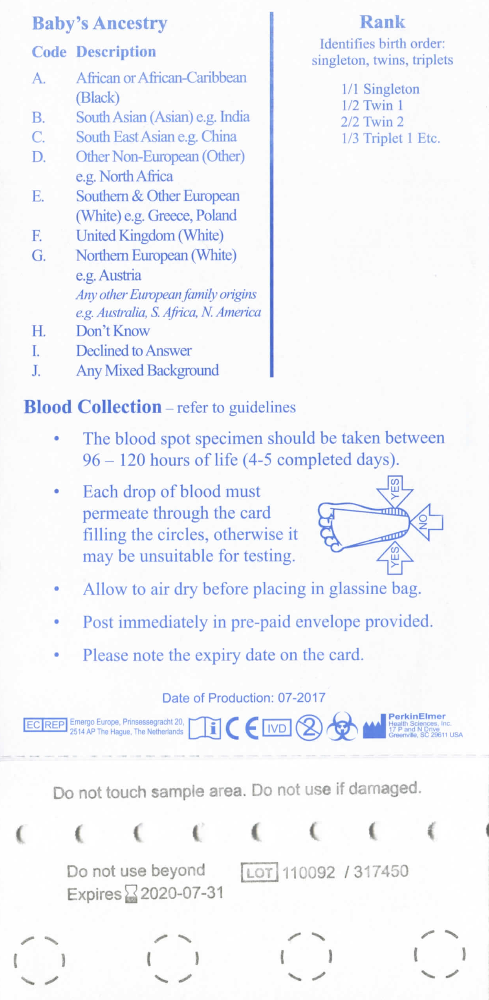

EDTA

Ethylene-diaminetetraacetic Acid (EDTA) is an anticoagulant used in some blood collection tubes. EDTA can interfere with the interpretation of testing and could lead to false negative results. Blood from EDTA tubes, citrate tubes or capillaries should never be used to fill blood spots as this will affect the measurement of Thyroid-Stimulating Hormone (TSH) for CHT and Immunoreactive Trypsinogen (IRT) for CF leading to false negative results

Sample collection

The routine dried blood spot specimen should be collected when the baby is at least 96 hours old.
A good quality blood sample is one that:
- is taken at the right time
- is appropriately labelled to allow identification of the baby, analysis and reporting of results
- contains sufficient blood to perform all tests i.e. blood has soaked through to the back of the card
- has not been contaminated or taken on an expired blood spot card
- arrives at the laboratory in a timely manner

For further information on blood spot collection please follow the link below:

http://newbornbloodspot.screening.nhs.uk/bloodspotsampling

A summary of the instructions for collecting the blood spot specimen are printed on the reverse of the blood spot card. Briefly, the heel is swabbed and punctured with a suitable bloodletting device and the blood droplets applied to the filter paper portion of the blood collection card.
All details requested on the card should be filled in at the time of collection. Blood spot cards can be obtained on request from the laboratory.

Sample Dispatch and Transport

The blood spot card should be air dried flat in a horizontal position and then placed in a glassine envelope provided with the card and sent directly to the Scottish Newborn Screening Laboratory in the pre-addressed, free post envelope as soon as possible after collection, ideally on the same day and no more than 24 hours after taking the sample. Only one blood spot card should be placed in each glassine envelope. No more than six blood spot cards should be placed in a single envelope as this will exceed the contracted postal weight and delay the delivery of specimens. Despatch should not be delayed in order to batch cards together for postage.

In the event of a postal strike or severe weather which may disrupt deliveries, staff should refer to their local NHS Board protocols and contingency plans to ensure the timely delivery of blood spot cards to the SNSL.

The sending of pathological specimens by taxi, through the post or by courier is subject to specific regulations. It is the responsibility of those taking and dispatching specimens to the laboratory to ensure that these samples are sent in accordance with any national guidelines and/ or local policies for packaging, labelling and transport of biological material. Further information regarding the packaging and transport of specimens can be found at,
http://www.unece.org/fileadmin/DAM/trans/danger/publi/adr/adr2013/English/VolumeI.pdf and
http://www.royalmail.com/sites/default/files/Guidance-Document-Infectious-Substances-171012.pdf

Danger of infection
Screening is offered routinely to all babies whose mothers are known or suspected to be infected with HIV or Hepatitis B. The blood spot card should be identified as a Biohazard. The envelope in which the card is placed must not be marked as ‘Biohazard’ to avoid breach of confidentiality.

Dried blood spot specimens are routinely collected for numerous biochemical tests. The presence of an infectious agent in such specimens would be rare and incidental.
If a bloodspot card did contain human immunodeficiency virus (HIV), the viral agent would be destroyed as the specimen is dried prior to posting.
Hepatitis B virus (HBV) may survive for an extended period of time in dried blood. However, when in the dried state, HBV is not readily transmissible. A person could not be exposed to HBV from a dried blood spot unless a suitable liquid mixed with dried blood to suspend the virus.

Opportunities for infection with HIV or HBV require direct entry into the blood stream through an open cut or penetration.

Service information leaflets

Information leaflets about newborn screening are available from your local Health Information Department. An electronic version and translations into other languages are available from the Health Scotland website at: - http://www.healthscotland.com/documents/4258.aspx

Parental consent
Parents should have a pre-test discussion with the healthcare professional taking care of them and their baby regarding the newborn blood spot test. Discussions should include the purpose, processes and benefits of the test. They will be provided with written information in the form of the NSD commissioned leaflet ‘Your baby’ available via the following link http://www.healthscotland.com/documents/4258.aspx

Parents will be asked to complete a consent form stating that they have received sufficient information to understand the reasons for testing, the significance of the results and the possible consequences of not having tests performed.

The form should be completed accepting or declining each individual test, storage of the card and the use of samples for anonymised research. The form should be countersigned by the healthcare professional taking the blood sample and filed in the maternity records.

The midwife will also ascertain family contact details for the first month and establish the preferred method of communication, should it be necessary to repeat testing.

Occasionally parents decline testing of some or all of the conditions. In these circumstances the midwife must complete the written part of the blood spot card, in the usual manner, stating that the parents have declined the offer of screening. Parents are given the option to take up screening at a later date.

Confidentiality
The Department has a responsibility for ensuring that confidential or personal patient or staff identifiable information is handled in a secure and confidential way. The Laboratory takes care to ensure that personal information is only accessible to authorised people and have a legal and contractual duty to keep personal health information secure and confidential. All laboratory staff undertake mandatory training in data protection and IT security. The access and use of all such personal information is governed by the NHS Scotland Code of Practice, the Data Protection Act 1998 along with the General Data Protection Regulation (GDPR), The Computer Misuse Act 1990 and Caldicott Principles.

Complaints
The department deals with complaints in accordance with the approved NHSGGC Complaints Policy. We will advise and assist with verbal complaints to the best of our ability. Please contact the Newborn Screening Director. Contact numbers are given at the front of this handbook. Formal, written complaints will be passed to the Patient Services Officer. They will manage the handling of the complaint on behalf of the Health Board. All complaints will be logged by the laboratory.
.

Improvements to the service

We aim to provide a high quality service and are constantly striving to improve. In order to do this we value any constructive comments from our users. If you have any comments you would like to make please feel free to contact the Director of Newborn Screening at:-

Ms Sarah Smith
Tel: 0141 354 9275
Email:sarah.smith2@ggc.scot.nhs.uk
The Newborn Blood Spot Screening Programme

The aim of the Newborn Blood Spot Screening Programme is to identify specific conditions, as soon after birth as possible and before the onset of recognisable clinical symptoms. By detecting these conditions early it is possible to treat and reduce their severity.

- Every baby born in Scotland is eligible for and routinely offered screening (approximately 60,000 per year)
- Includes tests for nine conditions:
  - Phenylketonuria (PKU)
  - Medium Chain Acyl CoA Dehydrogenase Deficiency (MCADD)
  - Maple Syrup Urine Disease (MSUD)
  - Homocystinuria (HCU)
  - Isovaleric Acidemia (IVA)
  - Glutaric Aciduria type 1 (GA1)
  - Congenital Hypothyroidism (CHT)
  - Cystic Fibrosis (CF)
  - Sickle Cell Disorders (SCD)
- PKU, MCADD, HCU, MSUD, IVA and GA1 are known collectively as the inherited metabolic disorders (IMDs)
- Parents may decline any or all of the tests (the IMDs must either be accepted or declined as a package of the five disorders) and must be informed that their baby remains eligible for screening within the Programme up to the age of one year.
- Written consent from a parent is required before the blood spot sample can be taken
- A newborn blood spot card must be completed for all babies, even if all tests are declined; this is to allow the lab to be notified that the parents have declined testing.
- The blood spot sample should ideally be taken as close after the baby turns 96 hours old as possible.
- Sometimes it is necessary to take more than one blood spot sample for clinical reasons.
- All newborn blood spot testing is carried out in the Scottish Newborn Screening Laboratory, located in the Queen Elizabeth University Hospital, Glasgow
- Every child up to the age of one year who moves into an NHS Board and/or where no previous screening has been recorded is eligible for and should be offered relevant tests

Scottish Newborn Screening Laboratory

The Scottish Newborn Screening Laboratory (SNSL) is a nationally commissioned service by the National Services Division and is the sole newborn screening laboratory in Scotland.

The remit of the laboratory is:

- To screen all newborn babies in Scotland for Phenylketonuria (PKU), Congenital Hypothyroidism (CHT), Cystic Fibrosis (CF), Medium Chain Acyl-CoA Dehydrogenase Deficiency (MCADD) and Sickle Cell Disorders (SCD), Maple Syrup Urine Disease (MSUD), Homocystinuria (HCU), Isovaleric acidemia (IVA), Glutaric Aciduria type 1 (GA1).
- To ensure the reporting of all results to the proper authorities and the prompt referral of all screen positive cases for diagnostic testing and treatment.
- To provide data on the incidence of conditions as required.
- to review new technology with a view to the incorporation of new tests/methods into the newborn screening programme .
- to undertake pilot studies and participate in research programmes related to newborn screening.

The laboratory testing is highly automated with two immunoassay analysers, a blood spot punching analyser, two high performance liquid chromatography (HPLC) analysers and two tandem mass spectrometers (MSMS) all interfaced to a Laboratory Information Management System.

Clinical Information

Phenylketonuria
About 1 in 8,000 babies born in Scotland has phenylketonuria (PKU). Babies with this inherited condition are unable to process a substance in their food called phenylalanine. If untreated, they will develop serious, irreversible, mental disability. Screening means that babies with the condition can be treated early through a special diet, which will prevent severe disability and allow them to lead a normal life. If babies are not screened, but are later found to have PKU, it may be too late for the special diet to make a real difference.

Medium-Chain Acyl-coA Dehydrogenase Deficiency (MCADD)
About 1 in 10,000 babies born in Scotland has MCADD. Babies with this inherited condition have problems breaking down fats to make energy for the body. This can lead to serious illness, or even death. Screening means that most babies who have MCADD can be recognised early, allowing special attention to be given to their diet, including making sure they eat regularly. This care can prevent serious illness and allow babies with MCADD to develop normally. Screening babies for MCADD enables those with the condition to be identified before they become suddenly and seriously ill.

Maple Syrup Urine Disease (MSUD)
MSUD is thought to affect approximately 1 in 200,000 live births in the UK (Scottish incidence unknown). Babies with this disorder have a deficiency in an enzyme needed to break down the branched amino acids leucine, valine, isoleucine and alloisoleucine. These compounds accumulate in tissue resulting in life threatening metabolic decompensation. By screening for MSUD, affected babies will begin a diet with restricted intake of leucine.

Homocystinuria (HCU)
The incidence in the UK is reported as 1 in 100,000 (Scottish incidence unknown). Babies with HCU cannot breakdown the amino acid methionine, causing a build-up on methionine and homocysteine in the body. By screening for HCU, babies can be put on a methionine restricted diet before they become symptomatic.

Isovaleric Acidaemia (IVA)
IVA affects approximately 1 in every 100,000 births in the UK (Scottish incidence is unknown). Babies with this disorder are unable to efficiently break down the amino acid leucine, causing a build-up of the toxic metabolites isovalaric acid and its glycine and carnitine derivatives. Without early treatment babies can develop vomiting, lethargy and progress to coma within the first few weeks of life. After being detected by newborn screening, babies with this disorder can be treated by a diet restricting leucine.

Glutaric Aciduria type 1 (GA1)
GA1 is thought to have an incidence of approximately 1 in 100,000 in the UK (Scottish incidence unknown). Babies with this condition are unable to break down the amino acids lysine, hydroxylysine and tryptophan. Left untreated, they will likely experience an encephalopathic crisis before they are two years of age. This crisis will usually result in neurological abnormalities with moderate to severe handicap. Screening means that the encephalopathy crisis can be avoided by sticking to a diet with restricted intake of lysine, hydroxylysine and tryptophan.

Congenital hypothyroidism
About 1 in 3,500 babies born in Scotland has congenital hypothyroidism (CHT). Babies with CHT do not have enough of the hormone thyroxine. Without this hormone, they do not grow properly and can develop serious, permanent, physical and mental disability. Screening means that babies with CHT can be treated early with thyroxine tablets, which will prevent serious disability and allow them to develop normally. If babies are not screened and are later found to have CHT, it may be too late to prevent them becoming seriously disabled.

Sickle cell disease
About 1 in 2,500 babies born in the UK has a sickle cell disease (SCD). These are inherited disorders that affect the red blood cells. If a baby has a sickle cell disease, their red blood cells can change to a sickle shape and become stuck in the small blood vessels. This can cause pain and damage to the baby’s body, serious infection, or even death. Screening means that babies with SCD can receive early treatment, including immunisations and antibiotics, which, along with parent education, will help prevent serious illness and allow the child to live a healthier life.

Cystic fibrosis
About 1 in 2,500 babies born in Scotland has cystic fibrosis (CF). This inherited condition can affect the digestion and lungs. Babies with CF may not gain weight well, and have frequent chest infections. Screening means that babies with CF can be treated early with a high energy diet, medicines and physiotherapy. Although a child with CF may still become very ill, evidence suggests that early treatment helps them live longer healthier lives.
If a family history of any of these disorders is known, a clinician may arrange testing at birth. It is important to remember that the routine screen at day 4-7 will still be needed.

Will screening for these conditions show anything else?
Screening for cystic fibrosis (CF) includes testing some babies for the most common gene mutations that cause CF. This means screening may identify some babies who are likely to be genetic carriers of cystic fibrosis. These babies may need further testing to find out if they are a healthy carrier, or have CF. Screening identifies babies who are genetic carriers of sickle cell or other unusual red blood cell disorders. Carriers of sickle cell disorders are healthy and will not be affected by the condition. Rarely, other serious conditions such as beta thalassaemia major can be identified. In this condition, the baby does not make enough red blood cells, and needs treatment for severe anaemia. The newborn screening laboratory will always refer a baby to a specialist clinician if a serious condition is detected.
More specific clinical advice on the screening programmes and on these conditions can be obtained by contacting the laboratory on 0141 354 9277 and we can direct your query to the most appropriate member of staff. The Laboratory Director’s contact details are as described in the Contacts section.

Offer of screening

It is important that parents can make an informed choice about screening for their baby and are prepared for the blood sampling procedure. In order to allow them to make an informed choice, parents should be offered screening for their baby at least 48 hours prior to taking the blood sample and provided with a copy of ‘Your baby, leaflet.
(Available for download at http://www.healthscotland.com/documents/4258.aspx)

It is the responsibility of the NHS Board through the Screening director and the Director of Public Health, to ensure that robust systems are in place locally to confirm that every newborn baby or child up to the age of one year, resident in their NHS Board, is invited to participate in screening.

Midwives working in hospital or in the community are responsible for ensuring that testing is offered and national protocols are followed which includes, in Scotland, the legal requirement for written consent.

If the baby is still in hospital on the fifth day of life, it is the responsibility of the ward, Neonatal Intensive Care Unit (NICU), Special Care Baby Unit (SCBU), or the Surgical Unit staff to obtain the blood spot sample.

Reporting of results

All screening results are reported to the Child Health/Screening Departments in each NHS Board who disseminate them to the appropriate healthcare professionals. The results are categorised as:

- Not Suspected
- Suspected
- Carrier
- Awaiting verification
- Refused/declined
- Tested late
- Other disorder

Outcome for each category:

  - Not suspected
Not suspected results are reported back to parents routinely at the 6-8 week child health surveillance examination by the Health Visitor.

  - Suspected
Suspected positive results are reported directly to the relevant nominated clinical specialist who will be responsible for diagnostic testing and ongoing management of the baby. The SNSL notifies directly by telephone on the day the result is known and follows up in writing. The laboratory also notifies the baby’s GP and the Consultant Paediatrician in the hospital where the baby was born.

  - Carrier
The screening programme will also detect carriers. The SNSL notifies the GP of the baby’s carrier status. The GP will make arrangements to meet with the family to inform them of the screening result, provide information and offer referral to the local genetics services for counselling.

  - Awaiting verification
Awaiting verification is used when a repeat sample is requested. This could be for a variety of reasons e.g. insufficient blood sample; the baby was transfused; the sample was taken before the baby was 96 hours old.

  - Refused/declined
Parents who have declined the screening test.

  - Tested late
This result is only used for CF results if the baby has been tested after 8 weeks of age. IRT levels will have dropped by this age, giving unreliable results.

  - Other disorder
On rare occasions, the screening programme may detect conditions out with the screening programme. This result is notified to a clinical specialist for follow-up and the baby’s GP would also be informed.

Turnaround times of results
The SNSL reports all suspected results on the day of confirmation within the laboratory to the nominated clinical specialist. The SNSL aims to have 95% of all written results reported within two working days of receipt of the specimen arriving within the laboratory. An interim report is sent out for all samples pending further investigation. Samples requiring secondary testing for Sickle cell screening will have a final report within 5 working days.

Recording of results

The SNSL reports all results to Child Health/Screening Departments for babies resident in their area. The results are recorded on the Scottish Immunisations Recall System (SIRS) which is a component of the Child Health Information System (CHIS). This allows tracking of babies through the screening process, highlighting any missed cases and enables monitoring and evaluation of the screening programme.

Repeat samples

Occasionally it may be necessary to repeat a test and a second blood sample will need to be collected. If a repeat sample is required, the SNSL notifies the relevant Child Health/Screening Department to arrange for a repeat sample to be obtained by the midwife or health visitor.

There are a number of reasons why a repeat sample may be requested:

- There was insufficient blood available to perform all tests
- The blood spot card was damaged or did not reach the laboratory
- Layering or compression of the blood
- Equivocal or borderline test results – this means that the test result is not abnormal enough for the baby to be referred to a specialist but is not completely within normal ranges. There are several reasons why tests give an inconclusive result and often the repeat specimen provides a definitive result. If the repeat sample is also inconclusive then arrangements will be made for the baby to be assessed by a nominated clinical specialist
- There were insufficient details on the card to allow accurate analysis of the results
- The baby was too young when the specimen was collected (less than 96 hours old)
- The card was not dried properly prior to being posted
- The analysis was unsatisfactory due to specimen contamination or deterioration
- The specimen took more than 14 days to reach the laboratory and was therefore unsuitable for testing
- The baby was transfused <72 hours prior to the sample being taken.

The ‘repeat sample’ box should be ticked on the blood spot card.

Storage of cards

After testing is complete, the blood spot card is stored in the laboratory at -20 degrees C for an initial period of 24 months so that if necessary, one or more of the tests can be repeated to check a particular result. The stored blood sample can also be used to test for other disorders which are not part of the standard screening programme. This may be useful if a child becomes ill and the doctor requests further tests. This is always discussed with the child’s parents first.

If a parent does not want the blood spot card to be stored after the initial 12 month testing period then “No card storage after 12 months” should be marked in the comments box of the blood spot card.

Leftover blood spot specimens can also be used anonymously for other laboratory purposes such as comparing different screening methods and developing new tests. Occasionally it is necessary to use identifiable specimens in which case parent’s permissions would always be sought.

If a parent does not want the stored blood spot card to be used for research then “No research” should be marked in the comments box of the blood spot card.

