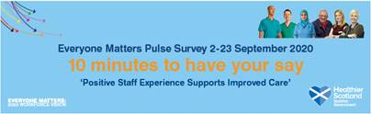 | NHSGGC Everyone Matters Pulse Survey  - click here to find out more

