## Frequently asked questions for Attend Anywhere/Near me

1. **Is it secure?**

Attend Anywhere video consultations are secure; the users privacy is protected. The user has their own private video room that only authorised clinicians can enter.

1. **How much does a video call cost the service user?**

The video call is free (except for internet usage).

1. **How much internet data will it use?**

Service users don’t use any data while waiting for a clinician to join them.

A video consultation uses less than half of the data expended while watching a YouTube video in High Definition. (About 230 MB on a mobile device, and 450 MB on a PC for a 20 minute call, which is similar to a Skype or FaceTime call.)

Data use is less on lower-speed internet connections, or if using a less powerful computer, tablet, or smartphone. These factors can also reduce the overall quality of the call.

Data use increases when there are more than two participants in the call.

1. **Some patients and clinical staff are saying when during a video call their batteries on their devices are draining quickly – What can we do about this?**

Please ensure you have a good charge on your device before you commerce a call or ensure you are plugged in and charging whilst on a call. Please advise your patients to have a good change on their devices as well.

1. **Where can I find more information?**

An online resource centre can be found at:-

<https://nhs.attendanywhere.com/resourcecentre/>

This contains a wider range of information covering the planning, implementation and operation of the system.

1. **What do I do if something is not working?**

Please contact IT if any of your equipment is not working or if Attend Anywhere software is not launching.

You can contact IT by selecting the IT service Desk icon on your desktop

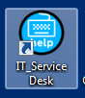

You can also download the [trouble shooting guide](https://sctt.org.uk/wp-content/uploads/2016/11/AttendAnywhere_TroubleshootingReference.pdf) from our webpage <https://www.nhsggc.org.uk/your-health/health-services/specialist-childrens-services/attend-anywhere-near-me/> or visit the [resource centre](https://nhs.attendanywhere.com/resourcecentre/) listed above for more information.

1. **What device can I use it on?**

For NHS staff

They will be able to use it on any of their devices as long as they have the Attend Anywhere 75 CHROME icon and as long as web cams and microphones and sound are available

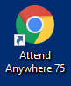

For the patient

|  |  |
| --- | --- |
| **Browser** | **Device** |
| Google Chrome web browser | Desktop, laptop, Android tablet or smartphone |
| Safari web | Apple iMac, MacBook, iPad, or iPhone web camera |

1. **How will patients know what to do?**

A guidance on this can be found at:-

<https://www.nhsggc.org.uk/media/259280/directing-patients-to-the-waiting-rooms.pdf>

1. **Will there be a specific letter?**

Yes there will be specific video call appointment letters and these will detail the date and time the patient will call in for their appointment.

Within this letter there will be a link for the Near Me/Attend Anywhere video call which will ensure the patient joins the correct waiting area for their given team.

This letter will also inform the parent/carer to add their child’s name when entering the waiting area and not their own name as it is the patient who is known to the service.

1. **As clinical staff, how do I ensure I can get logged in?**

The Quality Improvement Team will set up your account from your email address. You will receive an automated email prompting you to log in. To get the Attend Anywhere icon – You need to contact IT requesting that they add the Attend Anywhere icon to your desktop. *You do not need to add google chrome along with this.*

1. **Can you have multiple people in a call?**

Yes you can. You can have an appointment with x2 patients or more eg you can see parents – One who is at home and one who is at work.

* To do this one of the parents should come into the waiting room as normal.
* The clinician then answers the call as normal.
* The clinician will select the “Invite icon”
* They would send a text or email to the second parent by entering their information and selecting send.
* Note there is a third option – You copy the text here into an email and then this allows you to invite multiple people into the call at once.
* The parent will then follow the link sent and they will then appear in the call along with the first parent.

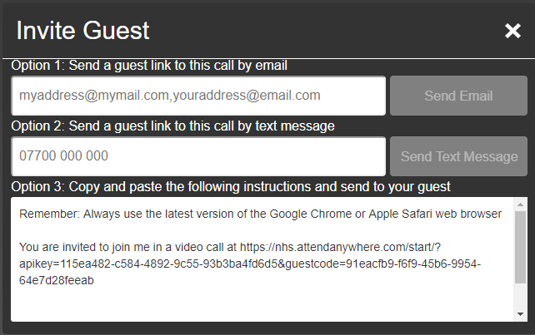

The above process will work for inviting other clinical staff into an appointment as well. You would invite them as above if the clinician does not use Attend Anywhere eg a teacher or social worker or if they do use Attend Anywhere but do not have access to the waiting room that you have access to.

If you are having a joint meeting with a clinician who does have the same access as you eg someone in your team they can enter the waiting area and join call along with you and the patient. In this instance there is no need to invite the other clinician.

You can have up to 5 people linked in to a call before the quality of the call reduces.

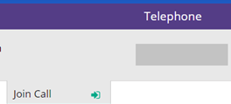

1. **When Sharing a screen with a patient please be aware of the following information:-**

**Entire Screen**

If you share your entire screen you are sharing your full desktop – Please be mindful if you have EMISWeb or Outlook open when doing this.

**Application Window**

This window will allow you to see anything that you have open already on your desktop as a thumbnail. You can then click on this to select and then click Share.

**Chrome Tab**

Chrome Tab – This window allows you to see any web pages that you currently have open in the Chrome browser only.

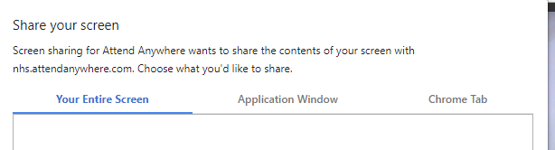

1. **How do you book an appointment for Attend Anywhere?**

Appointments should still be booked within Emis and the notes of the consultation added after to Emis as well.

The **Reason** ofthe appointment should be Video Call

Please read the following guidance re appointments. This shows you how to book an appointment or how to update an existing appointment to video call.

<https://www.nhsggc.org.uk/media/259597/scs-video-appt-process.pdf>

1. The call is glitchy – the video call is cutting out, camera is freezing – How can I fix this during my call so I can continuing using the video call?

If you have any of the issues listed please do a refresh of the call. The clinician should refresh their session and they should advise the patient to do the same.

The refresh button is located at the top right corner during a call.

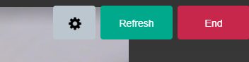

If you feel a refresh of the video call is needed you should advise that there is a pause in the appointment –

During this time the clinician should hit their refresh icon. Please ask the patient to wait as they will get a message on their screen saying that you have left the call. You will then reappear in the call.

It is advisable that once the clinician is back in the call that the patient do that same. The Clinician should hold on as they too will get a messaging saying the patient has left the call before their re-join.

1. **Play Therapy is hard – How can I make it better? And Exercises are proving difficult eg demonstrating and ensure patient is manging the exercise correctly and safety**

If you are planning on doing activities/therapy with the patient that require a number of props/resources please ensure you inform the parent ahead of the call to gather together the items that will be needed during the call. The clinician should also have their props and resources gathered and ready to use/share before the appointment begins.

If you need to physically demonstration eg an exercise ensure you are in an environment with enough space to do this and also ensure that the camera is positioned in a way that the patient can see the exercise clearly and fully.

The laptop may need to be positioned on the table or a shelf so the patient can see your full body.

The above applies to the patient as well if the clinician requires to see they perform the demonstration.

It may also be a good idea to have word documents with examples of the exercise ready to share or ready to post to the patient before or after the appointment.

The patient could also be directed to a video example or webpage.

**Hints and Tips:-**

**IT – For technical issues and to get the icon on your devices**

Please contact IT if you require the AA chrome icon – Please remember that this icon is also chrome and therefore you **do not** need chrome as well

This is the icon you need



If when trying to answer a patient you get a frozen black screen please contact IT

You can contact IT by selecting the IT Service Desk icon on your desktop



**Getting set up on Attend Anywhere – Contact the Quality Improvement Team to request an account (Specialist Children Service staff only)**

Quality Improvements contact number is as follows:-

0141 277 7475

**Help with using the Software**

If you need help using the Attend Anywhere software or would like practice run of a video call please contact the Quality Improvement Team on the number above.

**Attend Anywhere – Hints when using the software**

***Waiting Areas -*** Please ensure you know what Waiting Area you have access to so you are directing your patients to join the correct waiting area.

*Please note if the patient is in the incorrect waiting area you will not see the patient and therefore will not be able to answer the call.*

You can find out what room you have access to by logging into Attend Anywhere and clicking on the Waiting Area icon – Shown below.

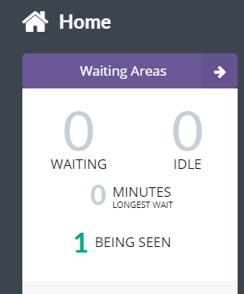

You will then be able to identify what waiting area you have access to e.g. below is Glasgow’s Waiting Area:-

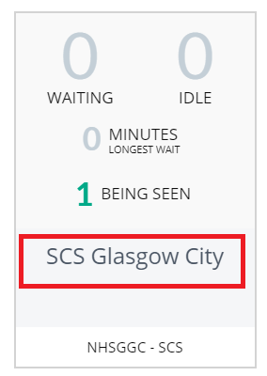

The waiting areas we have are as follows:-

* SCS Glasgow City
* SCS Central Choice
* Kids
* NHSGGC WOS Cleft and Craniofacial Team
* SCS Hosted Service
* SCS Inverclyde
* SCS Renfrewshire
* SCS Royal Hospital for Children
* SCS West Dunbartonshire

Please ask parents/carers calling on behalf of their child to add their child’s name and DOB when entering the Attend Anywhere waiting room. This makes the patient easier to identify as we would be able to look the child up on EMIS if required.

Please also monitor your waiting areas to ensure patients are not waiting long periods of time. You should be seeing your patient at the given appointment time.

Admin staff should be monitoring the waiting areas as they do with the current reception areas.

If the clinical staff are running late with their clinic the patient should be contacted by the “notify” message available in Attend Anywhere or by calling them on the phone number they have provided.

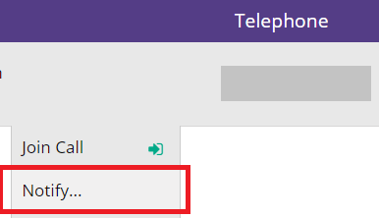

***Group Meetings***

***Inviting Guests into a patient appoint – below details how to invite a user into a call and also the steps the guest will need to follow in order to get into the call.***

|  |  |  |
| --- | --- | --- |
| Step | Action |  |
| 1 | You may also want to invite other people into the call who do not have access to Attend Anywhere – Any of the clinicians should be able to invite a person into the call – Click the Invite button. |  |
| Remember these important steps a guest needs to know before joining into an appointment:-  *You are inviting them into the appointment – Let them know in advance that they will be receiving an invite. This will allow them to ensure they have the appointment date and time blocked out and they will be waiting for the link.*  *Inform them that they will need to have Chrome or Safari web browsers in order to get into the appointment following the link that has been sent.*  *Let them know all information documented in Step 3 so they know what log in information to add* | | |
| 2 | The Invite Guest pop up box will now appear  There are x3 options for inviting a guest:-  **Option 1 – email** – enter a person’s email and a link will be sent to them inviting them into the current appointment  **Option 2 – text** – enter a person’s mobile number and they will be sent a text with a link inviting them into the current appointment  **Option 3** – This option allows you to invite more than x1 person at the same time – Copy the text shown in option 3 then open an email and paste the text into the body of the email – You can then send this link to multiple people at the same time |  |
| 3 | The link will be sent to the user within a few moments.  If Chrome or Safari is not the main browser for the user they may receive the following error when clicking on the link.  The user should click on the copy link button. This will copy the link **do not** try to highlight the link. |  |
| 4 | The user will then see the following warning message – say allow or the link will not be copied |  |
| 5 | The Copy Link icon will change to Copied if you have completed step 3 and 4 correctly – now minimise or shut the internet page – Go back to your desktop when using PC/laptop or home screen if using a tablet or phone |  |
| 6 | Now select either:-  Chrome if using a Microsoft PC/laptop/smart phone/tablet  Safari if apple device  Once the browser opens:-  right click on the address bar and paste or  click on the address bar and select the Ctrl key and V  The link will be pasted in  Hit return or select the search button | Chrome icon appears as follows:-    Safari icon appears as follows:- |
| 7 | Once the link has been copied into the correct browser –  They should go through the test equipment set up and they should fill in their details. This is the same process as detailed above for the patient.  Please advise that any person invited into the call should add in **their own details** eg own name when entering the call.  Due to the setup of the system it is mandatory for the user to fill in their DOB and phone number. This might not always be appropriate so ask the person to add:-  DOB – Todays date  Phone number – 0000000 |  |
| 8 | Once the link has been followed and details filled in the person will appear in the video call | |

***Muting your sound -*** When in a group meeting – eg an appointment with more than x2 people it is advisable for all participants to mute their sound unless they are speaking. This will stop any background noise coming through and interfering with the call. It will therefore ensure everyone on the call can hear clearly.

**Notifications noise and pop up within the Waiting Areas**

As the waiting areas are shared between SCS teams and CAMHS teams the waiting areas may get busy. Each time a patient calls in there is a notification. When you get a notification a pop up will appear at the bottom corner of your screen. There is also a notification noise.

When you first launch the application you will see the following screen:-

If you are happy to receive the notification say Allow.

If you do not wish to receive the notification say Block.

You will need to do this each day.

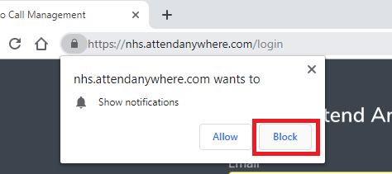

If the reception of the video call is not great please hit the refresh button and wait for a minute – you and the patient will get a warning saying each of you have left the call – Please hold on and do not end the call – The call will start again after the refresh has happened.

**Ending a Call and Post call Survey**

Please ensure that it’s the clinician who “ends the call”. Please ensure the clinician chooses the option “end call for everyone”. This will ensure the call will be ended.

There has been some issues when a patients reverts to “waiting” in the waiting room after their call has been answered and ended. Choosing “end call for everyone” should stop this.

Note that the clinician is leaving the call but other clinician will be staying with the patient then “leave the call just me” will need to be selected.

After a call is ended there is a survey for the patient and clinician. Any accompanying clinician or a second patient in the call will also get a survey when the call is ended. Please request that your patient fills this in.