Pre-Retirement Financial Awareness
Course Workbook
This workbook is issued in conjunction with the “Pre-Retirement Financial Awareness workshop NHS Staff Benefits & Create and Prosper run on a monthly basis for NHS Greater Glasgow & Clyde Learning and Education Department.

This work book has been designed to make you think about your financial and lifestyle plans as you approach retirement.

Activity 1- Pre-Retirement Questions
Do you want to retire?
Do you need to retire?
What will you miss about working?
What date will you retire from the NHS?
What age will you be when you retire from the NHS?

When do you qualify for your State Pension?
What age will you be when you start to receive your state pension?
Is your will up to date?
Have you considered “Power of Attorney”?

Notes :
Activity 2 - Expenditure and Income
Expenditure – Current and in Retirement (Monthly or Annually)
 | Current | In Retirement | Difference
Fixed Household Costs :-
Mortgage / Rent | £ | £ | £
Council Tax | £ | £ | £
Gas / Electricity | £ | £ | £
Telephone/Broadband | £ | £ | £
Food shopping | £ | £ | £
Building/contents insurance | £ | £ | £
TV / Satellite / Cable | £ | £ | £
Transportation Costs:-
Fuel | £ | £ | £
Car Tax | £ | £ | £
Car insurance | £ | £ | £
Servicing and maintenance | £ | £ | £
Public Transport | £ | £ | £
Financials:-
Credit/Store Card repayments | £ | £ | £
Loans/HP/Rental agreements | £ | £ | £
Savings | £ | £ | £
Life Insurance | £ | £ | £
Pension contributions | £ | £ | £
Accident & Sickness Cover | £ | £ | £
Miscellaneous:-
Maintenance / Alimony | £ | £ | £
School Fees | £ | £ | £
Holidays | £ | £ | £
Clothing | £ | £ | £
Other | £ | £ | £
TOTAL | £ | £ | £

Notes :

Extracted from the SPPA website 17/06/2020:-
The NHS Superannuation Scheme (Scotland) 1995 section
The 1995 section is one of three NHS pension schemes for people directly employed by the NHS along with medical, dental, opthalmic practitioners, general medical practice staff and staff working for certain approved employers in Scotland.
The 1995 section closed to new members on 1 April 2008. Members who were active in the scheme on 31 March and 1 April 2008 remained in the 1995 section but may have had the chance at a later date to move to the 2008 section as part of the Choice Exercise.
Key Features:-
Normal pension age of 60.
Option to retire at age 55 for Special Class members and Mental Health Officers.
Pension based on membership and final pensionable pay.
Automatic tax free lump sum upon retirement.
Valuable death benefits for your family.

If you're a member of the 1995 Section, you'll receive a basic annual pension plus a tax-free lump sum of three times your basic pension, which is based on your accrued Pensionable Service and the best year from your final 3 years' pensionable salary. Part years of service also count towards your pension.
Your pension is calculated as follows:
Pensionable Pay x Pensionable Service x 1/80 = pension
Your Lump Sum is calculated as follows:
Pensionable Pay x Pensionable Service x 3/80 = lump sum
The NHS Superannuation Scheme (Scotland) 2008 section
The 2008 section of the NHS Superannuation Scheme closed to new members from 1 April 2015 with all new NHS employees joining the 2015 scheme from that date.
Key features:-
normal pension age of 65
minimum Pension age of 55
pension based on membership and reckonable pay
pension worth 1/60th of your reckonable pay for each year of service
option to exchange part of your pension benefits for cash lump sum at retirement in a process known as commutation
death benefits payable to your legal spouse, registered civil partner, qualifying partner and dependent children from the date of your death.
If you're a member of the NHS 2008 scheme you receive a pension equal to 1/60th of your reckonable pay for each year of pensionable membership of the scheme. Your reckonable pay is the average of the best three consecutive years' pensionable pay in the last ten years of your service. Part years of service also count towards your pension.
As well as your annual pension, you have the option to give up some of your annual pension to receive a tax-free lump sum.
Your pension is calculated as follows: Reckonable Pay x Pensionable Service x 1/60 = pension

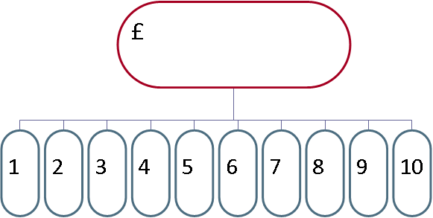
NHS Scotland 2015 scheme
Key features:-
Benefits accrued on a Career Average Revalued Earnings (CARE) basis.
Normal pension age the same as the your State Pension Age.
Pension accrual rate of 1/54th of pensionable earnings each year.
Benefits for active members revalued each year using the Consumer Prices Index (CPI) plus 1.5%.
Benefits for preserved members increased using the CPI each year.
Valuable death benefits for your dependents.
Option to take part of your pension and continue working.
Enhanced pension for working longer than normal pension age.
Option to purchase additional pension.
Option to buy out the actuarial reduction if retiring from age 65 and before state pension age.
Option to take up to 25% of pension pot as a tax-free lump sum.
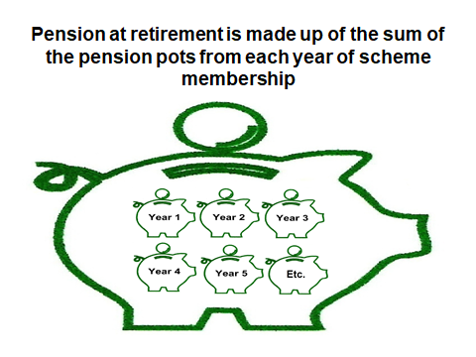

Nett Monthly Income – Current and in Retirement
 | Current | In Retirement | Date From
Salary from Employment | £ | £
Part Time or Other Employment | £ | £
Expenses and Allowances | £ | £
Trust income | £ | £
Rental income | £ | £
State benefits | £ | £
State pension | £ | £
NHS pension | £ | £
Other pension 1 (Income) | £ | £
Other pension 2 (Income) | £ | £
Other pension 3 (Income) | £ | £
Other | £ | £
Other | £ | £
TOTAL | £ | £

Other Sources of Income (Capital / Lump Sums)
 | Description | Current Value | Income Amount
Pension 1 (Tax Free Cash) |  | £ | £
Pension 2 (Tax Free Cash) |  | £ | £
Pension 3 (Tax Free Cash) |  | £ | £
Shares 1 |  | £ | £
Shares 2 |  | £ | £
Shares 3 |  | £ | £
ISA 1 |  | £ | £
ISA 2 |  | £ | £
ISA 3 |  | £ | £
Cash Savings 1 |  | £ | £
Cash Savings 2 |  | £ | £
Cash Savings 3 |  | £ | £
Downsizing Property |  | £ | £
SPPA Pension Lump Sum |  | £ | £
Other |  | £ | £
TOTAL |  | £ | £

For SPPA/NHS Pension Choices –
www.sppa.gov.uk
For Information Regarding When You Will Receive your State Pension and How Much You Will Receive –
www.gov.uk/check-state-pension
FACT: Did you know -You do not pay National Insurance Contributions on your NHS Pension
FACT: Commutation within the NHS Superannuation Scheme is defined as giving up part of the pension payable from retirement in exchange for an immediate lump sum.
Activity 3 - Life Expectancy and Health Life Expectancy
People are living longer. Improved working conditions, reduced smoking rates and improved healthcare have all contributed to increasing life expectancy from generation to generation.
To get an idea of what the Office for National Statistics consider your life expectancy mortality enter your age and sex on their calculator:-
https://www.ons.gov.uk/peoplepopulationandcommunity/healthandsocialcare/healthandlifeexpectancies/articles/lifeexpectancycalculator/2019-06-07.
………………………………………………………………………………………………………………………………………………………….Or you could use the American version which is a bit more interactive and asks more questions:-
https://media.nmfn.com/tnetwork/lifespan/#0

………………………………………………………………………………………………………………………………….Compliments of the NHS, advice, tips and tools to help you make the best choices about your health and wellbeing:-
https://www.nhs.uk/live-well/

At What Age Will Your Quality of Life Start to Diminish?
Do you have any underlying health issue which might impact on your health now or in the future
ONS Scottish Mortality Report Oct 2009 | https://www.nrscotland.gov.uk/files//statistics/seminars/30-oct-2009/uiphs09-scottish-mortality.pdf

Notes :

Activity 4 - Lifestyle Planning
What do you want to do, how often and how much it will cost
I Would Like To…………. | How Often or When | Annual or One Off Cost

Retirement Planning Checklist
Things to Consider
Work out your likely retirement income & outgoings
Don’t take risks with the pension savings
Consider ways to boost your pension
Budget for changes in your day-to-day spending
Clear your debts before you retire
Complete home repairs and improvements
Get advice on choices
State Pension
Have a look at information on https://www.gov.uk/state-pension
Workplace Pensions
Have a look at information on www.sppa.gov.uk
Gather details of SPPA pensions, visit www.mypension.sppa.gov.uk
Gather details of other pensions from past employers
Gather details of Personal Pensions, AVC’s and FSAVC’s
Savings and Investments
Get up to date details of ISAs and other investments
Get up to date details of bank accounts
Review your risk strategy
Calculations
Calculate your current and future income and expenditure
Work out tax free lump sums from your pensions
Calculate your pension income after tax
General
Have a plan for retirement in writing
Access online sources of information through the Money Advice Service
Seek advice from a qualified Financial Adviser
If you are within 6 months of State Pension age contact DWP

Joe Quinn & Graeme Inglis deliver the Pre-Retirement Fianancial Awareness Event for NHS Greater Glasgow & Clyde’s Learning & Education Department.
This course is designed to inform staff who are considering and or approaching retirement.
Pre-Retirement Financial Awareness will cover:
: 1995, 2008 & 2015 pension schemes.
: Protecting your money from all forms of tax, inflation and poor decisions.
: How to maximising your income during retirement and budget planning.
: Financial planning for the rest of your life as well as your family and or beneficiaries.
: Calculating your pension, tax free lump sum benefits and your entitlement to the state pension.
: Raising your awareness of information resources and planning tools.
: Raising your awareness of income tax and your pension income or returning to work post-retirement.
: The financial impact of retirement including investment risk and reward
: The retirement application process and phased retirement policy.
These Sessions provide the opportunity to seek free independent financial advice (no obligation consultation on request)*
Learning outcomes:
The aim of this event is to provide you with the knowledge you require to make informed decisions about your retirement finances.
…………………………………………………………………………………………………………………………………
• References in this presentation to legislation and tax are based upon Create and Prosper’s understanding of UK law and HM Revenue & Customs practice in the UK as at the date of presentation
• Tax and legislation are likely to change
• The value of tax reliefs depend on individual circumstances
• No guarantees are given regarding the effectiveness of any arrangements entered into on the basis of these comments
• Create and Prosper Financial services Ltd are responsible for financial advice not your employer, in accordance with the Financial Conduct Authority’s regulations.

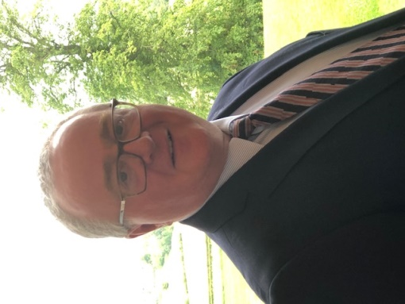

info@financialplanningclinic.co.uk
Joe is the Founding Director of PSSB Ltd and has practical experience in the provision and maintenance of voluntary employee benefits going back to April 1998. Joe has a very good understanding of NHS pension schemes, before you complete your pension application he can provide you with the knowledge you require to make the right decisions about your NHS pension benefits.

info@financialplanningclinic.co.uk
Graeme is the Founder of Create and Prosper and is a Director of the business. He has over 25 years financial services experience, is a Chartered Financial Planner and holds the Investment Management Certificate. Graeme can provide you with a comprehensive independent financial planning service for all your investment and protection needs.

