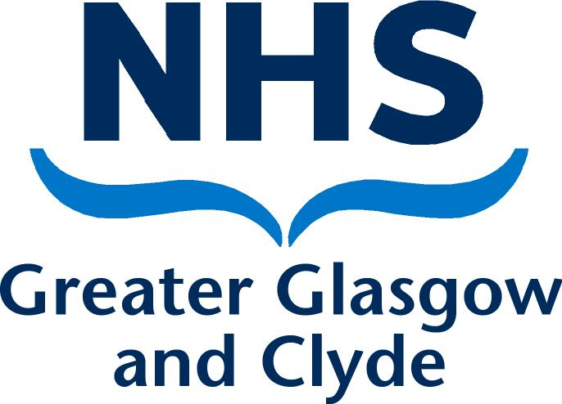
NHS GREATER GLASGOW AND CLYDE
CLAIM FORM FOR ADDITONAL AD-HOC HOURS WORKED
CAREER GRADE MEDICAL AND DENTAL STAFF (ONLY) COVID 19

As a result of staff being required to work flexibly and beyond the agreed Job Planned activities, this form should be use to claim for additional hours worked on an ad-hoc basis. ALL Sections of form must be completed otherwise claims cannot be processed. When agreed by your CD the form should be emailed to your General Manager.
Claimants Name: (Print) |  |  |  |  | Specialty:
Base Hospital: |  |  |  |  | Staff Pay No (from Payslip)
DAY | DATE | TIME |  | TOTAL HOURS WORKED | DESCRIPTION OF DCC WORKED ( brief description of activity undertaken) | OFFICE USE ONLY
 |  | From | To |  |  | Total core | Total premium
Total to be paid

I confirm this claim is an accurate record of the hours worked.
I wish to be paid for the above hours
I wish to take the above hours as TOIL
Claimant’s Signature: | Date:

Agreed with:
Name: (Clinical Director) | Signed: | Date:

Approved By:
Name: (General Manager) | Signed: | Date:

Where payment has been authorised (non TOIL Claims) please send this form to the Payroll Department, Caledonia House, 140 Fifty Pitches Road, Cardonald, G51 4EB.

