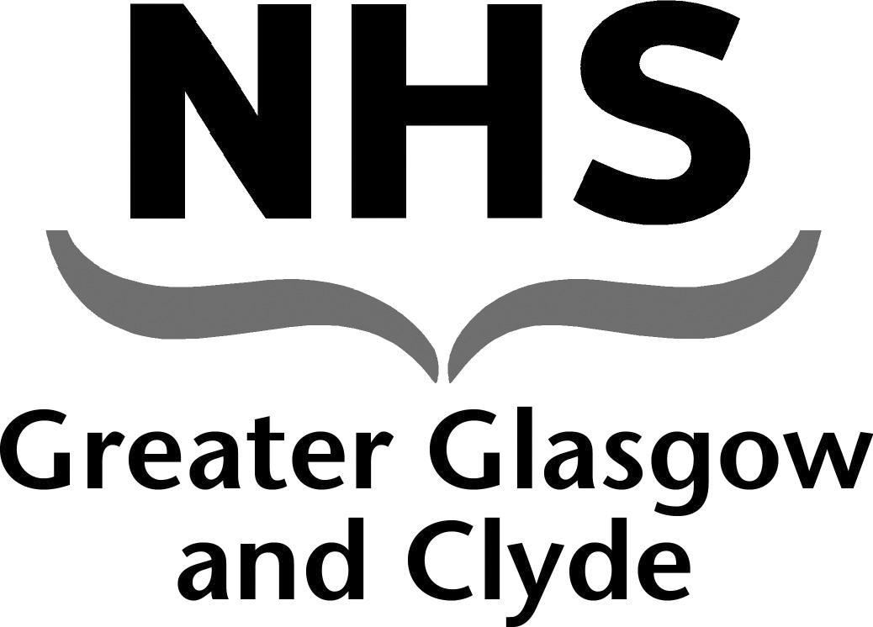
NEWSLETTER

May Day Public Holiday Monday 4th May 2020 Pay Arrangements

NHS GGC Nursing and Midwifery Staff Bank

This newsletter contains important information regarding changes to the payroll cut off dates for the signing off of shifts on the BankStaff system over the May Day Public Holiday .

Please note there will be early cut offs and Early pay dates.

Changes to Bank Shifts Pay Arrangements

Date of Shifts Worked | Timesheets MUST be completely signed off by: | Date Paid
17th April – 23rd April 2020 | 12pm on Friday 24th April 2020 | Friday  1st May 2020
24th April – 28th April 2020 | 12pm on Wednesday 29th April 2020 | Thursday  7th May 2020
29th April – 7th May 2020 | 12pm on Friday 8th May 2020 | Friday  15th May 2020

Tel 0141 278 2555
Email staff.bank@ggc.scot.nhs.uk

