This guide details how you access your LearnPro account. As an obligation of working within NHS Greater Glasgow & Clyde you are required to complete 9 core statutory and mandatory eLearning modules as well as a number of role specific mandatory health and safety modules.
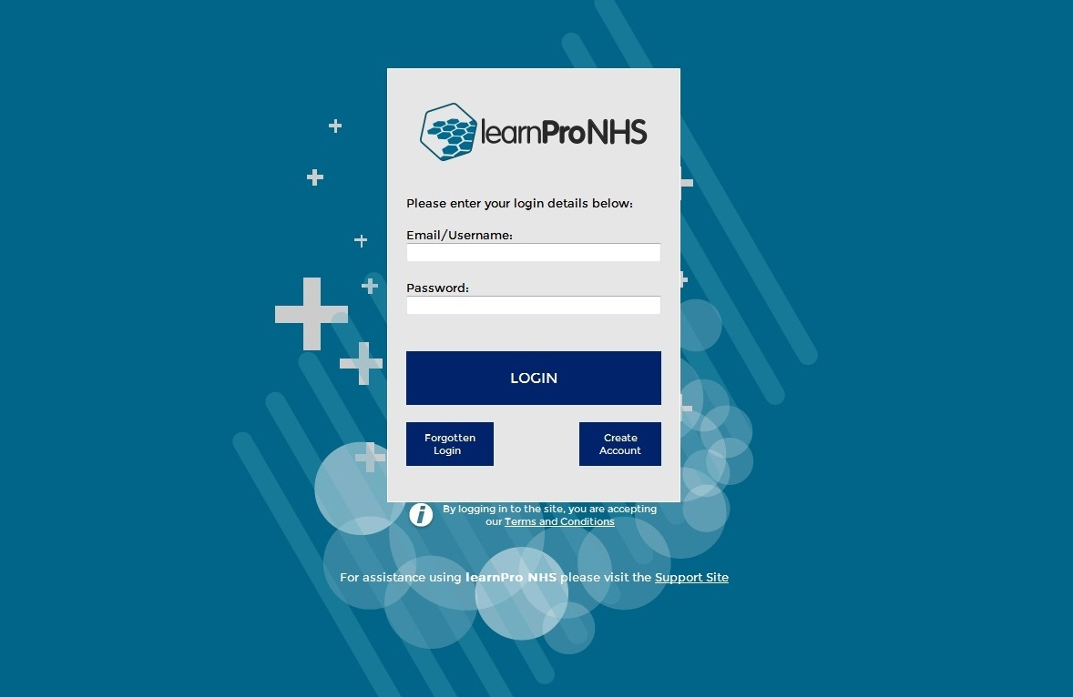
Access
Use this link https://nhs.learnprouk.com to access the LearnPro platform.

You will have been provided with a username and temporary password.

Selecting Learning Material
You are required to complete 9 core statutory and mandatory eLearning modules as well as a number of role specific mandatory health and safety modules as part of your placement. All modules are available on the NHS GGC LearnPro platform.

- Core statutory and mandatory training
These modules must be completed by all staff. They are located under the Statutory / Mandatory category on the LearnPro home page.
Code | Title | Validity period
GGC: 001 | Fire Safety | 1 year
GGC: 002 | Health and Safety, An Introduction | 3 years
GGC: 003 | Reducing Risks of Violence & Aggression | 3 years
GGC: 004 | Equality, Diversity and Human Rights | 3 years
GGC: 005 | Manual Handling Theory | 3 years
GGC: 006 | Public Protection - (Adult Support & Protection and Child Protection) | 3 years
GGC: 007 | Standard Infection Control Precautions | 3 years
GGC: 008 | Security and Threat | 3 years
GGC: 009 | Safe Information Handling - Foundation (Information Governance) | 3 years

- Healthcare-related sharps learning
All staff who use healthcare related sharps must complete both modules.
Staff who do not use sharps but work in areas where sharps are used must complete GGC: 061.
Code | Title | Validity period | Location (category) in LearnPro
GGC: 061 | Management of Needlestick & Similar Injuries | 2 years | Role Specific Mandatory Modules
NES | Prevention and Management of Occupational Exposure | 2 years | Infection Prevention and Control (NES Scottish IPC Education Pathway – Foundation)

- Falls learning
All Medical, Nursing and AHP staff working within Acute and Mental Health bed holding areas are required to undertake the following 6 elements of the Falls Awareness Programme (GGC: 215 – GGC: 219 are contained within the GGC: Falls Prevention Training programme. GGC: 221 Bedrails sits separately under the Role Specific Mandatory Modules).
Code | Title | Validity period | Location in LearnPro
GGC: 215 | An introduction to falls | 2 years | Role Specific Mandatory Modules (GGC: Falls Prevention Training)
GGC: 216 | The falls bundle of care | 2 years | Role Specific Mandatory Modules (GGC: Falls Prevention Training)
GGC: 217 | The risk factors for falls (part 1) | 2 years | Role Specific Mandatory Modules (GGC: Falls Prevention Training)
GGC: 218 | The risk factors for falls (part 2) | 2 years | Role Specific Mandatory Modules (GGC: Falls Prevention Training)
GGC: 219 | What to do when your patient falls | 2 years | Role Specific Mandatory Modules (GGC: Falls Prevention Training)
GGC: 221 | Bedrails | 2 years | Role Specific Mandatory Modules

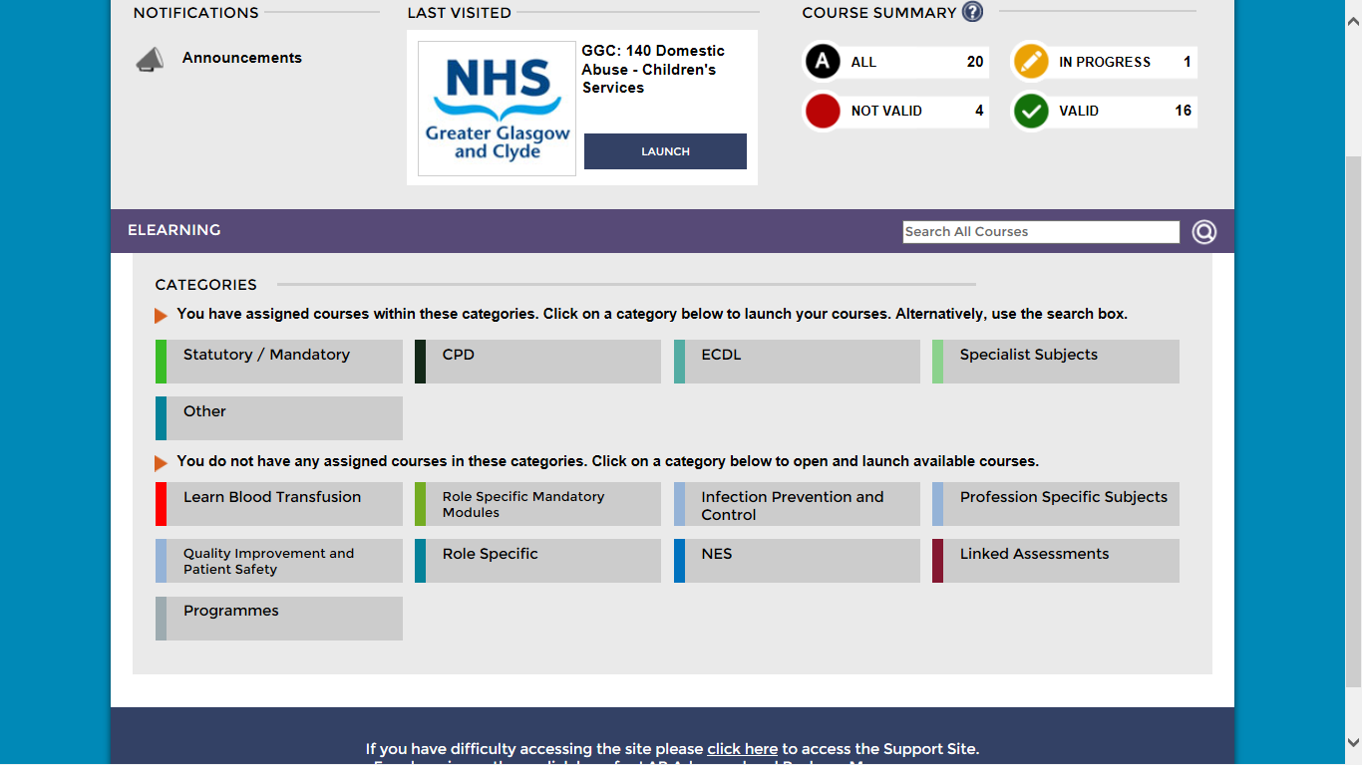
- How to find and launch Modules in LearnPro
The modules are located under three different category tabs. Core Statutory and Mandatory are located under the Statutory / Mandatory category. GGC Sharps and Falls are in the ‘Role Specific Mandatory Modules’ category.
To locate the NES Prevention and Management of Occupational Exposure module, click on the ‘Infection Prevention and Control’ category.

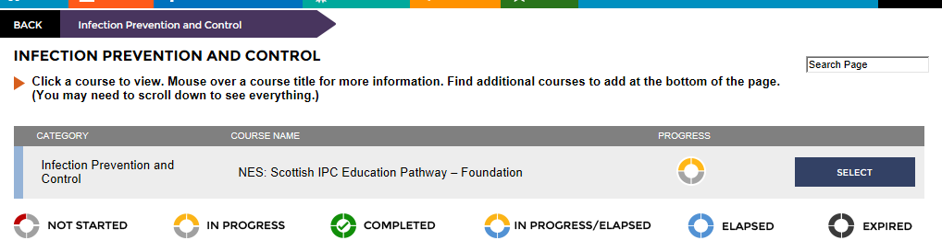
Find the course titled ‘NES: Scottish IPC Education Pathway – Foundation’ (also known as SIPCEP).
Click on ‘Select’.

The page you are taken to contains 15 modules, scroll down until you find the NES module you are looking for titled ‘Prevention and Management of Occupational Exposure’ and click on ‘Select’.

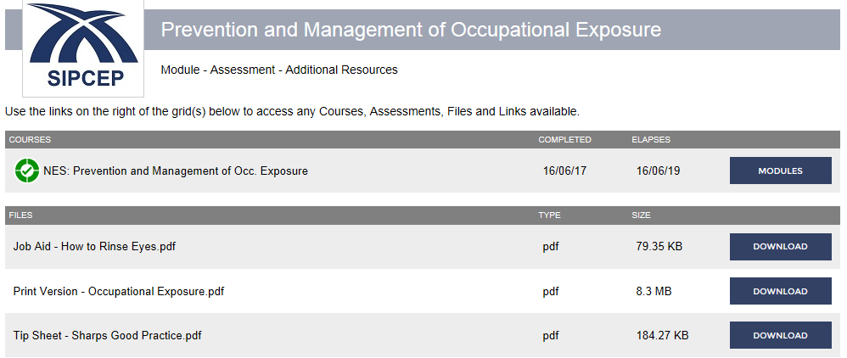
You will then get the following screen, clicking on the ‘Modules’ button will take you through to the module and the assessment module, both the learning content and the assessment will require to be completed.

You will now have access to the selected courses. To access a course click ‘Select’ followed by ‘Launch’.

The module will open. Click on “Next” to navigate through the course. The “Previous” button will also be available on the screen in case you want to go back and recap on any of the information.

When you have finished the course click on the “Close” button at the top right hand corner of the screen.

You will then be able to “Launch Assessment” (if available) to assess your learning and record module completion.

It is important that you click “Close and Update” to record your progress at the end of the module and/or assessment. If you don’t your progress and/or completion may not be recorded.

When you wish to come out of the platform please click on the Logout button.

Updating your Profile

If you are an existing employee of NHSGG&C and you move internally within the organisation, it is important that you update your profile on LearnPro.
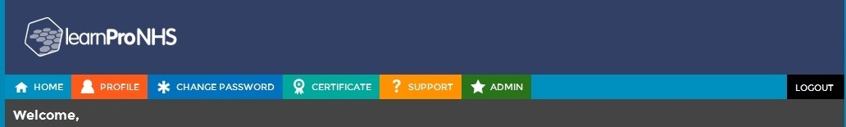
Firstly, login to LearnPro and choose Profile.

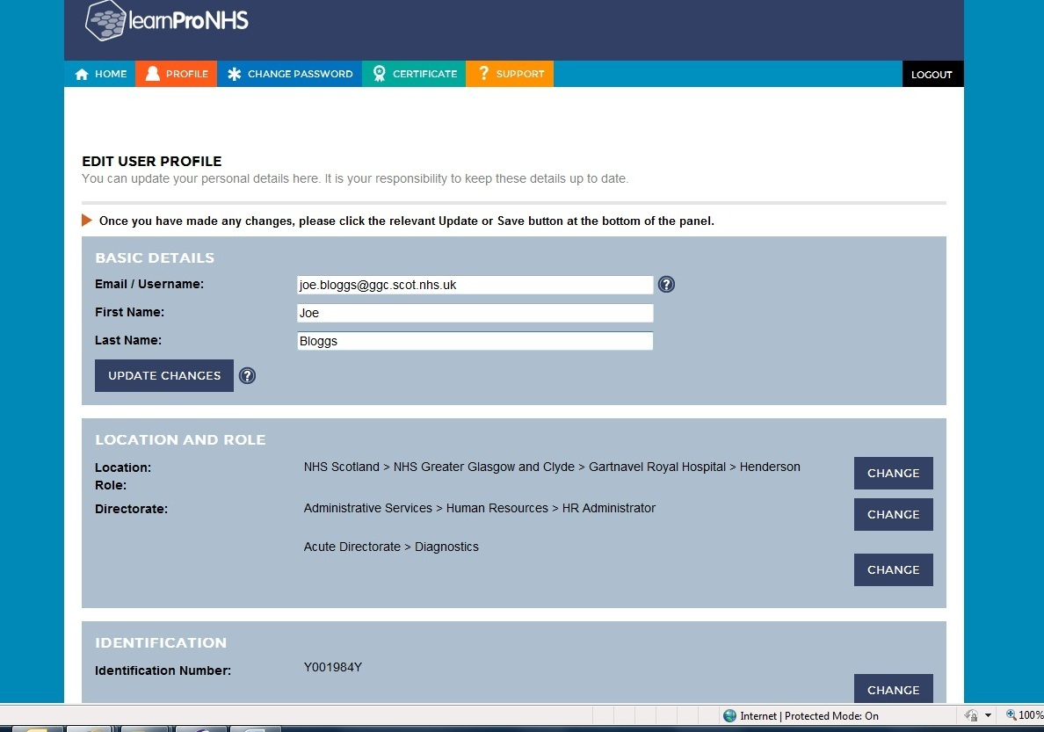
You will then have the option to edit your details.

Click Change next to Location/ Role/ Directorate to make changes to these areas. Choose your new location from the list presented. Now click “Save Changes”. See example below.

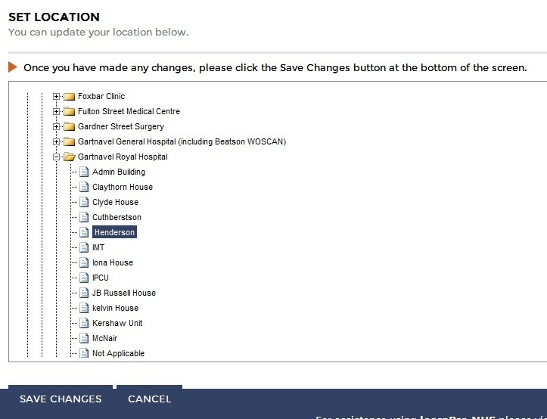

If you have also changed your Directorate and/or Job role, please follow the steps above and select from the list presented. Click “Save Changes”.

Common Questions

I’ve forgotten my password what do I do?
If you have forgotten your password please visit https://nhs.learnprouk.com and enter your email address at the bottom of the screen and click “Mail me a new one”

How do I change my password?
You can change your password, by logging into LearnPro and clicking on “Change Password” from the menu at the top of the screen. Enter your new password and click on “Change Password”.

How do I change my username?
If you want to change your username (e.g. from joe.bloggs@yahoo.co.uk to joe.bloggs@ggc.scot.nhs.uk) you can do this as below:

- Log into learnPro using your existing username and password
- On the menu bar at the top of the screen click “Profile”
- Enter your new username/email
- Click on “Update Changes”

If you have changed your email address to a ggc.scot.nhs.uk address, all communication (e.g. course expiry) will be sent here.

Where can I get more help and support?
The question mark symbol (blue question mark) appears throughout the platform and by clicking on it you will be given additional information.

As well as that there is a support option on the Main Menu bar at the top of the screen and a link to the Support Site shown at the bottom of some of the pages

You will find useful information such as Help Manuals and Frequently Asked Questions documents on the Support Site.

