This guide details how you create your LearnPro account and add the initial mandatory modules. As part of your induction to NHS Greater Glasgow & Clyde you are required to complete 9 core statutory and mandatory eLearning modules as well as a number of role specific mandatory health and safety modules.

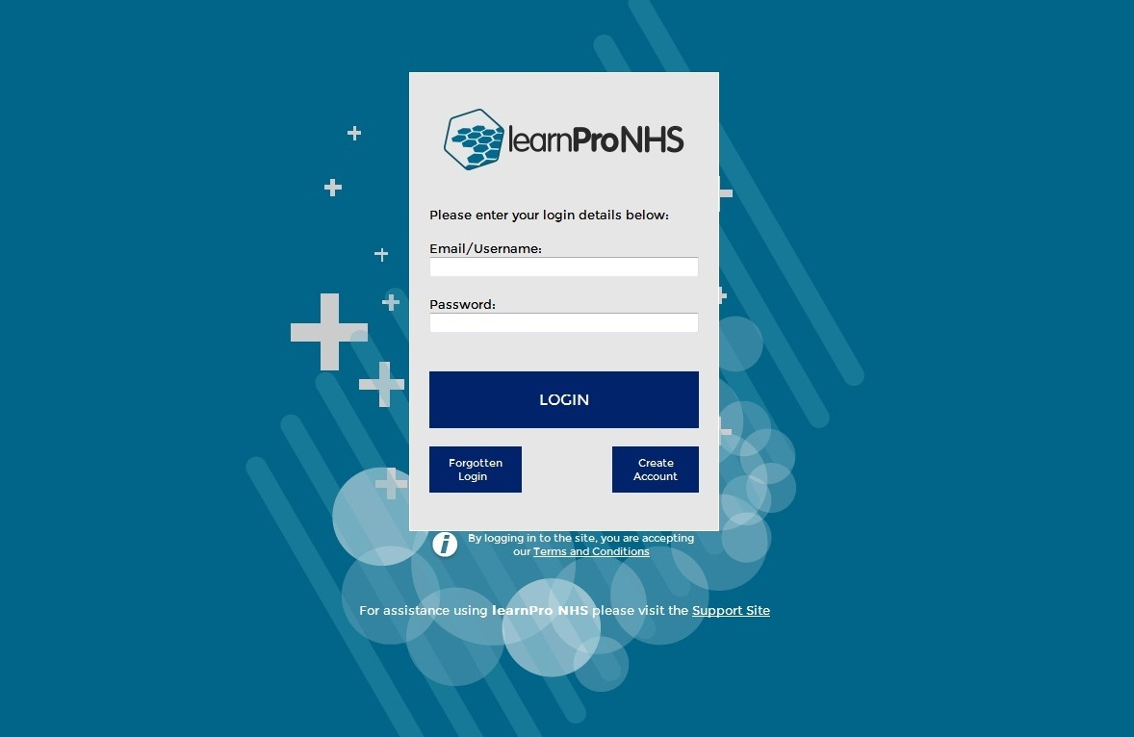
Access
Use this link https://nhs.learnprouk.com to access the LearnPro platform.

If you are new to LearnPro, please press “Create Account”. You now need to read and agree to the terms and conditions and click “I agree to the terms and conditions”. If you are already registered on learnPro then you just enter your Username and Password to Login.

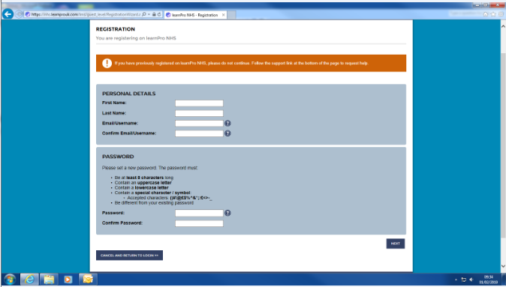
Registration
Please complete this section. If you have an email address please enter it on the registration screen. If you don’t have an email address, please enter your full name instead i.e. Joe Bloggs.

Enter a password as per the criteria on the screen. Details on how to change this are given later in this guide.

Please note that if you have entered an email address, automatic reminders will be sent by LearnPro to this email address if a course is about to expire e.g. Fire Safety. If you want to change your email address later on you can do so by using the Profile/Edit Details option from the Home Page. Details on how to change this are given later in this guide.

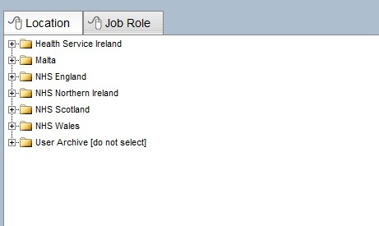
You will now see two tabs appearing at the top. One is for “Location” and the other is for “Job Role”

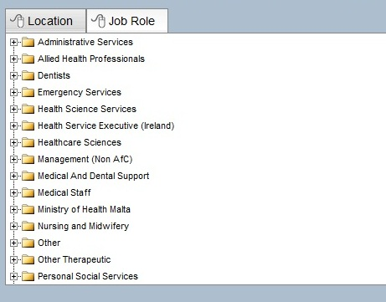
You need to select a location from the list given. First click on NHS Scotland, then click on NHS Greater Glasgow and Clyde, then the appropriate venue e.g. Queen Elizabeth University Hospital and finally the ward area, choose N/A if not sure which area applies.

Please repeat this process with “Job Role” as shown below. E.g. click on Nursing and Midwifery, then click on Nursing Services, then the appropriate job title e.g. Nurse Unregistered.

You will now be asked for an identification number. This will be your payroll number. If you are a new member of staff and you don’t have a payroll number, please contact the learning and e-support team (learning.e-support@ggc.scot.nhs.uk) who will provide you with an ID number.

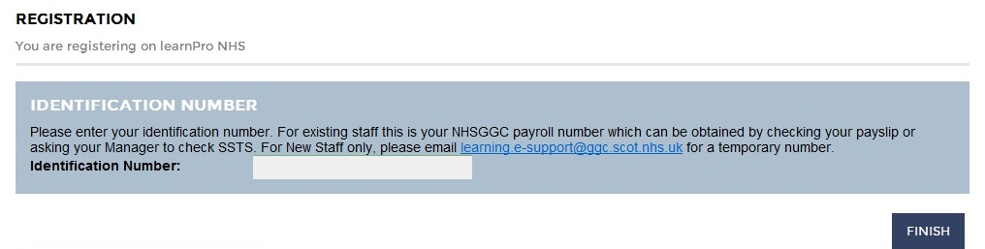
If all details are entered correctly a green tick will appear next to the number field and you can then click on the “Finish” button on this screen button.

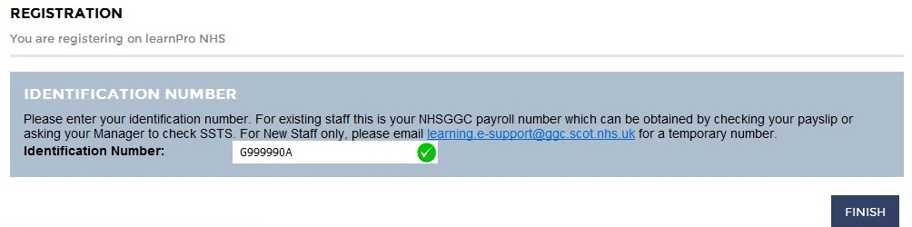
Your registration is now complete and the following confirmation message will appear.

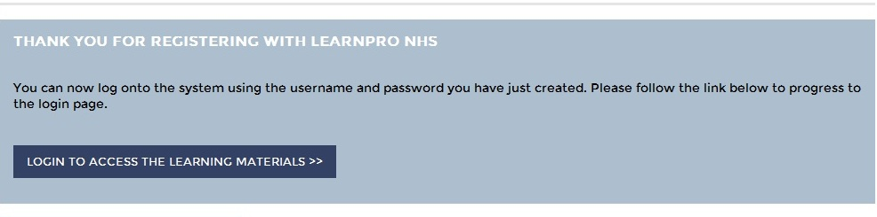

You can now Login to LearnPro using the link on the screen.

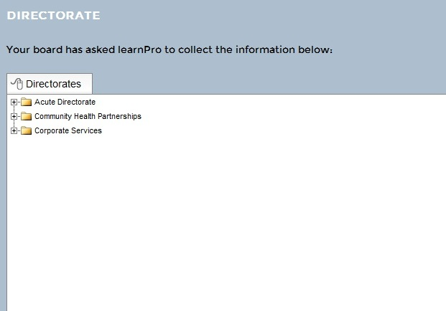
First login - complete registration details.

You will now be asked for a few more details before you can access your learning. Please choose your Directorate / Partnership area from the Directory structure.

Once you have done this, please click “Next”. A Consent screen will now appear. Please click “I Agree” at the bottom left hand corner of the screen and click “Next”.
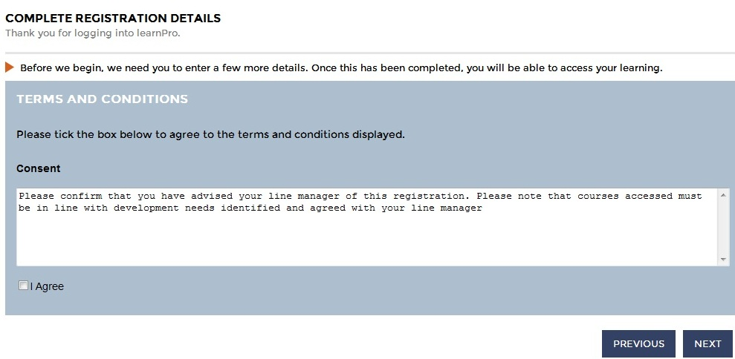

A screen will now appear and Click “Continue” button on the right hand side of the screen.

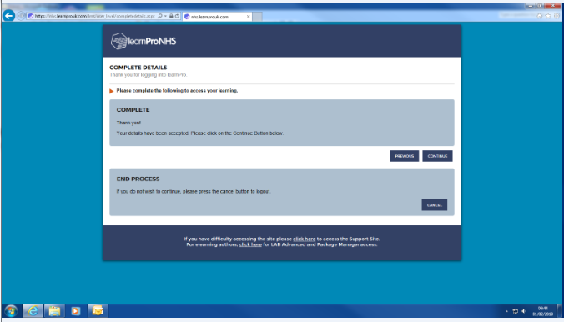

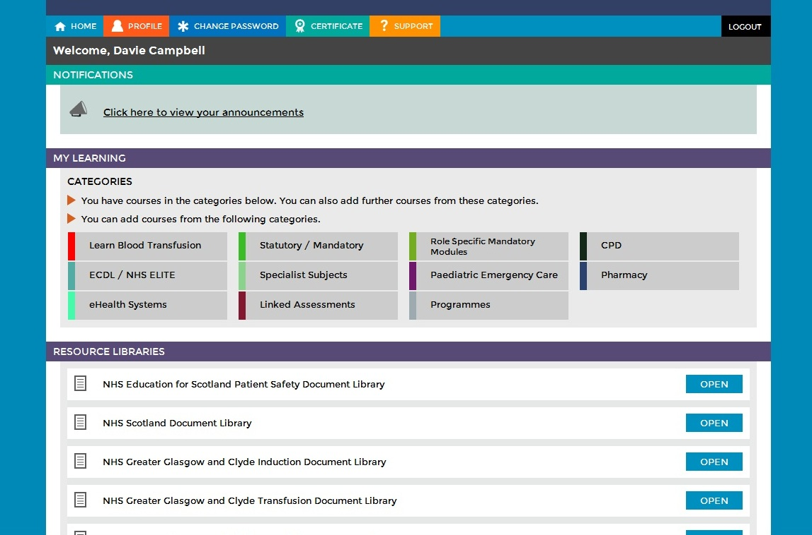
Choose Learning Material (adding your initial mandatory modules)

You will then see the home screen from which you have to choose the relevant courses. For example we have chosen Adult Protection which sits under the Statutory/Mandatory tab (Other courses can be found by clicking on the other tabs e.g. CPD). You would then click the Statutory/Mandatory tab.

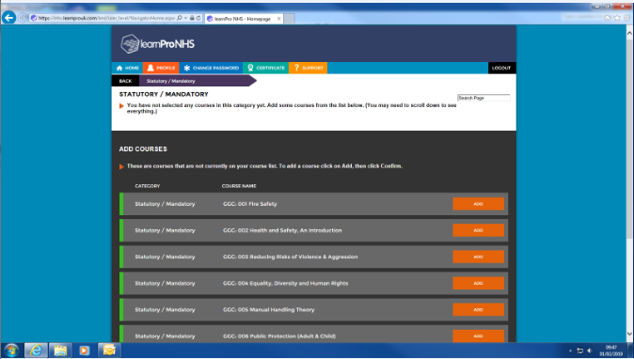
The following screen appears. Select each of the 9 modules by clicking on the ADD button next to the course title and confirming for each one.

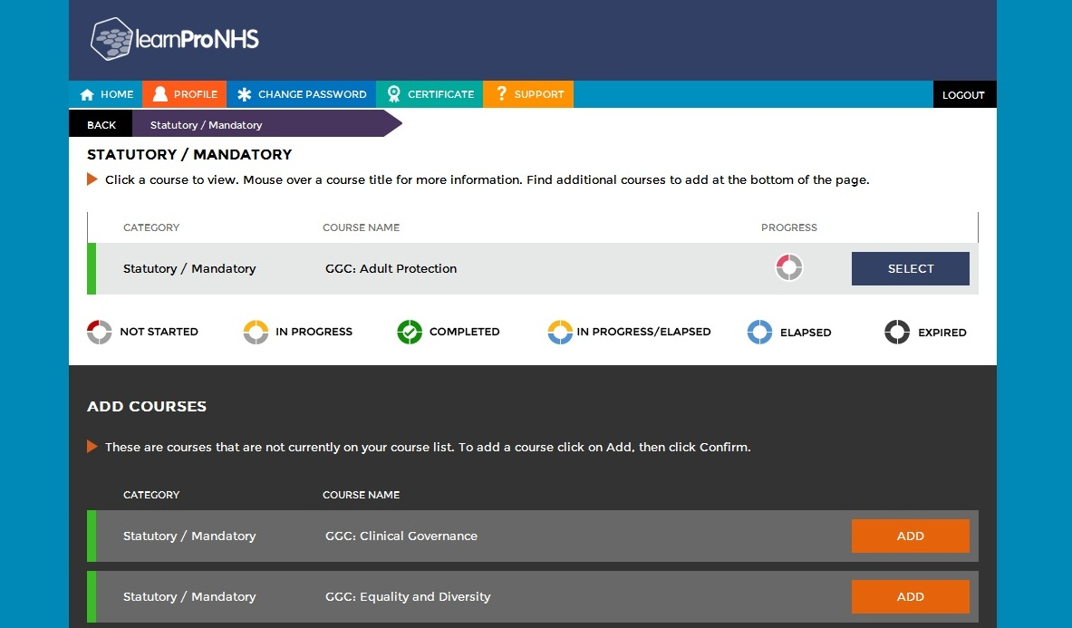
You will now have access to the selected course. To access the course click Select

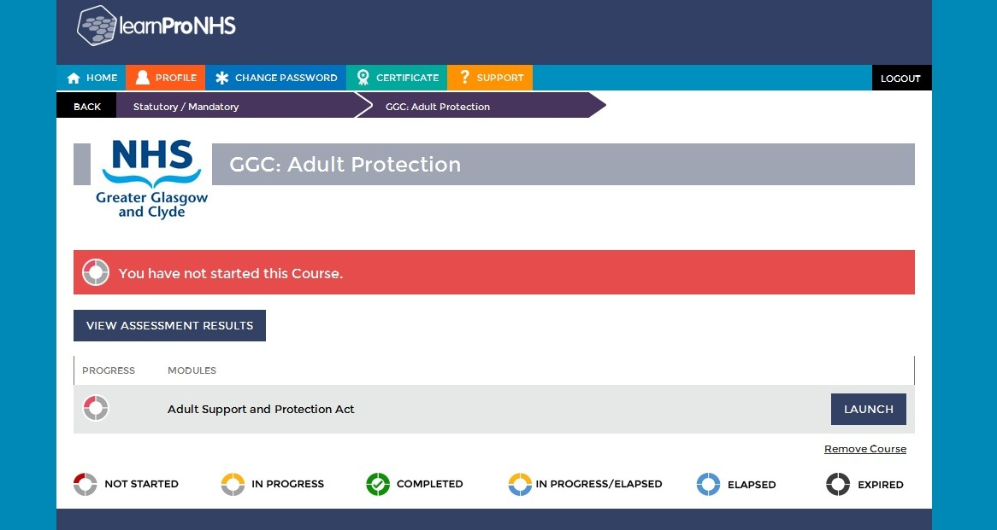
Now click Launch.

The module will open. Click on “Next” to navigate through the course. The “Previous” button will also be available on the screen in case you want to go back and recap on any of the information.

When you have finished the course click on the “Close” button at the top right hand corner of the screen.

You will then be able to “Launch Assessment” (if available) to assess your learning and record module completion.

It is important that you click “Close and Update” to record your progress at the end of the module and/or assessment. If you don’t your progress and/or completion may not be recorded.

When you wish to come out of the platform please click on the Logout button.

Updating your Profile

If you are an existing employee of NHSGG&C and you move internally within the organisation, it is important that you update your profile on LearnPro.
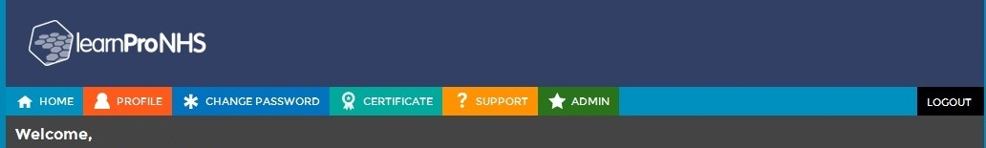
Firstly, login to LearnPro and choose Profile.

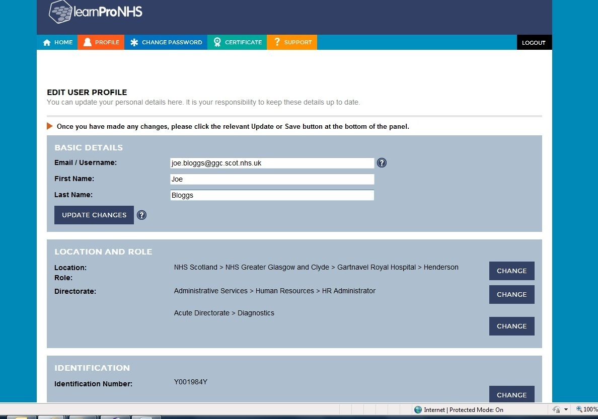
You will then have the option to edit your details.

Click Change next to Location/ Role/ Directorate to make changes to these areas. Choose you new location from the list presented. Now click “Save Changes”. See example below.

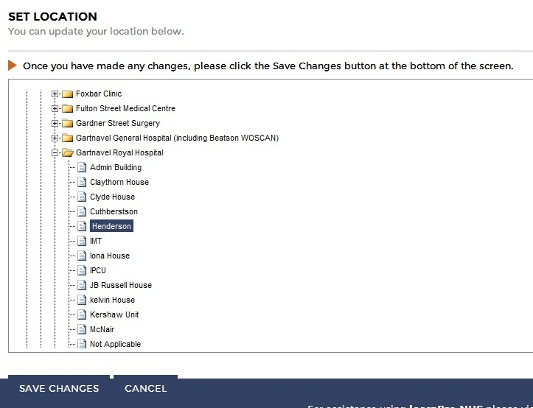

If you have also changed your Directorate and/or Job role, please follow the steps above and select from the list presented. Click “Save Changes”.

Common Questions

I’ve forgotten my password what do I do?

If you have forgotten your password and you have registered an email address, please visit https://nhs.learnprouk.com and enter your email address at the bottom of the screen and click “Mail me a new one”

If you have forgotten your password and you do not have an email address, then, please contact learning.e-support@ggc.scot.nhs.uk

How do I change my password?

You can change your password, by logging into LearnPro and clicking on “Change Password” from the menu at the top of the screen. Enter your new password and click on “Change Password”.

How do I change my username?

If you want to change your username (e.g. from joe.bloggs@yahoo.co.uk to joe.bloggs@ggc.scot.nhs.uk) you can do this as below:

- Log into learnPro using your existing username and password
- On the menu bar at the top of the screen click “Profile”
- Enter your new username/email
- Click on “Update Changes”

If you have changed your email address to a ggc.scot.nhs.uk address, all communication (e.g. course expiry) will be sent here.

Where can I get more help and support?
The question mark symbol (blue question mark) appears throughout the platform and by clicking on it you will be given additional information.

As well as that there is a support option on the Main Menu bar at the top of the screen and a link to the Support Site shown at the bottom of some of the pages

You will find useful information such as Help Manuals and Frequently Asked Questions documents on the Support Site.

In NHS Greater Glasgow and Clyde you can also get additional support by emailing learning.e-support@ggc.scot.nhs.uk

The contact details for the Main Help Desk are as follows;

Via email on nhs@learnpro.co.uk or by telephone on 0131 551 4666.

