**Quick Tips for Using the Healthy Minds Reading Collection with Your Child**

Have a notebook and pens handy

You and your child can write or draw out ideas from the books that your child may wish to try

Give your child support, but also allow them to read independently

Show interest in the book and try to read parts you know are relevant for them together, but allow them space to reflect on what they have read

Ask your child to identify how they think characters in the book may be feeling

This can be an opportunity to discuss a time when your child felt like that character

Incorporate reading time as part of your child’s routine

Reading can be a relaxing activity before bed and is less stimulating than spending time on electronic devices like tablets!

Get help if you child is struggling

If you are concerned about your child’s mental health, advice and support is available on the back page of this leaflet

Engage in self care

Containing your child’s difficult emotions can be challenging, so ensure you speak to your support network and make time for activities you enjoy!

**For more support**

The healthy minds reading collection may be helpful for mild emotional and mental health difficulties.

If a child or young person’s difficulties are more serious, have continued for a long time or continue after trying the healthy reading books, please contact the child or young person’s GP, nursery or school professionals to discuss other supports that might be helpful.

If you have **urgent concerns about a child or young person’s mental health** you should contact their GP or NHS-24 by phoning 111.

**Other Helpful Supports:**

**Childline**

Phone: (Free) 0800 1111

Web: www.childline.org.uk

**Breathing Space**

Phone: (Free) 0800 83 85 87

Website: https://breathingspace.scot

**Parentline Scotland**

Phone: (Free) 08000 28 22 33

Website: www.children1st.org.uk/help-for-families/parentline-scotland

**AyeMind**

Website: http://ayemind.com

Healthy Minds Reading Collection

Chosen a book from the Healthy Minds Collection?

Pick up this guide about supporting your child to use this!

For Parents of Children Aged **8 - 11**

Developed in partnership with Glasgow City Libraries and the NHS GG&C Early Intervention TIPS Project



**Emotional Development in 8 – 11 Year Olds**

Between the ages of 8 and 11, your child learns to use logic and begins to realise that not everyone has the same thoughts and opinions that they do. However, they will still need your help to understand and accept more abstract ideas. Although they may make sense of some of their emotions, they often still require support from adults to regulate themselves and fully make sense of their situation.

We recommend that you spend time with your child discussing your chosen book together. Your child may wish to read parts independently and it is advisable to follow your child’s lead on this. However, ensure that you regularly check in with them about their understanding of the book. It is important that you are available to talk about the issues raised, prompt them to think about their own experiences and explain more complicated concepts to them.

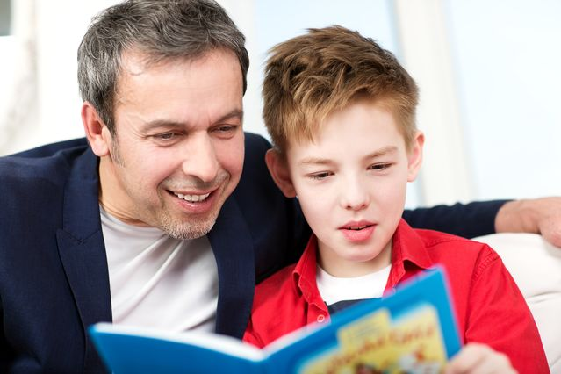

**Supporting Your Child to Use Fictional and Story Books**

Fictional and story books are useful for helping your child to explore their feelings about common life experiences. The fictional books in the collection have been chosen as they cover a range of common experiences that your child may find stressful or upsetting, including bullying, parental separations and bereavement.

When you have chosen a book, ask your child if they would like to read it together with you. If your child wishes to read it independently, accept this but ensure that you check in regularly and ask how your child is finding the story. Use the plot to start conversation with your child about their own experiences. If they struggle to speak about this, ask more about the characters, how they felt and whether your child could empathise with their reaction.

Reading stories where the characters are experiencing similar life stressors to them is helpful for normalising your child’s feelings. At a time when peer comparison is becoming more important to your child, it is useful to have a character that they feel they can relate to!

**Supporting Your Child to Use ‘Self-Help’ Books**

Your child may wish to access your chosen ‘self-help’ book by themselves, but it is a good idea to ensure you read through the book first so you can help them to make connections to their own experiences. It may be useful to read parts of the book together so you can work collaboratively with your child to think about how they might implement some of the strategies.

The self-help books included in the Healthy Minds Collection are based on the Cognitive Behavioural Therapy approach. These books encourage your child to think about the link between their thoughts, feelings and behaviour.

Ensure that you discuss the ideas with your child and refer to similar experiences they have had. Ask about how they felt, what they thought and how they reacted. Ensure that you remain non-judgemental and are encouraging if your child opens up about their experiences. With your help, your child can explore new coping strategies in a safe and supportive way.

Praise your child’s efforts to try new strategies and help them to problem solve if some do not seem to work for them. Remember that repeated practice is very important for learning new skills!