Adding Turas Learn To your Turas Appraisal Account
- Log on to Turas Appraisal and click on ‘Dashboard’
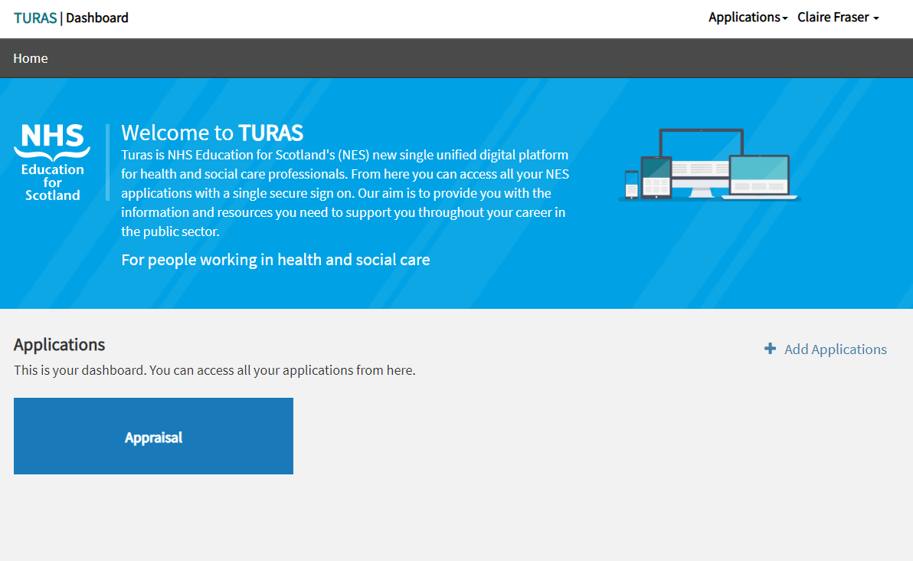
2) Click on ‘Add Applications’ link
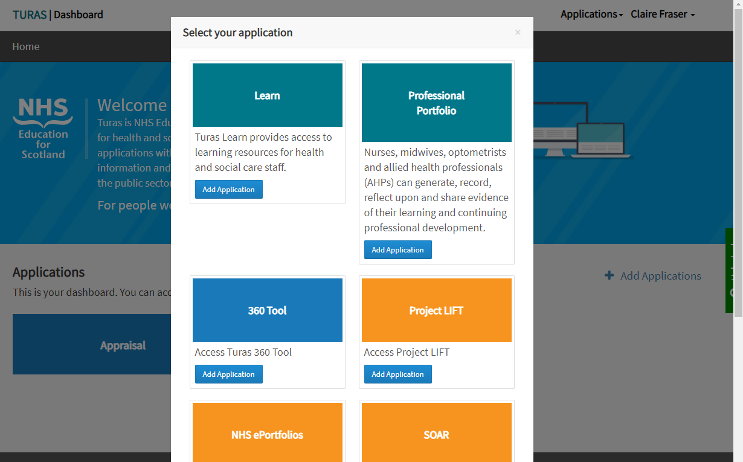
3) Click on ‘Add Application’ for Turas Learn and this will be added to your Dashboard

