1. Login to your LearnPro Account [here](https://nhs.learnprouk.com/lms/login.aspx?ReturnUrl=%2flms%2fuser_level%2fwelcome.aspx) and click on the **Profile tab**

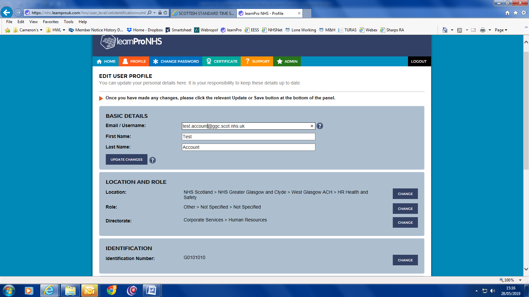

Check the ‘Location’ details commence with ‘NHS Scotland > NHS Greater Glasgow & Clyde’ – if not, click on the ‘CHANGE’ tab and find the best location match (detailed instruction below). This can be repeated for Role and Directorate.

You can update your username by simply overwriting the current entry and then clicking on ‘UPDATE CHANGES’

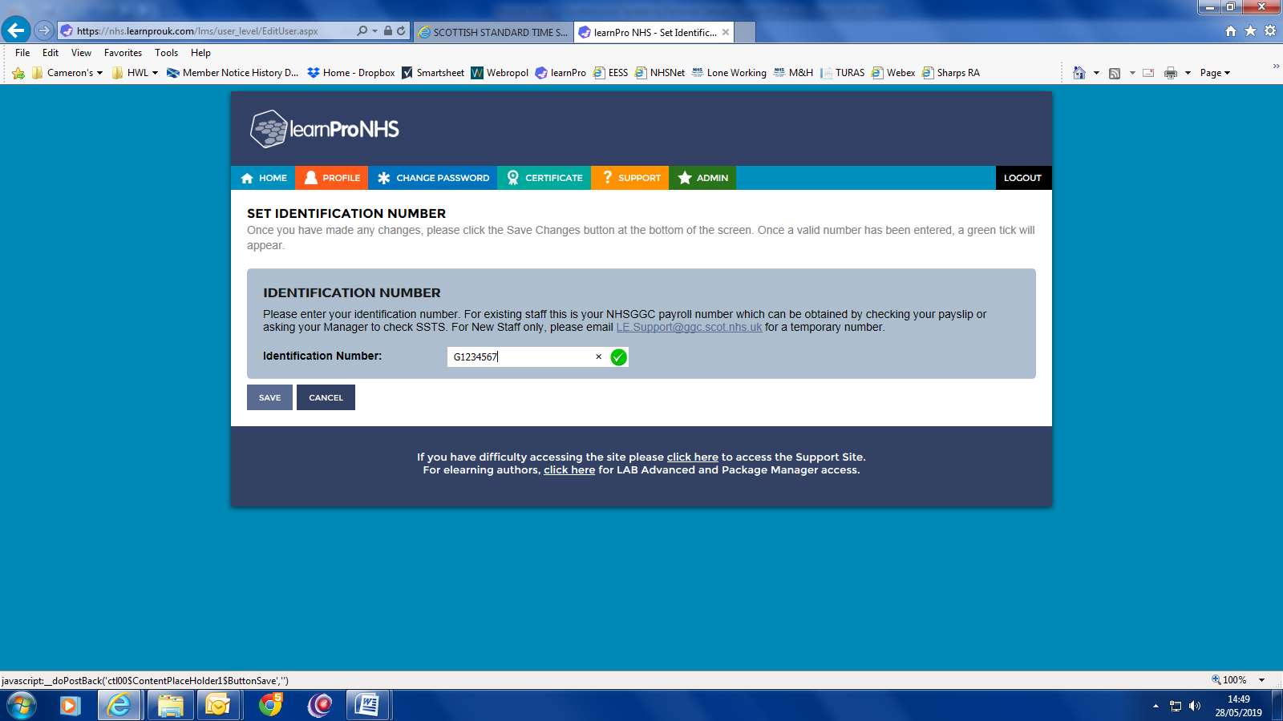

Check the ‘IDENTIFICATION’ details reflect your current Payroll Number, starting either ‘G’ or ‘C’ followed by 7 numbers – if not, click the ‘CHANGE’ tab. On the next screen enter or amend your payroll number and click ‘SAVE’.

1. To change your location, after you have pressed the change tab:

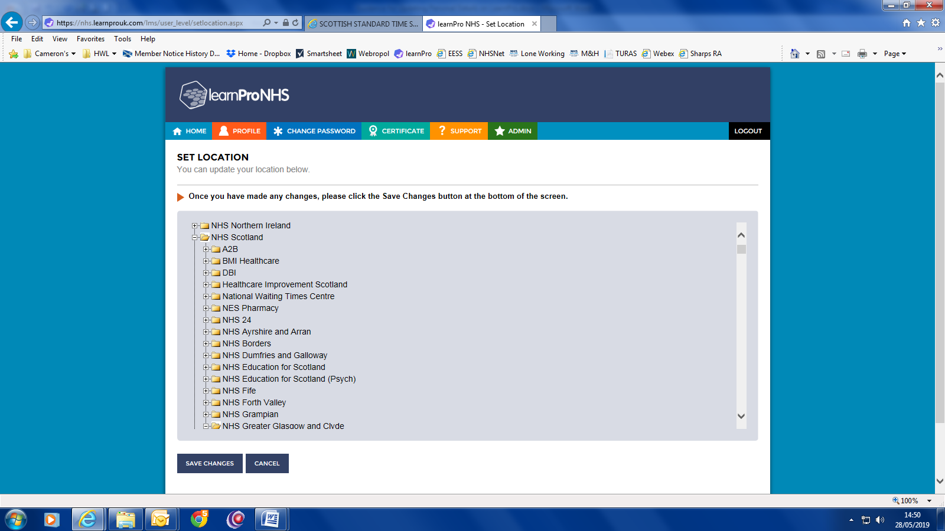

**c)** Click on ‘SAVE CHANGES’.

**c)** Click on the + sign beside ‘NHS Greater Glasgow and Clyde. Continue in this way until you identify the best match to your place of work.

**b)** Click on the + sign beside ‘NHS Scotland’.

**a)** Scroll to the top.