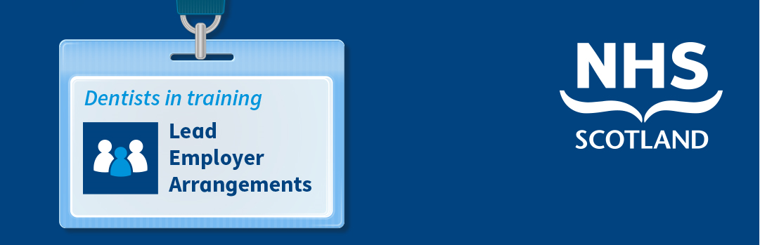

Dental CORE & SPECIALTY Trainees - Proposed Changes to Employment

Background
NHS Education for Scotland (NES) has a pivotal role in the attraction and retention of dentists in training in Scotland, so it is important to us to always consider how we can improve their training and employment journey. NES has identified that streamlining the employment arrangements may improve the consistency of employment experience for dentists in training.
From August 2020 it has been agreed that NES will be employer for dentists in training for the duration of a programme of training and it is anticipated that this will include vocational, core and speciality trainees.

We hope these changes improve the dentist in training employment journey as follows:
- less employment related administration and duplication of information provided;
- a single contract of employment for the duration of a programme;
- reduced tax issues;
- continuous service with one employer making it easier for you to access employee benefits; and
- clearer employment arrangements for money lenders (e.g. mortgages/ cars/ credit rating).
We think these anticipated benefits provide strong justification to review employment arrangements for dentists in training and so we are consulting with stakeholders in order to ensure we maximise the opportunities to improve the employment journey during postgraduate dental training.

Reasons for Change

- In August 2018, NHS Scotland moved from 22 Health Board employers to just 4 lead employers for doctors in training.
- There are 3 regional employers (West Region: NHS Greater Glasgow and Clyde; East Region: NHS Lothian; North Region: NHS Grampian) and one employer for national programmes (NHS Education for Scotland).
- Doctors in training now have a lead employer for the duration of programme of training.
- This has reduced the repetitive onboarding and associated administration for doctors in training.

Doctors in training rotate though placements, where they are hosted by ‘placement Boards’. Whilst the employing Boards have employment responsibilities, the placement Boards continue to have clinical governance responsibility for those engaged in providing clinical care to placement Board patients. The lead employer model for doctors in training has been developed in partnership with the British Medical Association.

Following the successful implementation of these arrangements for doctors in training, in order to enable dentists in training to enjoy similar benefits in their employment journey, work is being progressed to implement lead employer arrangements for core and specialty dental trainees. As dentists in training are often less likely to remain in one region for the duration of their training, it has been agreed that NES, as a national Board, is best placed to support the employment arrangements for dentists in training, from vocational dental training through to core and specialty training.

Consistent and standardised employment service/ employee relations practice:
Consistent application of NES employment policies to all dentists in training ensures a fair and equitable approach can be applied where there are any employment issues. Closer NES involvement in supporting trainees with employment issues may also allow for earlier recognition and resolution of any problems.

Maximising Digital Solutions:
Turas People is an application which has been designed to better join up the training and employment journey and enables trainees to store their employment related information in one place. It provides pre-employment information (with progress tracking and alerts) and supports issuing electronically employment related documentation, including payroll forms, occupational health pre employment assessments and contracts of employment.
Alignment to the training journey
- NES, through the Scottish Dental Deanery, is already involved in the training programme management of dentists in training. It is anticipated that the lead employer model will further join up the training and employer journey for dentists in training, from the vocational training year through core and specialty training.
- Further information on the lead employer arrangements are available on the Turas Hub: https://hub.nes.digital/lead-employer-arrangements/.

How does this affect me?
The change would mean that all Core and Specialty dentists in training commencing a new contract of employment for a core or specialty training programme in September 2020 will be employed by NES (as opposed to an NHS Board) for the duration of the core or specialty training programme. It would mean that all Core and Specialty dentists in training across NHS Scotland will have access to the same employment policies and procedures. Core and specialty dentists in training will continue to rotate through the posts required for the programme of training, the main difference will be that NES will be the employer for the duration of each training programme.

What happens now?
NES would like to work together with stakeholders to progress this work and implement the proposed changes to the employment arrangements of Core and Speciality dentists in training for September 2020. NES would therefore welcome any feedback on the proposed changes from all stakeholder groups. Please send any feedback to Lindsay.Lewis@nes.scot.nhs.uk by 30 September 2019.

FEEDBACK questionnaire for core and speciaLty trainees (please detach, complete and return)
Your feedback on your current experience of employment during training will be really helpful in enabling us to ensure that we develop the lead employer model arrangements to best support your needs, your feedback on the following questions, is much appreciated:
 | Question | Yes | No | Further detail
1 | Have you experienced any difficulties in your current employment arrangements?
2 | Are you clear on who your employer is?
3 | Have you experienced any difficulties in your onboarding and general employment experience?
4 | Have you experienced any payroll issues in relation to multiple employment contracts (e.g. mortgage applications, emergency tax codes)?
5 | How have a high number of fixed term contracts impacted on your identity as an NHS employee?
6 | Have you experienced any issues in relation to continuity of employment as a result of rotating between boards?
7 | Have you experienced any issues in relation to rotating between NHS boards during your training?
8 | Have you experienced any difficulties in relation to expense claims, including interview expenses?
9 | Do you feel you are part of the NHS workforce and how do your employment arrangements impact that?
10 | If you had any concerns in your post, would you know who to approach to talk to in confidence?
11 | Are you confident that you know, or could find out, who to approach for advice and guidance?
12 | Are you confident that you know, or could find out how to find relevant policies?
13 | Are you confident that you know how, or could find out how, to raise a concern about your education and training?

-THANK YOU FOR COMPLETING THIS QUESTIONNAIRE-

