47484D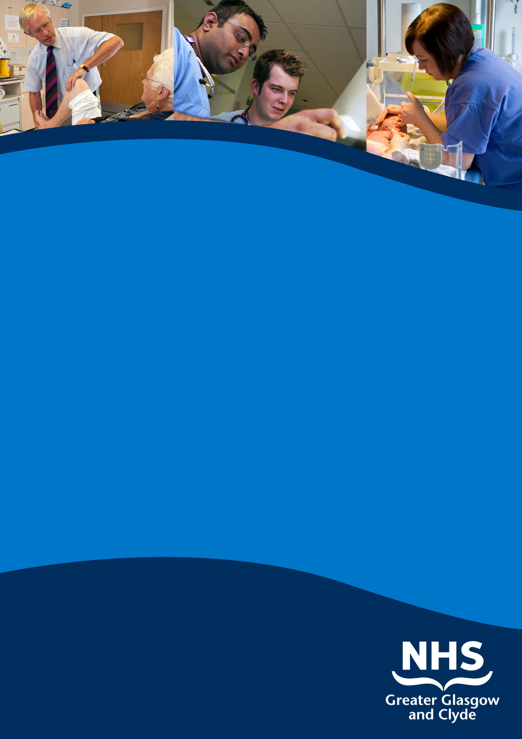

clinical fellow in general medicine
( 6 posts)

queen elizabeth university hospital

INFORMATION PACK

REF: 56410D

cLOSING DATE: 31st may 2019

www.nhsggc.org.uk/medicaljobs

SUMMARY INFORMATION RELATING TO THIS POSITION

Post: clinical fellow in general medicine (6 posts)

base: queen elizabeth university hospital

These posts will offer unique training opportunities for the successful candidates to be involved in the provision of a modern medical service within a major city centre teaching hospital, contribute to undergraduate teaching and undertake research opportunities. Posts are available from August 2019 for a period of 12 months.

All major specialties are represented within Queen Elizabeth University Hospital. There are currently there over 100 Consultant Physicians with special interests in Acute Medicine, Cardiology, Diabetes & Endocrinology, Gastroenterology, Respiratory Medicine, and Rheumatology within Medicine and a significant range of other medical specialties.

These posts will operate at the middle grade level and contribute to the medical receiving rota. By negotiation with the lead consultants and Clinical Director there will be flexibility in accommodating a reduced number of direct clinical sessions, an opportunity to train in a medical speciality of choice and contribution to specialist out-patient services.

To practice medicine in the UK you need to hold both GMC registration and a licence to practise.

These posts do not have educational approval from the Postgraduate Dean and are not recognised for training but appropriate educational supervision will be provided.

Acute Division

NHS Greater Glasgow and Clyde

Further Particulars of Post of:

CLINICAL FELLOW
IN GENERAL MEDICINE

BASED AT QUEEN ELIZABETH UNIVERSITY HOSPITAL
POST REFERENCE: 56410D

ABOUT US

The Acute Division of NHS Greater Glasgow & Clyde is the largest group of adult acute hospitals in Scotland - offering many opportunities to ensure job satisfaction and career development. We provide a wide range of services from community-based care through to the full range of general hospital services.

The south and West sector has a sound academic and research base and excellent teaching reputation with links to Glasgow’s three Universities, staff are committed to making a contribution to teaching at both undergraduate and post graduate level.

The Queen Elizabeth Hospital provides a wide range of secondary acute care for approx 560,00 people and employs approximately 14,300 staff. Much complex surgical work is also carried out in our hospitals as we are home to a number of the country’s tertiary and national services including renal transplantation. Our patients not only come from Greater Glasgow and Clyde but, in some instances, from the whole of the West of Scotland and, for our national services, the whole of Scotland.

1. General Remarks

A broad training in general internal medicine is offered and there are excellent opportunities for sub-specialty experience, research and audit.

2. Description of the Hospital and the Post

Queen Elizabeth University Hospital is one of the main teaching hospitals in NHS Greater Glasgow and houses all the major medical and surgical specialities. It opened in June 2015, combining on one site the majority of acute in-patient services from the previous Southern General, Victoria Infirmary, Western Infirmary and Gartnavel General. It now provides the Emergency Medicine service for the South and West districts of Glasgow and has inpatient beds in general medicine and related specialities, medicine for the elderly, general surgery, orthopaedics, ENT and obstetrics and gynaecology. There are also beds in intensive care, medical and surgical high dependency, and coronary care.

3. Duties of the Post

It is expected that this appointment will contribute to the management of inpatient downstream medical wards as part of one of the speciality teams at a middle grade level. The appointees will be expected to take part in the middle grade medical receiving rota.

There is a unique opportunity for appointees to select a medical speciality of interest and gain an invaluable experience in the speciality to advance their training and opportunities for obtaining a formal training post in the future. This opportunity for the appointee to develop further experience and skills in an area of special interest will be following discussion with lead consultants and agreement with management.

The appointee will be expected to contribute to outpatient clinics.

4. Study and Training

Study leave within the United Kingdom will be in accordance with the terms and conditions of service. For overseas study leave, application is made to the Divisions Clinical Director or Associate Medical Director.

An excellent and comprehensive medical library is located in the Teaching and Learning Centre. The successful candidates will be encouraged to attend and participate in the various South Sector postgraduate educational meetings.

The hospital has a major commitment to training junior staff and teaching medical students. During term-time the Unit has third and fourth year students on the wards and there are frequently post-graduate students training for the MRCP examination.

The appointee will be encouraged to take part in the undergraduate teaching programme of the University of Glasgow and will undertake teaching of postgraduates, nursing and technical staff on an ad-hoc basis.

Within the medical specialities there are numerous opportunities for audit and research which appointees can discuss with lead consultants.

LOCATION OF DUTIES

The post is based at the in the Queen Elizabeth University Hospital. Specialist outpatient services may also be delivered at Gartnavel General and New Victoria Hospitals.

DATE WHEN THE POST IS VACANT

August 2019

DETAILS OF ARRANGEMENTS FOR APPLICANT TO VISIT HOSPITAL/DISCUSS POST

Applicants may visit the Hospital and the Unit by arrangement with the following:
Dr J Morris Consultant Gastroenterology 0141 451 3280
Dr J Adams Consultant Cardiology 0141 451 6126
Dr E Ross Consultant Respiratory 0141 451 6094
Dr D Crosbie Consultant Rheumatology 0141 451 6118
Dr C Perry Consultant in Diabetes 0141 451 6188

TERMS AND CONDITIONS OF SERVICE

The conditions of service are those laid down and amended from time to time by the Hospital and Medical & Dental Whitley Council.

TYPE OF CONTRACT | Fixed Term
GRADE AND SALARY | Clinical Fellow  The salary scale will be £32,157 to £42,544 (pro rata)  New Entrants to the NHS will normally commence on the minimum point of the salary scale, (dependent on qualifications and experience). Salary is paid monthly by Bank Credit Transfer.
HOURS OF DUTY | Full Time 40.00
SUPERANNUATION | New entrants to NHS Greater Glasgow and Clyde who are aged sixteen but under seventy five will be enrolled automatically into membership of the NHS Pension Scheme. Should you choose to "opt out" arrangements can be made to do this via: www.sppa.gov.uk
REMOVAL EXPENSES | Assistance with removal and associated expenses may be given and would be discussed and agreed prior to appointment.
EXPENSES OF CANDIDATES FOR APPOINTMENT | Candidates who are requested to attend an interview will be given assistance with appropriate travelling expenses. Re-imbursement shall not normally be made to employees who withdraw their application or refuse an offer of appointment.
TOBACCO POLICY | NHS Greater Glasgow and Clyde operate a No Smoking Policy in all premises and grounds.
DISCLOSURE SCOTLAND | This post is considered to be in the category of “Regulated Work” and therefore requires a Disclosure Scotland Protection of Vulnerable Groups Scheme (PVG) Membership.
CONFIRMATION OF ELIGIBILITY TO WORK IN THE UK | NHS Greater Glasgow and Clyde (NHSGGC) has a legal obligation to ensure that it’s employees, both EEA and non EEA nationals, are legally entitled to work in the United Kingdom. Before any person can commence employment within NHS GGC they will need to provide documentation to prove that they are eligible to work in the UK. Non EEA nationals will be required to show evidence that either Entry Clearance or Leave to Remain in the UK has been granted for the work which they are applying to do. Where an individual is subject to immigration control under no circumstances will they be allowed to commence until the right to work in the UK has been verified. ALL applicants regardless of nationality must complete and return the Confirmation of Eligibility to Work in the UK Statement with their completed application form. You will be required provide appropriate documentation prior to any appointment being made.
REHABILITATION OF OFFENDERS ACT 1974 | The rehabilitation of Offenders act 1974 allows people who have been convicted of certain criminal offences to regard their convictions as “spent” after the lapse of a period of years. However, due to the nature of work for which you are applying this post is exempt from the provisions of Section 4 of the Rehabilitation of Offenders Act 1974 by virtue of the Rehabilitation of Offenders Act 1974 (Exceptions Orders 1975 and 1986). Therefore, applicants are required to disclose information about convictions which for other purposes are “spent” under the provision of the act in the event of employment, failure to disclose such convictions could result in dismissal or disciplinary action by NHS Greater Glasgow and Clyde. Any information given will be completely confidential.
DISABLED APPLICANTS | A disability or health problems does not preclude full consideration for the job and applications from people with disabilities are welcome. All information will be treated as confidential. NHS Greater Glasgow and Clyde guarantees to interview all applicants with disabilities who meet the minimum criteria for the post. You will note on our application form that we ask for relevant information with regard to your disability. This is simply to ensure that we can assist you, if you are called for interview, to have every opportunity to present your application in full. We may call you to discuss your needs in more detail if you are selected for interview.
GENERAL | NHS Greater Glasgow and Clyde operates flexible staffing arrangements whereby all appointments are to a grade within a department. The duties of an officer may be varied from an initial set of duties to any other set, which are commensurate with the grade of the officer. The enhanced experience resulting from this is considered to be in the best interest of both NHS Greater Glasgow and Clyde and the individual.
EQUAL OPPORTUNITIES | The postholder will undertake their duties in strict accordance with NHS Greater Glasgow and Clyde’s Equal Opportunities Policy.
NOTICE | The employment is subject to one months’ notice on either side, subject to appeal against dismissal.
MEDICAL NEGLIGENCE | In terms of NHS Circular 1989 (PCS) 32 dealing with Medical Negligence the Health Board does not require you to subscribe to a Medical Defence Organisation. Health Board indemnity will cover only Health Board responsibilities. It may, however, be in your interest to subscribe to a defence organisation in order to ensure you are covered for any work, which does not fall within the scope of the indemnity scheme.

FURTHER INFORMATION

For further information on NHS Greater Glasgow and Clyde, please visit our website on www.nhsggc.org.uk

View all our vacancies at: www.nhsggc.org.uk/medicaljobs

Register for Job Alerts at: www.medicaljobs.scot.nhs.uk

Applicants wishing further information about the post are invited to contact Dr Scott Davidson on 0141 451 6163 (via sec) with whom visiting arrangements can also be made.

How to apply

To apply for these posts please include your CV and names and addresses of 3 Referees, along with the following documents; (click on the hyperlinks to open)

Medical and Dental Application and Equal Opportunities Monitoring Form

Declaration Form Regarding Fitness to Practice

Immigration Questionnaire

Alternatively please visit www.nhsggc.org.uk/medicaljobs and click on the “How to Apply” tab to access application for and CV submission information.

NOMINATION OF REFEREES

It is Board policy that no person can act as a member of an Advisory Appointments Committee and be a referee for a candidate for that post. You should therefore check with your proposed referees whether there is likely to be any difficulty in this respect for we may otherwise have to invite you to submit another name or names

Return of Applications

Please return your application by email to nhsggcrecruitment@nhs.net or to the recruitment address below;

Medical and Dental Recruitment Team
NHS Greater Glasgow and Clyde
West Glasgow ACH (formerly Yorkhill)
2nd Floor
Dalnair Street,
Yorkhill,
G3 8SJ

CLOSING DATE

The closing date will be 31st May 2019

