

Nursing and Midwifery Bank Staff
Internal Recruitment

Guidance Document and Application Pack



Welcome and Introduction

Thank you for your interest in the NHS Greater Glasgow and Clyde Nursing and Midwifery Staff Bank.

NHS Greater Glasgow and Clyde Nursing & Midwifery Staff Bank are here to help when there are planned, or unplanned, shortfalls in the levels of nursing and midwifery staff.

We provide registered and non-registered nursing and midwifery staff to our hospital wards, outpatient clinics, health centres and community settings. The Staff Bank has approximately 11,000 temporary staff providing shift cover 24/7 365 days a year.

We rely on our Bank Workers to help provide safe, effective, person-centred care for patients across Glasgow and Clyde.

Recruitment Process

The process for recruiting both registered and non-registered nurses and midwives to NHS Greater Glasgow and Clyde Nursing and Midwifery Staff Bank follows the same robust recruitment and selection processes as required for substantive posts.

To register with the Staff Bank there is both an internal and external process and the purpose of this document is to provide clear guidance for employees and for managers supporting staff to register with NHSGGC Nursing & Midwifery Staff Bank through the internal process.

Internal Applicants

Nursing and Midwifery staff that hold substantive posts within NHSGGC can join the Staff Bank by completing an Internal Application. Substantive staff that register with the Staff Bank are permitted to do so through the internal application process, by virtue of existing employment with NHSGGC. This is on the basis that as Bank Workers they are fully supported by their substantive line manager in delivering high standards of care to patients within their bank role.

An internal application form is completed and is available on NHSGGC Hr Connect Staff bank page:
http://www.nhsggc.org.uk/working-with-us/hr-connect/staff-banks/nursing-and-midwifery-staff-bank/
*Only internal applications submitted on current version can be processed

The internal applicant’s line manager i.e. Senior Charge Nurse/Midwife/ Nurse Team Leader acts as the sponsor of the internal applicant and continues to vicariously manage the nurse/midwife whilst they are undertaking bank work, as per NHSGGC Nursing & Midwifery Staff Bank Operational Protocol: http://www.nhsggc.org.uk/working-with-us/hr-connect/staff-banks/nursing-and-midwifery-staff-bank/important-information/

The Senior Charge Nurse/Midwife / Nurse Team Leader and Professional Lead or Clinical Service Manager must complete and sign a reference supporting the individual's application. Before completing and signing the reference managers acting as the individual’s sponsor are asked to give due consideration of the suitability of the individual to undertake bank work i.e. reliability, competency, absence record. Managers are under no obligation to support an internal application request for a substantive staff member. NHSGGC Nursing & Midwifery Staff Bank reserves the right to reject an internal application.

The reference form must have signatures of both the line manager i.e. Senior Charge Nurse/ Midwife/ Nurse Team Leader and the Professional Lead or Clinical Service Manager before it can be processed, any incomplete applications will be returned to the nurse named on the application form. Internal Band 7 applicants must provide appropriate signatories i.e. Lead Nurse and Clinical Service Manager.

An internal application can only be submitted and processed whilst the applicant is still in substantive employment within NHS GGC. Applications received post termination date cannot be processed as an internal application.

N.B. Mental health community psychiatric nurses who wish to work within mental health inpatient areas must complete mandatory violence reduction and medical emergency training prior to undertaking bank shifts. Upon receipt of these applications, Staff Bank team will contact the nominated mental health Professional Nurse Advisor who will facilitate access to training.

Guidance for bank staff no longer in a substantive post:

Bank workers planning to leave their substantive employment within the organisation e.g. retirement and wish to continue to undertake bank shifts will no longer have sponsorship of the substantive line manager and therefore no means for the bank nurse’s competence to be assessed within the responsibilities of the role and job description.

Bank workers wishing to continue to undertake shifts when no longer substantively employed by NHSGGC must therefore undergo a reassessment process to transfer managerial responsibility to Staff Bank Nurse Management.

Staff who resign from their substantive post and wish to remain registered with the Nurse Bank must notify Staff Bank Management team a minimum of 4 weeks before termination of contract. This will allow the Staff Bank Nurse Management team to undertake the reassessment process i.e. satisfactory Occupation Health, PVG assessment, and mandatory training update.

Internal applicants must have completed all mandatory training as required. Additionally internal applicants must ensure mandatory training is kept updated at all times when undertaking bank shifts. NHSGGC Staff Bank will not offer shifts to any bank worker who fails to demonstrate full compliance with mandatory training requirements.

Thank you for your interest and if you require further please, please do not hesitate to contact the Nurse bank Recruitment Team via email to adminstaffbank@ggc.scot.nhs.uk or telephone on 0141-278 2555 (Press Option 2).

We look forward to hearing from you.

Julie Tomlinson
Professional Lead
NHSGGC Nursing and Midwifery Staff Bank

Nursing and Midwifery Bank
Internal Application - Process Flowchart

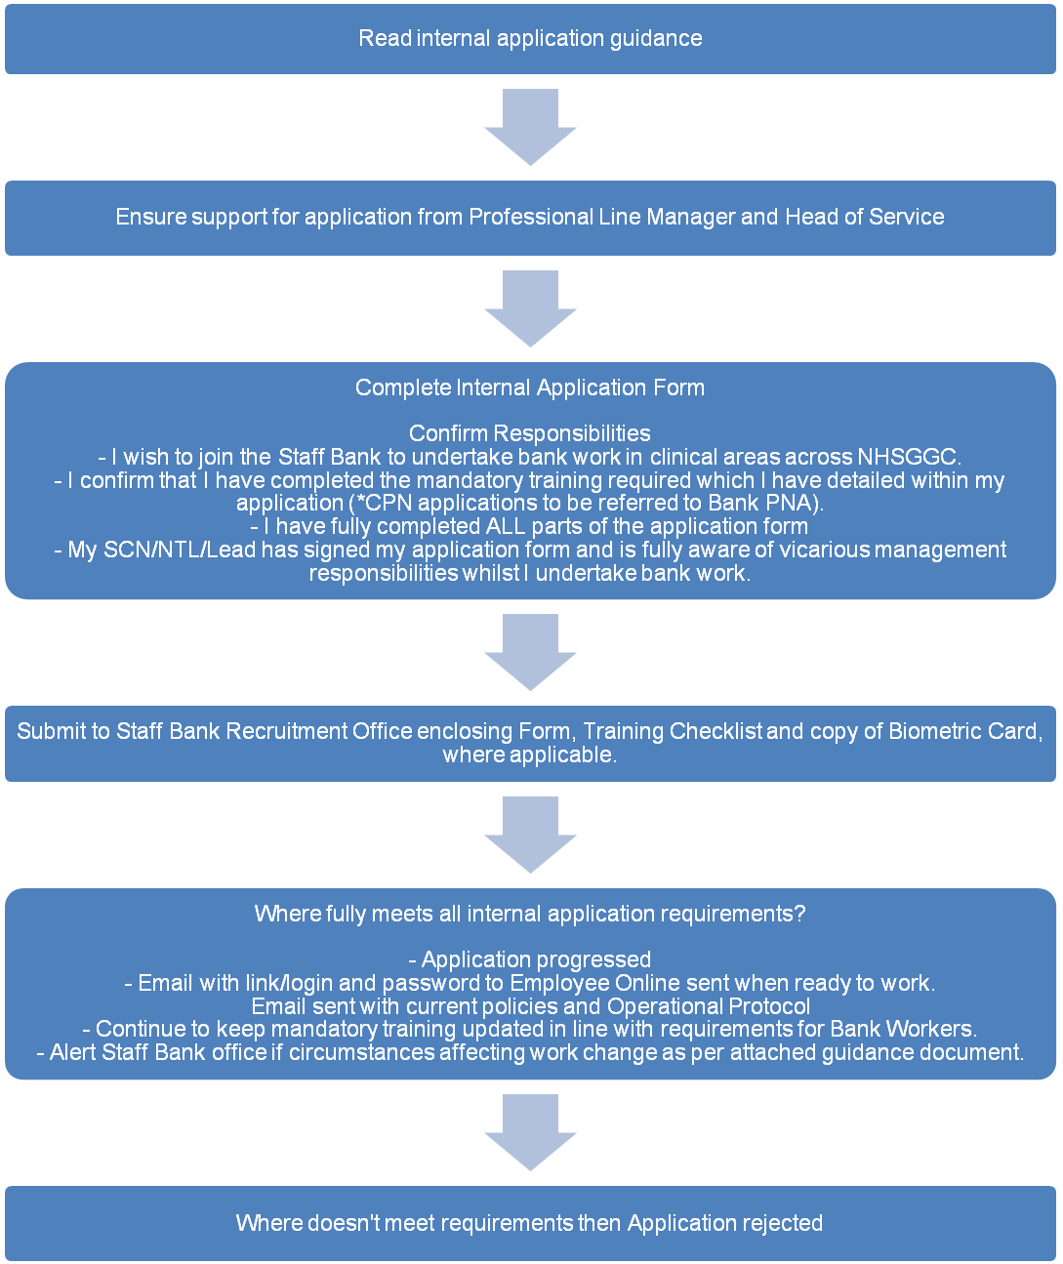

NHS Greater Glasgow and Clyde Nursing and Midwifery Staff Bank
Internal Application Form

Application for: | Please Tick
Registered Nurse (RN)
Mental Health Nurse (RMN)
Midwife (RM)
Registered Nurse (Children’s)
Healthcare Support Worker (Band 2/3)

PERSONAL DETAILS
Title |  | Name
Address |  |  |  |  |  | Postcode
Contact Number (Day) |  |  |  | Contact Number (Evening)
Mobile |  |  |  | E-Mail

WORK PERMIT
Do you require a work permit to take up this post? If yes, a copy of your biometric card is required. | Yes |  | No

WORKING IN THE UK
Are you eligible to work in the UK? | Yes |  | No

DISCLAIMER TO BE SIGNED BY ALL APPLICANTS

The details, to which I have supplied within this application form, are to the best of my knowledge, true and complete. If appointed to this post, this information will be kept as part of my personal file record. I will submit the required references to support this application. I understand that Membership of Professional Bodies will be verified.

I wish to join NHSGGC Nursing & Midwifery Staff Bank to work in clinical areas across NHSGGC.I shall not undertake any direct or indirect action out with the scope of my knowledge and skill and mandatory training while undertaking bank work for NHSGGC staff bank. I understand I can only commit to shifts in areas that I have the skills to work and have completed the necessary mandatory training as indicated on attached proforma. (NB: Training will not be provided by the Staff Bank).

⃰ Community Psychiatric Nurses who wish to work within mental health inpatient areas must complete necessary mandatory training before working bank shifts. Access to training will be negotiated between the Staff Bank PNA and nominated mental health Professional Nurse Advisor.

Signature |  | Date

CURRENT POST
Job Title |  | Location
Band |  | Ward/Department
Payroll Number |  | NI Number
Professional Qualification (if applicable) |  | NMC Registration Number (if applicable)

SHORT SUMMARY OF KNOWLEDGE AND SKILLS RELATED TO POST

The attached reference form should be completed by your current Line Manager and returned with your application. We cannot progress your application until both documents have been received.

Internal applicants must hold a substantive nursing post within NHSGGC and have completed all mandatory training.

Please note you are not activated to undertake bank shifts until you receive a call/text from bank/recruitment staff.

Please return to Nurse Bank Recruitment Office, 2nd Floor, West Glasgow ACH, Dalnair Street, GLASGOW G3 8SJ or scan and email to adminstaffbank@ggc.scot.nhs.uk. For further assistance please contact us via e-mail or telephone on 0141-278 2555 (Press Option 2).

NHS Greater Glasgow and Clyde Nursing & Midwifery Staff Bank -
Mandatory Training Checklist

In order to join the NHSGGC Nursing & Midwifery Staff Bank you must have completed ALL relevant Statutory and Mandatory Training.

This is detailed below for each post – please refer to the relevant table, both you and your line manager must sign to confirm you have completed all statutory and mandatory training relevant for your role.

Mandatory Training Checklists:

Core Must be Completed by ALL Bank Workers

Core Statutory & Mandatory Topics | Frequency | Completed  (please )
Fire Safety - Module GGC001 | Induction/every 2 years
Health & Safety – Module GGC002 | Induction/ every 3 years
Violence & Aggression – Module GGC003 | Induction/ every 3 years
Equality, Diversity & Human rights – Module GGC004 | Induction/every 3 years
Manual Handling Theory – Module GGC005 | Induction/every 3 years
Adult Support & Protection/ Child Support & Protection – Module GGC006 | Induction/every 3 years
Standard Infection Control Precautions – Module GGC007 | Induction/ every 3 years
Safe Information Handling – Foundation (information governance) – Module NES | Induction/every 3 years
Security and Threat - GGC008 | Induction/every 3 years
Management of Needle stick and Similar Injuries – GGC061 | Induction only
Confirm core statutory & mandatory training completed | Line manager signature: | Applicant signature:

Additional role specific training checklists:

Must be Completed by Registered Nurses only (RN)

Additional Mandatory Topics - RN | Frequency | Completed  (please )
Nursing Induction (Acute – one week training) | Induction only
Moving & Handling Passport ( 2 day training) | Induction only
Quality Improvement in HAI – Module CPD | Induction/every 3 years
Prevention & Control Of Infection: C.Difficile – Module Infection prevention & control. | Induction/every 3 years
Safe Blood Transfusion Practice – Module Learn Blood Transfusion | Induction/every 3 years
Dementia Awareness in an acute Care setting (n/a Paeds) – Module GGC | One off-within 6 months of start date
Dementia Promoting Excellence – informed (n/a Paeds)- Module Specialist Subjects | One off-within 6 months of start date
Active Care – Module GGC | One off-within 6 months of start date
A ‘MUST’ for Health Care – Module GGC | One off-within 6 months of start date
Recognising Deteriorating Patient (acute adult inpatient only) | One off-within 6 months of start date
Safe & Effective management of non IV medicines proficiency workbook | One off-within 6 months of start date
Trakcare/Clinical Portal access training | One off-within 6 months of start date
NES: Scottish IPC Education Pathway: Module – Prevention and Management of Occupational Exposure | One off – within 6 months of start date
Confirm additional mandatory topics completed | Line manager signature: | Applicant signature:

Must be Completed by Registered Mental Health Nurses only (RMN)

Additional Mandatory Topics - RMN | Frequency | Completed  (please )
Medical Emergency Training ( one day) | Induction/every year
GSA Management of Violence & Aggression/safe holding training ( 4 days) | Induction/ every 2 years
Quality Improvement in HAI – Module CPD | Induction/every 3 years
Prevention & Control Of Infection: C.Difficile – Module Infection prevention & control | Induction/every 3 years
Dementia Awareness in an acute Care setting (n/a Paeds) – Module GGC | One off-within 6 months of start date
Dementia Promoting Excellence – informed (n/a Paeds)- Module Specialist Subjects | One off-within 6 months of start date
Active Care – Module GG | One off-within 6 months of start date
A ‘MUST’ for Health Care – Module GGC | One off-within 6 months of start date
Safe & Effective management of non IV medicines proficiency workbook | One off-within 6 months of start date
EMIS/Trak/Clinical portal access training?? | One off-within 6 months of start date
Moving & Handling Passport ( 2 day training) | Induction only
NES: Scottish IPC Education Pathway: Module – Prevention and Management of Occupational Exposure | One off – within 6 months of start date
Confirm additional mandatory topics completed | Line Manager signature: | Applicant signature:

Must be Completed by Healthcare Support Workers only (HCSW Band 2)

Additional Mandatory Topics – HCSW (band2) | Frequency | Completed  (please )
Nursing Induction ( 2 days training) | Induction only
Moving & Handling Passport ( 2 day training) | Induction only
Quality Improvement in HAI – Module CPD | Induction/ every 3 years
Prevention & Control Of Infection: C.Difficile – Module Infection prevention & control | Induction/every 3 years
Safe Blood Transfusion Practice – Module Learn Blood Transfusion | Induction/every 3 years
Dementia Awareness in an acute Care setting (n/a Paeds) – Module GGC | One off-within 6 months of start date
Dementia Promoting Excellence – informed (n/a Paeds)- Module Specialist Subjects | One off-within 6 months of start date
Active Care – Module GGC | One off-within 6 months of start date
A ‘MUST’ for Health Care – Module GGC | One off-within 6 months of start date
HCSW Mandatory Standards workbook | One off-within 6 months of start date
Confirm additional mandatory topics completed | Line Manager signature: | Applicant signature:

Must be Completed by Healthcare Support Workers only (Mental Health Band 3)

Additional Mandatory Topics – HCSW MH | Frequency | Completed  (please )
Nursing Induction ( 2 days training) | Induction only
Moving & Handling Passport ( 2 day training) | Induction only
Quality Improvement in HAI – Module CPD | Induction/ every 3 years
Prevention & Control Of Infection: C.Difficile – Module Infection prevention & control | Induction/every 3 years
Medical Emergency Training ( one day) | Induction/every year
GSA Management of Violence & Aggression/safe holding training ( 4 days) | Induction/ every 2 years
Dementia Awareness in an acute Care setting (n/a Paeds) – Module GGC | One off-within 6 months of start date
Dementia Promoting Excellence – informed (n/a Paeds)- Module Specialist Subject | One off-within 6 months of start date
Active Care – Module GGC | One off-within 6 months of start date
A ‘MUST’ for Health Care – Module GGC | One off-within 6 months of start date
HCSW Mandatory Standards Workbook | One off-within 6 months of start date
Confirm additional mandatory topics completed | Line Manager signature: | Applicant signature:

Must be Completed by Registered Midwives only (RM)

Additional Mandatory Topics - RM | Frequency | Completed  (please )
Nursing Induction (Acute – one week training) | Induction only
Moving & Handling Passport ( 2 day training) | Induction only
Quality Improvement in HAI – Module CPD | Induction/every 3 years
Prevention & Control Of Infection: C.Difficile – Module Infection prevention & control | Induction/every 3 years
Safe Blood Transfusion Practice – Module Learn Blood Transfusion | Induction/every 3 years
Safe & Effective management of non IV medicines proficiency workbook | One off-within 6 months of start date
NHSGGC Staff Bank Midwifery Competency tool | One off-within 6 months of start date
Badgernet access training | One off-within 6 months of start date
NES: Scottish IPC Education Pathway: Module – Prevention and Management of Occupational Exposure | One off-within 6 months of start date
Confirm additional mandatory topics completed | Line manager signature: | Applicant signature:

NHS Greater Glasgow and Clyde Nursing & Midwifery Bank
MANAGERS’ REFEREE REPORT FORM - IN CONFIDENCE

A member of your staff has applied to register with NHS Greater Glasgow and Clyde Nursing and Midwifery Bank. As the individual is an employee of NHSGGC and has identified you as their current Manager we require you to complete this referee report to support their application.
Please note it is only necessary for 1 Referee to complete the Reference, but it must be signed by both the Line Manager, i.e. Senior Charge Nurse and the Clinical Services Manager/Lead Nurse or Professional Lead. When completing the application form please be aware as the sponsor of the internal applicant you continue to vicariously manage the nurse/midwife whilst they are undertaking bank work within NHSGGC and the applicant requires to have completed all mandatory training.

Candidates Name
How long and in what capacity have you know the candidate?
Please describe the main qualities and skills of the candidate and give your view as to their suitability for the role of bank worker.
Does the candidate have any ongoing health concerns that require Occupational Health review and/or any reasonable adjustment? |  | Yes |  | No
Does the candidate have a current formal disciplinary record? If yes please detail below in any other comments. |  | Yes |  | No

Please candidate's performance under the following headings:-
Area | Satisfactory | Unsatisfactory
Quality of work
Quantity of work
Performance in the job
Relationships with others
Unsupervised work
Attendance/timekeeping
Ability to perform the requirements of the job.

Please add any comments/observations relevant to the candidates application to join the nurse bank.

Referee signatures
Referee 1  Current Line Manager  (Senior Charge Nurse/Team Lead) |  | Referee 2  Lead Nurse/Professional Lead
Name |  | Name
Designation |  | Designation
Location |  | Location
Ward/Department |  | Ward/Department
Signature: |  | Signature:

Whilst you are being asked to provide this reference in strictest confidence, you should be aware that under the terms of the Data Protection Act and General Data Protection Regulations (GDPR), details of the reference may be released to the candidate should they request this. The post applied for is exempt from the provision of the Rehabilitation of Offenders Act 1974, by virtue of the Rehabilitation of Offenders Act 1974 - Exemptions Order 1975. It will not contravene the Act to disclose information which you may have in connection with this candidate regarding convictions which would otherwise be considered as spent. A conviction is taken to include a supervision requirement made under provision of the Social Work Scotland Act 1968. Any such information will be kept in strict confidence and used only as appropriate.

Managers acting as the individual’s sponsor are asked to give due consideration to the suitability of the individual to undertake bank work i.e. reliability, competency, absence record. Managers are under no obligation to support an internal application request for a substantive staff member.

