Guidance for locating healthcare related sharps modules
- What Sharps modules are required to be completed:
All staff who use healthcare related sharps are required to undertake 2 modules entitled:
- ‘GGC: 061 Management of Needlestick & Similar Injuries’ (GGC for short)
- ‘Prevention and Management of Occupational Exposure’ (NES for short)
Staff who do not use sharps but may come into contact with a sharp during their normal working duties are required to undertake 1 module entitled:
- ‘GGC: 061 Management of Needlestick & Similar Injuries’ (GGC for short)

- How to find the Sharps modules on LearnPro
The Modules are located in LearnPro (Login page). They are located in the two different category tabs circled below, GGC is in the Category ‘Role Specific Mandatory Modules’ and NES is in the category ‘Infection Prevention and Control’.
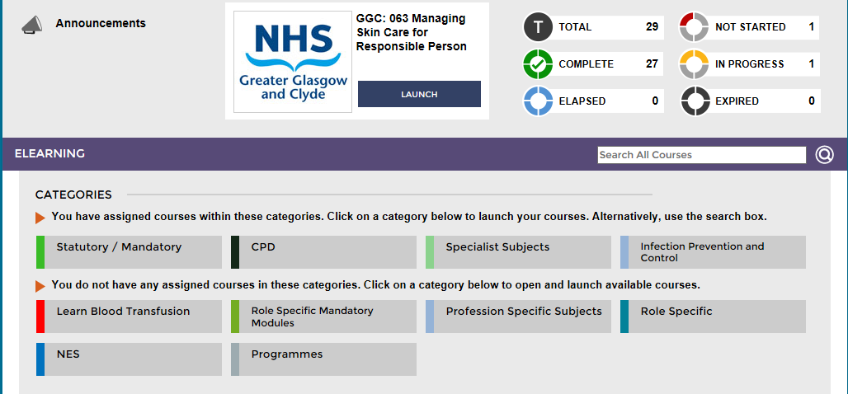
You may have to ‘assign’ 1 or both of the modules into your own learning portfolio. In the example above the learner has no modules in the category ‘Role Specific Mandatory Modules’ assigned to him, therefore, he will require to do this himself. Do this by clicking on the category ‘tab’ (Role Specific Mandatory Modules) and click on the ‘add’ sign opposite the GGC module as below:
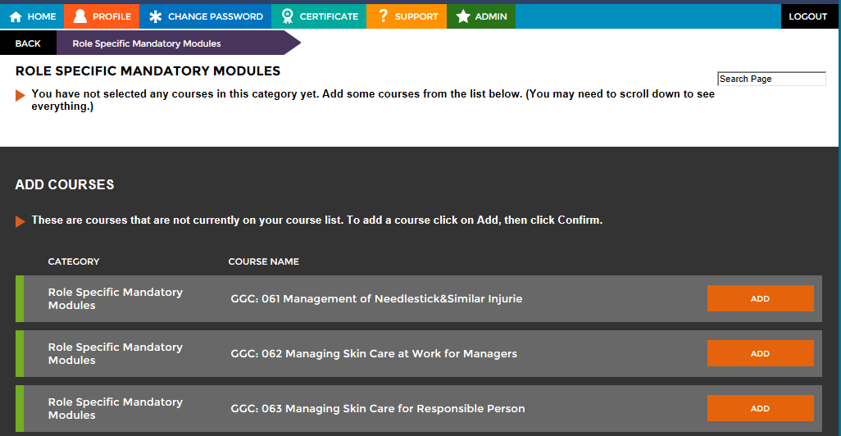
You will be prompted to click ‘Confirm’ and the module will be added to your learning profile along with the category tab. The GGC module can then be opened and completed as normal.
To locate the NES module, click on the category ‘Infection Prevention and Control’ tab. Find the course titled ‘NES: Scottish IPC Education Pathway – Foundation’, remember you may have to add this to your learning first.
Click on the ‘Select’ button:
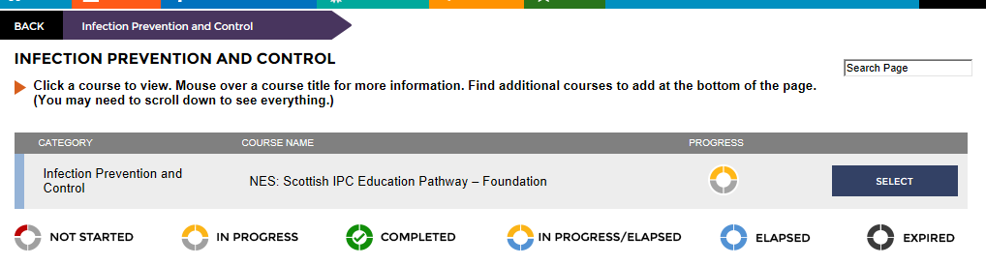
The page you are taken to contains 15 modules, scroll down until you find the NES module you are looking for titled ‘Prevention and Management of Occupational Exposure’ (7th one down) and click on ‘Select’:
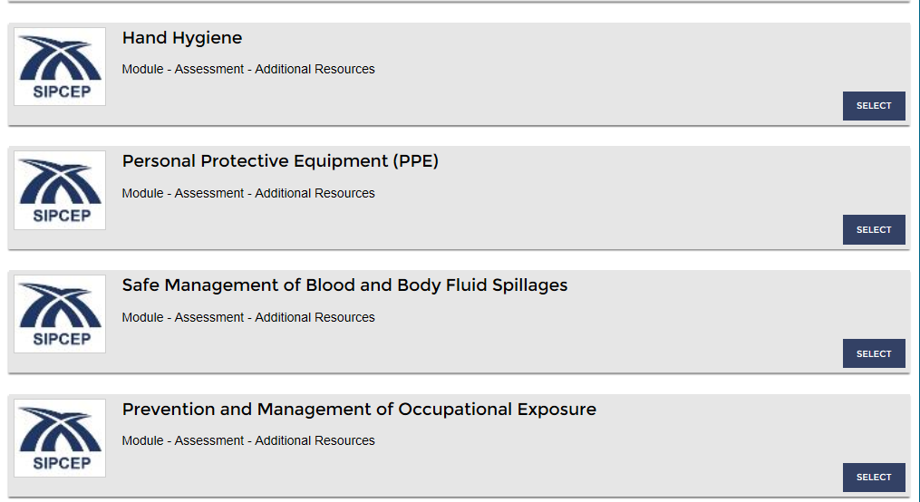
You will then get the following screen, clicking on the ‘Modules’ button will take you through to the module and the assessment module, both will require to be completed.
