eESS Quick-Start Guide - Managers

This guide has been designed to give you a quick-start to using the system as a manager, and details what you should do when you logon to eESS for the first time.

To Avoid Waiting in Call or E-Mail Queues

Please use this Guide in the first instance to try and troubleshoot any logon or user issues.

We anticipate an extremely high level of calls and e-mails post Go Live on the 23rd and would welcome your support in troubleshooting any logon issues as per the guidance below.

We would be grateful if you would also encourage your staff members to access the Employee Quick Start Guide.

Accessing eESS

To access eESS, click here.

Alternatively, you can access eESS via your ‘favourites’ menu on your Internet Explorer toolbar (just as you would access SSTS). Select favourites -> GGC Shortcuts -> Admin -> eESS

By 23rd November 2018, you will have received an e-mail with your Username and Password. (Note - this is a temporary password and you will be required to change this when you first log-on)

There is also an option for login assistance on the logon page (just below Login Button), as well as accessibility options.

Troubleshooting

I haven’t received my user ID and Password – by 26th November 2018 | If you have not received this, please contact the eESS Support Team at eESS@ggc.scot.nhs.uk.  Your details will be resent to you so please ensure you have sufficient space in your mailbox to receive new emails. Please keep these details safe for future use.
I have forgotten my user ID or password | Passwords on eESS are reset via a link sent by email. Click on the log-in assistance button on the log-in page and follow the instructions given. You can also have an email reminder of your user ID sent to you by following the link on the log-in page.
Where can I find eESS on my computer? | The link to the eESS site is found within Favourites on your Internet Explorer toolbar (just as you would access SSTS). Select Favourites -> GGC Shortcuts -> Admin -> eESS
I can’t connect to the eESS site | First of all, check that you have a valid internet connection by ensuring you can access another external website successfully.  If you can access other external websites, such as BBC News, you should contact the eESS Support Team at eESS@ggc.scot.nhs.uk. to report the issue.
I receive an error message when I sign in to the eESS reporting tool advising that I have the wrong version of Internet Explorer | eESS uses IE7 or 8 to run but GGC are currently on IE11. Therefore it is necessary to run the application in Enterprise Mode. This should already be in place for everyone but, if you have this error, it is easy to resolve this yourself.  From the Menu Bar, select Tools then Enterprise mode.
Why can’t I contact the IT Service Desk if I have an issue with eESS? | eESS is supported primarily by HR&OD in conjunction with a National eESS Support Team. Therefore the first stop for all queries regarding the system should be via the local eESS Support Team.  All other IT issues should be raised to the IT Service Desk as normal.

First Thing to Check

It is important that you check that your Employees are accurately assigned to you.

IMPORTANT - If you see a staff member who you are not responsible for then you should not open their file and immediately contact the eESS Support Team on 0141 278 2700, selecting option 5 or e-mail us at eess@ggc.scot.nhs.uk to have this amended.

To view those staff members assigned to you through the people hierarchy:

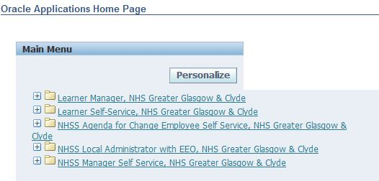
- Navigate to NHSS *Manager* Self Service

NB – you may not have access to all of the user rights on the left. So don’t worry if your menu doesn’t look exactly the same.
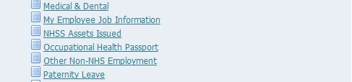
- Click My Employee Job Information
You will then see a list of your direct reports.
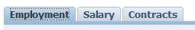
- You can select the different tabs to view employment, salary and contractual information

Maintaining Your Transactions
In order to ensure that transactions are authorised and flowing through the system timeously to Payroll then you need to monitor and maintain your transactions. You can do this in a number of ways:

VIEW ACTIONS AWAITING YOUR ATTENTION
- Navigate to NHSS *Manager* Self Service | - Click on All Actions Awaiting Your Attention  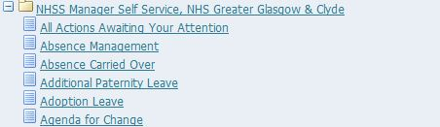
- Click on appropriate transaction under Subject. | - Review changes and click Approve, Reassign or Reject* (Top Right / Bottom right of the screen). Or, Scroll Down the page to Return for Correction.  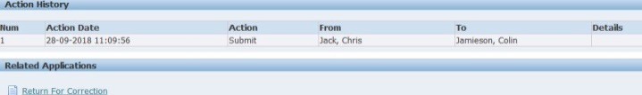  *Please note that selecting ‘Reject’ deletes the entire transaction

Alternatively you can view your Worklist. Please note that this list includes all notifications of updates as well as transactions that require action, so you will have to scroll through.

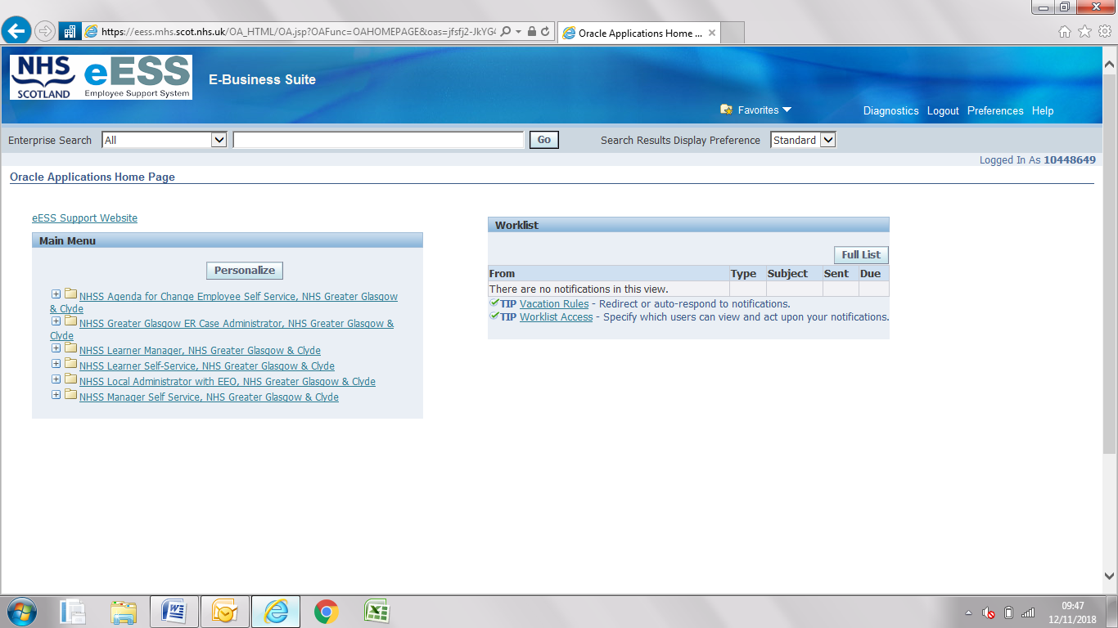

Going on Leave
If you are going on leave and want to nominate a colleague to manage transactions in your absence you can set this up in Vacation Rules on your home screen. This needs to be a colleague who reports directly to someone who is a Band 7 or above, in order to meet Standing Financial Instructions (SFI).

How to Input Transactions
There are step by step Standard Operating Procedures for each transaction. You can view these here - https://www.eess.nhs.scot/mss/.

If you are unsure please contact us – specifically for transactions relating to Terminations.

Thank you for taking the time to read and use this Guide. We hope it has helped you get started on eESS and fix any logon queries.

