Department Name
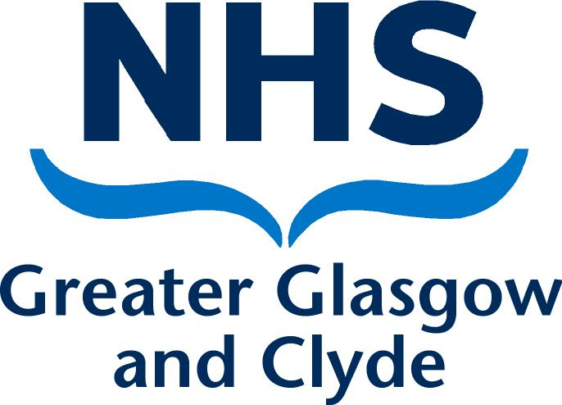
Directorate
Address 1
Address 2
Address 3
Post Code

PRIVATE & CONFIDENTIAL
NAME  ADDRESS1  ADDRESS2  ADDRESS3  POST CODE | Date: DATE  Ref No:  Direct Line: Number  Email:  Contact: NAME
Dear [Insert Complainant's Name],

Dignity at Work: Complaint did not meet Definition

I refer to your Dignity at Work Complaint Notification dated [insert date]. Your complaint is in relation to [Insert Name And Job Title Of Respondent] and has been submitted under the NHS Greater Glasgow and Clyde Dignity at Work Policy, which has already been provided to you.

Following exploration and discussion with you, I must advise that your complaint does not meet the definition as described within the aforementioned policy therefore there is no requirement to appoint a joint investigation panel (JIP).

[Include as applicable:]

However, you may wish to refer to the procedure for dealing with disrespectful behaviour within the Dignity and Work Policy.

Or

However, I do believe that there are issues which need to be addressed with the wider team and it is my intention to [summarise actions to be taken].

Or

However, I believe that the team would benefit from training in [insert details of training courses to be considered].

If you disagree with this decision then you may wish to access the NHS Greater Glasgow and Clyde Grievance Policy and Procedure.

In the meantime, if you have any queries please do not hesitate to contact me on [insert contact telephone number].

Yours sincerely,

[Insert Commissioning Manager's Name]
[Insert Commissioning Manager's Job Title]

