Department Name
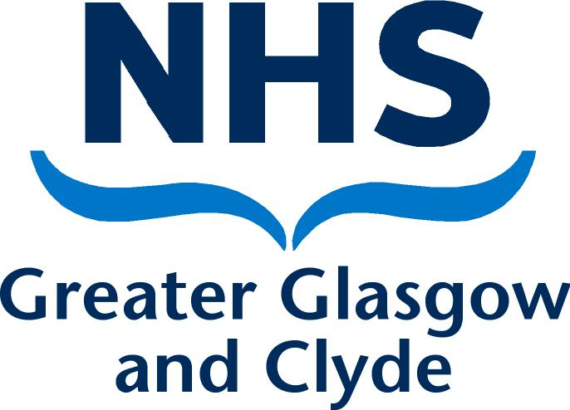
Directorate
Address 1
Address 2
Address 3
Post Code

PRIVATE & CONFIDENTIAL
NAME  ADDRESS1  ADDRESS2  ADDRESS3  POST CODE | Date: DATE  Ref No:  Direct Line: Number  Email:  Contact: NAME

Dear [Insert Name Of Complainant Or Respondent],

Dignity at Work: Outcome Meeting

Thank you for attending the meeting on [insert date of meeting]. As you are aware the purpose of this meeting was to discuss the outcome of the joint investigation panel’s (JIP) report. [Insert Name Of Hr Representative Supporting Commissioning Manager] was also present at the meeting. You chose to attend the meeting [insert accompanied by or unaccompanied] by [Insert Name Of Representative And Organisation Associated With].

At the meeting I confirmed [insert summary of discussion regarding investigation and report].

I confirmed that there is: (delete as applicable)

- no evidence of bullying found; no interventions recommended

OR

- no evidence of bullying found, however the matter requires consideration for a suitable development intervention such as training, mentoring or coaching;

OR

- evidence supports allegation of bullying and [As applicable:] [insert details of training, mediation, disciplinary hearing being arranged].

In the meantime, if you have any queries please do not hesitate to contact me on [insert telephone contact number].

Yours sincerely,

[Insert Commissioning Manager's Name]
[Insert Commisioning Manager's Job Title]

