Advanced Nurse Practitioner

Clinical Supervision

Definition of clinical supervision
“Clinical supervision is an activity that brings skilled supervisors and practitioners together in order to reflect upon their practice.” (RCN 2018). It “is a formal process of professional support and learning which enables individual practitioners to develop knowledge and competence, assume responsibility for their own practice and enhance consumer protection and safety of care in complex situations ” (DoH 1993, RCN 2003).

Supervision and NMC Revalidation
Participation in Clinical Supervision can be used towards the 35 hours of Continuing Professional Development (CPD) required for revalidation and can be counted as ‘participatory learning’. It may also provide an opportunity to receive and reflect on feedback (NES 2017b).
The NMC have described the benefits of clinical supervision as “improved capacity to identify solutions to problems, increased understanding of professional issues, improved standards of patient care, opportunities to further develop skills and knowledge and enhanced understanding of own practice” (NES 2017a). The principles of clinical supervision are closely linked to the NMC’s revalidation process.

Models of Supervision
A number of different models of clinical supervision exist. These are conceptual frameworks that can guide practitioners and supervisors through the clinical supervision process. Proctor’s three-function model (Proctor 1987) is one of the most widely used; however other models can be used.

Proctor’s Model
Proctor’s model describes three functions that need to be addressed in supervision. Namely:
- Normative/managerial
- Formative/educative
- Restorative/supportive
The focus can be on one or more of these functions and will vary according to the needs and values of the supervisee. The different functions may also overlap.

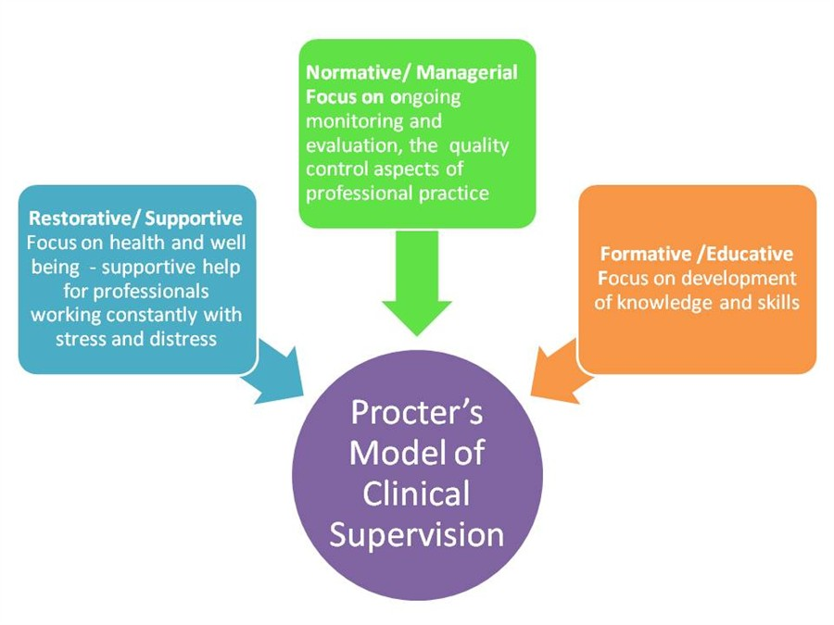

  - Fig 1. Proctor’s Model of Clinical Supervision
This paper will describe clinical supervision for:
- Trainee ANPs
- Qualified ANPs
It will also describe a formal ‘sign-off’ process to demonstrate that an individual is competent to practice as an ANP.

Trainee to experienced ANP
Trainee ANPs will require closer and more intense supervision than experienced ANPs.

Clinical Supervision for Trainees
Trainee ANPs require supervision throughout their entire ANP education. They will require:
- Practice Supervision
- Educational Supervision
- Professional Supervision
A ‘tripartite’ approach is encouraged. This will involve:
- A Practice Supervisor who will be an experienced senior clinician who is doing or is able to do the same job the trainee ANP is preparing for. This individual could be a suitably qualified and experienced ANP or they may be another suitably qualified and experienced healthcare professional, most often a consultant, General Practitioner or registrar.
- An Educational Supervisor who will be a suitably qualified and experienced educationalist (e.g. personal academic tutor). This could be the Programme Leader for the course the trainee is undertaking, or another member of the programme team the responsibility is delegated to
- The trainee’s line manager who will be responsible for ensuring that the trainee is supported and appropriately clinically supervised throughout their entire training.
If the trainee’s line manager is a registrant they may provide Professional Supervision. Otherwise one of the other supervisors may perform this role providing they are a senior registered nurse. Ideally, at least one of the supervisors should be an Advanced Nurse Practitioner.
On occasion one individual may be able to undertake more than one of these roles. However, best practice would be to involve three separate people with distinct responsibilities.

Responsibilities of supervisors
- The Practice Supervisor will be responsible for ensuring that the trainee is appropriately clinically supervised throughout their training. This may involve one-to-one supervision, especially near the beginning of the training, or may involve ensuring that a team of suitably qualified and experienced people are available to provide supervision if the Practice Supervisor isn’t present. The Practice Supervisor should meet with the trainee on a regular basis to discuss progress. As a minimum this would be on a 6-8 weekly basis. The Practice Supervisor will liaise with the line manager at regular intervals.
- The Educational Supervisor will be responsible for ensuring that the trainee can access the modules on the programme, will provide academic advice and support to the trainee and will liaise with the Line Manager.
- The Line Manager will be responsible for ensuring that the Supervision model is working, that the trainee is getting the personal, professional, academic and clinical support that they need. The Line Manager is also responsible for ensuring that the trainee has appropriate time for learning built into their job plan and that they can access all appropriate learning opportunities
The three supervisors should communicate with each other on a regular basis and it would be good practice for all three to meet together with the trainee at least once a year.
The three supervisors should have open lines of communication to share progress and discuss issues.
- The trainee also has responsibilities. The trainee should liaise with the line manager on a regular basis regarding progress and should raise any issues that might impact on training and development at an early stage.
- The trainee should also share relevant information with their clinical supervisor and education supervisor as appropriate.
- The trainee is an adult learner as is expected to identify their own learning needs, assisted by the clinical and education supervisors and line manager.

Designated Medical Prescriber (DMP)
During the Non-Medical Prescribing (NMP) module the trainee will also need to have a DMP. If the Practice Supervisor is a medical practitioner then they may wish to take on this role. If the Practice Supervisor isn’t a medical practitioner then a DMP will need to be included as part of the Supervision team, as a minimum for the NMP module, but ideally from the NMP module to the end of the training (in most programmes this would equate to the second year of training if undertaking the full postgraduate diploma).

Dissertation Supervisor
If the trainee goes onto complete the Masters programme, they will require a Dissertation Supervisor. This Supervisor will be appointed by the Higher Education Institution.

Requirements of supervisors
The following are minimum requirements. Different Higher Education Institutions and/or additional awarding bodies (e.g. RCEM, FICM, RCN) may have additional requirements.
- Practice Supervisor – must be a senior clinician who is technically skilled to undertake the role the trainee is preparing for. They must be registered by their Registering Body (NMC, GMC, HCPC) and not have any limitations on their practice. They also must be able to prescribe. Ideally they should hold a masters level qualification.
- Educational Supervisor – must be part of the Programme Team at the Higher Education Institution the trainee is undertaking the qualification at. They must either be employed by the Institution or hold an Honorary Contract with that institution. Educational Supervisors must have access to the academic transcripts of the trainees they are supervising. They must hold a masters level qualification or above and ideally be an Advanced Practitioner
- Line Manager – must be willing to take on the responsibility to support the supervision of the trainee and to facilitate the training within the workplace

Collecting Evidence
Part of the role of the supervisors is to help the trainee build a portfolio of evidence to demonstrate their competence in Advanced Practice.

ePortfolio
All trainee ANPs and ANPs are expected to use the NES TURAS ePortfolio (https://turasnmportfolio.nes.nhs.scot)
Within the ePortfolio trainees need to demonstrate the following (as a minimum):
- Record of their learning including clinical experience as a trainee
- Completion of all academic requirements (record of all modules undertake, including results and copy of their final exit award certificate)
- Work Based Practical Assessments (formative and summative). This is likely to include:
  - Mini-CEX
  - DOPS
  - Case Based Discussions
  - Feedback from others
- Competencies – where appropriate competencies may be mapped to evidence elsewhere in the portfolio
- Supervision reports
Different Higher Education Institutions and/or additional awarding bodies (e.g. RCEM, FICM, RCN) may have additional requirements and may require other Portfolios to be used for different stages. Evidence can be shared between portfolios.

Competencies
The ANP role continues to evolve and new frameworks are being developed on a regular basis. As a minimum ANPs in Scotland must meet all the ‘high level’ competencies for an ANP, all the Prescribing competencies and the competencies for one of the broad groups of ANPs (e.g. neonatal, paediatric, primary care/community, adult acute care, mental health or learning disabilities).
Additional competencies may be required by different Higher Education Institutions and/or additional awarding bodies (e.g. RCEM, FICM) and/or the employer.
The supervision team will help the trainee identify all the required competencies for their role.

Final Sign-off
Completing a course of academic study isn’t sufficient to demonstrate that an individual is competent to practice as an ANP.
Each employer needs to ensure an appropriate mechanism is in place for ‘final sign-off’. Final sign-off is required when an individual:
- Completes initial training
- Changes job especially if it’s in a new speciality
Final Sign-off involves:
- The individual’s line manager who will take the lead on the sign-off process
- The Practice Supervisor or a nominated Practice Assessor
- The Education Institution – this would usually be through evidence of completion of a programme of education (for example a copy of the Postgraduate Diploma in Advanced Practice and/or academic transcript)
The Line manager would set a date for the trainee ANP to submit a ‘Share Pack’ of their portfolio. The line manager would share this with the Practice Supervisor/Assessor. Both would be expected to review the portfolio and confirm it is completed to a satisfactory standard. As a minimum the following is expected.
- Record of their learning including clinical experience as a trainee.
  - A minimum of 400 hours of supervised practice over a minimum of 1 year
  - Evidence of learning:
    - Clinical assessment
    - Clinical reasoning, judgement and diagnostic decision making
    - Anatomy and physiology
    - Non-medical prescribing
    - Leading, delivering and evaluating care
    - Worked based learning
- Completion of all academic requirements (record of all modules undertake, including results and copy of their final exit award certificate) and recorded as a non-medical prescriber with the Nursing and Midwifery Council.
  - Copy of a masters level qualification in advanced practice (or evidence of equivalence [this would normally be 120 credits with a minimum of 50% at masters level).
  - Evidence of being recorded with the NMC as a Nurse Independent Prescriber
  - Evidence of being recorded with Health Board as a prescriber
- A range of Work Based Practical Assessments demonstrating competence is managing the broad range of patients seen within the role. This is likely to include:
  - Mini-CEX
  - DOPS
  - Case Based Discussions
  - Feedback from others
- Completed competencies – where appropriate competencies may be mapped to evidence elsewhere in the portfolio
- Satisfactory Supervision reports which confirm the trainee has completed training and has been assessed as competent performing as an ANP
The Practice Supervisor/Assessor and Line Manager will together determine whether the trainee has:
- Passed - Satisfactorily passed all academic requirements and evidence of competence to practice in ANP role contained within ePortfolio
- Provisional pass – satisfactorily passed all academic requirements, but some minor gaps in evidence of competence.
- Fail – either has still to pass all academic requirements or has major gaps in evidence of competence or both.
If the trainee has passed, the line manager would inform the individual within the Board who is responsible for recording ANPs on the Scottish Standard Workforce Information System (SWISS). The trainee, employed as Band 7 Annex 21 or Band 6, would be expected to move to a Band 7 at this stage.
If a provisional pass, the line manager would set a period of time (no less than 1 month and usually no-more than 6 months) for the individual to obtain the required evidence. Trainees employed as Band 7 Annex 21 or band 6 would not normally move until competence has been achieved. The trainee would not normally move to a Band 7 until after confirmation that satisfactory evidence has been submitted.
If a fail, the line manager, in consultation with others (which may include the clinical supervisor, education supervisor and Human Resources) the most appropriate course of action for the individual. This may include re-doing part of the training or termination of the traineeship.
If the Practice Supervisor/Assessor and Line Manager cannot agree on a grade the view of the internal moderator should be sought. If agreement can still not be reached then advice can be sought through the external moderation mechanism system i.e. the Academy.

Moderation
A sample of portfolios will be internally and externally moderated each year. Each Board will put in place a mechanism for internal moderation.
The Advanced Practice Academy will put in place a mechanism for external moderation of a sample of portfolios from each board every year. This mechanism will involve a suitable expert(s) from another Board reviewing ePortfolios and providing feedback to the line manager, the Board Advanced Practice Lead and the Board Nurse Director.
External Experts will be recorded within their employing Board as an ANP or NMAHP Consultant and either have teaching and assessing qualification or be recognised by the Academy as an ‘External Expert’.
The Academy’s recommendations will be advisory only. Ultimately it will be for the employer to determine whether an individual has met all the requirements to practice.

Clinical Supervision for Qualified ANPs
The model for Clinical Supervision for qualified ANPs differs significantly from that for trainee ANPs. Instead it reflects the model for qualified Midwives.
See http://www.nes.scot.nhs.uk/education-and-training/by-theme-initiative/maternity-care/about-us/clinical-supervision.aspx.
Qualified ANPs will have a network of support and supervision which will support day-to-day practice. This network may include the on-call medical consultant, senior medical staff, ANP colleagues, other Advanced Practitioners, the individual’s line manager, lead and or chief nurse and consultant nurse.
In addition to this each ANP will have a named Clinical Supervisor who will either meet with the supervisee on a one-to-one basis or in a group with other supervisees. Supervisees should meet with their Clinical Supervisor at least once a year.
The ANPs line manager will be responsible for ensuring that each qualified ANPs has a named Clinical Supervisor.
Clinical Supervision will consist of:
- A reflective component
- Support from a skilled facilitator
- Focus on clinical practice (including team dynamics, communication and personal coping)
- Professional Development
- Improving patient treatment and care

Record Keeping
The Clinical Supervisor and Supervisee are jointly responsible for ensuring records are kept of supervision sessions. Records will help supervisees:
- revisit their discussions, reflections and action points over time
- provide evidence that they have participated in clinical supervision
- document and commit to any agreement to take anything out of a session

Clinical Supervisor
The Clinical Supervisor for a trained ANP will be an experienced senior clinical who is doing is able to do a similar job to the ANP. Ideally this individual should be a suitably qualified and experienced ANP however they may be another suitably qualified and experienced healthcare professional for example a GP. Clinical Supervisors will undertake preparation for the role.

Annual review
ANPs are responsible for compiling, maintaining and sharing an ePortfolio which evidences their competence to practice as an ANP. At least once a year the ANP should meet with their line manager for an annual review. If the line manager isn’t an ANP it would be good practice to either undertake a joint review with the ANP’s Clinical Supervisor. If a joint meeting isn’t possible the Clinical Supervisor should provide the line manager with a report which details the clinical supervision sessions.
Annual review will involve the following:
- ePortfolio review
  - Record of learning activities, reflection, feedback from others (including clinical supervisor)
- Case notes for discussion and review which should related to the individuals level of competence, prescribing practice and include reflection as well as learning/action points (either for review by the line manager, or evidence of peer review or review by the Clinical Supervisor)
- Job planning – this should follow the Board’s Job Planning guidance for ANPs. Job Plans should include time for Supporting Professional Activities (including Continuing Professional Development and contributions towards the other pillars of Advanced Practice: facilitation of learning, leadership, and research).

Normally the KSF would also be completed at this review and revalidation every three years.

NMC revalidation
Evidence of Clinical Supervision should be included within your evidence for revalidation.

Summary
These guidelines set out the minimum standards for Clinical Supervision of Advanced Nurse Practitioners within the West Region. Individual Boards, Higher Education Institutions or other awarding bodies may have additional requirements.

References
Department of Health (1993) A Vision for the Future Report of the Chief Nursing Officer. London: NHS Management Executive:
NHS Education for Scotland (2017a) Clinical Supervision for Midwives. Unit 1: Fundamentals of Clinical Supervision. Edinburgh: NHS Education for Scotland.
NHS Education for Scotland (2017b) Clinical Supervision for Midwives. Unit 4: Leadership and Clinical Supervision; promoting person centred, safe and effective practice. Edinburgh: NHS Education for Scotland.
NMC (2008) The code – standards of conduct, performance and ethics to nurses and midwives. London: Nursing and Midwifery Council.
Proctor B (1987) Supervision: a co-operative exercise in accountability. Enabling and Ensuring: Supervision in Practice. MM and PM Leicester, National Youth Bureau and the Council for Education and Training Youth and Community Work.
RCN (2002) Clinical Supervision in the Workplace: Guidance for Occupational Health Nurses. London: Royal College of Nursing

RCN (2018) Clinical Supervision [online] Available at: http://www.rcn.org.uk/get-help/rcn-advice/clinical-supervision [Accessed 16 Jan 2018]

Approved at the WoS AP Academy on Friday 4th May 2018

Supervised practice may involve direct supervision where the supervisor is physically present with the trainee or indirect where supervision is provided at a distance or delegated to another clinician
Digital Resource Pack available from NHS Education for Scotland
TURAS ePortfolio recommended from NHS Education for Scotland
This can be submitted as a ‘Feedback from Others’ form in the TURAS ePortfolio

