# Norovirus Outbreak Daily Actions Checklist

**For ongoing monitoring until the outbreak is under control.**

|  |  |
| --- | --- |
| **Name of Care Home/Care area:** |  |
| **Person in charge:** |  |
| **Date of first symptoms:** |  |

|  |  |  |  |  |  |  |  |  |
| --- | --- | --- | --- | --- | --- | --- | --- | --- |
| **DAILY CHECKLIST DATE/SHIFT:** | |  |  |  |  |  |  |  |
| All residents with symptoms assessed for symptom severity (GP contacted if concerned) **Initial:** | |  |  |  |  |  |  |  |
| Anti-sickness medication considered for symptomatic residents (checked first with GP) | |  |  |  |  |  |  |  |
| All residents with symptoms assessed for signs of dehydration | |  |  |  |  |  |  |  |
| Stool chart completed for all symptomatic residents | |  |  |  |  |  |  |  |
| Date of start and end of symptoms recorded for all residents/staff  (use Norovirus Outbreak Data Record) | |  |  |  |  |  |  |  |
| Doors to symptomatic residents rooms are closed whenever possible | |  |  |  |  |  |  |  |
| Symptomatic residents rooms have been disinfected as per enhanced cleaning protocol | |  |  |  |  |  |  |  |
| Residents and visitors have been updated about any changes to visiting (if necessary) | |  |  |  |  |  |  |  |
| Posters have been displayed informing all visitors of temporary suspension of visiting (if necessary) | |  |  |  |  |  |  |  |
| Receiving units (ambulances/hospitals) have been informed of the outbreak if transferring today | |  |  |  |  |  |  |  |
| Carers of residents discharged to home care have been informed of infection control requirements | |  |  |  |  |  |  |  |
| Any changes to outbreak status have been communicated to all staff/residents/visitors | |  |  |  |  |  |  |  |
| A terminal clean of the wider facility has been organised with the HPT once all persons have been symptom-free for at least 48 hours | |  |  |  |  |  |  |  |
| **[Image result for Bristol stool chart](https://www.google.com/url?sa=i&rct=j&q=&esrc=s&source=images&cd=&cad=rja&uact=8&ved=2ahUKEwjzmsSh-drdAhXO-KQKHW1QB_QQjRx6BAgBEAU&url=https://www.continence.org.au/pages/bristol-stool-chart.html&psig=AOvVaw1X6GZgJpj5d7DITcAzQRYo&ust=1538129552478292)Number of new cases (residents):** |  |  |  |  |  |  |  |
| **Number of new cases (staff):** |  |  |  |  |  |  |  |
| **Total number of cases (residents):** |  |  |  |  |  |  |  |
| **Total number of cases (staff):** |  |  |  |  |  |  |  |

[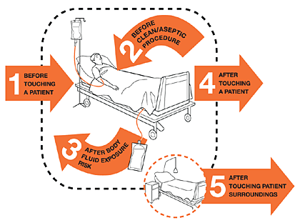](http://www.google.com/url?sa=i&rct=j&q=&esrc=s&source=images&cd=&cad=rja&uact=8&ved=2ahUKEwil0OzW-NrdAhUI2aQKHQZ7DckQjRx6BAgBEAU&url=http://www.who.int/gpsc/5may/background/5moments/en/&psig=AOvVaw00tuWAied5VZRnjyWExGXo&ust=1538129334635402)