**Leading Change**

**Information and Guidance for Managers**



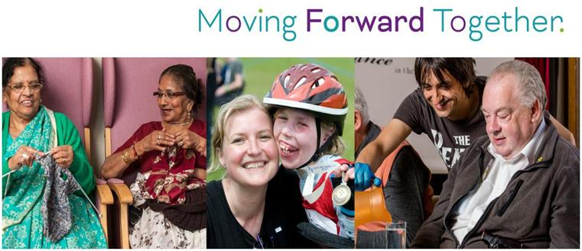

**Table of Contents Page**

**­­­­­­­­­­­­­­**



1. **How leaders and their teams can use this guidance**

* **Introduction 3**
* **How the document works 3**
* **Additional Guidance - Knowledge and Skills to Lead Change 4**

**2. Understanding the stages of change**



* **Developing awareness -** of the change and its likely impact on your team   
   or service
* **Creating Readiness** - for implementation of change
* **Implementing** - and embedding the change
* **Sustaining** - benefits and outcomes



**3. Recommended tools and approaches to manage each stage of change**

* Understanding how people behave during change
* Recognising the activities needed at each stage of change
* Guidance on using tools to help you deliver these
* Understanding the tools or approaches to support and engage your teams



**Accessing alternative tools and information via HR Connect**

* Being familiar with the additional tools and approaches available to suit your specific need and guidance on using these
* Understanding the HR Connect web pages and how to navigate these

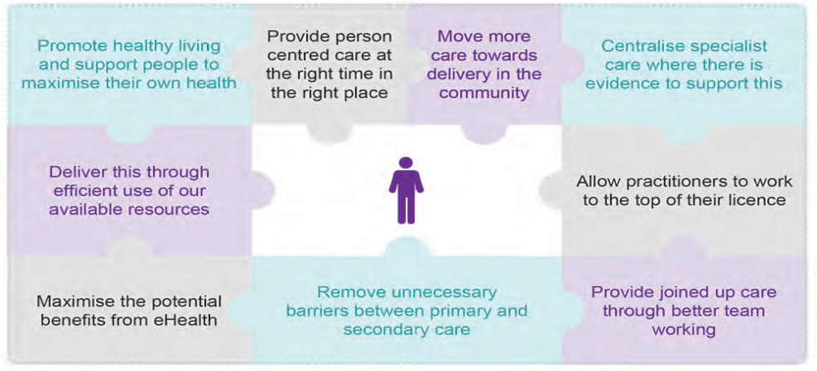

**Local support**

* Accessing the support of HR, OD and L&E colleagues in the change   
   process



**1. How leaders and their teams can use this guidance**

**INTRODUCTION**

This document is intended to guide anyone leading or managing organisational change eg ***Moving Forward Together*,** as this affects their teams and services. The purpose of this guidance document is to provide you with a framework of relevant tools and information designed to be self led and to help you engage and support your staff through the each of the stages of change as these happen.

You may from time to time engage additional support from other functions eg HR & OD to work with you on the more complex areas of change using relevant tools and models.

As leaders of change you have a critical role to play in ensuring that the change effort is successful.

**HOW THE DOCUMENT WORKS**

The document follows an incremental approach with a section structured around one of the four main stages of change. Tools and information provided in each section are specific to the activities of the stage of change and build where relevant on the activities of the previous ie

* **Developing awareness -** Of the change and its likely impact on your   
   team or service
* **Creating Readiness** - Assessing readiness, Planning and preparing   
   for the implementation of change
* **Implementing** - The actions needed to successfully implement   
   and embed the changes identified and agreed
* **Sustaining the Change** - New ways of working, outcomes and benefits

Each section will offer:

* An initial section designed to highlight the common activities across all stages of change eg Communication and Engagement and the skills leaders can develop to manage these most successfully
* A summary of the main leadership activities for that stage of change ie ***what you need to do***
* A description of, and how to use, one or two main tools or information to support these activities ie ***How you might do this***
* Links to additional and alternative tools and information via HR Connect
* Links to additional reading or case studies where relevant

**ICONS USED IN THE DOCUMENT**

[](https://www.google.co.uk/imgres?imgurl=https://upload.wikimedia.org/wikipedia/commons/thumb/1/18/Circle-information.svg/2000px-Circle-information.svg.png&imgrefurl=https://de.wikipedia.org/wiki/Datei:Circle-information.svg&docid=ldsrDLwVna2ebM&tbnid=t3I7OucOQd4rmM:&vet=1&w=2000&h=2000&hl=en&bih=612&biw=1242&ved=2ahUKEwiToqXhlonfAhUR3RoKHbwuAX8QxiAoAXoECAEQEg&iact=c&ictx=1)

highlights links to additional information



highlights a topic of communication or engagement

[](https://www.google.co.uk/url?sa=i&rct=j&q=&esrc=s&source=images&cd=&ved=2ahUKEwiU8a_pl4nfAhVR5IUKHQMGBLUQjRx6BAgBEAU&url=https://vk.com/audit_smm&psig=AOvVaw3BRffeTckFEviAySyHnVrz&ust=1544116333994633)



highlights an assessment tool for use with individual or teams

highlights tools or models you may find useful

**ADDITIONAL GUIDANCE - THE KNOWLEDGE AND SKILLS TO LEAD CHANGE**

There are common activities at each stage of a change process and knowledge and skills a manager can develop to support all of these. General guidance and tips are provided below.



**Communication and engagement:**

The content and focus of communication with your teams will differ at each stage of the change journey but remains equally important.

**General tips for effective communication during change**

• Uncertainty is more painful than bad news, so communicate early and often

• Seek first to understand and then to be understood

• Communicate directly with the people that matter using multiple media, but preferably face-to-face

• Make the communication process transparent and two-way

• Be honest and tell the truth

• The result of a communication is the response you get back, which may be different   
from what you intended

• You will always be communicating, even when you think you’re not. A person cannot **NOT** communicate, and behaviour is the highest form of communication

• As a rule of thumb: state the position, identify the problems, present the possibilities

[](https://www.google.co.uk/imgres?imgurl=https://upload.wikimedia.org/wikipedia/commons/thumb/1/18/Circle-information.svg/2000px-Circle-information.svg.png&imgrefurl=https://de.wikipedia.org/wiki/Datei:Circle-information.svg&docid=ldsrDLwVna2ebM&tbnid=t3I7OucOQd4rmM:&vet=1&w=2000&h=2000&hl=en&bih=612&biw=1242&ved=2ahUKEwiToqXhlonfAhUR3RoKHbwuAX8QxiAoAXoECAEQEg&iact=c&ictx=1)

Click on the link below for further information on communication during change

Managing Behaviours – conflict / resisitance

**Understanding the stages of change**



**Stage 1 - Developing Awareness**

A primary reason for resistance to change is a lack of awareness, where the need for change and the benefits of making the change have not been communicated, discussed or explained.



**Communication and Engagement in Stage 1**

Communication during Stage 1 of a change process must describe the compelling need for change ie Why are we doing this? What do we expect to achieve? What is the risk if we don’t change? and how the changes align to our vision for care?

Employees will want to understand how the change affects the organisation but more specifically what this means for them personally and the work they do.

Communication for Stage 1 of a change should be regular, face to face and allow time for discussion, exploration and questions. Involving your people in understanding the change not only helps to avoid unnecessary resistance but allows you to identify the early adopters (or change champions) and the likely resistors. Research tells us 60-70% of your staff will be undecided about the change or how this will affect them. Your leadership role is to influence and encourage acceptance of the change.

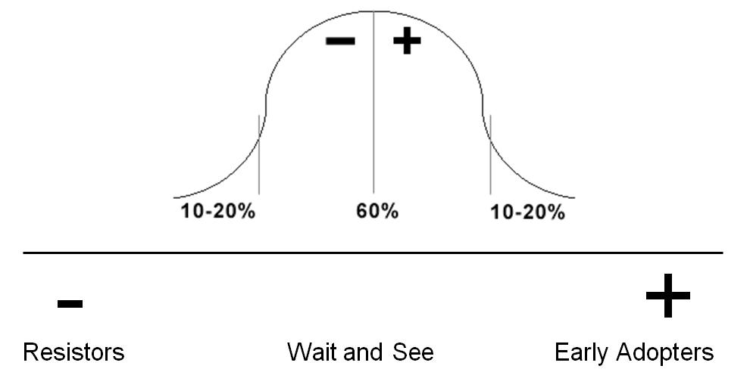

Figure 1 - Reactions to change

Regular communication allows you to keep your teams up to date with what is happening, to hear and understand their concerns and to surface and respond to potential resistance. Common sources of resistance include:

* Being comfortable or happy with the current situation
* Questioning the credibility of the change message
* Questioning the need for change
* Conflicting information (usually drawn from the “grapevine”)

The “grapevine” will be active during a period of change and will seek to provide the answers or fill the information gaps if regular and meaningful communication is not in place.

Managers should encourage their staff to attend available engagement events, share the latest information and updates with their teams and provide regular opportunity for questions and concerns to be raised. Particularly for areas of the service that are directly impacted by the change this might form part of your regular team meetings. A range of ***information and presentations*** can be found on the link below:

[](https://www.google.co.uk/imgres?imgurl=https://upload.wikimedia.org/wikipedia/commons/thumb/1/18/Circle-information.svg/2000px-Circle-information.svg.png&imgrefurl=https://de.wikipedia.org/wiki/Datei:Circle-information.svg&docid=ldsrDLwVna2ebM&tbnid=t3I7OucOQd4rmM:&vet=1&w=2000&h=2000&hl=en&bih=612&biw=1242&ved=2ahUKEwiToqXhlonfAhUR3RoKHbwuAX8QxiAoAXoECAEQEg&iact=c&ictx=1)

<http://www.movingforwardtogetherggc.org/moving-forward-together/>

It is important to explore the implications of the change with your team, on the service they deliver and where relevant their roles or the work they do. Before you do this it is essential you are able to clearly explain the change, why this is needed and the vision for what this will deliver.

[](https://www.google.co.uk/url?sa=i&rct=j&q=&esrc=s&source=images&cd=&ved=2ahUKEwiU8a_pl4nfAhVR5IUKHQMGBLUQjRx6BAgBEAU&url=https://vk.com/audit_smm&psig=AOvVaw3BRffeTckFEviAySyHnVrz&ust=1544116333994633)

Completing the ***Change Leadership Readiness Self Assessment*** on the link below will help you to identify where you may need to prepare a little more, add to your current knowledge or understanding of change management or to draw support from other people or sources.

ADD LINK FOR LEADERSHIP READINESS SELF ASSESSMENT



There are no “perfect” change models or initiatives, particularly in terms of people and their reactions, but it can be helpful to use a model of change as a baseline to plan and navigate your way through this. You may find different models useful at different stages of your change activity.

The link below offers a series of established change models for you to consider. A brief summary of how each of these might add value is provided.

`` ADD LINK FOR CHANGE MODELS

All of the change models provided consider the human factors of change however The *Kübler-Ross’* change curve model can be helpful in Stage1 to help you understand the reactions individuals may have to change, how to recognise the behaviours you are seeing in relation to this and ways to plan for and manage these.

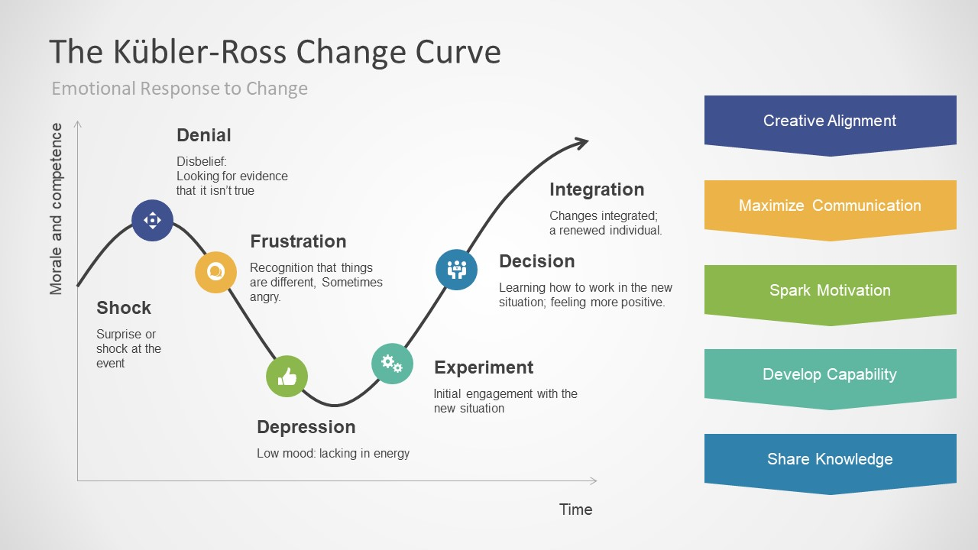



**Understanding the stages of change**

**Stage 2 – Creating Readiness for Change**

Stage 2 builds on the work you have undertaken in Stage 1 to develop awareness of the change and its likely impact on your service area and the teams or individuals who deliver this. Stage 2 now works with a firm picture of WHAT will change but may not yet have defined HOW this will be delivered.



**Communication and Engagement in Stage 2**

The reality of the change is much firmer now for individuals and teams and they will begin to create an understanding of what this means for them and the work they do. Things you can do to retain staff engagement in Stage 2 will include:

* Being clear, consistent and open on the planned changes and how these will begin to take place
* Being clear that you value the roles and contributions people make
* Taking time to acknowledge how people may be feeling
* Continuing to communicate regularly allowing time for discussion and issues to surface
* Providing 1-1 where appropriate or you feel needed
* Being visible and update your people as soon as things develop or further information is available
* Involving your teams in exploring how some of the changes can take place, the opportunities that these may offer or the improvements you might realise.
* Managing early resistance to change in a positive way. Remember the change models offered will help you do this.

LINK TO CHANGE MODELS

You may at this stage begin to identify those individuals who are embracing the change or who can offer a practical support to their colleagues. These are the early adopters or “change champions” who can play a major role in being ready to implement change and influence those who are still undecided to accept and align to the change happening.

Further information on the role and attribute of change champions is available on the link below:

LINK TO CHANGE CHAMPIONS <http://639969719114303356.weebly.com/definition-and-the-role-of-a-champion.html>



**Understanding the stages of change**

**Stage 3 – Implementing the Change**

Stage 3 is where activities to explore, identify and agree HOW changes will be taken forward begin. It is at this stage leaders will work with their teams to develop a clearer picture of what will change, a firmer picture of the impact these changes will have on people, their service and their stakeholders.

Stage 3 has two main areas of activity leaders will undertake with their teams ie:

* Reviewing and, where appropriate, redesigning processes to support their service
* Managing the transition of staff to the new service, their resistance, behaviours and engagement



**Communication and Engagement in Stage 3**

As far as possible you should now be communicating the specifics of change as these relate to your services and teams. Until now communications will have been more generic, focusing on the organisational need and benefit of the change initiative.

At Stage 3 of change the focus becomes the actual change in terms of your service area and the timelines, expected outcomes and activities you will undertake to achieve these. Some things you can do to maintain effective communications during Stage 3 includes:

* Sharing information regularly and updating your people as often as you can. It is important to maintain a steady stream of communication even when there is little new information. Staff will always assume you have more of the facts than you may have and can equate silence with secrecy.
* Being as factual and honest as you can be, ensuring you share positive and less positive information. Nothing impacts a leader’s credibility more than not telling the truth
* Working with staff to understand the changes affecting their particular role making time for 1-1 conversation when needed
* Remembering communication is a two way process and how important it is to allow time for staff to ask questions, share concerns or offer ideas and suggestions
* Beginning to introduce planning and improvement discussions with your teams. Encourage sharing of ideas and experience, testing options or raising potential issues with a suggested process change. Staff being part of the solution and involved in the changes that affect them is a positive change management tactic.
* If you haven’t already, identify your Change Champions *(See stage 1)* and consider how they can support you or help their colleagues come to terms with the changes affecting them.

Activities to deliver the change

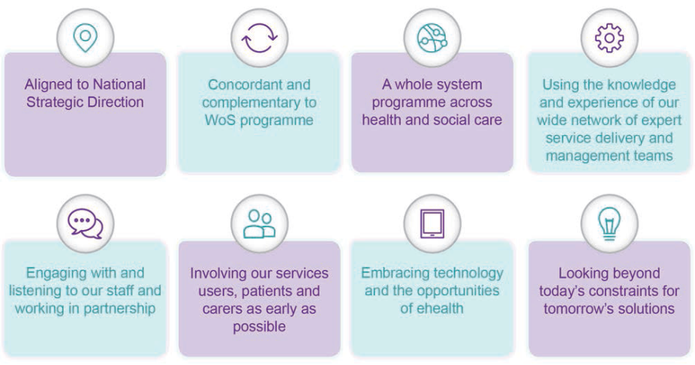 **D**eveloping awareness and understanding of Change and its need