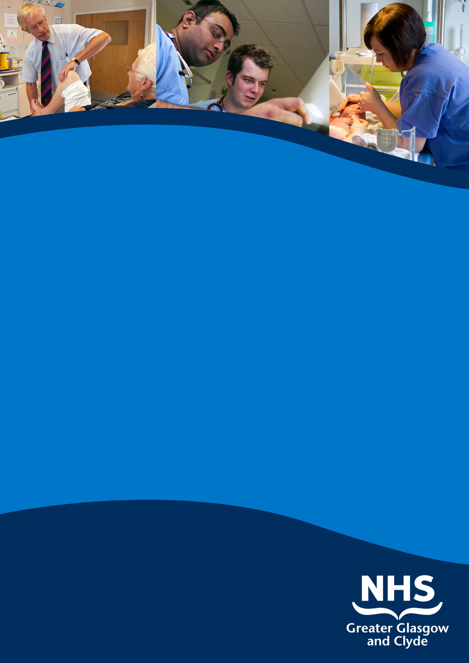

clinical fellow in general surgery (fy1 Level)
QUEEN ELIZABETH UNIVERSITY HOSPITAL

INFORMATION PACK

ref: 54211d

cLOSING DATE: 14th december 2018

www.nhsggc.org.uk/medicaljobs

SUMMARY INFORMATION RELATING TO THIS POSITION

Post: clinical fellow in general surgery (fy1 Level))

Base: Queen Elizabeth university hospital

A vacancy exists in General Surgery until 1st April 2019 at FY1 level based at Queen Elizabeth University Hospital. You will be a foundation year doctor. Training opportunities will be made available to the successful candidate

This post has not been approved for Training purposes by NES.

To practise medicine in the UK you need to hold both GMC full registration and a Licence to Practise.

For further information please contact Ms Karen Bell. Clinical Service Manager 01414526440

NHS GREATER GLASGOW AND CLYDE
SURGERY AND ANAESTHETICS DIRECTORATE
CLINICAL FELLOW
GENERAL SURGERY
FY1 LEVEL
Job Description

- BRIEF DESCRIPTION OF THE DIVISION

Acute Services Division is part of NHS Greater Glasgow and Clyde and is the largest Acute Division in Scotland. The hospitals, within Glasgow, all with teaching responsibilities are Glasgow Royal Infirmary (including Princess Royal Maternity Hospital), Stobhill Ambulatory Care Hospital and Gartnavel General Hospital. In south Glasgow the Queen Elizabeth University Hospital and the new Victoria ACH Hospital, providing ambulatory care, support the acute surgical patient. Within Clyde sector we have the Royal Alexandra Hospital, Inverclyde Royal Hospital and the Vale of Leven Hospital all providing acute medical/surgical care with RAH and IRH also supporting unscheduled care..

The Division provides a comprehensive range of services from community-based care (midwives, dental services and various outreach services) through the full range of general hospital services through to regional specialist services. In addition it has close links with the Universities in Greater Glasgow and makes a significant contribution to teaching. The expanded Division now employs 44,000 staff across its sites, making it a significant employer.

- DESCRIPTION OF THE HOPSITAL

The Queen Elizabeth University Hospital

The Queen Elizabeth University Hospital is a major new Teaching Hospital in Glasgow resulting from the amalgamation of the City’s Western Infirmary, Victoria Infirmary and Southern General Hospital. This integrated acute adult hospital is built over 14 floors and provides 1109 beds. Every patient in the general wards has their own single room with an en-suite and views out across the campus, for some this will be to the hills beyond the city; no bedroom will overlook another. The standard of internal finish is attracting admiration from all visitors.

Other services include a range of high quality health care services including Accident and Emergency, General Medicine (including sub-specialties), General Surgery (including sub-specialties), Medicine for the Elderly (including Assessment, Rehabilitation, and Day Services), and Orthopaedics. Surgical services will incorporate all aspects of General Surgery, Vascular Surgery, Urology, ENT, Orthopaedics and Transplantation Surgery
The above services are supported by other consultant-based services which incorporate diagnostic and clinical components including Anaesthetics, Laboratory Medicine, and Radiology. There is also available a wide range of therapeutic services which include Clinical Psychology, Dietetics, Occupational Therapy, Physiotherapy and Speech and Language Therapy.
The Maxillofacial Department for the whole city was centralised at the hospital site in the autumn of 2002 providing trauma and elective surgery and specialist provision for head and neck cancer. The Assessment and Rehabilitation service for the Physically Disabled is also provided for the whole city from the Southern General Hospital.
There is also a wide range of diagnostic and therapeutic services including Audiology, Clinical Psychology, Dietetics, Occupational Therapy, ECG, Physiotherapy, Radiology (including MRI and CT provision for the general hospital service) and Speech Therapy.
- THE POST

Title: FY1 Clinical Fellow in General Surgery

- DUTIES OF THE POST

This post is within the Surgical Directorates. The duties involve the clinical care of acute and elective admissions to the General Surgical Units with participation in an emergency rota.

- TRAINING

The successful applicant would be actively encouraged to be involved in both undergraduate and postgraduate teaching.

TERMS AND CONDITIONS OF SERVICE

The conditions of service are those laid down and amended from time to time by the Hospital and Medical & Dental Whitley Council.

TYPE OF CONTRACT | Fixed Term
GRADE AND SALARY | Clinical Fellow FY1 level  £ 24,382 - £27,425 per annum (pro rata)  New Entrants to the NHS will normally commence on the minimum point of the salary scale, (dependent on qualifications and experience). Salary is paid monthly by Bank Credit Transfer.
HOURS OF DUTY | Full Time 40.00
SUPERANNUATION | New entrants to NHS Greater Glasgow and Clyde who are aged sixteen but under seventy five will be enrolled automatically into membership of the NHS Pension Scheme. Should you choose to "opt out" arrangements can be made to do this via: www.sppa.gov.uk
REMOVAL EXPENSES | Assistance with removal and associated expenses may be given and would be discussed and agreed prior to appointment.
EXPENSES OF CANDIDATES FOR APPOINTMENT | Candidates who are requested to attend an interview will be given assistance with appropriate travelling expenses. Re-imbursement shall not normally be made to employees who withdraw their application or refuse an offer of appointment.
TOBACCO POLICY | NHS Greater Glasgow and Clyde operate a No Smoking Policy in all premises and grounds.
DISCLOSURE SCOTLAND | This post is considered to be in the category of “Regulated Work” and therefore requires a Disclosure Scotland Protection of Vulnerable Groups Scheme (PVG) Membership.
CONFIRMATION OF ELIGIBILITY TO WORK IN THE UK | NHS Greater Glasgow and Clyde (NHSGGC) has a legal obligation to ensure that it’s employees, both EEA and non EEA nationals, are legally entitled to work in the United Kingdom. Before any person can commence employment within NHS GGC they will need to provide documentation to prove that they are eligible to work in the UK. Non EEA nationals will be required to show evidence that either Entry Clearance or Leave to Remain in the UK has been granted for the work which they are applying to do. Where an individual is subject to immigration control under no circumstances will they be allowed to commence until the right to work in the UK has been verified. ALL applicants regardless of nationality must complete and return the Confirmation of Eligibility to Work in the UK Statement with their completed application form. You will be required provide appropriate documentation prior to any appointment being made.
REHABILITATION OF OFFENDERS ACT 1974 | The rehabilitation of Offenders act 1974 allows people who have been convicted of certain criminal offences to regard their convictions as “spent” after the lapse of a period of years. However, due to the nature of work for which you are applying this post is exempt from the provisions of Section 4 of the Rehabilitation of Offenders Act 1974 by virtue of the Rehabilitation of Offenders Act 1974 (Exceptions Orders 1975 and 1986). Therefore, applicants are required to disclose information about convictions which for other purposes are “spent” under the provision of the act in the event of employment, failure to disclose such convictions could result in dismissal or disciplinary action by NHS Greater Glasgow and Clyde. Any information given will be completely confidential.
DISABLED APPLICANTS | A disability or health problems does not preclude full consideration for the job and applications from people with disabilities are welcome. All information will be treated as confidential. NHS Greater Glasgow and Clyde guarantees to interview all applicants with disabilities who meet the minimum criteria for the post. You will note on our application form that we ask for relevant information with regard to your disability. This is simply to ensure that we can assist you, if you are called for interview, to have every opportunity to present your application in full. We may call you to discuss your needs in more detail if you are selected for interview.
GENERAL | NHS Greater Glasgow and Clyde operates flexible staffing arrangements whereby all appointments are to a grade within a department. The duties of an officer may be varied from an initial set of duties to any other set, which are commensurate with the grade of the officer. The enhanced experience resulting from this is considered to be in the best interest of both NHS Greater Glasgow and Clyde and the individual.
EQUAL OPPORTUNITIES | The postholder will undertake their duties in strict accordance with NHS Greater Glasgow and Clyde’s Equal Opportunities Policy.
NOTICE | The employment is subject to one months’ notice on either side, subject to appeal against dismissal.
MEDICAL NEGLIGENCE | In terms of NHS Circular 1989 (PCS) 32 dealing with Medical Negligence the Health Board does not require you to subscribe to a Medical Defence Organisation. Health Board indemnity will cover only Health Board responsibilities. It may, however, be in your interest to subscribe to a defence organisation in order to ensure you are covered for any work, which does not fall within the scope of the indemnity scheme.

FURTHER INFORMATION

For further information on NHS Greater Glasgow and Clyde, please visit our website on www.nhsggc.org.uk

View all our vacancies at: www.nhsggc.org.uk/medicaljobs

Register for Job Alerts at: www.medicaljobs.scot.nhs.uk

Applicants wishing further information about the post are invited to contact Karen Bell on 0141 451 5958 with whom visiting arrangements can also be made.

How to apply

To apply for these posts please include your CV and names and addresses of 3 Referees, along with the following documents; (click on the hyperlinks to open)

Medical and Dental Application and Equal Opportunities Monitoring Form

Declaration Form Regarding Fitness to Practice

Immigration Questionnaire

Alternatively please visit www.nhsggc.org.uk/medicaljobs and click on the “How to Apply” tab to access application for and CV submission information.

NOMINATION OF REFEREES

It is Board policy that no person can act as a member of an Advisory Appointments Committee and be a referee for a candidate for that post. You should therefore check with your proposed referees whether there is likely to be any difficulty in this respect for we may otherwise have to invite you to submit another name or names

Return of Applications

Please return your application by email to nhsggcrecruitment@nhs.net or to the recruitment address below;

Medical and Dental Recruitment Team
NHS Greater Glasgow and Clyde
West Glasgow ACH (formerly Yorkhill)
2nd Floor
Dalnair Street,
Yorkhill,
G3 8SJ

CLOSING DATE

The closing Date will be 14th December 2018

