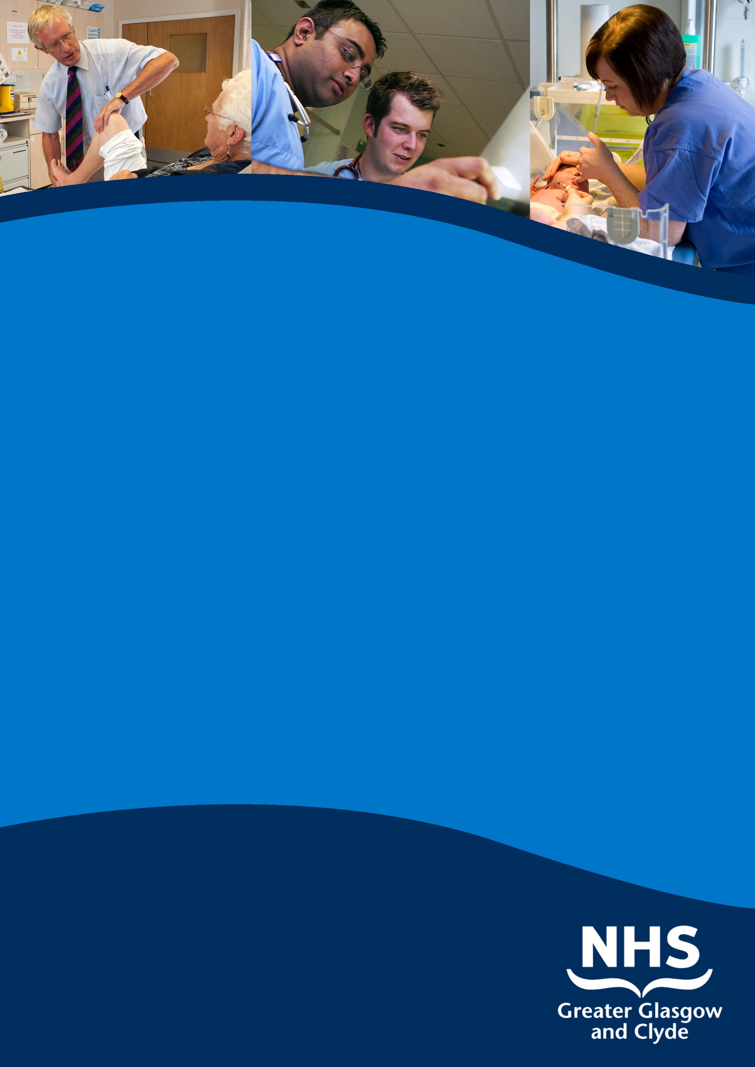

SENIOR clinical fellow paediatric orthopaedics

royal hospital for children, GLASGOW

Information pack

reF: 53825D

Closing Date: 7th DECEMBER 2018

www.nhsggc.org.uk/medicaljobs

SUMMARY INFORMATION

Post: SENIOR clinical fellow paediatric orthopaedics

Base: Royal Hospital for Children, Glasgow

We have two posts available commencing on 6th February 2019 for a period of six or twelve months based at the Royal Hospital for Children, Glasgow.

These posts are ideally suited to senior surgical trainees planning to develop a specialist practice in paediatric orthopaedics. We also welcome applications from career grade surgeons wishing to improve their paediatric orthopaedic knowledge and experience. The rota is currently on-call 1 in 7 (non resident). There is an active teaching programme and there are opportunities for research.

The Royal Hospital for Children, Glasgow, is the largest paediatric teaching hospital in Scotland with all paediatric medical and surgical subspecialties represented on-site. The hospital provides the major Undergraduate Paediatric Teaching facility for the University of Glasgow and accommodates various University Departments.

Appointees will gain experience in all major subspecialties of paediatric orthopaedic surgery and trauma, apart from surgery for correction of spinal deformity. All duties will be performed at the Royal Hospital for Children, Glasgow, based on the Queen Elizabeth University Hospital campus.

To practice medicine in the UK you need to hold both GMC registration and a license to practise.

PARTICULARS OF THE POST OF

SENIOR CLINICAL FELLOW IN PAEDIATRIC ORTHOPAEDIC SURGERY
Women’s and Children’s Directorate
Royal Hospital for Children, Glasgow.

Personal Specification for the Post.

This post is targeted ideally towards the following applicants:-

- British or European medical graduates who wish to gain further experience in paediatric orthopaedics and trauma with a view to specialising in this field. Candidates would normally be expected to have passed the FRCS(Orth) exam or its equivalent and to have good experience in the generality of orthopaedics to enable them to gain maximum benefit from the post.

- An overseas medical graduate who wishes to gain experience in paediatric orthopaedics and trauma and whose skills gained will subsequently be used to provide services and training in their own country. The candidate will normally be expected to have a good experience in the generality of orthopaedics and trauma and to have obtained a higher qualification in orthopaedics and trauma in their own country.

- Career grade surgeons who wish to learn the fundamentals of the management of fractures and other acute musculoskeletal conditions in children, and the basics of elective paediatric orthopaedic practice. Candidates would be expected to possess the MRCS examination or equivalent, and have an active ATLS provider certificate. They should have good experience in the assessment and management of the injured patient and a grounding in the principles and practice of trauma and orthopaedic surgery.

Brief Description of Hospital

This post is based at the Royal Hospital for Children (RHC) on the Queen Elizabeth University Hospital campus in Govan, Glasgow. All duties will be performed on this site. The Royal Hospital for Children, Glasgow is part of a recent major redevelopment of inpatient services in Glasgow. The hospital opened in the spring of 2015. An extensive reorganisation of both elective and emergency services has taken place across the city. It has affected the majority of medical and surgical specialties in one way or another, including adult and paediatric orthopaedics. A 900 bed adult hospital has been built on the Govan site. The Royal Hospital for Children is attached to the adult hospital, but is functionally separate. However since paediatric and adult orthopaedic services are located on the same site, cooperation occurs when required.

Children with fractures who live in the Greater Glasgow and Clyde region and need surgical treatment are all treated at the RHC. Children with fractures are transferred in from surrounding districts or Health Board areas if required – this depends on the age of the child and the complexity of the injury. All of the inpatient elective paediatric orthopaedics in Glasgow, and much of the surrounding areas, takes place in the Royal Hospital for Children. Tertiary level care is provided to children from surrounding Health Board areas including Ayrshire and Arran, Lanarkshire, Forth Valley and Dumfries and Galloway and occasionally from other Health Board areas. As a result, the hospital acts as a tertiary referral centre for the whole of the West of Scotland (population approximately 2.5 million).

The appointee will receive the widest possible exposure to the management of paediatric trauma as well as learning to deal with elective orthopaedic referrals ranging from the basic and simple to the most complex of problems.

The children’s hospital provides a comprehensive range of surgical services for children including general paediatric surgery, neonatal surgery, cardiac and neurosurgery, plastic and ENT surgery. Several national services (e.g. ECMO, cardiac surgery, renal medicine, complex airway, bone marrow transplant) are based at Royal Hospital for Children. There are two large maternity units within the city which handle 13,000 deliveries per year. One is situated on the Queen Elizabeth University Hospital campus.

The acute management of adult trauma is undertaken at the either Glasgow Royal Infirmary, Queen Elizabeth University Hospital, the Royal Alexandra Hospital in Paisley or at Inverclyde Royal Hospital, Greenock. Several Minor Injury Units throughout the city feed into these centres. The young adult hip service, the facilities for gait analysis and prosthetic management (West of Scotland Mobility and Rehabilitation Centre (Westmarc)) and the National Spinal Injuries Centre are based at the Queen Elizabeth University Hospital.

The Work of the Department

The post ensures a wide exposure to general orthopaedics and trauma in children. In addition, all the sub-specialties of paediatric orthopaedics, with the exception of surgery for spinal deformity, are represented.

Consultants 6
Senior clinical Fellows 3
SpRs from the West of Scotland scheme 4

FY1s are responsible for the day-to-day management of inpatients.

Training will be provides in the following areas:-

Normal paediatric orthopaedic variants and simple conditions
Paediatric trauma, including simple spinal injuries. Complex spinal injuries are managed in conjunction with neurosurgeons, colleagues in the adult sector and the Queen Elizabeth National Spinal Injuries Unit, which is also based at the Govan site.
Perthes disease.
DDH.
CTEV.
Neuromuscular conditions.
Limb reconstruction/ lengthening.
Obstetric brachial plexus injury.
Tumour management, benign and malignant.
Complex Bone Disorders - Osteogenesis imperfecta & metabolic bone disease.
Complex congenital problems.

The paediatric and adult orthopaedic services enjoy good working relations and cooperation between the two is common with respect to knee ligament reconstruction and trauma or tumours affecting the pelvis, for example.

The Job Itself

a) Title: Senior Clinical Fellow in Paediatric Orthopaedic Surgery

- Names of Consultant Members of Department:

Mr. R. D. D. Duncan
Miss H. S. Read
Mr D. J. Rowland
Miss C. Murnaghan
Miss J.E.M. McCaul
Miss A. C. Smith

- Duties of the post:

The post will provide training in paediatric orthopaedics and trauma – the timetabling and responsibilities will vary depending on the training requirements of the appointees. It is assumed that the applicant will have training in the fundamentals of orthopaedics and trauma. It is expected that the successful applicant will contribute enthusiastically to research and teaching as part of their overall training. At the end of their time conscientious doctors will be comfortable with all aspects of paediatric orthopaedic problems. It is expected that the fellows and the SpRs will work together and support each other both in clinical work and in the running of the department.

- Clinical Commitments:

Fellows will normally spend 3 months with one consultant and then rotate to another one. However, in order to gain as wide an experience as possible in paediatric orthopaedics, fellows should attend clinics and operating sessions run by consultants to whom they are not attached otherwise exposure to some highly specialised areas will not be covered. Mr C Adams and Mr E Garrido of the Scottish National Spinal Deformity Service run clinics in Glasgow and are happy to accommodate local trainees or fellows. The management of young adult hip problems is covered by Mr Patil at the Queen Elizabeth University Hospital, Glasgow. Gait analysis and seating clinics are provided by Miss H Read at the Westmarc, QEUH.

The rota is Band 2A on call rota during British Summer time and changes to Band 2B when the clocks go back in the Autumn, reflecting the fact that the on call is generally quieter in the winter months. During term time fellows will normally be expected to provide cover for SpRs attending West of Scotland Core Curriculum Teaching sessions on Friday afternoons, with SpRs repaying the time for Friday cover out of term time.

The posts are non resident but when on-call appointees must be available within a reasonable time period. To ensure compliance with the European Working Time Directive and the New Deal, the pattern of work will be an on call rota. The post was compliant on monitoring which was undertaken in Summer 2016, but there was a further monitoring in winter of 2016 which has not yet been fully evaluated and discussed.

e) Teaching:

There is a daily trauma meeting at 0815 which all junior members of staff are expected to attend. The appointee will also be expected to attend the weekly unit postgraduate training meeting, within the constraints of the rota, and will be asked to participate in the organisation and presentation of some of the sessions. The meeting takes place on Friday mornings from 0900-1230. These comprise talks on important topics in paediatric orthopaedics, case presentations, audit, morbidity and mortality, journal clubs and clinico-pathological conferences. A weekly indications meeting takes place at which all elective admissions for the following week are reviewed and discussed.

Undergraduate teaching takes place throughout the year. Occasionally there may be students from other hospitals or from overseas attached to the Department on a full time basis. During term time, the orthopaedic department of the Royal Hospital for Children, Glasgow provides lectures on paediatric orthopaedics. Additional clinical teaching on the wards and in clinics is provided on an ad-hoc basis. Senior fellows should provide such teaching and advice as seems appropriate to undergraduates and junior trainees on cases attending the wards or clinics.

f) Research:

The appointee will be expected to participate in and initiate research projects in consultation with their supervising consultant. There is ample opportunity for clinical research, facilitated by the departmental database which contains coding details of every in- and out-patient treated in the department since 1989. There are regular meetings to monitor progress.

g) Library Facilities:
Excellent library facilities exist in the Teaching and Learning Centre on the Govan campus, at the University of Glasgow and in the Royal College of Physicians and Surgeons of Glasgow. In addition computers are provided within the orthopaedic base with access to most journals via NHS Scotland e-library. There are excellent Medical Illustration Services. Audit Facilitators and assistance with statistical analysis are available.

Study and Training.

Although the posts are not currently recognised for postgraduate training, the department would support any applicant wishing to apply for such recognition. The duties and training provided is identical to the general training given to SpRs rotating through the unit. However, in recognition of their greater requirements in highly specialised areas, potential career paediatric orthopaedic surgeons will be trained to a higher level in these areas.

Study leave within the United Kingdom will be in accordance with the Terms and Conditions of Service. Applications should be made to the Clinical Director of Anaesthesia, Critical Care, Neonatology and Surgical Specialties.

For arrangements to view the hospital please contact Miss A Smith, Consultant Orthopaedic Surgeon – Telephone: 0141 451 6561

TERMS AND CONDITIONS OF SERVICE

The conditions of service are those laid down and amended from time to time by the Hospital and Medical & Dental Whitley Council.

TYPE OF CONTRACT | Fixed Term
GRADE AND SALARY | Senior Clinical Fellow  £ 32,157 to £50,563 per annum (pro rata)  New Entrants to the NHS will normally commence on the minimum point of the salary scale, (dependent on qualifications and experience). Salary is paid monthly by Bank Credit Transfer.
HOURS OF DUTY | Full Time 40.00
SUPERANNUATION | New entrants to NHS Greater Glasgow and Clyde who are aged sixteen but under seventy five will be enrolled automatically into membership of the NHS Pension Scheme. Should you choose to "opt out" arrangements can be made to do this via: www.sppa.gov.uk
REMOVAL EXPENSES | Assistance with removal and associated expenses may be given and would be discussed and agreed prior to appointment.
EXPENSES OF CANDIDATES FOR APPOINTMENT | Candidates who are requested to attend an interview will be given assistance with appropriate travelling expenses. Re-imbursement shall not normally be made to employees who withdraw their application or refuse an offer of appointment.
TOBACCO POLICY | NHS Greater Glasgow and Clyde operate a No Smoking Policy in all premises and grounds.
DISCLOSURE SCOTLAND | This post is considered to be in the category of “Regulated Work” and therefore requires a Disclosure Scotland Protection of Vulnerable Groups Scheme (PVG) Membership.
CONFIRMATION OF ELIGIBILITY TO WORK IN THE UK | NHS Greater Glasgow and Clyde (NHSGGC) has a legal obligation to ensure that it’s employees, both EEA and non EEA nationals, are legally entitled to work in the United Kingdom. Before any person can commence employment within NHS GGC they will need to provide documentation to prove that they are eligible to work in the UK. Non EEA nationals will be required to show evidence that either Entry Clearance or Leave to Remain in the UK has been granted for the work which they are applying to do. Where an individual is subject to immigration control under no circumstances will they be allowed to commence until the right to work in the UK has been verified. ALL applicants regardless of nationality must complete and return the Confirmation of Eligibility to Work in the UK Statement with their completed application form. You will be required provide appropriate documentation prior to any appointment being made.
REHABILITATION OF OFFENDERS ACT 1974 | The rehabilitation of Offenders act 1974 allows people who have been convicted of certain criminal offences to regard their convictions as “spent” after the lapse of a period of years. However, due to the nature of work for which you are applying this post is exempt from the provisions of Section 4 of the Rehabilitation of Offenders Act 1974 by virtue of the Rehabilitation of Offenders Act 1974 (Exceptions Orders 1975 and 1986). Therefore, applicants are required to disclose information about convictions which for other purposes are “spent” under the provision of the act in the event of employment, failure to disclose such convictions could result in dismissal or disciplinary action by NHS Greater Glasgow and Clyde. Any information given will be completely confidential.
DISABLED APPLICANTS | A disability or health problems does not preclude full consideration for the job and applications from people with disabilities are welcome. All information will be treated as confidential. NHS Greater Glasgow and Clyde guarantees to interview all applicants with disabilities who meet the minimum criteria for the post. You will note on our application form that we ask for relevant information with regard to your disability. This is simply to ensure that we can assist you, if you are called for interview, to have every opportunity to present your application in full. We may call you to discuss your needs in more detail if you are selected for interview.
GENERAL | NHS Greater Glasgow and Clyde operates flexible staffing arrangements whereby all appointments are to a grade within a department. The duties of an officer may be varied from an initial set of duties to any other set, which are commensurate with the grade of the officer. The enhanced experience resulting from this is considered to be in the best interest of both NHS Greater Glasgow and Clyde and the individual.
EQUAL OPPORTUNITIES | The postholder will undertake their duties in strict accordance with NHS Greater Glasgow and Clyde’s Equal Opportunities Policy.
NOTICE | The employment is subject to one months’ notice on either side, subject to appeal against dismissal.
MEDICAL NEGLIGENCE | In terms of NHS Circular 1989 (PCS) 32 dealing with Medical Negligence the Health Board does not require you to subscribe to a Medical Defence Organisation. Health Board indemnity will cover only Health Board responsibilities. It may, however, be in your interest to subscribe to a defence organisation in order to ensure you are covered for any work, which does not fall within the scope of the indemnity scheme.

FURTHER INFORMATION

For further information on NHS Greater Glasgow and Clyde, please visit our website on www.nhsggc.org.uk

View all our vacancies at: www.nhsggc.org.uk/medicaljobs

Register for Job Alerts at: www.medicaljobs.scot.nhs.uk

Applicants wishing further information about the post are invited to contact Miss Alexandra Smith, Consultant Paediatric Orthopaedic Surgeon, on 0141 4516561 or email alexandra.smith@ggc.scot.nhs.uk with whom visiting arrangements can also be made.

How to apply

To apply for these posts please include your CV and names and addresses of 3 Referees, along with the following documents; (click on the hyperlinks to open)

Medical and Dental Application and Equal Opportunities Monitoring Form

Declaration Form Regarding Fitness to Practice

Immigration Questionnaire

Alternatively please visit www.nhsggc.org.uk/medicaljobs and click on the “How to Apply” tab to access application for and CV submission information.

NOMINATION OF REFEREES

It is Board policy that no person can act as a member of an Advisory Appointments Committee and be a referee for a candidate for that post. You should therefore check with your proposed referees whether there is likely to be any difficulty in this respect for we may otherwise have to invite you to submit another name or names

Return of Applications

Please return your application by email to nhsggcrecruitment@nhs.net or to the recruitment address below;

Medical and Dental Recruitment Team
NHS Greater Glasgow and Clyde
West Glasgow ACH (formerly Yorkhill)
2nd Floor
Dalnair Street,
Yorkhill,
G3 8SJ

CLOSING DATE

The closing Date will be 7th December 2018

