NHS Greater Glasgow & Clyde
West of Scotland Specialist Virology centre

User manual
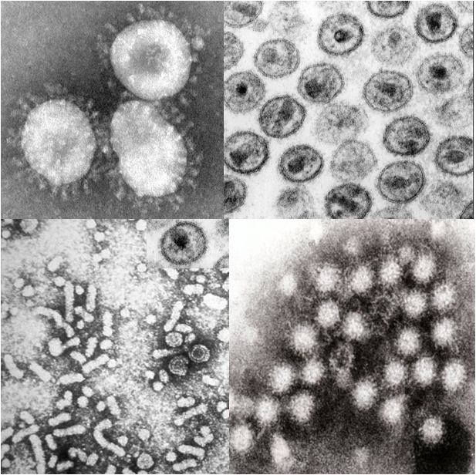
Version 13, March 2019, Q-pulse MAN-Q-037

West of Scotland Specialist Virology Centre User manual, Q-pulse document MAN-Q-037 version 13

Document prepared by Dr Samantha Shepherd and Ms Sally Taylor on behalf of the West of Scotland Specialist Virology Clinical Group
Authorised by Dr Rory Gunson, Consultant Clinical Scientist and Virology Clinical Lead/Laboratory director

Pictures on the front: coronavirus (https://en.wikipedia.org/wiki/Coronavirus#/media/File:Coronaviruses_004_lores.jpg), HIV (https://emedicine.medscape.com/article/211316-overview), norovirus (https://www.norovirus.com/wp-content/uploads/2014/06/norovirus-e1403938112285.jpg) and HBV (https://upload.wikimedia.org/wikipedia/commons/1/12/Hepatitis-B_virions.jpg)

Table of Contents

Content | Page
West of Scotland Specialist Virology Centre introduction | 4
Laboratory location | 5
Laboratory delivery details | 6
Working hours | 7
Contact details | 7
Urgent and on-call requests | 7
Staff contacts – main laboratory staff | 8
Staff contacts – senior clinical team | 9
Request forms and specimen criteria | 10
How to transport specimens to the laboratory | 11
Specimen containers accepted at WoSSVC | 13
Symptoms and specimens used for diagnosis | 16
Investigations available at WoSSVC and turnaround times | 22
User access to results | 28
Requesting additional tests | 28
Retention of specimens | 29
Laboratory policy on protection of personal information | 29
Feedback | 29
Quality assurance and variability | 30
Kits supplied by the laboratory | 31
Referral to reference laboratories | 32

West of Scotland Specialist Virology Centre
The West of Scotland Specialist Virology Centre (WoSSVC) forms part of the acute division service within NHS Greater Glasgow and Clyde (NHS GGC).
The WoSSVC provides virology services (diagnostic, clinical, educational) for the whole of the Greater Glasgow region. We are also a referral laboratory for the west of Scotland and for regions out with the west of Scotland.
The West of Scotland Specialist Virology Centre is UKAS accredited to ISO 15189:2012 - Reference number 9319
We have extensive experience in the diagnosis of viral pathogens using a range of commercial and in-house serological and molecular based assays. We have a high throughput serological laboratory offering tests on both BBV and non-BBV pathogens. We also offer serological diagnosis on syphilis. We are one of only two laboratories in Scotland to offer HIV avidity testing. Molecular testing can be performed on respiratory specimens, blood, stool and CSF. We offer Bordetella pertussis, Mycoplasma pneumoniae and Aspergillus fumigatus diagnosis through real-time PCR. We also provide BBV testing of dried blood spots for community addiction teams, prison service and pharmacies.
National laboratory responsibilities:
- National Respiratory Virus Screening service
  - Annual surveillance of respiratory viruses, influenza typing and resistance testing
- Specialist Blood Borne Virus testing service for the West and North of Scotland
  - HIV resistance testing and subtyping
  - HBV resistance testing
  - HCV genotyping and resistance testing
  - HDV quantitative real-time PCR
- Avian Influenza and Middle East Respiratory Syndrome (MERS) coronavirus national testing centre for Scotland (except Lothian, Borders and Fife)
  - 24/7 testing service available
- Designated laboratory (in conjunction with PHE Birmingham) for confirmation of HBV DNA viral loads in healthcare workers who perform exposure prone procedures

Laboratory location

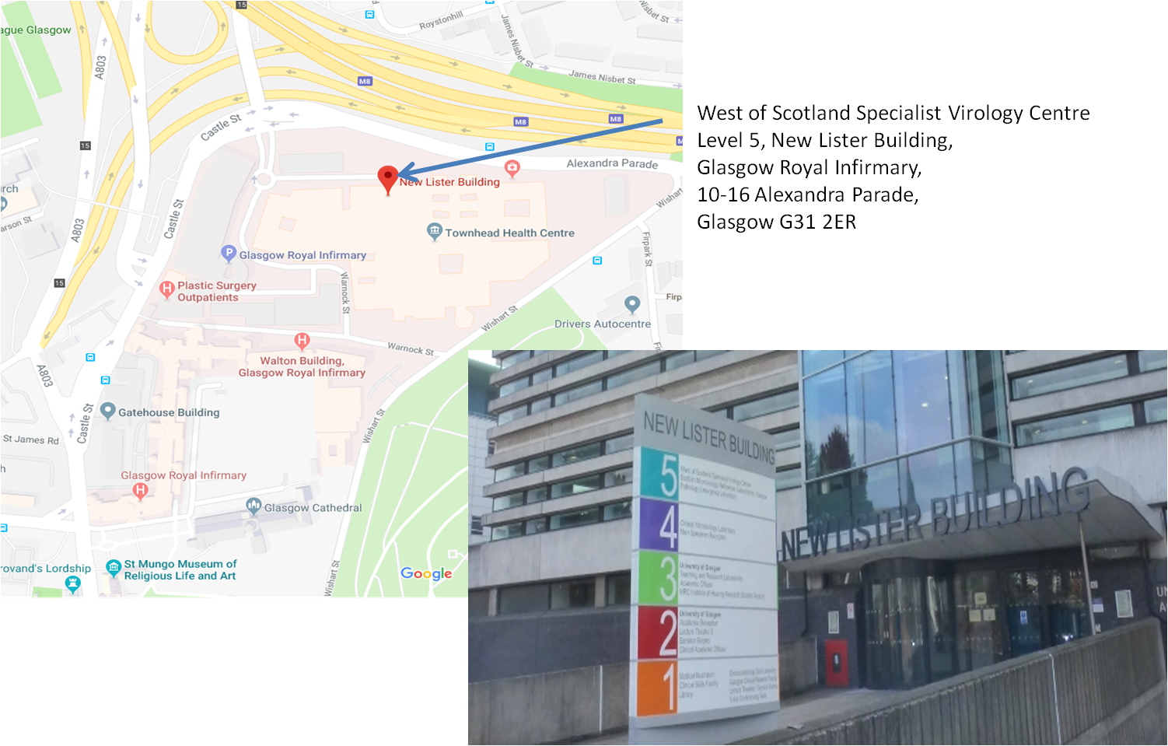The West of Scotland Specialist Virology Centre is located on Level 5 of the New Lister Building which is located on Alexandra Parade and forms part of the Glasgow Royal Infirmary complex. We share the 5th floor with the Scottish Microbiology Reference Laboratory.

Laboratory delivery details
Virology Reception (Level 5)
New Lister Building,
Glasgow Royal Infirmary
10-16 Alexandra Parade
Glasgow G31 2ER
Main Reception (Level 4)
New Lister Building,
Glasgow Royal Infirmary
10-16 Alexandra Parade
Glasgow G31 2ER

DX Address: West of Scotland Specialist Virology Centre
DX number:6491304, DX exchange: Glasgow 94G

Glasgow Royal Infirmary POD system number: 0605
Urgent samples out-of hours address
(Do not send to this address unless discussed with on-call staff).
Deliver specimen to the black box marked “microbiology and virology urgent samples drop box” which can be found in the door way of the:
Princess Royal Maternity (Emergency Entrance & drop-off)
Glasgow Royal Infirmary
Wishart Street
Glasgow G31 2HT
Glasgow G31 2HT

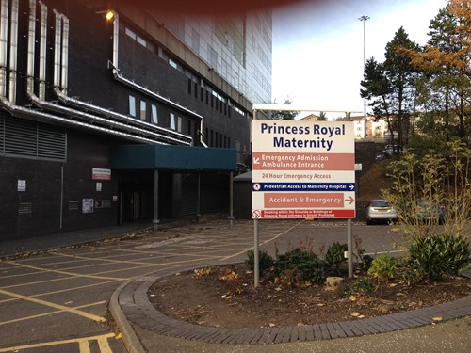
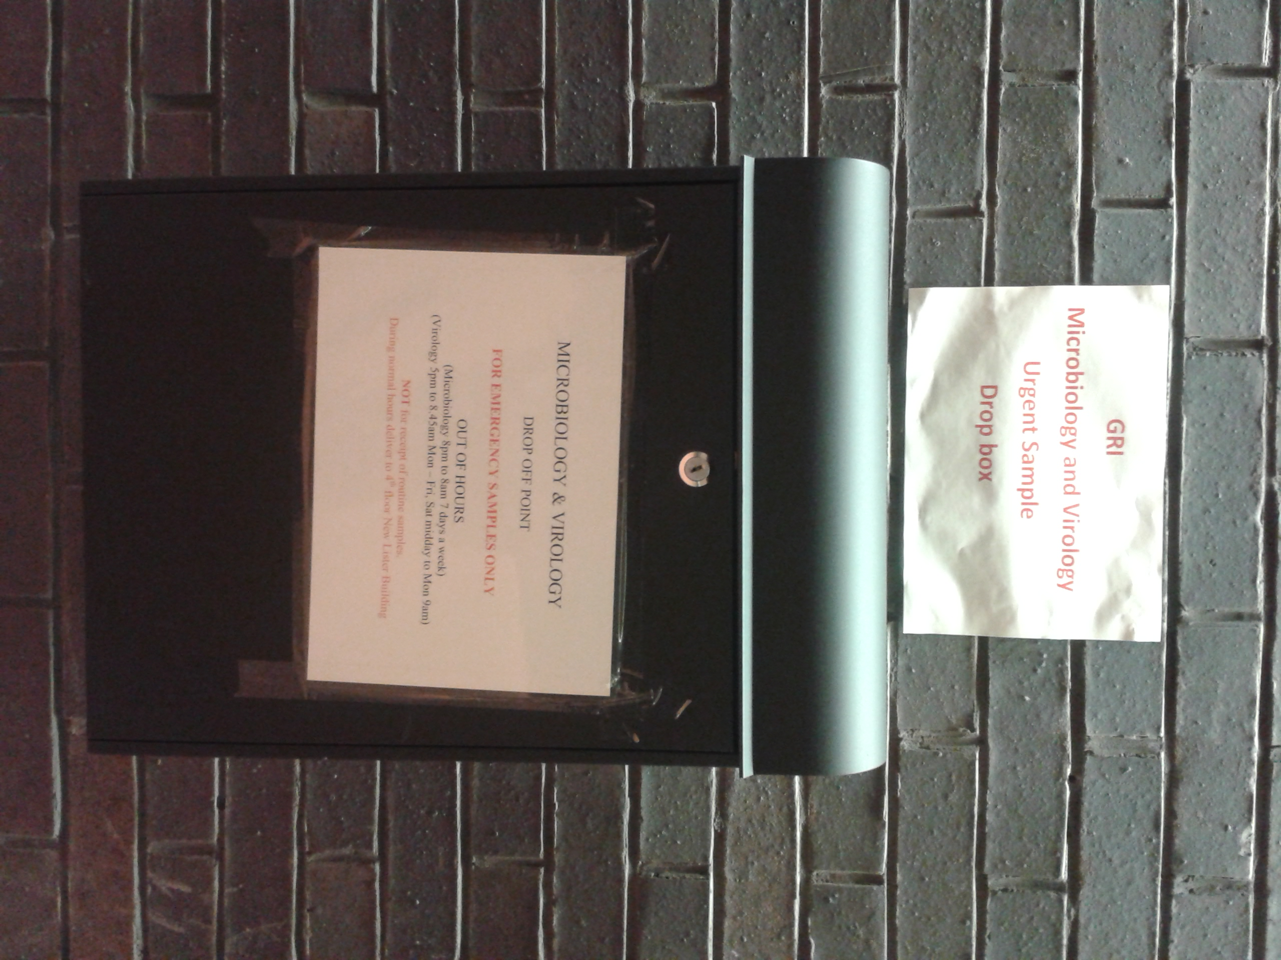

Working hours
Routine Opening hours
Monday to Friday: 0845 – 17:00
Saturday: 09:00 – 14:00
Sunday: 10:00 – 14:00
The laboratory offers an on-call service out with working hours/public holidays (see contact details below)
Contact details
Routine Opening times
General phone enquires and results: 0141 201 8722 (internal 38722)
Clinical advice and urgent testing: 0141 201 8721 (internal 38721) alternatively email west.ssvc@nhs.net (we aim to respond to your email within 1 hour)
To add on tests please email west.ssvc@nhs.net with clinical details and tests required
Results are available on clinical portal, SCI Store and TrakCare for GGC patients provided a patient CHI has been provided.

Out-of hours (after 5pm Monday – Friday / weekends / public holidays)
Out-of hours and weekends please contact the on-call service via the GRI switchboard (0141 211 4000)
Clinical advice (after 5pm Monday – Friday and weekends) is via the switchboard (0141 211 4000), this is a consultant lead service
Transplant co-ordinator should contact the on-call technical staff via the switchboard (0141 211 4000)
Urgent and on-call requests
A limited range of laboratory tests are available outside normal working hours, contact GRI switchboard (0141 211 4000) and ask to speak to the on-call virologist. Organ donor screening can be arranged directly with the duty Biomedical Scientist via the GRI switchboard (0141 211 4000).

Staff contacts – key laboratory staff
Mr Stephen Hughes HNC, HND, BA, FIBMS
Technical Services Manager email: Stephen.Hughes@ggc.scot.nhs.uk
Telephone: 0141 201 8744

Ms Ann Hawthorn BSc, PGdip, MSc
Site Lead email: Ann.Hawthorn@ggc.scot.nhs.uk
Telephone: 0141 201 8738

Ms Jane McOwan BSc(Hon), FIBMS
Integrated Systems Manager email: Jane.McOwan@ggc.scot.nhs.uk
Telephone: 0141 201 8739

Ms Christine Ritchie
Office manager email: Christine.Ritchie@ggc.scot.nhs.uk
Telephone: 0141 201 8725

Staff contacts – senior clinical team

Dr Rory Gunson BSc, MSc, PhD, FRCPath
Consultant Clinical Scientist email: Rory.Gunson@ggc.scot.nhs.uk
Clinical Lead Telephone: 0141 201 8737
Laboratory director
Head of Molecular Development and Specialist Typing

Dr Eleri Wilson-Davies MBBS, MSc, FRCPath
Consultant Medical Virologist email: Eleri.Davies@ggc.scot.nhs.uk
Telephone: 0141 201 8736
Dr Celia Jackson MBChB, MRCP, FRCPath
Consultant Infectious Disease email: Celia.Jackson@ggc.scot.nhs.uk
& Virology Telephone: 0141 201 8739

Dr Samantha Shepherd BSc(Hon), MSc, PhD, FRCPath
Consultant Clinical Scientist email: Samantha.Shepherd@ggc.scot.nhs.uk
Telephone: 0141 201 8734

Request forms and specimen criteria
Please note NHSGGC request forms are now produced by TrakCare, please refer to the website for further information on how to fill out TrakCare requests: http://www.nhsggc.org.uk/virology
The following request forms are available from the website (http://www.nhsggc.org.uk/virology):
- Manual WoSSVC generic request form
- WoSSVC Dried blood spot request form
- Hepatitis B DNA testing for healthcare workers (HCW) involved in exposure prone procedures (EPP)
Specimen essential information
Full name or unique coded identifier
Date of Birth and or CHI (Community Health Index) number

Request form essential information
Full name or unique coded identifier
Date of Birth and or CHI (Community Health Index) number
Investigation(s) required
Clearly marked clinical details (specimens will be stored if NO clinical details given)

Laboratory statement to users:
The laboratory aims to test all specimens within designated turn-around-times. In order for this to occur and the correct investigations to be chosen, we ask that all users fill out the required information clearly on the request forms and that the correct patient identifiers are present on both the specimen and the request form. We ask that specimens are packaged appropriately and are correctly sealed to prevent leakage in transit. For urgent testing please contact the laboratory in advance to arrange when a result can be available.

How to transport samples to the laboratory
NHSGGC GP collection service, interlab vans and couriers all deliver to the laboratory from: Queen Elizabeth University Hospital, Gartnavel General Hospital, Royal Alexandra Hospital, Inverclyde Royal Hospital, Sandyford Initiative, Monklands Hospital, Wishaw General Hospital, Hairmyres, Crosshouse and Dumfries & Galloway Royal Infirmary,

Specimens also arrive at the laboratory via Royal Mail post or DX collection (DX number 6491304, DX exchange Glasgow 94G).

Glasgow Royal Infirmary wards can send specimens via the POD system, number 0605

Specimens taken out with working hours of the laboratory should be kept in the fridge at 4ºC and sent to the laboratory on the following day.

Delivery address for the laboratory can be found on page 5-6 of this manual

All specimens should be packaged according to national and international regulations. Specimens are classified as Category A or Category B according to the micro-organisms they contain (or be reasonably expected to contain).

How to transport samples to the laboratory

Please refer to:
NHSGGC Transport and disposal of specimen containers and specimens policy:http://www.staffnet.ggc.scot.nhs.uk/Acute/Diagnostics/All%20Laboratory%20Medicine/Mortuary%20Services/SGPathology/Documents/Trans%20of%20Specimen%20Policy%20Oct%2016%20final.pdf
Transport of specimens guideline: http://www.nhsggc.org.uk/media/236255/guidance-transport-of-specimens.pdf
WHO guidance on regulations for the transport of infectious substances 2013-2014: http://www.nhsggc.org.uk/media/236255/guidance-transport-of-specimens.pdf
Instructions for DX packaging should be followed, refer to www.thedx.co.uk
Urgent sending of Middle East Respiratory Syndrome (MERs) coronavirus (CoV): Please contact the clinical team (0141 201 8721) before sending the samples. Urgent out of hours Mers-CoV testing please contact the switchboard (0141 211 4000) and ask to speak to the on-call virologist before sending any samples. There are UN3373 boxes marked specifically for MERS-CoV in various locations around NHSGGC which can fit in the laboratory out-of-hours urgent testing box. Further information can be found at:http://www.nhsggc.org.uk/your-health/infection-prevention-and-control/mers-cov-information-hub/

Specimen containers accepted at WoSSVC

Swabs ( for CT/NG testing please see page 15)
Swabs should be used in conjunction with Viral PCR Sample Solution (VPSS), which is available from the laboratory (see page 31). After the swab is taken it should be expressed on the side of the vial and discarded. The cap should be replaced tightly prior to being sent to the laboratory. Ensure the swab is NOT left in the sample container or the sample will NOT be tested. We prefer flocked swabs, if these are not available other sample types can be used, if unsure please contact the laboratory.
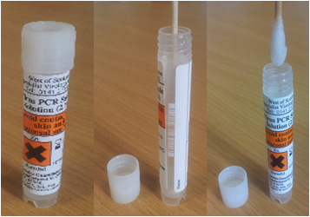
These swabs can be used in the following areas: Throat, nasal, eye, vesicle, ulcer, mouth and rectal.

Please place swabs into VPSS wherever possible, if you are unable to obtain VPSS prior to sending the sample then the laboratory will accept charcoal and amies swabs.

White top universal (sterile) containers
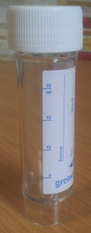Universal containers can be used for CSF, urine, gargles, sputum, bronchoalveolar lavage (BAL), aqueous humor, corneal scrapings, amniotic fluid, vomit, biopsy and post mortem tissue.
DO NOT send Boric acid containers with urine samples; these will be discarded by the laboratory.

Stool specimens can be sent in a white top universal; alternatively we accept stool sample pot containers (see below).
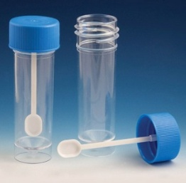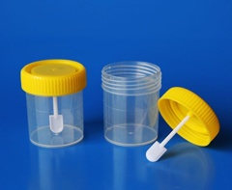

Specimen containers accepted at WoSSVC
Endotracheal secretions
Please ensure that the tubing has been removed from the specimen collection device and the lid has been firmly capped and fitted to prevent leakage. If the tubing is left in, the specimen will leak and the laboratory will discard the specimen.
Nasopharyngeal aspirates
Collect and send in the trap, make sure secure to prevent leakage

Blood samples
Most assays in our laboratory (both serological and molecular) use an EDTA blood.
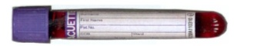Please send a single 9ml EDTA blood tube (5ml if paediatric or difficult to bleed, please note that this may be insufficient if confirmatory testing is required on the specimen).

Clotted blood can also be sent to the laboratory as an alternative , if EDTA blood tubes are not available. Clotted blood is also required for by some reference laboratories when a specimen needs to be sent away.

Procalcetonin testing
This is a consultant led request and is not availa ble in TrackCare or GPice. Same day testing is avaible if the samples arrive by 3pm (Monday-Friday) and by 12pm (weekends). Clotted blood or lithium heparin plasma ONLY should be sent.

Dried blood spot
The DBS sample is an alternative method of screening for HIV, HCV and HBV. Please ensure that all five spots on the card are fully saturated up to the dotted lines both on the front and back of the card. Insufficient saturated sample will result in the card being discarded.
Specimen containers accepted at WoSSVC
Abbott multi-collect specimen collection kit for Chlamydia trachomatis/Neisseria gonorrheae PCR ONLY
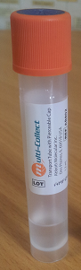Please make sure the swab remains within the container (only specimen sent to WoSSVC where this should happen)*.
Please follow the manufacturer’s instructions provided with the kit, this is a commercial assay and therefore all manufacturers’ guidelines on the appropriate way to take these samples should be followed.
Female: Vaginal swab (self-collected and clinician-collected)
Rectal swab*
Pharyngeal swab
DO NOT SENT URINE for WOMEN

Male: Urine – MUST BE SENT IN THE ABBOTT COLLECTION TUBE
Rectal swab*
Pharyngeal swab

*The rectal swabs should be removed from the Abbott multi-collection tube

QuantiFERON-TB Gold Plus Tubes:
The following tubes should be used:
1. QuantiFERON Nil Tubes (gray cap with white ring)
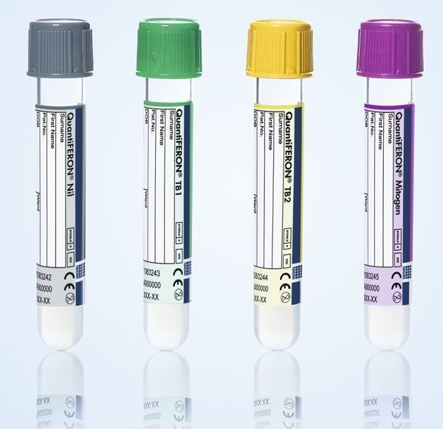2. QuantiFERON TB1 Tubes (green cap with white ring)
3. QuantiFERON TB2 Tubes (yellow cap with white ring)
4. QuantiFERON Mitogen Tubes (purple cap with white ring)
Each patient MUST have one of each tube type with the correct volume of blood present in each tube
TB Quantiferon Gold Plus tubes are ordered from the users’ local Microbiology department
Immediately after filling the tubes, invert them ten times just firmly enough to ensure that the entire inner surface of the tube is coated with blood, to dissolve antigens on tube walls. Once filled the blood tubes are required to reach the laboratory within 16hrs post collection.

Samples may arrive at the laboratory Monday to Friday up to 5pm.

 | Symptoms and specimens used for diagnosis |  | Specimens for testing  Please see pages 21 – 26 for the full range of tests available at WoSSVC and turn-around times
System involved/  clinical group | Clinical features | Common pathogens | Mouth swab / buccal swab | Throat swab | Gargle | NPA | Sputum / Induced sputum | ETA | BAL | CSF | Eye (swab), aqueous humor, corneal scrapings | DBS | EDTA | Clotted blood | Stool | Urine | Skin / vesicle swab | Biopsy
Respiratory | URTI/LRTI  (Adults & outpatient paediatrics) | Influenza (A&B), adenovirus, RSV, Mycoplasma pneumoniae |  | Any respiratory specimen  (one is enough)
 | URTI/LRTI  (Patients in ICU, critical care, immunocompromised or in-patient paediatrics) | Influenza (A&B), adenovirus, RSV, parainfluenza 1-4, coronavirus, rhinovirus/enterovirus human metapneumovirus, Mycoplasma pneumonia  Babies < 8 weeks test for Chlamydia trachomatis if clinically requested |  | Any respiratory specimen  (one is enough)
 | Travel related LRTI | Middle East Respiratory Syndrome (Mers-CoV) | A throat swab, lower respiratory tract specimen and a clotted blood are required for this investigation. Testing must be arranged with the laboratory. DO NOT send any specimens before contacting the laboratory.
 |  | Avian influenza | A throat swab and/or a lower respiratory sample (if possible) are required for this investigation. DO NOT send any specimens before contacting the laboratory.
 | Immunocompromised  (automatically full extended respiratory screen above) | Pneumocystis jirovecii / cytomegalovirus (CMV) |  |  |  |  | √ | √ | √
 |  | Aspergillus species and Aspergillus fumigatus |  |  |  |  |  |  | √ |  |  |  | √
 | Whooping cough | Bordetella pertussis |  | Any respiratory specimen  (one is enough)
 | Parotitis/Mumps | Mumps virus | √

Symptoms and specimens used for diagnosis

Specimens for testing
Please see pages 21 – 26 for the full range of tests available at WoSSVC and turn-around times
System involved / clinical group | Clinical features | Common pathogens | Mouth swab / buccal swab | Throat swab | Gargle | NPA | Sputum / Induced sputum | ETA | BAL | CSF | Eye swab, aqueous humor, corneal scrapings | DBS | EDTA | Clotted blood | Stool | Urine | Skin / vesicle swab | Biopsy
GI tract | Gastroenteritis | Norovirus |  |  |  |  |  |  |  |  |  |  |  |  | √  (also vomit)
 |  | Adenovirus, sapovirus, astrovirus, rotavirus  (children <10 years, immunosuppressed & outbreaks only) |  |  |  |  |  |  |  |  |  |  |  |  | √
 | Hepatitis | Hepatitis A (HAV), Hepatitis E (HEV) |  |  |  |  |  |  |  |  |  |  | √ |  | (√)  Available on request
 |  | Hepatitis B (HBV), Hepatitis C (HCV), Hepatitis D (HDV) |  |  |  |  |  |  |  |  |  | √  (not HDV) | √
 | Gastric ulcer | Helicobacter pylori |  |  |  |  |  |  |  |  |  |  |  | √
 | Crohns  (Pre-biologic screening) | Epstein barr virus (EBV), cytomegalovirus (CMV) |  |  |  |  |  |  |  |  |  |  | √
 | Crohns  (active colitis) | Epstein barr virus (EBV), cytomegalovirus (CMV) |  |  |  |  |  |  |  |  |  |  | √ |  |  |  |  | √

Symptoms and specimens used for diagnosis

Specimens for testing
Please see pages 21 – 26 for the full range of tests available at WoSSVC and turn-around times
System involved/ clinical group | Clinical features | Common pathogens | Mouth swab / buccal swab | Throat swab | Gargle | NPA | Sputum / induced sputum | ETA | BAL | CSF | Eye (swab), aqueous humor, corneal scrapings | DBS | EDTA | Clotted blood | Stool | Urine | Vesicle swab | Biopsy
Nervous system | Aseptic meningitis, encephalitis | HSV1, HSV2, VZV, Enterovirus/Parechovirus |  | (√)  Enterovirus  Parechovirus  only |  |  |  |  |  | √
 | Immunocompromised aseptic meningitis/encephalitis | HSV1, HSV2, VZV, Enterovirus/Parechovirus  HHV6, CMV, EBV, JCPyV |  | (√)  Enterovirus  Parechovirus  only |  |  |  |  |  | √
 | Progressive multifocal leukoencephalopathy (PML) | JCPyV (JC virus) |  |  |  |  |  |  |  | √
 | Ring enhancing regions | Toxoplasma gondii |  |  |  |  |  |  |  | √ |  |  | √
 | Guillian Barre Syndrome (GBS) | CMV, EBV, enterovirus |  |  |  |  |  |  |  | √
 | Transverse myelitis | HSV1, HSV2, VZV, CMV, EBV, enterovirus, mycoplasma |  | (√)  Enterovirus  Mycoplasma |  |  |  |  |  | √
 | MS, demyelination, parethesia and/or peripheral neuropathy | HSV1, HSV2, VZV, enterovirus |  | (√)  Enterovirus  only |  |  |  |  |  | √
 | Febrile Convulsions | HSV1, HSV2, VZV,  HHV6/HHV7  Enterovirus, influenza, lower respiratory tract infection |  | Any respiratory specimen  (one is enough) |  |  |  |  |  | √

Symptoms and specimens used for diagnosis

Specimens for testing
Please see pages 21 – 26 for the full range of tests available at WoSSVC and turn-around times
System involved/ clinical group | Clinical features | Common pathogens | Mouth swab / buccal swab | Throat swab | Gargle | NPA | Sputum / induced sputum | ETA | BAL | CSF | Eye (swab), aqueous humor, corneal scrapings | DBS | EDTA |  | Clotted blood |  | Stool |  |  | Urine |  | Vesicle swab | Biopsy
Sexually transmitted diseases/ GUM clinic | Vaginal discharge, pain on urination, lower abdominal pain, urethritis, fever | Chlamydia trachomatis  Neisseria gonorrheae | Specimens should be collected in Abbott multi-collect specimen collection kit devices  (refer to page 15 of the user manual)
 | Vesicles/ulcers | Syphilis |  |  |  |  |  |  |  |  |  |  |  | √ |  |  |  |  |  |  | √
 |  | HSV1 and HSV2 |  |  |  |  |  |  |  |  |  |  |  |  |  |  |  |  |  |  | √
 | Blood borne virus infection | HIV-1, HIV-2, HBV, HCV, HTLV-1/HTLV-2 |  |  |  |  |  |  |  |  |  | √  (not HTLV) |  | √
Ophthalmic | Conjunctivitis, keratitis, uveitis, ARN, PORN | Adenovirus, HSV, VZV, Chlamydia trachomatis |  |  |  |  |  |  |  |  | √
Transplant | Pre-transplant Donor/Recipient screen (exact tests depend on transplant) | HIV-1/HIV-2, HBV, HCV, HTLV-1/HTLV-2, HEV, CMV, EBV, VZV, HSV, Syphilis, Toxoplasma gondii |  |  |  |  |  |  |  |  |  |  |  | √
 | Post-transplant surveillance and diagnosis | CMV, EBV, adenovirus, HBV, HEV, HSV, VZV |  |  |  |  |  |  |  |  |  |  |  | √
 | Haemorrhagic cystitis | BKPyV, JCPyV |  |  |  |  |  |  |  |  |  |  |  | √ |  |  |  |  | √

Symptoms and specimens used for diagnosis
Specimens for testing
Please see pages 21 – 26 for the full range of tests available at WoSSVC and turn-around times

System involved/  clinical group | Clinical features | Common pathogens | Mouth swab / buccal swab | Throat swab | Gargle | NPA | Sputum / induced sputum | ETA | BAL | CSF | Eye (swab), aqueous humor, corneal scrapings | DBS | EDTA | Clotted blood | Stool | Urine | Skin/ Vesicle swab | Biopsy
Haematological | Thrombocytopenia | CMV, EBV, B19 |  |  |  |  |  |  |  |  |  |  | √
 | Atypical lymphocytes | EBV, CMV , HIV |  |  |  |  |  |  |  |  |  |  | √
 | Henoch-Schonleinpurpura | Mycoplasma pneumonia |  | Any respiratory specimen  (one is enough)
 | Persistent anaemia | CMV, EBV, B19, HIV |  |  |  |  |  |  |  |  |  |  | √
Skin and mucosa | Maculopapular / erythematous | B19, CMV, EBV |  |  |  |  |  |  |  |  |  |  | √
 |  | Enterovirus, HHV6, HHV7, measles, rubella | √ | √
 | Vesicular | HSV1, HSV2, VZV, Enterovirus |  |  |  |  |  |  |  |  |  |  |  |  |  |  | √
 | Erythema mutliforme/Steven Johnson syndrome | HSV, CMV, EBV |  |  |  |  |  |  |  |  |  |  | √ |  |  |  | √
 |  | Mycoplasma pneumoniae |  | Any respiratory specimen  (one is enough)
 | Mouth ulcers | HSV, enterovirus |  |  |  |  |  |  |  |  |  |  |  |  |  |  | √
Systemic | Sepsis | Procalcitonin  (Consultant lead request) |  |  |  |  |  |  |  |  |  |  |  | √
 | Fulminant hepatitis | HBV |  |  |  |  |  |  |  |  |  |  | √
 | Lymphadenopathy | EBV, CMV, Toxoplasma gondii, HIV-1, HIV-2 |  |  |  |  |  |  |  |  |  |  | √
Symptoms and specimens used for diagnosis
Specimens for testing
Please see pages 21 – 26 for the full range of tests available at WoSSVC and turn-around times

System involved/  clinical group | Clinical features | Common pathogens | Mouth swab / buccal swab | Throat swab | Gargle | NPA | Sputum / induced sputum | ETA | BAL | CSF | Eye (swab), aqueous humor, corneal scrapings | DBS | EDTA | Clotted blood | Stool | Urine | Skin/ Vesicle swab | Biopsy
Pregnancy | Antenatal screen | HIV-1, HIV-2, HBV, syphilis |  |  |  |  |  |  |  |  |  |  | √
 | Fetal abnormalities on scan, intrauterine death | CMV, B19, Toxoplasma gondii, VZV, rubella (rare) |  |  |  |  |  |  |  |  |  |  | √
 | Maternal rash | B19, measles, rubella, Enterovirus, HSV1, HSV2, VZV |  | √ |  |  |  |  |  |  |  |  | √ |  |  |  | √
 | Maternal exposure to rash | VZV, B19, measles, rubella (rare) |  |  |  |  |  |  |  |  |  |  | √
Neonatal | Congenital CMV  (samples >21 days may be postnatally acquired CMV) | CMV |  | √ |  |  |  |  |  |  |  |  |  |  |  | √
 | Maternal HSV infection  (Discuss with the laboratory prior to sending specimens) | HSV |  | √ |  |  |  |  |  | √ | √ |  | √ |  |  |  | √  (rectal & skin swab)
 | Maternal HIV | HIV-1, HIV-2 |  |  |  |  |  |  |  |  |  |  | √
 | Septic baby | Enterovirus, parechovirus |  | √ |  |  |  |  |  | √ |  |  | √
 | Conjugated bilirubinemia | CMV, HSV, Toxoplasma gondii, syphilis, Enterovirus (rare), rubella (rare) |  | √ |  |  |  |  |  |  |  |  | √ |  |  | √

Investigations available at WoSSVC
Recent/current infections can use both serology and/or molecular techniques, depending on the pathogen. Past exposure/immunity requires serology testing only.
Please see “specimen containers accepted at WoSSVC” on page 12, for specimen types accepted at WoSSVC.
Amount of specimen required will depend on the number of investigations requested for that specimen.
In general the following rules apply:
Specimen | Amount
Clotted blood | 6ml
CSF | ≥0.2ml
Dried Blood Spot (DBS) | 5 spots fully saturated back and front
EDTA blood | 5ml or 9ml
Plasma aliquot | 0.5 -1 ml (1000μl required for molecular)
Serum aliquot | 0.5 -1 ml (1000μl required for molecular)
Respiratory specimen | 1ml

Turn-around-times are cited below next to each test, please contact the clinical team on 0141 201 8721 (internal 38721) if urgent testing is required. Turn-around-times cited are based on the number of working days.

Investigations available at WoSSVC
Hepatitis Viruses | Test | Specimen type | Turnaround time (days)
Hepatitis A  (HAV) | HAV IgM | EDTA | 1-3
 | HAV IgG | EDTA | 1-3
 | HAV PCR | EDTA  Stool | 3-7
Hepatitis B  (HBV) | HBsAg | EDTA  DBS | 1-3
 | HBsAg neutralisation | EDTA  DBS | 1-4
 | HBsAg quantification | EDTA | 1-3
 | HBcore IgM | EDTA | 1-4
 | HBcore IgG | EDTA  DBS | 1-4
 | Anti-HBs | EDTA | 1-3
 | HBV DNA PCR | EDTA | 3-7#
 | HBV resistance testing  (not routine test) | EDTA | 12
Hepatitis C  (HCV) | Antibody | EDTA  DBS | 1-3  3-7
 | Antigen | EDTA | 1-3
 | HCV RNA detection/quantification (viral load) | EDTA  DBS | 3-7
 | HCV genotyping | EDTA/clotted blood | 12
 | HCV resistance testing  (not routine test, available on request) | EDTA/clotted blood | 12
Hepatitis D (HDV) | RNA detection/quantification | EDTA | 12
Hepatitis E (HEV) | Antibody (IgM / IgG) | EDTA | 5-10
 | HEV qualitative PCR | EDTA  Stool | 3-7
Retroviruses
HIV-1/ HIV-2 | HIV screen (antigen/antibody) | EDTA  DBS | 1-2
 | HIV-1/2 antibody differentiation | EDTA  DBS | 1-2
 | HIV-1 avidity | EDTA | 14
 | HIV-1 RNA quantification (viral load) | EDTA | 3-7
 | HIV-1 resistance testing | EDTA/clotted blood | 12
 | HIV-1 subtyping | EDTA/clotted blood | 12
 | CCR5 tropism | EDTA* | 12
HTLV-1/ HTLV-2 | Antibody | EDTA | 1-3
# HBV DNA PCR testing in HCW samples, TRT within 3-7 days of any individual sample OR test 3-7 days once we have received two samples, if two samples are required.
*CCR 5 resistance testing varies as per HIV viral load, viral load >1000 copies/ml send at least 5 ml EDTA, viral load <1000 copies/ml send at least 2ml EDTA

Investigations available at WoSSVC
Herpesviruses | Test | Specimen | Turnaround time (days)
Cytomegalovirus (CMV) | Antibody IgG | EDTA | 1-4
 | Antibody IgM | EDTA | 1-4
 | IgG Avidity | EDTA | 1-4
 | DNA detection  (quantification available only on EDTA) | Amniotic fluid  BAL  CSF  EDTA  Throat swab  Urine  Biopsy | 1-3
Epstein Barr Virus (EBV) | Antibody IgG (VCA/EBNA) | EDTA | 1-4
 | Antibody IgM | EDTA | 1-4
 | DNA detection (quantification available only on EDTA) | CSF  EDTA  Biopsy | 1-3
Herpes simplex  (HSV1 & HSV2) | Antibody IgG | EDTA | 1-4
 | DNA detection | CSF  EDTA  Eye  Throat swab  Rectal swab  Skin swab  Vesicle swab  Biopsy | 1-3
Varicella Zoster (VZV) | Antibody IgG  (past immunity only) | EDTA  Clotted blood | 1-4
 | DNA detection | CSF  EDTA  Eye  Vesicle swab | 1-3
Human herpes virus 6 (HHV6) | DNA detection | CSF  EDTA  Throat swab | 1-3
Human herpes virus 7 (HHV7) | DNA detection | CSF  EDTA  Throat swab | 1-3

Investigations available at WoSSVC
Respiratory pathogens | Test | Specimen | Turnaround times (days)
Respiratory viruses  (Influenza (A and B), Adenovirus, RSV, parainfleunza 1-4, coronaviruses, rhinovirus/Enterovirus, human metapneumovirus | RNA detection  Influenza typing by PCR  Oseltamivir resistance (H1N1 only)  Influenza HA1 sequencing (surveillance only) | Any respiratory sample | 1-3
Middle East Respiratory Syndrome (MERS-CoV) | RNA detection | Nose/throat swab or NPA in VPSS  AND  Induced sputum or ETS or BAL  AND  Clotted blood | To be agreed with laboratory
Mycoplasma pneumoniae | DNA detection | Any respiratory sample | 1-3
Pneumocystis jirovecii (PCP) | DNA detection | ETS  Sputum  Induced sputum  BAL | 1-3
Bordatella pertussis | DNA detection | Any respiratory sample | 1-3
Aspergillus species and Aspergillus fumigatus | DNA detection | BAL  EDTA blood | 1-3
Cystic fibrosis screen  Pseudomonas aeruginosa  Burkholderia cepacia complex | DNA detection | Isolates only (Only available NHSGGC microbiology laboratories) | 1-4

Investigations available at WoSSVC
Gastroenteritis | Test | Specimen | Turnaround time (days)
Norovirus | RNA detection | Stool  Vomit | 1-3
Rotavirus  Adenovirus  Sapovirus  Astrovirus | RNA detection (multiplex PCR) | Stool | 1-3
Sexually transmitted pathogens
Syphilis | Screen (IgM/IgG combination)  Antibody IgM  RPR  TPPA  Syphilis line immunoassay  DNA detection | EDTA  Vesicle swab | 1-3 screen  2-7 for confirmation testing  1-3
HIV | See retrovirus section
HBV | See hepatitis virus section
HSV | See herpes virus section
Chlamydia trachomatis | Abbott multi-collect specimen collection kit for DNA detection | Vaginal swab  Rectal swab  Pharyngeal swab  Urine (men only) |  | 7
 | DNA detection | Eye swab in VPSS |  | 1-3
Neisseria gonorrheae | Abbott multi-collect specimen collection kit for DNA detection | Vaginal swab  Rectal swab  Pharyngeal swab  Urine (men only) |  | 7
 | DNA detection | Eye swab in VPSS |  | 1-3
Other pathogens
Enterovirus | RNA detection  (NO serology available) | CSF  EDTA  Stool  Throat swab  Vesicle swab |  | 1-3 for CSF  1-7all other samples
Parechovirus | RNA detection  (NO serology available) | CSF  EDTA  Stool  Throat swab  Vesicle swab |  | 1-3 for CSF  1-7 all other samples

Investigations available at WoSSVC
Other pathogens | Test | Specimen | Turnaround time (days)
JC Polyomavirus (JCPyV) | DNA detection | CSF | 1-3
BK Polyomavirus (BKPyV) | DNA detection | Urine  EDTA | 1-3
Adenovirus | DNA detection  (NO serology available)  Quantitation (viral load) available on EDTA (transplant ONLY) | Any respiratory sample  EDTA  Eye  Urine  Stool | 1-3
Measles | RNA detection | Mouth swab  Throat swab | 1-3
 | Past immunity IgG antibody | EDTA | 1-3
Mumps | RNA detection | Buccal swab  Mouth swab  Throat swab | 1-3
 | Past immunity IgG antibody | EDTA | 1-3
Rubella | RNA detection | Throat swab | 1-3
 | Past immunity IgG antibody (assisted conception ONLY) | EDTA | 1-4
Parvovirus B19 | Antibody IgG | EDTA | 1-7
 | Antibody IgM | EDTA | 1-7
 | DNA detection | Throat swab  Amniotic fluid  EDTA | 3
Toxoplasma | Antibody IgG | EDTA | 1-3
Procalcitonin | Peptide detection | Clotted blood  Lithium heparin plasma | 1-2
Helicobacter Pylori | Antibody IgG | Clotted blood  EDTA  Vacuette tube (5ml) | 5
Mycobacterium tuberculosis | QuantiFERON-TB Gold Plus | Quantiferon Nil  Quantiferon TB1  Quantiferon TB2  Quantiferon Mitogen | 5

User access to results
If a patient CHI is available, an electronic copy of the report will be found on Clinical Portal, SCI store and Track Care for all NHSGGC patients. This is the fastest way for results to be picked up is via Clinical Portal or SCI store.
Urgent results are communicated to the user in the manor agreed when the user called to arrange urgent testing – phone call, email or Clinical Portal/SCI Store.
All HIV new diagnosis, acute hepatitis B and acute hepatitis C are phoned to the requesting physician or sending laboratory. In NHSGGC these results are also phoned to public health (HBV and HCV) and the Sandyford clinical (HIV, HBV and acute HCV).
Health Protection Scotland (HPS) receive laboratory reports via ECOSS
Results can be emailed to users and laboratories using a secure NHS account.
Non-electronic reports are printed out and sent via the Royal Mail in envelopes marked confidential.
Users can call the laboratory 0141 201 8722 (internal 38722) to ask for results.
If users require interpretation of results, a member of the clinical team is always available to respond to queries, telephone 0141 201 8721 (internal 38721) or email west.ssvc@nhs.net Monday to Friday 9am to 5pm.

Requesting additional tests
To request additional tests, email west.ssvc@nhs.net with clinical details and investigations required. Please supply name and contact telephone/page number in case the clinical team need to discuss the request.
For urgent requests including varicella (chickenpox/shingles) and parvovirus B19 (“slapped cheek”) contacts in pregnancy telephone the laboratory (0141 201 8721) or email west.ssvc@nhs.net. Please supply the laboratory with the gestational age at time of contact, nature of exposure and date of contact.

Retention of specimens
Routine specimens are stored at -80ºC for six months and then discarded.
Specimens sent to the laboratory with no clinical information will be stored for 1 year.
Exceptions are:
Antenatal booking blood samples – stored for 2 years
Needlestick injury stored blood – stored for 2 years
If CT/GC specimens are rejected, the specimen is only stable for 14 days post collection, so testing will only be considered for processing if within this 2 week time period.

Laboratory policy on protection of personal information
The West of Scotland Specialist Virology Centre is part of NHSGGC. The laboratory complies with NHS Scotland information security policy when handling and processing personal data.
http://www.staffnet.ggc.scot.nhs.uk/Corporate%20Services/eHealth/PoliciesandProcedures

Feedback
The laboratory aims to provide a service for all users. If there are any complaints or positive feedback regarding an aspect of the laboratory service, contact the laboratory technical services manager (telephone: 0141 201 8744 or email: Stephen.Hughes@ggc.scot.nhs.uk). A user survey is also available on the laboratory web page (http://www.nhsggc.org.uk/about-us/professional-support-sites/microbiology/west-of-scotland-specialist-virology-centre/)
All positive and negative feedback is stored within the laboratory quality management system.

Quality assurance and variability
WoSSVC is UKAS accredited to ISO 15189:2012 - Reference number 9319. The full scope of accredited tests offered is available on the UKAS website http://www.ukas.com. Any tests reported by the laboratory which are NOT on this scope are clearly identified as such on the report. The laboratory has a quality management system in place to direct and control the laboratory with regard to quality. The laboratory participates in external quality assurance schemes including Quality Control for Molecular Diagnostics (QCMD) and UK National External Quality Assessment Scheme (NEQAS).
There are various factors which can influence testing within the laboratory leading to the factors which can result in random errors. Uncertainty of measurement provides quantitative estimates of the level of confidence that a laboratory has in its analytical precision of test results and therefore represents the expected variability in a laboratory result if the test is repeated a second time. The uncertainty of measurement has been implemented for BBV and serology testing. Internal controls and negative/positive controls are run with all molecular tests

To ensure the highest quality of testing please ensure:
- Whole blood arrives in the laboratory within 3 days of being taken
- The blood specimens are NOT haemolysed or hyperlipaemic
- DBS should arrive in the laboratory within 14 days of being taken
- Herparinised specimens should not be sent for molecular testing
- The specimens are not leaking
- Appropriate specimen is taken for the appropriate test

Kits supplied by the laboratory
DBS kits are available from the WoSSVC by emailing west.ssvc@nhs.net. When requesting the order make sure to include the name and address of where the kits are to be sent and the number of kits required. Please indicate if Freepost labels are required.

VPSS – phone specimen reception (0141 201 8742) or email west.ssvc@nhs.net

Abbott multi-collect specimen collection kit for Chlamydia trachomatis/Neisseria gonorrheae NAAT testing, phone specimen reception (0141 201 8742)

Referral to other laboratories
Users may request investigations which are not in the repertoire of WoSSVC and these will be sent to appropriate reference laboratory. Alternatively, WoSSVC may send samples to reference laboratories for confirmation of results.
Reference Laboratory | Testing
PHE Virus Reference Department (VRD), Colindale | Main tests sent from WoSSVC are:  HSV resistance testing  Intrathecal antibody testing (HSV, VZV, JC, measles)  Confirmation of avian influenza (H5, H7 & H9)  HHV8 PCR  JC polyomavirus antibody and tissue PCR  ORF and Molluscum contagiosum  Please refer to VRD website for VRD manual and appropriate forms to fill out and samples to send. Please ensure that the VRD form as well as a TrackCare or manual WoSSVC form are both filled out, send the specimens and both forms to WoSSVC  https://www.gov.uk/government/collections/virus-reference-department-vrd
Diagnostic Virology Barts Health NHS Trust | HIV-2 RNA viral load (EDTA blood)
Regional Antimicrobial Laboratory, Bristol | Therapeutic drug monitoring:  Aciclovir  Ganciclovir
Animal and Plant Health Agency (APHA) | Rabies antibody titres (clotted blood)
Rare Imported Pathogens Laboratory (RIPL), Porton Down | RIPL offer a wide range of tests on imported fevers, including haemorrhagic fever, arboviruses and bacterial infections including anthrax, riskettsiae, leptospirosis and Q-fever.  Routine tests are run in regional and symptomatic panels. For the most up-to-date list of pathogens tested for please see (https://www.gov.uk/government/collections/rare-and-imported-pathogens-laboratory-ripl)  Please refer to RIPL website for RIPL manual and appropriate forms to fill out. Please ensure that the RIPL form as well as a TrackCare or manual WoSSVC form are both filled out, send the specimens and both forms to WoSSVC
Referral to other laboratories

Reference Laboratory | Testing
Manchester Medical Microbiology Partnership (MMMP), Clinical Sciences Centre, Manchester Royal Infirmary | HSV 1 & 2 type specific antibody  http://www.cmft.nhs.uk/info-for-health-professionals/laboratory-medicine/manchester-medical-microbiology-partnership/how-to-complete-the-request-form/virology-request-forms
Scottish National Blood Transfusion, Herriot Watt University | HTLV 1/2 confirmation
PHE West Midlands, Birmingham | HBV testing in HCW  HIV-2 resistance testing  CMV resistance testing
Lab 21 Ltd, Cambridge | HIV therapeutic drug monitoring
The National Creutzfeldt-Jakob & Surveillance Unit | Please contact WoSSVC prior to sending any samples (https://www.cjd.ed.ac.uk/)
SBSTIRL Microbiology Department, Edinburgh Royal Infirmary | Lymphogranuloma venereum (LGV) testing  Neisseria gonorrheae confirmation
Scottish Human Papillomavirus Reference Laboratory (SHPVRL), Edinburgh Royal Infirmary | Please refer to the SHPVRL website for contact information and appropriate request forms (http://www.edinburghlabmed.co.uk/Specialities/reflab/hpv/Pages/default.aspx)
Scottish National Viral Haemorrhagic Fever Test Service, Royal Infirmary Edinburgh | Please contact RIE directly regarding urgent testing: Ebola, Lassa fever, Marburg, Crimean-Congo haemorrhagic fever virus.  https://www.hps.scot.nhs.uk/reflab/SNVTS.aspx

