, and innovation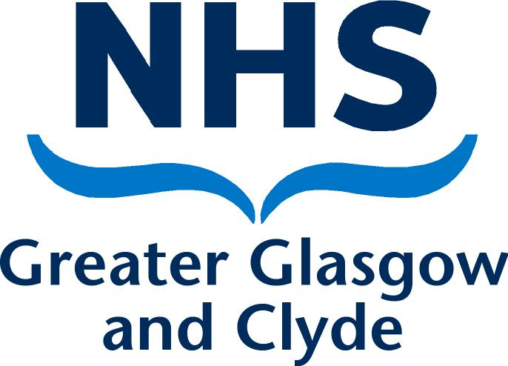

Staff guide

Fairwarning

2

What is Fairwarning?

Fairwarning® is privacy detection software which has being rolled out across NHSScotland to strengthen existing surveillance and detection capabilities on electronic records.

The nature of healthcare is that NHS staff encounter information which is both confidential and sensitive in nature on a daily basis. For the majority of staff, this will be a legitimate requirement of their job function. However, it is a requirement of the organisation to ensure that adequate measures are taken to prevent breaches of confidentiality through inappropriate access. This is in line with Information Governance security practices and standards and as part of the professional and/or contractual obligations upon NHSScotland staff.

The Fairwarning® software will allow us to identify more easily those individuals who inappropriately access electronic clinical information by auditing staff access on a daily basis.

What does it mean for me?

If you are accessing electronic clinical information as a genuine part of your job then nothing will change. Electronic systems provide many benefits for us in terms of accessing clinical information in a quick and simple way, and we want to continue this usage.

Fairwarning® will allow us to identify individuals who are looking at records of patients for whom there is no valid requirement. Examples of inappropriate access can include looking at:

- Your own clinical information;
- Family/ friends/ colleagues information;
- High profile/celebrity information; or
- Neighbours’ information.

3

What happens if I inappropriately access records?

If you are flagged as having potentially inappropriately accessed an electronic record, an alert will be sent to your line manager asking them to investigate why this access may have occurred. If there is a legitimate explanation for access, no further action will be taken.

If, however, the record is found to be accessed inappropriately, then a more formal discussion between the member of staff and manager will take place and depending on the severity of the breach, there could be a number of consequences:

- Sent for refresher training on confidentiality;
- Management discussion re access to records formally documented and stored in your personnel file;
- Formal investigation/action under the Board’s Disciplinary Policy
- Termination of employment;
- Report to the Information Commissioner’s Office.

All cases will be looked at on a case by case basis by the Line Manager with input from Human Resources to decide what steps may be appropriate. Further advice will be sought from the Information Governance Manager if required.

What support is there for staff?

If you are unsure what your responsibilities are around patient confidentiality or use of IT systems, you can:
- Read the Information Governance policies on StaffNet;
- Seek guidance from your professional body e.g., General Medical Council or Nursing and Midwifery Council;
- Contact the Data Protection Advisor for informal advice on 0141 355 2059 or by email to: Data.protection@ggc.scot.nhs.uk;

Complete training available via Learn Pro (Safe Information Handling module) or attend the Statutory/Mandatory Acute Training Programme;
- Read the communications available via Staffnet on updates with Fairwarning.
- The IG Dept. will be happy to deliver face to face training for departments.

