

**Health And wellbeing curriculum**

**SUBSTANCE MISUSE**

**PSE PACK**

**SECONDARY EDUCATION PACK**

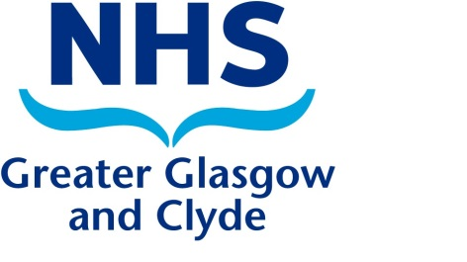

Pack developed by The Greater Glasgow & Clyde Substance Misuse Education Working Group 2018

Based on original pack by East Dunbartonshire Council

|  |  |
| --- | --- |
| **S5 LESSONS** | **Learning Outcomes** |
| Learner Activity 1 – **Alcohol and Advertising** | * Become more aware of the ways that alcohol is advertised and targeted at young people |
| Learner Activity 2 – **Trouble in Town** | * Examined local drug problems and consider the impact they have on the local community |
| Learner Activity 3 – **Alcohol and Drugs – What do you think?** | * Shared, and clarified, attitudes towards drug-related issues. * Examined their own attitudes towards the use of alcohol and drugs. * Checked out what other young people's attitudes are. * Challenged certain attitudes towards the use of alcohol. |
| Learner Activity 4 – **Scott’s Story – Cannabis and Driving** | * How to recognise if someone has a substance use problem * What the terms substance use and misuse mean * What to do if someone they know has a substance use problem and where help can be accessed * The impact of substance use and the law nationally and internationally |



**SUBSTANCE MISUSE PSE PACK**



|  |  |
| --- | --- |
| * For more information on drugs discussed, effects, risks and legal status please refer to: | **Know the Score**  [**http://knowthescore.info/drugs-a-z/**](http://knowthescore.info/drugs-a-z/) |
| * Information about alcohol, its associated harm and how it affects different sections of society as well as briefings on key alcohol issues e.g. minimum pricing and licensing | **Alcohol Focus Scotland**  [**http://www.alcohol-focus-scotland.org.uk/**](http://www.alcohol-focus-scotland.org.uk/) |
| * A suite of positive digital resources designed to support young people to use the internet, social media and mobile technologies to improve their mental health and wellbeing | **Aye Mind**  [**http://ayemind.com/**](http://ayemind.com/) |
| * Contains information, advice and facts about drugs, alcohol, tobacco and online safety | [**Choices for life**](https://young.scot/choices-for-life/)  [**https://young.scot/choices-for-life/**](https://young.scot/choices-for-life/) |
| * NHS Greater Glasgow & Clyde service with specialist support for schools and youth organisations | **Quit Your Way**  [**http://www.nhsggc.org.uk/your-health/healthy-living/smokefree/quit-your-way/**](http://www.nhsggc.org.uk/your-health/healthy-living/smokefree/quit-your-way/) |
| * Factual information and up-to-date advice on drugs, and a range of issues relating to substance use and misuse | [**Talk to Frank**](http://www.talktofrank.com/)  [**http://www.talktofrank.com/**](http://www.talktofrank.com/) |
| * Youth work essentials addressing tobacco prevention issues developed by Ash Scotland and Youth Scotland | [**Tobacco Free Generation**](http://www.youthworkessentials.org/youth-tobacco.aspx)  [**http://www.youthworkessentials.org/tobacco-free-generation.aspx**](http://www.youthworkessentials.org/tobacco-free-generation.aspx) |



**WHERE TO GO FOR FURTHER SUPPORT**

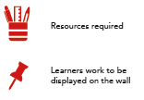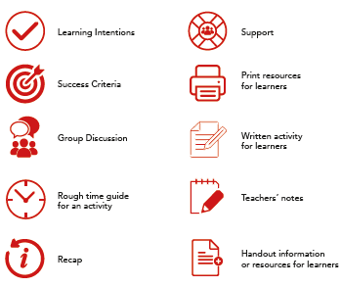

**ICON GUIDE**

**ALCOHOL AND ADVERTISING – LEARNER ACTIVITY 1**

# Part 1:

* Ask the young people to discuss what alcohol advertising they are aware of (e.g. packaging, social media, television, celebrity endorsement, sponsorship of sports, music and cultural events, and across digital platforms and the internet, including social media.)
* Split the class into small groups and ask them to discuss the adverts on the worksheet “The Power of Advertising”:
* Which of these alcohol related products would appeal mostly to adults?
* Which ones would appeal mostly to kids and teens?
* How can you tell?
* Ask the young people to describe what influence they feel advertising has over the choices they make.
* Young people who start drinking alcohol are affected by a range of influences. What other influences can the young people identify? (e.g. friends, family, celebrities, sports personalities, characters in TV programs etc.

# Part 2:

* Distribute copies of News Article “Child alcohol awareness”
* Divide the class into two groups and ask them to debate the pros and cons of having stricter advertising legislation in this country

**Key Messages**

* There are many varied and clever methods of advertising alcohol.
* It is useful to be aware of the fact that alcohol companies use advertising to target and attract young people, men and women to particular drinks.

[](https://www.coloribus.com/adsarchive/prints/budweiser-over-head-5608355/)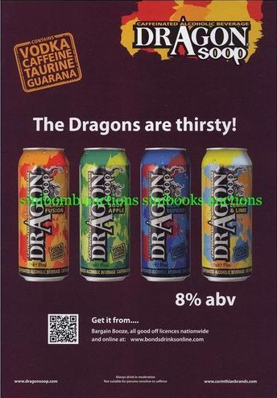**the power of ADVERTISING – pArt 1**[](https://www.google.co.uk/url?sa=i&rct=j&q=&esrc=s&source=images&cd=&cad=rja&uact=8&ved=0ahUKEwiMpcGo_MrYAhXJVhQKHUFlDLYQjRwIBw&url=https://www.youtube.com/watch?v=ARX45NZI5P4&psig=AOvVaw1aEoMDQogWamkyrcFbTPU4&ust=1515590379581748)[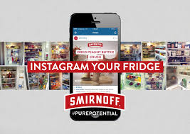](https://www.google.co.uk/imgres?imgurl=https://files1.coloribus.com/files/adsarchive/part_2270/22706260/file/smirnoff-smirnoff-pure-potential-image-3-2000-17692.jpg&imgrefurl=https://www.coloribus.com/adsarchive/online/smirnoff-smirnoff-pure-potential-image-3-21794560/&docid=4N4a4TgE4xAgKM&tbnid=vnyxMlY0Jvp-gM:&vet=10ahUKEwixieim8crYAhXCwxQKHfYoAb0QMwjVAShFMEU..i&w=3000&h=2121&bih=981&biw=1347&q=smirnoff%20advert&ved=0ahUKEwixieim8crYAhXCwxQKHfYoAb0QMwjVAShFMEU&iact=mrc&uact=8)

**OR**

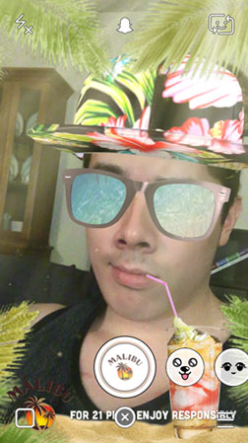****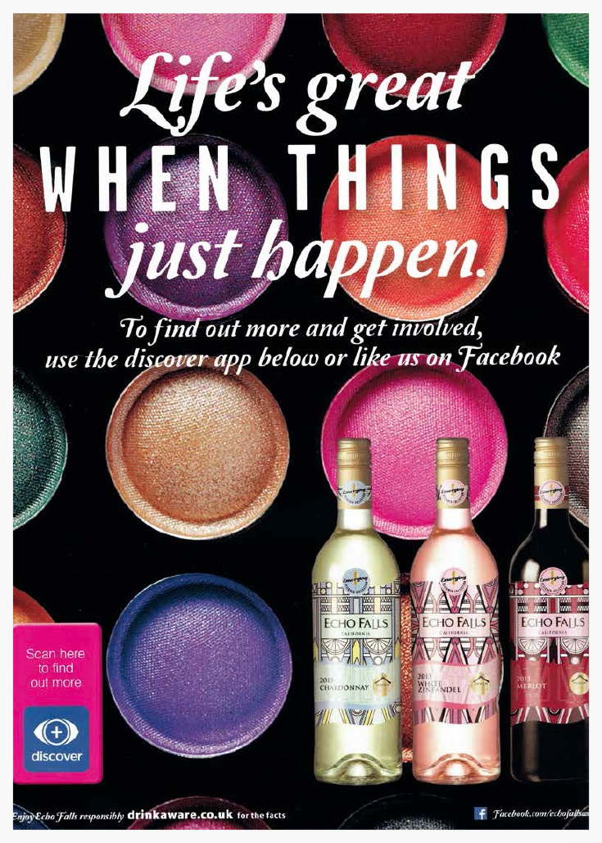[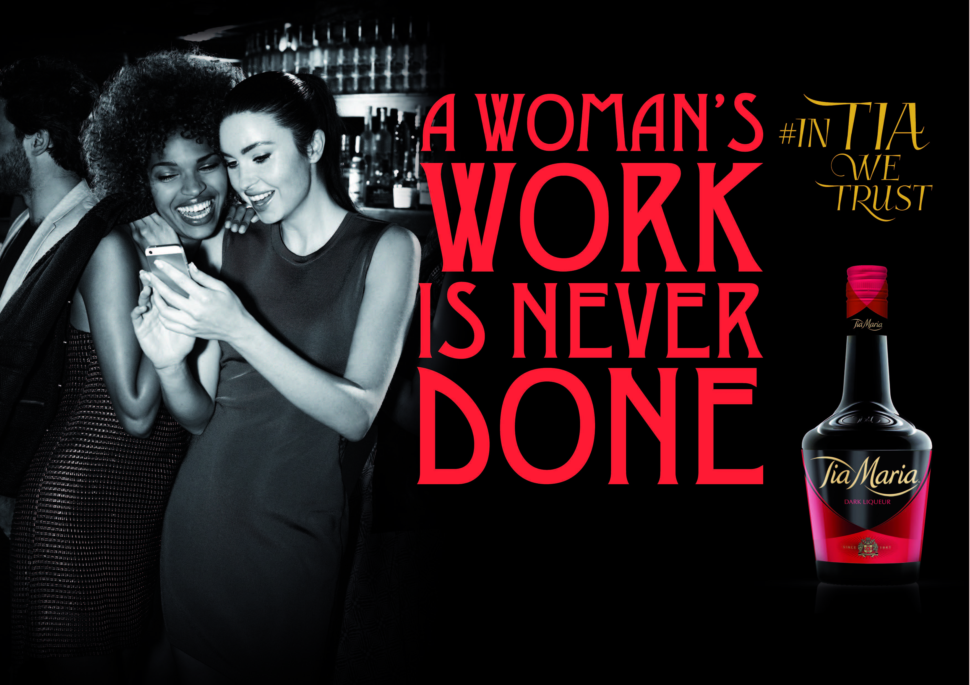](http://www.google.co.uk/url?sa=i&rct=j&q=&esrc=s&source=images&cd=&cad=rja&uact=8&ved=0ahUKEwiQ4LGK_MrYAhWCOhQKHcMQBL4QjRwIBw&url=http://www.nevsmodels.co.uk/news/tia-maria-campaign-starring-emma-miller&psig=AOvVaw2tB4iE6jFpMzRiYmT0bKaZ&ust=1515590309103459)

**Part 2: News Article**

** Tue 10 Jan 2017 15.38 GMT**

**Public health experts call for ban on alcohol advertising in UK**

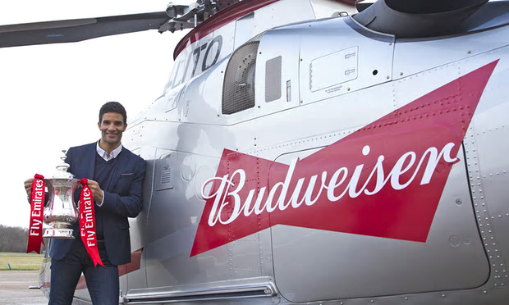**Global study claims industry’s marketing methods are encouraging young people to drink and often breach codes of practice**

Budweiser is the official beer of the FA Cup. Experts said alcohol marketing was evading statutory limits, particularly through endorsement of sporting events.

*Photograph: Henry Browne/Rex/Shutterstock*

Public health experts have called for a ban on alcohol advertising in the UK in light of new research that claims the industry’s marketing practices encourage young people to drink.

Studies into the impact of alcohol advertising around the world found that marketing practices often seemed to breach the industry’s own voluntary codes of practice, which in any case were not sufficient to protect children.

“It is clear that self-regulation is not working and we welcome calls for greater action from governments to protect children from exposure to alcohol marketing,” said Prof Sir Ian Gilmore, chair of the [Alcohol Health Alliance](http://ahauk.org/) (AHA), an umbrella group of more than 40 UK health NGOs, including the Academy of Medical Royal Colleges.

“We know that alcohol marketing contains content and messages that appeal to children, and that due to exposure to this advertising, children drink more, and start drinking at an earlier age.”

The call comes despite recent data showing that [levels of youth drinking in the UK are the lowest on record](https://www.theguardian.com/society/2016/dec/15/smoking-drinking-young-people-lowest-level-on-record-england), with only about 17% of children aged eight to 15 admitting to ever drinking alcohol.

AB Inbev and Diageo, two of the world’s biggest alcoholic drinks makers, have reported ploughing as much of 15% of their annual global sales back into marketing, amounting to $7bn (£5.75bn) and £1.6bn respectively. The new research, published on Tuesday in the journal [Addiction](http://www.addictionjournal.org/), investigated the techniques of alcohol marketing and their effects on young people.

The findings of the 14 studies included claims that marketing practices around the 2014 Fifa World Cup appeared to breach voluntary codes of practice, that young people were increasingly exposed to alcohol marketing through social media, and that much of the marketing included content likely to appeal to young people.

The lead editor, Prof Thomas Babor from the University of Connecticut, said: “No other legal product with such potential for harm is as widely promoted and advertised in the world as alcohol. These papers provide a wealth of information to support governments in their efforts to protect children and other vulnerable populations from exposure to alcohol marketing.”

In the UK, advertising for alcoholic drinks follows a code enforced by the Advertising Standards Authority, while the packaging and branding of the products is subject to self-regulation. One recent drinks advert judged to be in breach of standards was [a promotional film for Captain Morgan rum](https://www.theguardian.com/media/2016/aug/31/captain-morgan-tv-ad-scuppered-for-implying-alcohol-can-boost-confidence) featuring a raucous party aboard a sailing ship, which was banned for implying alcohol can make you more confident.

[](https://www.theguardian.com/society/2017/jan/10/public-health-experts-call-ban-alcohol-advertising-uk" \l "img-2)

[A man walks past an advert for Captain Morgan rum at the offices of Diageo in London.](https://www.theguardian.com/society/2017/jan/10/public-health-experts-call-ban-alcohol-advertising-uk" \l "img-2)

*[Photograph: Chris Ratcliffe/Bloomberg](https://www.theguardian.com/society/2017/jan/10/public-health-experts-call-ban-alcohol-advertising-uk" \l "img-2)*

Ian Hamilton, a specialist in problem drug use at the University of York, who was not involved in any of the Addiction papers, said alcohol marketing had found ways to evade statutory limits, particularly on social media and through endorsements of music and sporting events.

“Some of the messages are quite subtle, but they are persistent,” he said. “So this idea that alcohol is necessary for social success, or is both a stimulant as well as a sedative, that it removes sexual inhibition, that it improves – bizarrely – your sporting and mental abilities.

“Of course, the way they do it is they don’t say go and buy Carlsberg, but they’ll do endorsed interviews with celebrities or they’ll offer free music downloads or notices of events, so they do it in quite subtle and clever ways.”

A spokesperson for the AHA said while a comprehensive ban – similar to one in place in Norway – was the ultimate aim, in the meantime the organisation would like to see an interim solution that began with stopping sports sponsorship, introducing a watershed for alcohol adverts on television, and restricting cinema adverts so that they could be shown only before 18 certificate films.

Such a partial ban would still allow adverts in newspapers, billboards and radio, but would restrict them to providing basic information including a product’s origin, strength and production method, the spokesman suggested. Such a framework would be far stronger than the current ASA code of practice, which only stipulates what cannot be included in an advert.

“Tighter alcohol marketing regulation in the UK, without industry involvement, is desirable, achievable and effective,” said Paul Lincoln, the chief executive of [UK Health Forum](http://www.ukhealthforum.org.uk/), which is a member of the AHA.

The claims and recommendations were disputed by the alcohol industry. Dave Roberts, the director general of the [Alcohol Information Partnership](http://alcoholinfopartnership.co.uk/), an industry-funded group, said levels of underage and harmful drinking had been falling year on year in the UK.

He said: “Official data shows the vast majority of people drink in moderation and in a convivial manner. A self-regulatory framework and a partnership approach have clearly been working.

“The best way to reduce alcohol-related harm is to target programmes and policies at harmful drinkers. Instead of restricting companies’ freedom to operate and compete it would be better for government to focus on understanding what has worked so well over the past decade and encourage more of the same. Where there are pockets of harm, intervention should be directed towards those communities or age groups.”

Hamilton also warned that a blanket ban on alcohol advertising could be seen as “taking a sledgehammer to crack a nut”, with the danger that such a policy could give drinking a kind of outlaw prestige that might increase its appeal to some.

But, he added, a similar policy on tobacco advertising had apparently proved successful in diminishing the appeal of smoking. “I think the state does have some kind of responsibility,” Hamilton said. “We can’t have do-it-yourself regulation by industry whose prime motive is to find the next generation of consumers.”

[Damien Gayle](https://www.theguardian.com/profile/damien-gayle) [@damiengayle](https://twitter.com/damiengayle)

Tue 10 Jan 2017 15.38

**trouble in town – LEARNER ACTIVITY 2**

* This activity will examine local drug problems and consider the impact they have on the local community.
* In mixed groups issue the scenarios.
* Ask the small groups to consider their chosen scenario and to discuss how they think the local community might respond to it
* Stress that they will also need to consider different people, agencies and services in the community.
* If necessary provide the small groups with access to [www.knowthescore.info](http://www.knowthescore.info) for more information on their drug.
* Groups feedback to whole class about their scenario,

**Conclude by discussing:**

* How do they think drug problems could be managed in their community?
* Whether there are particular issues that they want to find out more about and how you might find out more about them.

# Further activities:

* Conduct a similar activity around particular drug problems that have arisen in your local community.
* Choose one of the scenarios that the group is particularly interested in. Use this scenario to develop a simulated public meeting to discuss what should be done. To do this you will need to discuss relevant roles with the group. For example, some could play local police, local drug/alcohol workers, doctors, teachers, journalists from local papers, elderly people, parents, councillors, local MP, young people, drug users, pub/club owners etc. Someone will need to chair the public meeting. Allow time for role preparation and discussing how the meeting will be conducted. After holding the simulated meeting discuss (out of role) the issues that arose and what the group think should (and should not) be done.
* Invite a key local decision maker (or a few) to meet with the group to discuss local drug problems and how they are dealt with. This might be a local councillor, the MP, police officer or manager of the local drug or alcohol service etc.



**Key Messages**

* Young people should be aware of and consider substance related issues within their own community and consider how this impacts on other people.
* Members of the public should never move needles and syringes. They should be reported to the local council for removal.

**trouble in town – scenarios**

|  |
| --- |
| **Alcohol use by young people in pubs and on the streets**  There are problems in pubs and clubs and on the streets, especially after closing time. Fights, damage to property and sexual harassment of young girls are all common. Abusive and aggressive behaviour towards taxi drivers and staff at take-aways and restaurants is also a problem. |
| **Reckless trade in NPS goes online**  Since the introduction of the 2016 Psychoactive Substances Act to tackle the sale of “legal highs”, young people have been turning to the internet to purchase these drugs. New psychoactive substances (NPS) are substances designed to produce the same, or similar effects, to drugs such as cannabis, cocaine and ecstasy and in some cases, NPS are just as – or more - dangerous as controlled drugs. |
| **Discarded syringes**  Discarded injecting equipment is sometimes found in public spaces such as parks, common closes and backyards. This has included needles and syringes. |
| **Binge drinking by young people**  There are large numbers of young people under the age of 16 years, drinking large amounts of alcohol in public parks at night at the weekends. There have been complaints by local people about noise levels, fights and broken bottles being left in the park. |
| **Crackdown on buying drinks for minors**  Young people are waiting outside the local corner shop and approaching strangers to ask them to buy them alcohol. Known locally as a “jump in”, many shoppers are feeling under pressure and intimidated when approached by large groups of teenagers and additionally there are concerns about the vulnerability of children approaching strangers at night. |

**alcohol and drugs: what do you think? – LEARNER ACTIVITY 3**

* Issue the groups with the Alcohol and Drugs: What Do You Think Statements, ask them to cut into 14 strips
* Issue the groups with the Agree, Disagree, Don’t Know headings and ask to cut into three strips.
* Ask the groups to place the statements under the three headings.
* First discuss the statements the groups strongly agreed with and why that was the case. Make a note of any contentious issues.
* Repeat step 4 with the statements the groups strongly disagreed with.
* Repeat for the statements the groups were not sure about.
* Conclude by discussing:
* Whether the activity has led to anyone changing their mind and, if so, in what way?
* Whether there are particular issues that they want to find out more about and how you might find out more about them.

# Alternative method:

* Set up a line continuum across the room - strongly agree, agree, not sure, disagree, strongly disagree. Read out statements and invite the group to stand at a point on the continuum that represents their view. Discuss why people are standing where they are.
* Ask the young people if any would like to change their position in the light of the discussion.
* Repeat the process with all or a selected number of the other statements.

# Further activities:

* Invite the group to use the worksheet to find out what other people think of drug issues. They could ask friends, brothers/sisters, parents/carers, and young people of different ages to fill in whether they agree or disagree on a copy. Ask the group to feedback on what they found out about different people's views and whether they were surprised at people's response or not, and if so why?

**Key Messages**

* It is important to think about and discuss your own and others' attitudes towards substance related issues
* It is important to remember everyone is unique and different and there is a need to understand that other people will have different views/attitudes
* Everyone will have different views on drug and alcohol use and it is important to come to an agreement to reinforce the prevention message



**alcohol and drugs: what do you think? – Teachers notes**

|  |
| --- |
| 1. **Cigarette smoking should be banned in all public places, for example, parks or in the street.**   The smoking in public places ban cam into effect in Scotland in 2006. The law prohibits smoking in certain public places which are 'wholly or substantially enclosed', including the majority of workplaces. It will be an offence to smoke in no smoking premises or to knowingly permit smoking in no smoking premises.  A second law came into force on 5th December 2016 protecting children from smoking in cars. It is against the law for a person over the age of 16 to smoke in a car if there is somebody under the age of xx in the car.  Currently, there are few laws banning smoking in outdoor places because they are difficult to legislate and to enforce. Some of Scotland’s local authorities have introduced smoke free playparks but this is a request only and cannot be enforced - it relies on the goodwill of visitors. |
| 1. **16 year olds should be allowed to buy alcohol.**   It’s against the law for anyone under 18 to buy alcohol in a pub, off-licence or supermarket or online. The shopkeeper is committing an offence by selling alcohol to under-18's. They could be fined and lose their licence to sell alcohol.  Children aged under 16 must be accompanied by an adult in a pub or bar.  It’s illegal for an adult to buy alcohol for someone aged under 18, except where that person buys beer, wine or cider for someone aged 16 or 17 to be drunk with a table meal while accompanied by a person over 18. |
| 1. **People who are addicted to illegal drugs should get medical help rather than be put in prison.** |
| 1. **People who have heart problems through smoking should wait longer than others for medical treatment.** |
| 1. **Needle replacements (where people who inject drugs are given clean injecting equipment) are a good idea.**   Injecting equipment provision (IEP) is a social service that allows people who inject drugs to obtain needles, syringes and other injecting paraphernalia free of charge. This harm reduction intervention has been shown to reduce the risk of blood bourne viruses such as HIV and Hepatitis C as well as other injecting related complications. |
| 1. **People have always used drugs and they always will.** |
| 1. **It is not right that alcohol and tobacco are legal and cannabis is not.**   Cannabis is a class B drug  Possession - Up to 5 years in prison, an unlimited fine or both  Supply and production -up to 14 years in prison, an unlimited fine or both |
| 1. **Once someone is addicted to a substance they are addicted for life.** |
| 1. **Too many young people drink too much alcohol.**   The Scottish Schools Adolescent Lifestyle and Substance Use Survey (SALSUS) provides national level data on smoking, drinking, drug use and lifestyle issues amongst Scotland’s secondary school children.  [SALSUS 2018](http://www.gov.scot/Topics/Research/by-topic/health-community-care/social-research/SALSUS) shows:   * Just over a third of 13 year olds (36%) have ever had an alcoholic drink and 71% of 15 year olds have ever had one. * Just over half of 13 year olds (53%) and around two-thirds of 15 year olds (70%), who had ever had an alcoholic drink, had been drunk at least once. 4% of 13 year olds and 21% of 15 year olds reported being drunk more than 10 times. * Between 2015 and 2018, there has been an increase in the proportion of boys who had drunk in the last week: from 4% to 7% among 13 year olds and from 16% to 20% among 15 year olds. There was also an increase among 13 year old girls, from 4% in 2015 to 6% in 2018. Among 15 year old girls there has been no statistically significant change * Among both age groups, pupils were most likely to get alcohol from their home, from a friend or from a relative. Direct purchase of alcohol from a business was rare. * The most common drinking location for 13 year olds was at their own home. The next most common places were someone else’s home, at a party with friends or out in the street. Among 15 year olds, the most common places to drink alcohol were at their home, at a party with friends and at someone else’s home |
| 1. **Many doctors are too quick to prescribe medicines for their patients.**   Scottish Prescription Costs 2015 (www.isdscotland.org)  In 2015/16 the total number of items dispensed was 102.61 million items with a gross ingredient cost of £1.10 billion.  How else can medical practitioners help their patients?  In some cases, it may be possible to use social prescribing in conjunction with prescribing medicines. Social prescribing is a way of linking patients in primary care with sources of support within the community. It provides GPs with a non-medical referral option that can operate alongside existing treatments to improve health and well-being. While there is no widely agreed definition of social prescribing, or ‘community referrals’, reports on social prescribing include an extensive range of prescribed interventions and activities such as health walks, befriending and self help groups. |
| 1. **Drinking and driving is not on but it is ok to drive after smoking cannabis.**   It’s illegal to drive if either:   * you’re unfit to do so because you’re on legal or illegal drugs * you have certain levels of illegal drugs in your blood (even if they haven’t affected your driving)   Legal drugs are prescription or over-the-counter medicines. If you’re taking them and not sure if you should drive, talk to your doctor, pharmacist or healthcare professional.  The police can stop you and make you do a ‘field impairment assessment’ if they think you’re on drugs. This is a series of tests, eg asking you to walk in a straight line. They can also use a roadside drug kit to screen for cannabis and cocaine.  If they think you’re unfit to drive because of taking drugs, you’ll be arrested and will have to take a blood or urine test at a police station.  You could be charged with a crime if the test shows you’ve taken drugs. |
| 1. **It is not ok for young women to get really drunk.**   Weekly Guideline for regular drinking: The Chief Medical Officers' guideline for both men and women is that: you are safest not to drink regularly more than 14 units per week, to keep health risks from drinking alcohol to a low level. |
| 1. **It is ok for young men to get really drunk.**   CMO guidance is the same for men as it is for women! |
| **14. It is unfair to be banned from entering countries like the USA if you get caught and charged for possession of drugs.**  Under US Immigration law, if you have been arrested at any time, you are required to declare the arrest when applying for a visa. If the arrest resulted in a conviction, you may be permanently ineligible to receive a visa. If you are permanently ineligible, in order to travel, a waiver of the permanent ineligibility is required.  The Rehabilitation of Offenders Act does not apply to the United States visa law. Therefore, even travellers with a spent conviction are required to declare the arrest and/or conviction. |

**alcohol and drugs:**

**what do you think Statements?**

|  |
| --- |
| 1. Cigarette smoking should be banned in all public places, for example, parks or in the street. |
| 1. 16 year olds should be allowed to buy alcohol. |
| 1. People who are addicted to illegal drugs should get medical help rather than be put in prison. |
| 1. People who have heart problems through smoking should wait longer than others for medical treatment. |
| 1. Injecting equipment provision where people who inject drugs are given clean injecting equipment is a good idea. |
| 1. People have always used drugs and they always will. |
| 1. It is not right that alcohol and tobacco are legal and cannabis is not. |
| 1. Once someone is addicted to a substance they are addicted for life. |
| 1. Too many young people drink too much alcohol. |
| 1. Many doctors are too quick to prescribe medicines for their patients. |
| 1. Drinking and driving is not on but it is ok to drive after smoking cannabis. |
| 1. It is not ok for young women to get really drunk. |
| 1. It is ok for young men to get really drunk. |
| 1. It is unfair to be banned from entering countries like the USA if you get caught and charged for possession of drugs. |



**Scott’s story: cannabis and driving – learner activity 4**

**Part 1:**

* Show the Choices for Life Film “Scott’s Story” (18 minutes). This can be found at the link below or by typing “Choices for Life” into Youtube.

<https://young.scot/get-informed/national/video-dramas-dealing-with-peer-pressure>

* Use the film observation sheet to discuss the following questions with the class.

1. What effects could cannabis have on Scott’s body?
2. What effects could cocaine have on Scott’s body?
3. How does Gordon influence Scott’s attitudes and values regarding substance misuse?
4. What impact does Gordon have on Scott’s actions?
5. What decisions does Scott make regarding substance misuse? Are these informed decisions?
6. Where could Scott access support if he has a problem with substance misuse?
7. What aspects of Scott’s behaviour were safe?
8. What aspects of Scott’s behaviour were unsafe?
9. What could Chloe have done to try and avoid the accident?
10. What could happen to Scott as a result of the accident?
11. What are the international consequences for Scott if he is convicted of a crime involving substance misuse?

## Part 2:

* In groups discuss what you would do if someone had a problem with substance use - who would you contact?
* Now discuss these questions:
* Why might a young person find it difficult to seek help for their substance use/misuse?
* How would you approach the issue of substance use/misuse with a parent/carer, teacher or friend?
* How would you deal with a friend’s problematic substance misuse?



**Key Messages**

* Cannabis is one of the most common illegal drugs which young people may experiment with and it's important to understand the short term and long term effects of cannabis use
* Cannabis IS illegal and it is important to understand that there are consequences if a young person is caught in possession or supply of cannabis

**scott’s story: film observation sheet**

|  |
| --- |
| 1. What effects could cannabis have on Scott’s body? |
|  |
| 1. What effects could cocaine have on Scott’s body? |
|  |
| 1. How does Gordon influence Scott’s attitudes and values regarding substance misuse? |
|  |
| 1. What impact does Gordon have on Scott’s actions? |
|  |
| 1. What decisions does Scott make regarding substance misuse? Are these informed decisions? |
|  |
| 1. Where could Scott access support if he has a problem with substance misuse? |
|  |
| 1. What aspects of Scott’s behaviour were safe? |
|  |
| 1. What aspects of Scott’s behaviour were unsafe? |
|  |
| 1. What could Chloe have done to try and avoid the accident? |
|  |
| 1. What could happen to Scott as a result of the accident? |
|  |
| 1. What are the international consequences for Scott if he is convicted of a crime involving substance misuse? |
|  |