SCREEN TIME TRACKING P1-3 pPppP1333333Example
Name: _________________________________________

Day of the week | SCREEN TIME: TV, Gaming,  Surfing the net, iPad, Laptop, Smartphone etc. | How many times in the last 24 hours at home for entertainment has your child watched: TV and used the laptop, smart phone, iPad, computer
Monday | 3 ½ hours | TV 2 times  Smart Phone 3 times  Ipad once
Wednesday | 2 hours | TV 1 time  Smart Phone 3 times  Ipad twice
Saturday | 6 hours | TV 2 times  Smart Phone 4 times  Ipad 3 times
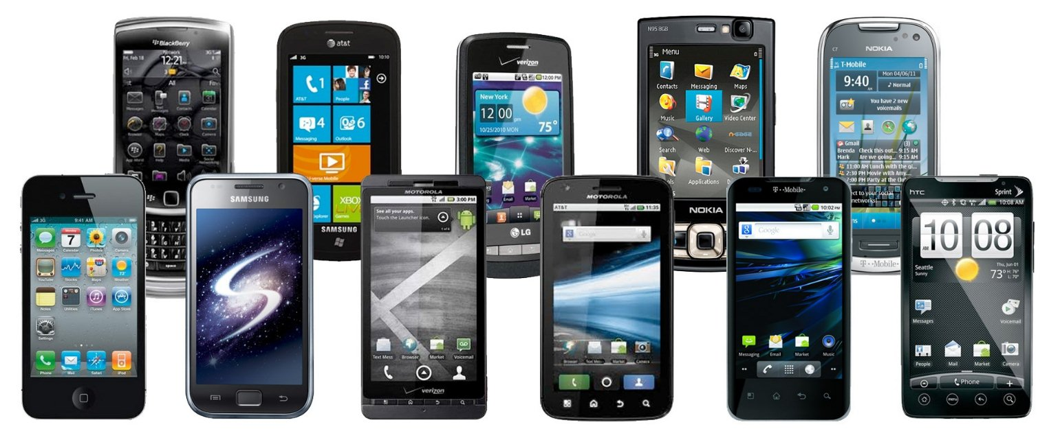
Comment:

Are you surprised by the results? Yes or no

Do you think the results are a concern? Why or why not?

What do you think you should do now?

