NHSGGC Processional Governance Event
21st May 2018
Hosted by the Professional Governance and Regulation Directorate
Event Feedback Analysis Report

What was good about the event?

Word cloud
about advice allocation although around aspect aspects attendance board breath clear colleagues costs could different director disclosure discussion discussions earth effectively eloquent engagement engaging enjoyed enlightening enough especially every excellent fantastic fresh getting great handouts information informative inspirational inspiring interactive interesting liaison longer McGuire Newman nurse particularly practising preferred presentation presentations presented producing provoking really regarding relevant representation scenarios Scotland service session sessions share speaker speakers staff staffing studies talks these think thoroughly thought throughout topic topics variety witness would

Groups
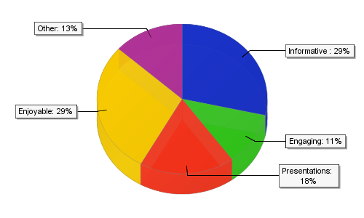

Words
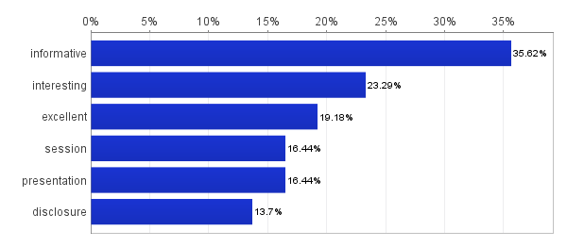

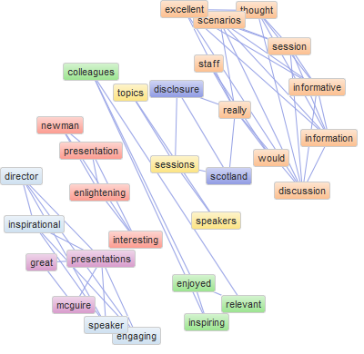
Word map

Informative
- NMC presentation particularly engaging
- Nurse Director very interesting & motivating
- Board Director Margaret McGuire engaging and interesting speaker
- NMC presentation – interesting and informative
- BND session – inspirational and down to earth
- Disclosure Scotland was very interesting and informative
- NMC session was fantastic, thought provoking, informative, engaging, lots of advice/info to share will colleagues
- NMC talk – case studies were the best
- A lot of information regarding the NMC registration which I will take back to share with staff.
- Examples that Tony Newman showed and had group discussion very interesting and informative
- Link liaison service (NMC) – employer link
- Tony from NMC really good discussions and scenarios
- NMC was excellent, enough time for an interactive session
- From the presentation by Tony Newman, 99.3% of nurses are practising safely and effectively – a reassuring statistic we are getting something right
- NMC – discussions – well presented and interactive
- Enjoyable and informative
- Tony from NMC was excellent; thoroughly knew his topic and was engaging, eloquent speaker
- Tony Newman’s presentation enlightening and very interesting
- NMC very interesting and informative
- Disclosure talk enlightening
- Informative on all aspects, particularly Tony Newman – very catching and interesting
- NMC session very interesting, especially scenarios
- NMC scenarios & discussion around these was excellent
- NMC talk very interesting
- Please invite NMC representation back to future governance events – really useful to hear about change
- NMC very informative and interesting
- NMC attendance and great context provided
- Interesting regarding disclosure – highlighted some deficiencies in this
- Disclosure – really interesting, could have listened longer. Definitely generated discussion.
- Wide variation of talks – interactive
- Interesting and informative presentation
- Interesting, engaging speakers
- Really interesting subject matter throughout the day

Engaging
- Enjoyed Board Nurse Director talk – inspirational
- NMC presentation – interesting and informative
- BND session – inspirational and down to earth
- Disclosure – excellent, informative, thought provoking session.
- NMC + Disclosure Scotland sessions excellent
- NMC session was fantastic, thought provoking, informative, engaging, lots of advice/info to share will colleagues
- All sessions very informative, speakers very clear and encouraging of audience engagement
- Preferred the morning session, speakers had good engagement
- Presentations were excellent and very informative – thought provoking.
- Enjoyed every aspect of the day, inspiring! All relevant, lots to take away to think about and pass on to colleagues
- Increased knowledge of all topics covered, well presented and informative sessions
- Informative, relevant practice information, thought producing scenarios, inspirational

Presentations
- Pace of day perfect
- Allocation of time to each speaker was good
- Margaret McGuire a great speaker for end of day. Left feeling uplifted and appreciated
- Board Director Margaret McGuire engaging and interesting speaker
- Great Presentation Margaret McGuire although was one of the shortest presentations
- Examples that Tony Newman showed and had group discussion very interesting and informative
- Tony from NMC really good discussions and scenarios
- NMC was excellent, enough time for an interactive session
- NMC talks – need more of these
- From the presentation by Tony Newman, 99.3% of nurses are practising safely and effectively – a reassuring statistic we are getting something right
- NMC – discussions – well presented and interactive
- Enjoyable and informative
- Good to hear – breath of fresh air
- Tony Newman’s presentation enlightening and very interesting
- Informative on all aspects, particularly Tony Newman – very catching and interesting
- NMC session very interesting, especially scenarios
- NMC scenarios & discussion around these was excellent
- Tony Newman NMC was excellent
- Tony Newman – excellent informative presentation
- Margaret McGuire was excellent
- Scenarios re NMC
- Wide variation of talks – interactive
- Informative, relevant practice information, thought producing scenarios, inspirational

Enjoyable
- Pace of day perfect
- Allocation of time to each speaker was good
- Margaret McGuire a great speaker for end of day. Left feeling uplifted and appreciated
- Great to hear Margaret McGuire being supportive of correct staffing levels especially when we are being asked to cut costs
- Enjoyed Board Nurse Director talk – inspirational
- Great Presentation Margaret McGuire although was one of the shortest presentations
- Very informative – really enjoyed Margaret McGuire and NMC presentation
- Disclosure – excellent, informative, thought provoking session.
- Handouts given full of information, advice and web links
- NMC + Disclosure Scotland sessions excellent
- NMC session was fantastic, thought provoking, informative, engaging, lots of advice/info to share will colleagues
- NMC session excellent – would like excellence in care presentation
- NMC was excellent, enough time for an interactive session
- NMC – great session – could have been longer very valuable information
- NMC – discussions – well presented and interactive
- Enjoyable and informative
- Good to hear – breath of fresh air
- Tony from NMC was excellent; thoroughly knew his topic and was engaging, eloquent speaker
- Excellent NMC presentation
- Tony from NMC was excellent; thoroughly knew his topic and was engaging, eloquent speaker
- Excellent NMC presentation
- Really enjoyed NMC session, very informative. All registered staff would benefit from a session like this.
- Very well thought out and structured programme – will be circulating slides to staff
- Tony’s speech was excellent
- NMC scenarios & discussion around these was excellent
- Tony Newman NMC was excellent
- Tony Newman – excellent informative presentation
- Margaret McGuire was excellent
- NMC attendance and great context provided
- Interesting regarding disclosure – highlighted some deficiencies in this
- Presentations were excellent and very informative – thought provoking.
- Enjoyed every aspect of the day, inspiring! All relevant, lots to take away to think about and pass on to colleagues
- Excellent day – very informative
- Great day, very informative. Good balance of speakers.
- Enjoyed the study day
- The day is very much focused for SCNs, would be great to see more of them attend. Was a good day would have got more out of a full NMC day.
- Enjoyed the whole day, very informative

Other
- Information re disclosure
- PRG session, very good & new information
- Disclosure Scotland – very informative
- Enhanced awareness of Disclosure Scotland
- The NMC session + GGC witness support session were very informative
- NMC talk was very informative
- Very informative presentations – overall preferred NMC
- NMC speaker Tony
- Margaret McGuire talk very engaging and inspiring
- Disclosure session very informative
- Informative Day
- Variety of different topics and speakers
- Well produced day
- Very very good

What could have been better?

Word cloud
abbreviations acute afternoon allocation attended better chief clinical compulsory concerning could dedicated delivery director disappointing disclosure enough especially explained future geared generic great handouts happens information informative interesting lectures little longer lovely lunch McGowan microphones midwifery negative nurse nurses nursing organisations overrun perhaps presentation process programme protecting provided public Rachael rather really related running rushed schedules seating service session sessions short should slides speakers spent staff staffing success suggested talks therefore times topic towards uncomfortable useful value volume working would

Groups
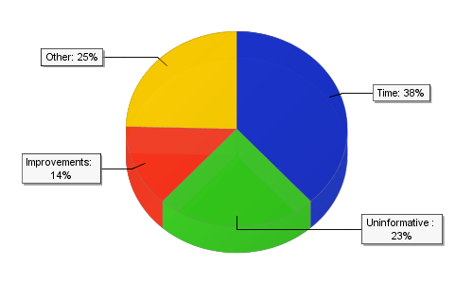

Words

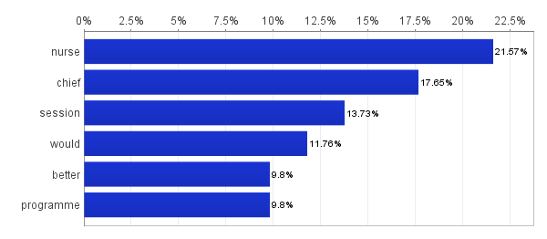

Word map
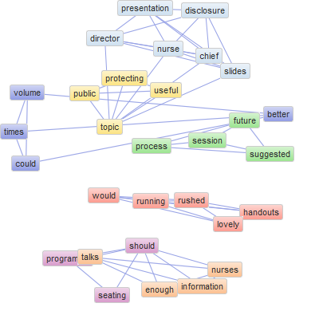

Time
- A bit longer for HR and how the new process will impact on SCN’s in the clinical areas
- Afternoon session was not as good as the morning. Lost engagement
- Disclosure talk interesting but would have likes this to be more related to healthcare workers rather than generic presentation
- Disclosure Scotland session could be shorter.
- Chief Nurse talk was perhaps too long?
- Chief Nurse too rushed, - slides very busy & therefore uninformative
- Not so useful – protecting the public Chief Nurse role
- Lack of handouts for disclosure
- Too much information on CN role talk – too much strategic discussion & not enough on actual role of CN.
- More involvement from the CN & Nurse Director on the day, less time on disclosure
- Probably not enough time – but that’s not always the case and actually shows success of the event
- Sessions running on time
- Nurse Director not being rushed due to lack of time
- More dedicated time to Chief Nurse Director – very informative and valuable session
- A lot of information provided in last 2 talks that was quite rushed – would have been better if more time was spent on them
- All good though overrun on time
- Chief nurse role- a little DIY
- Volume from microphones could be better at times
- What was the value of the chief nurse session?
- Suggested future session – recruitment process nursing/midwifery
- Suggested future session – collaborative working H&SC
- Need more info/future session on retaining staff
- More handouts would be great i.e. lecture notes
Sessions running late
Rushed at lunch break as time I got to lovely lunch only had 15 mins to eat.
- Chief Nurse talk – slides too busy, very drab delivery and didn’t inspire
- Chief nurse presentation too many slides of info to absorb
- 1. Some talks seemed to be geared at all the ways that nurses are disciplined or fall fill of the organisations or NMC. A bit negative at times.

Uninformative
- Just a question, as NMC fees are compulsory why can’t fees be taken off salary at source?
- Disclosure talk interesting but would have likes this to be more related to healthcare workers rather than generic presentation
- Disclosure Scotland session could be shorter.
- Chief Nurse talk was perhaps too long?
- Chief Nurse too rushed, - slides very busy & therefore uninformative
- Not so useful – protecting the public Chief Nurse role
- Chief Nurse great in theory but for future days both Acute and Partnership would be better, it’s concerning that people don’t know who the CN is. Topic wasn’t on role of CN, more on role of RN.
- Lack of handouts for disclosure
- More involvement from the CN & Nurse Director on the day, less time on disclosure
- Nurse Director not being rushed due to lack of time
- More dedicated time to Chief Nurse Director – very informative and valuable session
- Chief nurse role- a little DIY
- What was the value of the chief nurse session?
- Chief Nurse talk – slides too busy, very drab delivery and didn’t inspire
- Chief nurse presentation too many slides of info to absorb
- Some lectures were not good towards nurses on the ward
- 1. Some talks seemed to be geared at all the ways that nurses are disciplined or fall fill of the organisations or NMC. A bit negative at times.

Improvements
- Chief Nurse too rushed, - slides very busy & therefore uninformative
- Nurse Director not being rushed due to lack of time
- A lot of information provided in last 2 talks that was quite rushed – would have been better if more time was spent on them
- Volume from microphones could be better at times
- More comfortable seating
- Uncomfortable seating
- More handouts would be great i.e. lecture notes
Sessions running late
- Should have been better attended

Other
- Copy of programme on wall/in room
- Lunch really not required, especially in current climate. Was lovely but no need.
- Lots of abbreviations used that not all staff would know and were not explained
- Useful to know if ‘Link’ service happens/exists with AEI’s – To aid issues
Health issues
Communication
English
a well organised day
- Would have liked to hear more from Margaret McGuire.
- Time allocation to speakers & programme needs reviewed. Disappointing Rachael McGowan unable to attend
- Need to stick to time schedules
- Safe staffing should have been given more time
- Protecting public – too big a topic to be done in a short space of time.
- More time for HR presentation
- Considering it is NMAHP approach, why was focus on nursing & midwifery?
- More information from audience.
- Programme too busy, too many topics/speakers
- Programme not running on time
- Broad programme
- Need more info about New NMC Standards for Education, missed opportunity
- More time for protecting the public/strengthening governance

