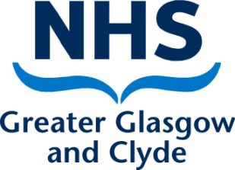

Meeting the requirements of equality legislation in Integrated Succession, Career and Development Planning

Decisions made by managers on Integrated Succession, Career and Development Planning need to take into account NHSGGC’s requirements under the Equality Act (2010) in relation to our staff. This means ensuring that all our processes are free from discrimination.

While managers do not set out to discriminate evidence has shown that our assessments are often affected by unconscious bias. This can lead to: a lack of diversity within our workforce; occupational segregation; or ‘glass ceilings’ which prevent certain groups achieving their full potential.

One example of this is the number of women who enter science, technology, engineering and maths (STEM) professions. It is estimated that only 25% of people employed in the STEM sector are women. Equate Scotland, which supports women into STEM suggest that unconscious bias has contributed to the low numbers of women. Unconscious bias refers to a bias that we are unaware of, and which happens outside our control. It happens automatically and is triggered by our brains making quick judgments and assessments of people and situations, influenced by our background, cultural environment and personal experiences. This can impact on recruitment and selection processes where there is a tendency for managers to appoint people similar to themselves.

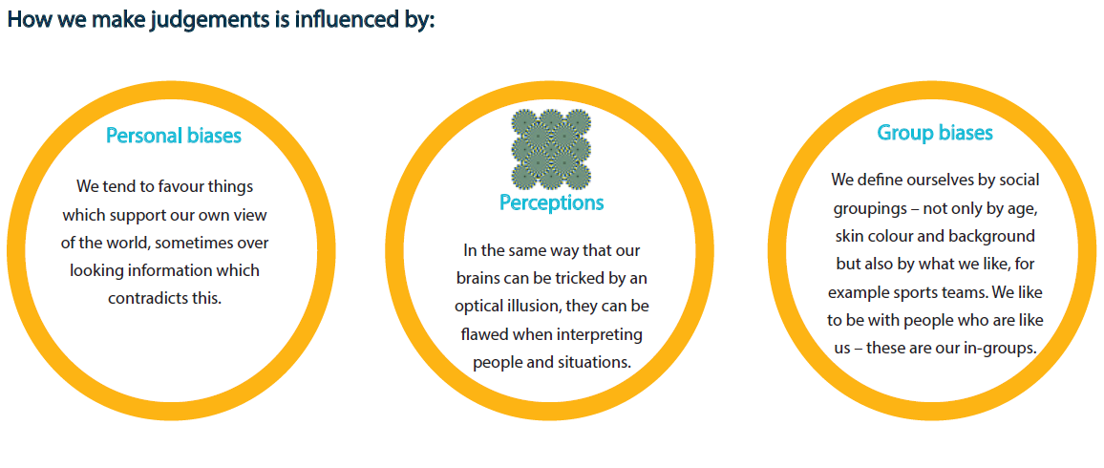

An understanding of unconscious bias is essential in increasing equality, diversity and inclusion and ensuring that there is equal access to career progression opportunities across all the protected characteristics named in the Equality Act 2010: age, disability, gender reassignment, marriage & civil partnership, pregnancy & maternity, sex, race, religion & belief and sexual orientation.

NHSGGC has a diverse population and Figure 1. shows this using local data* where available or national data** where this is unavailable. This gives a picture of the relative size of different groups in our population by protected characteristic.

Figure 1. Estimation of NHSGGC’s Diverse Population

Protected Characteristic | Estimation
Sex* | 51% women and 49% men
Ethnicity* | 12% Glasgow  (Next highest is East Renfrewshire at 6%)
Disability** | 19% working age population
Sexual Orientation** | 6% of the population
Religion* | 31% no religion  27% Roman Catholic  23% Church of Scotland  5% Muslim  4% other Christian  1% Hindu  1% Buddhist  1% Sikh  7% not stated
Age* | 18% 0-17  57% 18-54  18% 55-75  7% over 75
Gender reassignment** | 3 people in 100,000  150 to 200 people in Scotland per annum reassign their gender

A significant difference between NHSGGC and the rest of Scotland is the higher number of ethnic minority people in Glasgow City and the diversity within this group. Figure 2. shows the 5 main ethnic groups in Glasgow and their relative sizes. These groups make up 83% of all the ethnic minority population in Glasgow, a relatively young population and therefore likely to increase over the coming years.

Figure 2. Relative Size of the Ethnic Minority Population in Glasgow.

More information on equality, diversity and human rights can be found on HR Connect and the Equalities in Health website www.equality.scot.nhs.uk

A Fairer NHSGGC: Meeting the requirements of equality legislation 2016-20 http://www.equalitiesinhealth.org/_literature_134841/A_Fairer_NHS_2016-2020
Equate Scotland website http://www.equatescotland.org.uk/about/the-issue/

