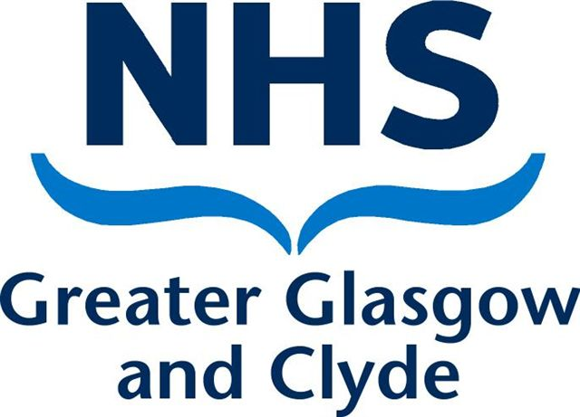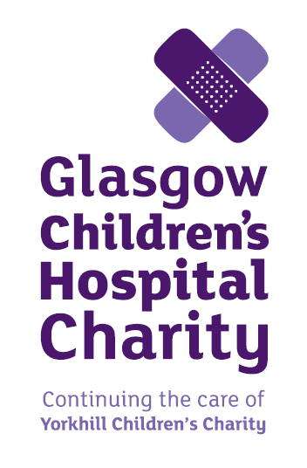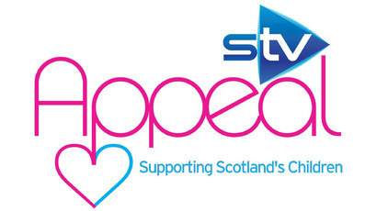
ROYAL HOSPITAL FOR CHILDREN
MINDFULNESS COURSE – CAN THIS HELP YOU?
Date: Starts Thursday 9th February for 8 weeks
Time: 10.30 -12.30
Venue: Royal Hospital for Children – 3rd Floor Discharge Lounge
Trainer: Chloe Homewood
How this can help: The course will give you different techniques to help you manage your current situation and the thoughts and feelings that you are dealing with. It will also give you the chance to speak to others who may be in similar situation and understand how you are feeling.
The 8 week course has a strong evidence base and has been shown to help in the following ways:
- The ability to cope more effectively with stress and anxiety, depression, anger and panic states
- An increased ability to relax and an improvement in quality and duration of sleep
- The ability to cope better with chronic pain and reduction in pain levels
- Greater enthusiasm, creativity and increased energy levels
- Improved self-esteem and clarity of thought
- A more effective immune system
If you are interested please speak to Family Support on 0141 201 4012 or call in to Family Support on the ground floor of the Children’s hospital 