Department Name
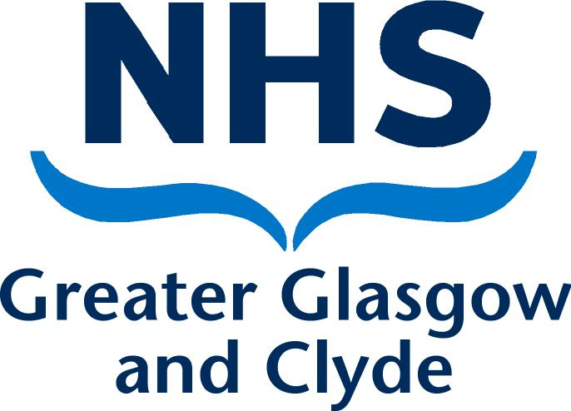
Directorate
Address 1
Address 2
Address 3
Post Code

PRIVATE & CONFIDENTIAL
NAME  ADDRESS1  ADDRESS2  ADDRESS3  POST CODE | Date: DATE  Ref No:  Direct Line: Number  Email:  Contact: NAME
Dear [name]

Outcome of Investigation Process

I write in accordance with NHS Greater Glasgow & Clyde Disciplinary Policy & Procedure with reference to the investigation commissioned into the following allegation/s

Add allegations

I can confirm the investigation has now concluded. After careful consideration of all the information collated the investigating officer does not recommend a disciplinary hearing is convened to consider the case further in this instance. However, the investigating officer has noted aspects of your conduct which not of an acceptable standard:

- Insert details of actions and/ or behaviours which were below standard

On this basis, the above aspects of your conduct require improvement and [add name and title] will schedule a meeting to discuss and establish a Supported Improvement plan.

Your conduct will be monitored during the period the Supported Improvement plan is in place, and a copy of this letter will be retained on your employee record. The letter and any associated documents will be removed from your personal file after six months from the date of this letter, if there have been no further incidents and no further cause for concern.

I must advise that any future acts of misconduct, whether of the same or a different nature, may lead to formal disciplinary action being taken against you.

[Managers name, job title] will arrange to meet with you to agree the details of the Supported Improvement plan, confirm the required improvements and appropriate timescales.

In the meantime, if you have any questions about the content of this letter, please contact [either me or name and job title] on [contact details].

Yours sincerely

[Managers Name]
[Title]
[Service]

