5 Steps for Signposting

- Visit www.aliss.org

- Enter a Search Topic and Location, select a Search Radius and click ‘Submit’.
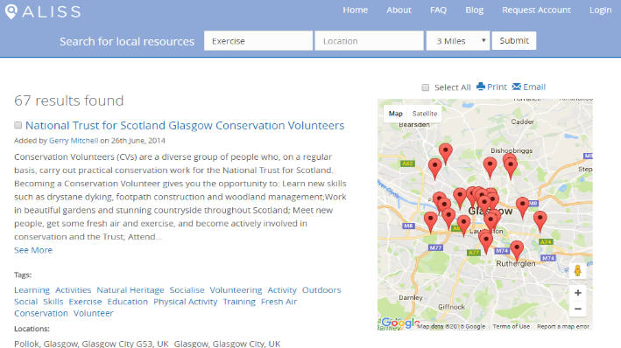

- Browse results returned.

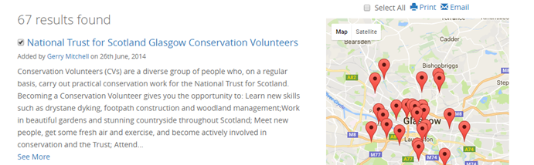
- Select relevant resources by clicking the checkbox to the left of the Title.

- Print or Email selected resources for the person you are signposting by clicking print or email.

