Department Name
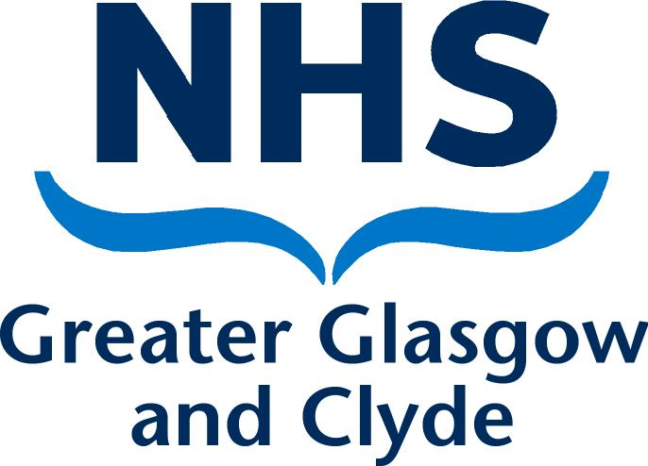
Directorate
Address 1
Address 2
Address 3
Post Code

PRIVATE & CONFIDENTIAL
NAME  ADDRESS1  ADDRESS2  ADDRESS3  POST CODE | Date: DATE  Ref No:  Direct Line: Number  Email:  Contact: NAME
Dear [name]

Formal Stage 2 capability Final Review Meeting

I am writing to confirm the outcome of the Formal Stage 2 Final Review meeting that was held on [date] in [location]. The meeting was held in accordance with NHS Greater Glasgow and Clyde Employee Capability Policy and Procedure.

You attended with [name of person representing / accompanying the employee & name of organisation if relevant] OR: [You attended on your own and confirmed at the beginning of the hearing that you wished to go ahead without representation.] [HR name and job title] was also in attendance.

At the meeting we discussed the following performance issues
[summary of capability issues, evidence/ examples of areas achieved and not achieved.]

The purpose of this letter is to confirm to you of the outcome of the Formal Stage 2 Capability Final Review Meeting and next stage of the process.

After consideration of the written evidence and discussion I concluded that you have not made satisfactory progress in the following areas: [summary of capability issues and examples/ evidence of areas not satisfactorily achieved].

EITHER:

We agreed revised performance targets and a revised action plan (enclosed). I will monitor your progress towards meeting these targets over the next [timescale] and will provide the support as outlined in the action plan to facilitate your improvement. Therefore, your period of Formal Stage 2 Capability has been extended to further support you. I must advise that if the required improvements and performance targets are not achieved during the extension, in accordance with the Board’s Employee Capability Policy and Procedure, it will be necessary to progress to NHS Greater Glasgow and Clyde’s Disciplinary Policy and Procedure.

A further formal review meeting has been arranged to take place [details]. Following the next formal review meeting, if progress is not satisfactory, I will consider whether there should be any further formal meetings in accordance with NHS Greater Glasgow and Clyde’s Employee Capability Policy and Procedure,

Or

After consideration of the written evidence and discussion I am pleased to conclude that you have made satisfactory progress in respect of the standard of performance required by you in your role and no further formal action in accordance with NHS Greater Glasgow and Clyde Employee Capability Policy and Procedure is required, provided that your performance is maintained. We agreed a revised action plan (enclosed), and I will continue to monitor your performance at regular meetings over the next [timescale].

Or

If at the final stage of the process:
After consideration of the written evidence and discussion, I concluded that you have not made satisfactory progress in the following areas [summary of capability issues and examples/ evidence of areas not satisfactorily achieved], despite the provision of support and clarity about the performance targets you were required to meet. Given this, I have taken the decision to refer the matter to the NHS Greater Glasgow and Clyde’s Disciplinary Policy and Procedure in accordance with NHS Greater Glasgow and Clyde Employee Capability Policy and Procedure. A letter will be sent to you separately with details of an invite to a Disciplinary Hearing.

Can you please review the content of this letter and sign and return a copy to me if you are in agreement that the letter accurately reflects the content of the meeting. If you feel there are any inaccuracies, then please advise me of these in writing within 5 working days of receiving this letter. If you fail to return a signed copy of this letter or advise me of any inaccuracies within 5 working days, it will be assumed that you accept the document as an accurate account of the meeting.

In the meantime, if you have any queries please do not hesitate to contact me on [phone number].

Yours sincerely

[Managers Name]
[Job Title]
[Service]

-----------------------------------------------------------------------------------------------------------------

Acknowledgement Form

I, [employee name], confirm that I have received the letter dated [date] and understand all of the contents of this letter. I also agree that the letter details an accurate reflection of what was discussed at the meeting.

Signed:…………………………………………………………….. Date………………………..

Please sign and return one copy of this letter to me within 5 working days. A copy will be placed in your personal file

