Department Name
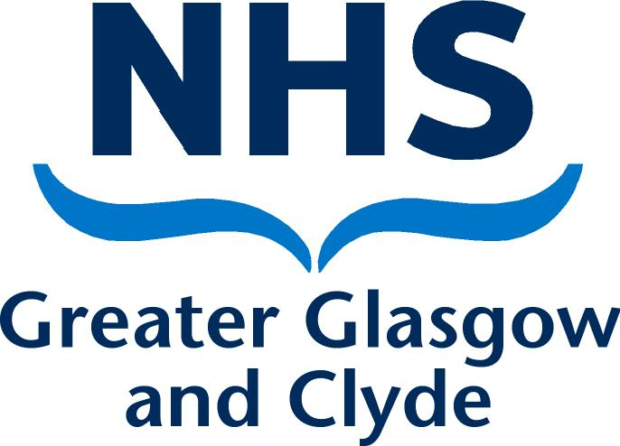
Directorate
Address 1
Address 2
Address 3
Post Code

PRIVATE & CONFIDENTIAL
NAME  ADDRESS1  ADDRESS2  ADDRESS3  POST CODE | Date: DATE  Ref No:  Direct Line: Number  Email:  Contact: NAME
Dear [name]

Outcome of Formal Stage 1 Capability Meeting

I write to confirm the outcome of the Formal Stage 1 Capability meeting that was held on [date] in [location]. The meeting was held in accordance with NHS Greater Glasgow and Clyde’s Employee Capability Policy and Procedure. [You attended with [name of person representing / accompanying the employee & name of organisation if relevant] OR: [You attended on your own and confirmed at the beginning of the hearing that you wished to go ahead without representation.] Also present at this meeting was [HR name], [job title].

At the meeting we discussed the following performance issues: -
[Include:
  - Clear details of the performance concerns
  - The improvement(s) required
  - An agreed Action Plan to achieve improvement
  - Details of how the plan is going to be monitored, providing dates for review meetings if agreed
  - Confirmation of the timescales]

The purpose of this letter is to advise you of the outcome of the formal meeting and the next stage of the process. We agreed revised performance targets and a revised action plan (enclosed). I will monitor your progress towards meeting these targets over the next [timescale] and will provide the support as outlined in the action plan to facilitate your improvement. As part of the Formal Stage 1 Capability Plan it was also agreed that you would be assigned a Mentor who will be [name], [job title].

A Formal Stage 1 Mid Review Meeting will be arranged in [timescale] and a Final Review Meeting will be arranged in [timescale]. I must advise that if the required improvements and performance targets are not achieved by the Final Review Meeting, in accordance with the Board’s Employee Capability Policy and Procedure, it may be necessary to progress to Formal Stage 2 of the Capability procedure.

Can you please review the content of this letter and sign and return a copy to me if you are in agreement that the letter accurately reflects the content of the meeting. If you feel there are any inaccuracies, then please advise me of these in writing within 5 working days of receiving this letter. If you fail to return a signed copy of this letter or advise me of any inaccuracies within 5 working days, it will be assumed that you accept the document as an accurate account of the meeting.

In the meantime, if you have any queries please do not hesitate to contact me on [phone number].

Yours sincerely

[Managers Name]
[Job Title]
[Service]

-----------------------------------------------------------------------------------------------------------------

Acknowledgement Form

I, [employee name], confirm that I have received the letter dated [date] and understand all of the contents of this letter. I also agree that the letter details an accurate reflection of what was discussed at the meeting.

Signed:…………………………………………………………….. Date………………………..

Please sign and return one copy of this letter to me within 5 working days. A copy will be placed in your personal file

