NHS GREATER GLASGOW AND CLYDE
DIGNITY AT WORK POLICY & PROCEDURE
MANAGER & HR SUPPORT DOCUMENTATION

- INTRODUCTION

- GENERAL PRINCIPLES

- DISINGUISHING BETWEEEN DISRESPECTFUL BEHAVIOUR & BULLYING,HARRASSMENT & VICTIMISATION

- DEFINITIONS
  - Dealing with disrespectful behaviour
  - Dealing with bullying, harassment and victimisation

- DISRESPECTFUL BEHAVIOUR
5.1 General Guidance

- BULLYING,HARRASSMENT & VICTIMISATION
6.1 Key Considerations
6.1.1 Employee raises a complaint
6.1.2 Managers Judgement
6.1.3 Clear Evidence
6.1.4 Evidence misconduct unclear
6.1.5 Complaint does not meet definitions
6.1.6 Joint Investigation Panel (JIP) commissioned
6.1.7 JIP Report
6.1.8 JIP Outcome
6.1.9 Evidence to support allegations
6.1.10 No evidence and no interventions required
6.1.11 No evidence but some intervention required
6.1.12 Basis of Grievance
6.1.13 Disciplinary Policy
6.1.14 Counter Claim

7. EMPLOYEE COUNSELLING SERVICE

8. ROLE OF OCCUPATIONAL HEALTH

9. MEDIATION FRAMEWORK

10. DOCUMENTATION/INFORMATION & RECORD KEEPING

11. STANDARD CORRESPONDANCE & DOCUMENTATION

APPENDIX

1.0 INTRODUCTION
The Dignity At Work (DAW) policy outlines NHS Greater Glasgow and Clyde’s commitment to promote dignity and respect at work and to help foster a positive and dignified workplace culture. It also details the courses of action open to members of staff who experience inappropriate or unacceptable behaviour from a colleague. This framework supports the NHS GGC Dignity at Work Policy to give direction and guidance on what to do when issues emerge in relation to disrespectful behaviour or bullying, harassment or victimisation.
2.0 GENERAL PRINCIPLES
The DAW policy applies to all employees of the Board, whether full or part-time or whether on permanent contracts or bank contracts, and also to employees of the Board in their work with staff from the Board’s partner agencies. In the event of a complaint about an employee from another organisation, there will need to be close collaboration between Management and Human Resources from both organisations. Employees can only access and be bound by the terms of their employer’s policies and not by those of an employer to whom they are not contracted to work.
3.0 DISTINGUISHING BETWEEN DISRESPECTFUL BEHAVIOUR AND BULLYING, HARRASSMENT & VICTIMISATION
The Dignity at Work policy makes a separation between what is termed ‘disrespectful behaviour’ and what is termed as more serious bullying, harassment and/or victimisation. The policy contains the Board’s definition of each term.
- Dealing with disrespectful behaviour
- Dealing with bullying, harassment and victimisation
Please refer to the following hyperlinks to view separate flowcharts for ‘Dealing with Disrespectful Behaviour’ and ‘Dealing with Bullying, Harassment and Victimisation’.
Flowchart - Dealing with Disrespectful Behaviour
Flowchart - Dealing with Bullying, Harassment and Victimisation
4.0 DEFINITIONS
4.1 DEALING WITH ‘DISRESPECTFUL BEHAVIOUR’
The DAW policy sets out courses of action open to members of staff who experience behaviour from another member of staff that displays a basic lack of respect. The term ‘disrespectful behaviour’, is defined as:
Rude or discourteous behaviour that causes the receiver to feel belittled or insulted or to have their reputation damaged. If left unchecked it creates an uncomfortable or even hostile work environment and could develop into bullying and harassment.
Examples include:
- Use of demeaning or offensive language,
- shouting,
- openly disregarding other’s views,
- frequent interrupting,
- being deceptive or manipulative,
- gossiping behind another’s back (including online),
- being disruptive
- or not making a full contribution in the workplace to the detriment of colleagues.
4.2 DEALING WITH BULLYING, HARASSMENT AND VICTIMISATION DEFINITIONS
Bullying is an escalating process of offensive, intimidating, malicious or insulting behaviour aimed at an individual, which occurs repeatedly and regularly (e.g. weekly) over a period of time (e.g. six months). It often involves an abuse of power and authority and makes the victim feel upset, threatened or humiliated. Bullying tends to have the effect of undermining self-confidence and can make people feel vulnerable and stressed. Bullying has no legal definition, whereas harassment does.
Harassment describes unwanted conduct affecting the dignity of people in the workplace, i.e. acts which are unacceptable and demeaning to the victim. Harassment may be related to age, sex, race, disability, religion, sexual orientation, nationality, marriage/civil partnership, maternity/pregnancy status or any personal characteristic of the individual. Harassment may be persistent or an isolated incident.
The legal definition of harassment in the Equality Act 2010 refers to ‘…unwanted conduct related to a relevant protected characteristic which has the purpose or effect of violating an individual’s dignity or creating an intimidating, hostile,degrading,humiliating or offensive environment for that individual’.
Victimisation is punishing or treating an individual unfairly, for example, because they have either made a complaint, intend to make a complaint or are believed to have made a complaint. The National NHS policy on Equality, Diversity and Human Rights defines victimisation as detriment suffered by a member of staff as a result of issues or allegations they have raised in good faith, or because they have participated in an associated process, for example as a witness.
5.0 DISRESPECTFUL BEHAVIOUR
When an employee encounters disrespectful behaviour, either to themselves or others, they should - where they feel confident in doing so - tell the person responsible to stop the particular behaviour or action that is causing the difficulty as near to the time of the incident occurring as practicable. This may resolve the issue and stop any recurrence, and can usually be done in a way that defuses tension in the situation.
If the member of staff feels they have no choice but to escalate the issue, they should make a complaint to their Line Manager or use their Trade Union/Professional Organisation Representative to do so on their behalf. In instances where the issue involves the Line Manager, then the approach should be to the next-in-line Manager. In response to such a complaint from a member of staff the manager will listen, discuss and explore the nature of the issue with the staff member and agree next steps with them. For cases of alleged disrespectful behaviour the manager should aim to resolve the issue informally and in a way that allows positive working relationships to be rebuilt and maintained.
This may in some cases be helped by interventions from Human Resources, Organisational Development, Learning & Education or perhaps by independent mediation.
Mediation is a process that attempts to resolve conflict by involving a neutral third party to bring conflicting parties together with the aim of reaching a mutual agreement on how to move forward in a constructive fashion. For more detailed information the Mediation Framework can be found online on HRConnect.
Following the agreed actions being taken, the manager will continue to monitor and review the situation until they and the member of staff are satisfied that the issue is concluded. If the member of staff is not satisfied about the way the issue is being handled or feels that the issue is not being progressed effectively towards resolution, they may invoke the Grievance Procedure.
If the employee wishes to pursue their complaint formally then they may invoke the Grievance Procedure.
6.0 DEALING WITH BULLYING, HARASSMENT AND VICTIMISATION
When issues emerge in relation to claims of bullying, harassment or victimisation this first step is to check the Board definitions (click here). Thereafter if it appears that the matter relates to bullying and harassment, as per the definitions, the formal process to be followed is outlined in the process flowchart (figure 2) in the appendix of this document:
A member of staff who feels they are experiencing Bullying, Harassment or Victimisation, should immediately report the matter to their line manager. If the allegation involves the line manager then the next in line manager should be approached. Allegations of above behaviour will always be formally investigated and if there is clear evidence of misconduct this can result in disciplinary action, up to and including dismissal, under the Board’s Disciplinary Policy and Procedure.
If the evidence is deemed unclear by the line manager or next in line manager, then there will be an independent review of the evidence. This investigation will be carried out by a Joint Investigatory Panel (JIP).
6.1 KEY CONSIDERATIONS

6.1.1 - Employee raises complaint:

All formal complaints should be in writing. If an employee is not willing to put the complaint in writing then an investigation cannot proceed. The manager should ensure that the employee is aware of mediation and should check that this has already been explored.

Documentation
Dignity at work Complaint Notification Form

6.1.2. Managers Considerations and Judgement

The Manager has several considerations and actions to take when an issue presents:

- needs to determine who they need to speak to on receipt of a written complaint
- speak to the employee raising the concern and the employee who the complaint is against
- needs to establish whether the Dignity at Work Policy is applicable in the circumstances – by reference to the definitions as per the policy.
- needs to make a judgement as to whether there should be an investigation.
- seek advice from HR if unsure as to how to proceed
- should consider separating the parties as necessary and confirm any alternative working arrangements in writing as a temporary measure.

The manager is not expected to speak to potential witnesses at this stage.

Add details regarding the management meeting with the employee and who should be present at this meeting, purpose of meeting etc.

6.1.3 – Clear Evidence:

Clear evidence would be matter of recorded fact, e.g. a direct admission or document evidence such as emails or a social media download.

The manager would then commission an investigation under the Board’s Disciplinary Policy and Procedure. The manager would be responsible for identifying an independent manager to be the Investigating Officer and liaising with HR for investigatory support. Refer to Disciplinary Policy.

6.1.4 – Evidence misconduct unclear:

Before an investigation begins the manager should make both employees aware that there will be an investigation. Establish if the employee(s) intend to be represented by a trade union or professional organisation.
Documentation

Template Letters confirming JIP will investigate complaint -complainant and respondent
Template Letters Invite to Investigation meeting – complainant, respondent and witness

6.1.5 – Complaint does not meet definitions:

Manager should write to employee to confirm this.

Documentation
Template Letter – Complaint Did not Meet Definitions

Manager should explain why the complaint does not meet the definitions of the policy and attempt to help the employee understand the decision. Manager may also refer back to informal measures outlined in the policy.

If the employee disagrees they can invoke the Grievance Procedure.

6.1.6 – Commissions Joint Investigation Panel (JIP)

Manager should appoint a chair of the JIP who is situated out-with the immediate service area and not implicated in the complaint.

The following guidance outlines the process and responsibilities for a JIP:

Step | Action | Responsible Person
1. | JIP chair to be nominated/appointed (different area/sector) | Commissioning Manager
2. | HR to nominate/select Staff side representative (Hyperlink to list on HR connect) | Appointed HR Practitioner
3. | JIP Panel to arrange pre-meet – draft JIP Terms Of reference | JIP Panel
4. | JIP to schedule diary dates | JIP Panel
5. | Correspondence (invites, venue etc) issued – use of template letters | JIP Chair
6. | Arrange person to take Note(s) of meeting. HR to assist in the event that admin support unavailable. | JIP Chair
7. | Admin/HR to write up note and forward to JIP Chair | Admin/HR Practitioner
8. | Notes sent out to relevant parties for Approval/Comment (refer to section 6.1.7) | JIP Chair (with support of Admin/HR)
9. | Notes returned to chair – once signed and dated | Complainant/Respondent
10. | On receipt of all notes approved – write up of JIP Report (using report template) | JIP Chair
11. | Report sent out to relevant parties for opportunity to comment (refer to section 6.1.7) | JIP Chair (with support of Admin/HR)
12. | On receipt of comment the JIP Chair liaises with Commissioning Manager | JIP Chair/Commissioning Manager
13. | Commissioning Manager reviews report and forms conclusion – JIP Outcome section 6.1.8) | Commissioning Manager
14. | JIP roles ends unless case proceeds to disciplinary – where JIP Chair presents the case or is called to give evidence by Commissioning Manager | JIP Chair/Commissioning Manager
15. | All relevant documentation to be scanned and archived in accordance with Record Retention Policy | JIP Chair/Commissioning Manager

The members of the JIP should be appropriately trained. Appropriate training is available – click for link to investigation training.

Documentation
Investigation Report template/Confirmation of Extension of Investigation
Investigation Meeting Notes templates - Complainant/Respondent/Witness
Failure to Attend templates – Complainant/Respondent/Witness

Click here for further details of the actual JIP investigation meeting – do’s and don’ts, role of the panel etc (refer to appendix).

6.17 – JIP Report:

The report is shared to all parties to provide comment (excluding witnesses). Additional comments can be included by way of an appendix and submitted with the final report. Sharing of the report does not provide an opportunity for the report to be rewritten.

Documentation
JIP Template Report Invite and Discuss – complainant and respondent

The policy states that the report should be completed within a 6 week timescale. Parties should be given one week only in which to comment, this timescale may be extended on approval from the chair of the JIP following request with good reason.

Following submission of comments the JIP should consider these and determine whether any further investigation is required. On completion of the report the chair of the JIP should meet with the commissioning manager to outline the findings from the investigation and explain the rationale in relation to the outcome of the investigation.

6.1.8 – JIP Outcome

The JIP’s report should be submitted to the line manager unless the line manager has been involved in the investigation as a witness or implicated in another way. In such circumstances the report should be submitted to the next-in-line manager.

Documentation
JIP Report Outcome Meeting

The manager meets with individual parties to discuss the final outcome. The employee may be represented at this meeting by their appointed representative. A representative from HR, not previously involved in the investigatory process, will also be in attendance at the meeting

When conducting this meeting the manager should be mindful of the sensitivities surrounding the circumstances of the investigation and the recommendation(s) made.

The manager should remind the employee of the Occupational Health Service (section 8) and Employee Counselling Service (section 7) which they may find helpful at this time.

6.1.9 – Evidence to support allegations

This should be a brief meeting to confirm that the matter will proceed to a formal disciplinary hearing and that the individual will be written to in due course with arrangement to attend a hearing. The manager should also advise the employee as to whether any alternative working arrangement should continue or be put in place pending the outcome of the disciplinary hearing. The manager should also advise the employee to continue to refrain from discussing the matter with colleagues.

The manager should remind the employee of the Occupational Health Service (section 8) and Employee Counselling Service (section 7) which they may find helpful at this time.

6.1.10 – No evidence and no interventions required

This should be a brief meeting to confirm the outcome of the investigation. The manager should briefly explain the JIP’s findings and rationale behind the outcome based on the managers discussion with the JIP chair following the investigation.

The manager should work with the individuals to rebuild working relationships in order to move forward. The manager should consider accessing Organisational Development for support in improving communications and relationships within the team where appropriate.

Click here for link to OD.

The manager should remind the employee of the Occupational Health Service (section 8) and Employee Counselling Service (section 7) which they may find helpful at this time.

The manager should look to support the individuals informally and may consider highlighting the availability of mediation (section 9) should the local management support be unsuccessful.

6.1.11 – No evidence but some intervention required

The manager should meet to confirm the outcome of the investigation and should also briefly explain the JIP’s findings, rationale behind the outcome and interventions identified. This will be based on the manager’s discussion with the JIP chair following the investigation.

In considering the interventions identified by the JIP the manager should explore with the employee methods of addressing the issues identified. This may include, but not restricted to consideration of the employees PDP, exploring development opportunities, exploring possibility of mentoring and/or accessing the L&E training calendar.

The manager should remind the employee of the Occupational Health Service (section 8) and Employee Counselling Service (section 7) which they may find helpful at this time.

Click here to access e-KSF
Click here to access L&E training calendar

The manager should work with the individuals to rebuild working relationships in order to move forward. The manager should consider accessing Organisational Development (OD) for support in improving communications and relationships within the team where appropriate.

Click here for link to OD

The manager should remind the employee of the Occupational Health Service (section 8) and Employee Counselling Service (section 7) which they may find helpful at this time.

The manager should look to support the individuals informally and may consider highlighting the availability of mediation (section 8) should the local management support be unsuccessful.

6.1.12 – Basis of grievance

A grievance can be raised by either party in relation to the investigatory process, should they feel the process was flawed in some way. However there is no right to raise a grievance in relation to the outcome of the investigatory process and such grievances will be deemed not competent.

Any grievances submitted in relation to the investigatory process must be submitted within a reasonable period of time following completion of the investigation in order to be considered. If a competent grievance is raised prior to the completion of the investigation please be aware the JIP investigation will be put on hold to allow for the grievance process to be concluded.

Click here to access Grievance Policy

6.1.13 – Disciplinary Policy

Click here for link to Disciplinary Policy

6.1.14 Respondent raises counter claim

Should the occasion arise when the respondent makes a counter allegation of bullying, harassment or victimisation during the formal process (e.g. they themselves feel they were subject to inappropriate behaviours/treatment from the complainant) they will be signposted to complete the relevant document (DAW Complaint Notification form). This will be submitted to the commissioning manager who in turn will consider this in respect of the DAW definitions (section 4.2) and thereafter take the appropriate steps. If it does meet the definitions then the commissioning manager will update the JIP Terms of Reference to include a mandate to fully investigate these new allegations. This will be under the remit of the same investigation process.

The JIP will investigate both complaints – and draft separate reports - one addressing the original complaint and the other the counter claim.
Templates for counter complaints are included in the Dignity at Work Guidance suite of letters.

Further advice must be sought from HR in all instances of counter allegations.

Documentation
Counter Claim (Respondent)
Counter Claim (Complainant)

7.0 Employee Counselling Service
It is important to remind staff of the availability of counselling for confidential advice and support when facing such issues. Click here to access Occupational Health Service on HRConnect.
8.0 Role of Occupational Health
At any point during the process it may be useful to remind staff of the service available from Occupational Health. Referrals can be made by the individual themselves or through a management referral. Click here to access Occupational Health Service on HRConnect.
9.0 Mediation
The Board's Mediation Framework is a potential option for employees in dispute. An informal approach, such as mediation, can provide greater flexibility to suit specific circumstances. The confidential nature of the process can offer a pause and a safe environment to facilitate more open and honest discussion. However it is important to consider if it is always the most appropriate option. The following lists are examples and not exhaustive.
Mediation may be appropriate:
• To address a range of issues, including relationship breakdown, personality clashes or communication problems;
• To resolve conflict involving colleagues of a similar job or grade, or between a line manager and a member of their team;
• To help re-establish working relationships after a formal dispute has been resolved / formal procedure completed;
• Where an ongoing professional working relationship is required / or there is a requirement to act cooperatively;
• Where there are questions over fairness and reasonableness;
• Where it is in the interest of both parties to resolve a situation without recourse to the Grievance Procedure.
Mediation is not appropriate:
• As a first resort – because people should be encouraged to speak to each other and talk to their manager before they seek a solution via mediation;
• To address issues of Bullying, Harassment and/or Victimisation. These issues are dealt with under the Disciplinary Policy & Procedure or, if evidence is unclear, they are investigated by a Joint Investigation Panel and the issue may then, depending on findings, proceed to the Disciplinary Policy & Procedure;
• Where a decision about right or wrong is needed, for example where there is possible criminal activity;
• Where there is an unbridgeable imbalance of power;
• Where the individual bringing a discrimination case wants it investigated;
• Where someone has learning difficulties or mental health problems (the party may be permitted to have someone to attend in an “advocacy” capacity –if agreed, the latter would only be permitted into the mediation if they signed a confidentiality agreement;
• Where the parties do not have the power to settle the issue;
• Where one side is completely intransigent and using mediation will only raise unrealistic expectations of a positive outcome.
Click here for further information on the board’s Mediation Framework.
10. Documentation/Information and Record Keeping
It is imperative that documentation is kept up to date and that accurate records are made of all meetings and relevant discussions. To this end the standard documentation templates must be utilised (see section 11).
11. Standard Correspondence and Documentation
A suite of templates letter have been developed to support the effective application of the Dignity at Work Policy with regards bullying, harassment and victimisation situations. These have been drafted to cover a range of scenarios in relation to claims or counter claims of breaches of dignity. If managers are in any doubt in which template(s) to use please contact Human Resources – link to HR Connect>HRSAU.
Dignity at Work letters and form templates (Bullying, Harassment and Victimisation)
Letter 1A | JIP Investigation to be arranged (respondent)
Letter 1B | JIP Investigation to be arranged (complainant)
Letter 1C | JIP Investigation meeting date confirmation (respondent)
Letter 1D | JIP Investigation meeting date confirmation (complainant)
Letter 1E | JIP Investigation meeting date confirmation (witness)
Letter 2 | Complaint did not meet definitions
Letter 3A | Confirm outcome investigation and invite to discuss (respondent)
Letter 3B | Confirm outcome investigation and invite to discuss (complainant)
Letter 4 | Outcome Meeting JIP Report
Letter 5A | Failure to Attend Investigation Meeting (respondent)
Letter 5B | Failure to Attend Investigation Meeting (complainant)
Letter 5C | Failure to Attend Investigation Meeting (witness)
Letter 6A | Counter Claim (respondent)
Letter 6B | Counter Claim (complainant)
Letter 7A | Investigation Meeting Notes (respondent)
Letter 7B | Investigation Meeting Notes (complainant)
Letter 7C | Investigation Meeting Notes (witness)
Letter 8A | JIP Report Opportunity to Comment (respondent)
Letter 8A | JIP Report Opportunity to Comment (complainant)
Letter 9 | Confirmation of extension of investigation
Template | Complaint Notification Form
Template | Investigation Report

Figure 1

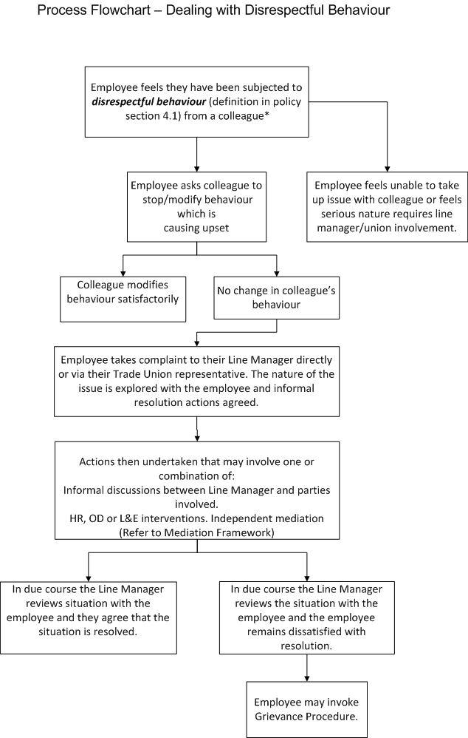

Figure 2

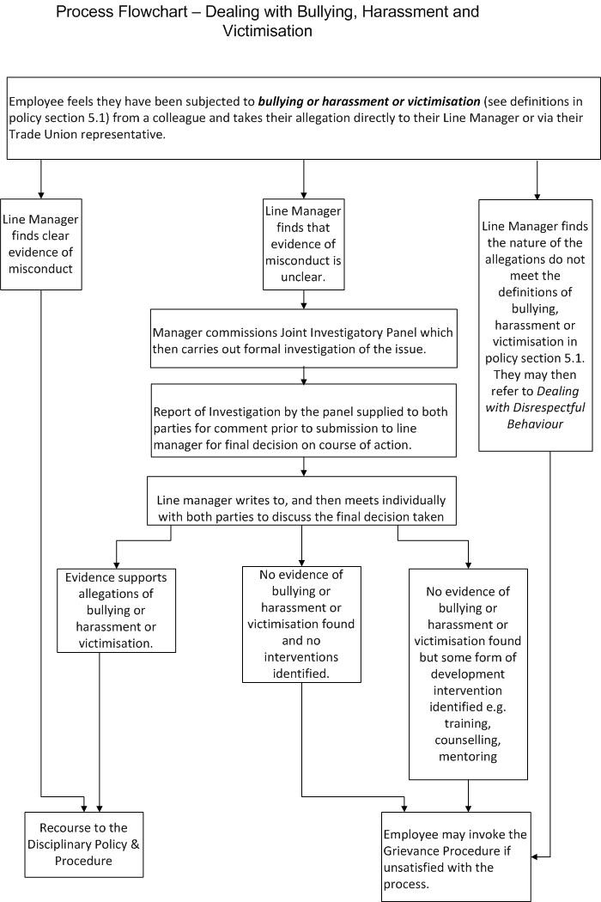

APPENDIX 7:

JOINT INVESTIGATION PANEL GUIDANCE
1. Introduction
A Joint Investigation Panel (JIP) is instigated by a line manager who has received a complaint from a member of staff alleging bullying, harassment or victimisation and the evidence in the case is unclear and requires an independent review of that evidence. In cases where the evidence of misconduct is clear then the line manager will not establish a JIP but will progress directly to the Disciplinary Procedure.
The JIP operates under the authority of the line manager and will conduct a thorough investigation likely to include interviews with the key people involved and the gathering of written statements and other relevant material. The JIP chair will seek to compile a comprehensive report with evidence and recommendations for the line manager to reach a decision about further actions.

2. Forming the Panel
The JIP will consist of a Manager as Chair, supported by a Human Resources Representative and a Staffside Representative, from the Area Partnership Forum approved list, of a Trade Union/Professional Organisation not representing any staff involved. The Manager should not be Line Manager of any of the staff involved. All will be impartial.

3. Preparation
Before the process commences, it is helpful to clarify:

3.1. Details of the precise issue to be investigated. Allegations of bullying and/or harassment must be clearly recorded from the harassee and must be addressed fully. This includes ensuring that each allegation is fully explored on an individual basis and that any final report identifies a response to each allegation.

3.2. The methodology for conducting the investigation (e.g. identification of initial witnesses, copies of relevant policy under which investigation is being held);

3.3. For what purpose and by whom any subsequent investigation report produced would be used;

3.4. Techniques, such as root cause analysis, which might be helpful;

3.5. The questions to be used in interviews with the aggrieved employee, the alleged harasser and witnesses. Standardisation of questions can assist to clarify facts and ensure there is consistency. This includes ensuring questions are around What, When, Who and How. The panel must avoid closed questions to ensure witnesses state the facts fully.

3.6. The commitment required as a panel member. It is recognised that the timescale within the policy can be challenging and if staff are nominated to be members of a JIP they must commit to freeing up time to undertake the investigation. It is expected that from original complaint to completion of JIP Report should take no more than 6 weeks.

3.7. Where interviews should take place. As with any sensitive issue, meetings of this nature should be held in appropriate venues to ensure privacy and lack of interruption. This includes ensuring appropriate housekeeping e.g. water, quiet space and more than one room if it’s necessary to separate witnesses. The Human Resources lead on the panel should ensure these arrangements are made.

4. Investigatory interviews and witnesses

4.1. As part of the investigation, it will be necessary to interview the individual who is the alleged harasser the investigation, as well as any potential witnesses.

4.2. It may be necessary to carry out additional subsequent interviews in order to clarify details where, for example, conflicting accounts are received or where new information comes to light in the course of the investigation.

4.3. The order in which investigatory interviews take place should, where possible, follow a logical order, in order to minimise the likely need to undertake such additional subsequent interviews. However, it is appreciated that this may not always be possible and that, indeed, further witnesses may be identified during the course of the investigation.

4.4. Individuals should receive written notice of a request to provide a statement and attend an investigatory interview, which should set out the purpose of the interview and confirm the individual’s right to be accompanied, and include a copy of the Dignity at Work Policy.

4.5. Written statements should be obtained, signed and dated as an accurate account of events.

4.6. In the case of the individual who is the subject of the investigation, it is important that they are made aware of the allegations being investigated at an early stage (although it is recognised that these may change during the course of the investigation).

4.7. The investigating officer should identify what needs to be established from each investigatory interview and prepare accordingly.

4.8. Those being interviewed should be encouraged to recall their version of events in their own words, with the use of open, rather than closed, questions being used to gain information, clarify the issues and to check understanding of what has been said.

4.9. In the case of witnesses, they should be informed that their statement may be shared with the individual who is the subject of the investigation, that the statement may be used if further action is taken and that they may be required to give evidence if matters subsequently proceed to a disciplinary hearing. If a witness refuses to participate it is important that the investigating officer meets with them to understand their reasons and to discuss any means by which such refusal might be overcome.

4.10. The investigating officer should make full notes of the investigatory meeting. While those interviewed may subsequently be invited to sign and date those notes as an accurate reflection of the discussion, there is no obligation on the part of interviewees to do so. However, in such cases, a separate signed and dated written statement would be required from the individual.

4.11. Where witnesses have been identified by either the aggrieved employee or the alleged harasser they must be contacted. It is not appropriate in the spirit of fairness and transparency for the JIP to decide not to call witnesses unless the Panel has evidence that the witnesses have no relevant information to provide. If there are
exceptional circumstances as to why a witness cannot be called, e.g. illness, the JIP should use their discretion and aim to get a written statement.

4.12. All witnesses who come forward with information must be willing to substantiate their comments.

4.13. The JIP may decide to interview others within the department if appropriate, this must be clearly explained to those involved.

4.14. The witness process must be seen to be fair to all parties involved:
- Must be transparent.
- Must be clearly explained.
- Must be seen to be unbiased.
- All witnesses will be questioned on their statement.
- If possible, all witnesses will be interviewed on the same day to avoid any opportunity to confer.
- Be asked structured, open questions in the interview.
- Be both supported, through counselling if required, and have the assurance of freedom of intimidation.

5. Assessing Evidence

5.1. The JIP are required to establish facts relating to the allegations, which either, supports the claim of bullying and harassment has taken place, or clearly illustrates that there is no evidence to support such allegations.

5.2. The evidence presented should include specific instances to support the allegations or a pattern of behaviours, which on the balance of probability supports the allegations. In either case there should be rational belief, which can be tested beyond reasonable doubt.
5.3. The JIP have to explore all evidence to ensure no vexatious claims are made. Should they find evidence of a vexatious claim this may lead to disciplinary action.

5.4. Evidence must be facts not feelings.

5.5. Dates, times and places must correlate with allegations. (As these can be used for effect.)

5.6. Particular attention should be given to the following:
- Direct witness evidence (which will usually be stronger than indirect information relating to the incident/ allegation);
- Evidence which is inconsistent with documents produced at the time;
- Evidence which is vague, omits significant details or contains inherent contradictions; and
- Any bias or influence individual witnesses may have.

5.7. JIP members need to recognise that these are emotional meetings and they may have to deal with a spectrum of emotions which should not influence either the process or their recommendations.

5.8. Evidence must be fully understood by all involved (e.g. Off-duty rotas)

5.9. Re-interview may be necessary.

5.10. The JIP should at all times avoid becoming involved with other matters that are not related to the actual allegations unless they are directly linked to an allegation.

6. Gathering Other Evidence

6.1. Do not just rely on witness statements, as this may result in other crucial evidence being overlooked.

6.2. Files, documents, computer records, policy documents and training records can all be produced as evidence where relevant.

6.3. If any evidence is likely to perish or be removed, gather it as a priority.

7. Preparing the Investigation Report
The report should be structured in a logical format.

7.1 Introduction – a brief introduction to the report clarifying the allegations/incidents which have been investigated, details of the person against whom the allegation has been made and the names of the JIP panel.

7.2 Methodology – detail the process of the investigation including a list of the people interviewed, specifying if written statements/notes from meetings have been taken, details of Board policies reviewed and details of any other activities undertaken as part of the investigation.

7.3 Findings – detail the findings from the investigation, including the facts and evidence presented; any inconsistencies found, with explanations where applicable; any mitigating circumstances; and any risks identified. Where information from written statements/notes from meetings is cited, note must be made of the relevant appendices where these can be found.

7.4 Recommendations – this section should include the conclusions drawn by the JIP panel including suggested recommendations for consideration.

7.5 Appendices – all written statements/notes from meetings, copies of correspondence, policies cited during the report and any other relevant information should be included.

8. Recommendations

8.1 The JIP’s role is to collect evidence and make recommendations.

8.2 Recommendations must be detailed, clear and fair to all and be able to be justified by the JIP.

8.3 Evidence must be concrete.

8.4 JIP must explain their findings and all feedback delivered will be detailed, transparent and fair.

8.5 Aggrieved Employees should be supported, through the process including assessing the most suitable options for the long term.

8.6 HR members of the panel should support the Chair in the development of the report. Other HR support should be available to support all employees in the process impartially.

8.7 The report will be submitted to the line manager who commissioned the report for consideration.

8.8 Where there is no evidence of bullying or harassment identified:
- In order to ensure transparency in the decision-making process, where it is held that there is no case to answer, a discussion will take place between the aggrieved employee and manager to explain the basis on which the decision was reached and seek to agree, and at a minimum determine a constructive way forward.
- The employee will not have a right of appeal but may invoke the Grievance Procedure if unsatisfied with the process.

8.9 Where there is insufficient evidence to neither support nor disprove the allegations:
- Recommendations may still be made to the line manager, aggrieved employee or alleged harasser as there maybe training and/or organisational development interventions which may support the way forward for all parties to ensure an effective working relationship.

8.10 Where evidence supports allegations of bullying or harassment
- Where the evidence supports the allegations the JIP should ensure each allegation is clearly identified with supporting evidence as the manager may determine to use the report as part of the disciplinary procedure.

9. Further Actions

9.1. Disciplinary
- Where the findings of the JIP identify that there is sufficient evidence presented which substantiates the allegation that an individual has undertaken bullying and harassment tactics against a fellow employee then this should be addressed through the Board’s Disciplinary Policy and Procedure.
- The full investigatory report will be sent to the appropriate Line Manager so that a disciplinary investigation can be set up to consider the findings of the report. The Joint Investigatory Panel may require to present the findings of their investigations to the Disciplinary Chair Panel and should be prepared to answer questions from the Disciplinary Chair Panel and the alleged harasser.

9.2. Counselling
- It is recognised that the investigatory process may be stressful for all parties involved and to ensure that appropriate support is in place throughout the investigation, counselling is available for anyone who feels this would be of assistance.
- It is the responsibility of the panel to ensure that all parties are aware of this assistance via Occupational Health 0141 201 5612 and ensure that appropriate arrangements are made to accommodate this wish. Support is also available from Trade Union Representatives, Professional Organisation and your local HR Dept.

9.3. Anger Management
- Where clear evidence is established that an individual has acted in a manner which is unacceptable and demonstrates a sequence of behaviours which have not been managed appropriately, anger management coaching can be accessed as part of the disciplinary process.
- Guidance should be sought from Occupational Health 0141 201 5612 so that the appropriate anger management control systems are established for future working relationships.

9.4. Improving Communications
- Many investigations establish that rather than a concerted effort to bully and harass an employee, the main problem has resulted from poor communication between the aggrieved employee and the alleged harasser.
- Where this is clearly established as the main root of the problem the Joint Investigatory Panel needs to make this clear in their findings report. It is thereafter the responsibility of the local line manager to ensure that work is undertaken with all associated individuals to facilitate discussion, which is intended to lead to a better communication process where all parties feel engaged. The Learning and Education Department 0141 201 3562/3720 can support this process via focussed training.

9.5. Team Building
- The submission of a bullying and harassment allegation can be symptomatic of the working relationship having broken down or exhausted itself, in as much that one of the parties feels that they can no longer continue without external support. In such cases it is important to re-establish working relationships via team building exercises and the Learning and Education Department and Organisational Development can provide useful guidance. A clear plan should be outlined which focuses on specific problems that had been encountered and seeks to minimise the opportunity for them arising in the future via re-establishing the team bond where possible.

