Greater Glasgow and Clyde Weight Management Service

Information for Patients Taking Orlistat (Xenical)

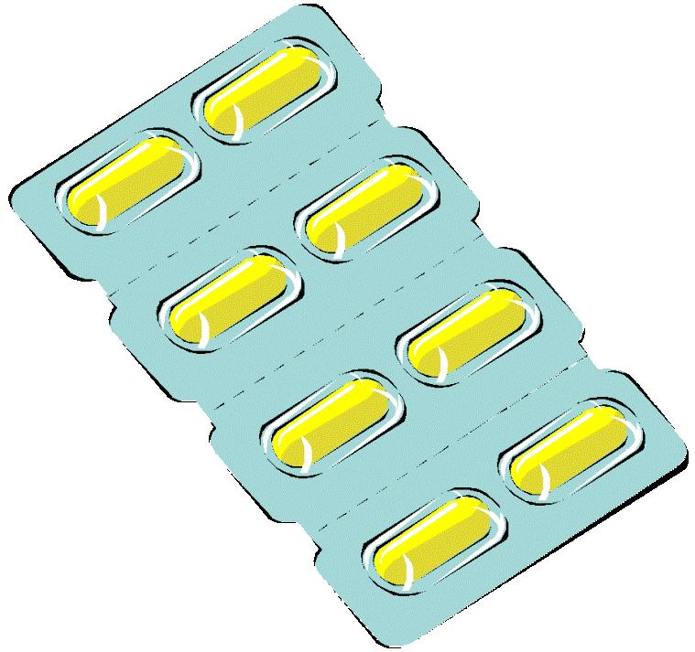
What is Xenical?
Xencial is a medication which can be prescribed by your family doctor (GP) to help you lose weight.

How does it work?
Xenical works by stopping your body absorbing some of the fat in your diet. It will help you learn to take a low fat diet so that you avoid side effects. It does not remove body fat or reduce appetite.

How do I get a prescription for Xenical?
If you have not yet met the 5kg (11lb) target since beginning phase 1, you may choose to try Xenical. We will now write to your GP to ask them to prescribe it.
You should make an appointment to see your GP within 2 weeks. Your group leader will tell you how long you should wait. Your doctor will discuss the medication with you and write a prescription.

When should I take it?
You can start taking Xencial once you have collected your prescription or you might want to wait until your next group session. Either is fine but try to make a note of when you start it.

You should take Xenical three times a day – one tablet at breakfast, lunch and evening meal. You can take it right before, during, or up to one hour after a meal.
Does Xenical have side effects?
The most common side effects happen when you eat too much fat:
- Flatulence (wind)
- Fatty or oily stools
- Increased frequency of bowel movements
If you have these side effects, check what you’ve had to eat as it may have been too high in fat. Keeping lifestyle diaries can be useful to remind you exactly what you’ve had and keep count of the total fat you’ve had each day.
If you experience any other side effects which concern you, see your GP or speak to your group leader.

What should I be eating?
You should keep following your ‘PDP’ from Phase 1 to be sure your diet stays balanced.
Meals and snacks should be low in fat to keep total calories down and avoid unpleasant side effects.

How do I know if my meal is low in fat?
Your fat intake should be around 40-50g/day.
Each meal should have less than 15g of fat in it.
Check how many grams of fat there are in the ‘per serving’ column of the food label. If you are using more than one packaged item in your meal then add the amounts together.
Remember to also check the calories per serving to fit in with your ‘PDP’.

How much weight should I be losing?
1-2lb (0.5-1kg) per week – the same as at phase 1.
The aim is to lose 5% of your body weight in the first 12 weeks. If you manage this you may be able to keep taking Xenical during phase 3. Your group leader can tell you what 5% means for you.

What else do I need to do?
Xenical does not do all the hard work. It is important to keep making lifestyle changes such as working on your activity levels.

Xenical does not affect appetite, cravings, habits or comfort eating. Use the phase 1 manual, the self-help guide or attend the psycho-educational talks if you still need to work on these.

Who do I contact if I have other questions?
Call Glasgow and Clyde Weight Management to speak to your group leader:
Mansionhouse Unit, Langside: 0141 201 6115
Sir James Clark Building, Paisley: 0141 531 3400

Visit the GCWMS website for information about the service and additional support. www.nhsggc.org.uk/gcwms
Register at www.mapassist.co.uk for support and information from the company that makes Xenical.


