Line Managers - Assigning KSF Post Outlines and Reviewers to a member of your team

Click on the Line Manager link on your Turas Appraisal home page and then click on My Team button

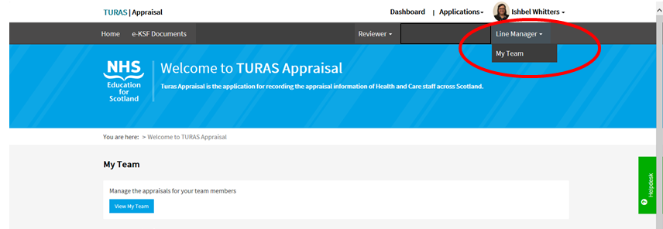

At the right hand side of the member of staff you wish to assign a KSF Post Outline or Reviewer to click on the Actions button and then the Update Employments button

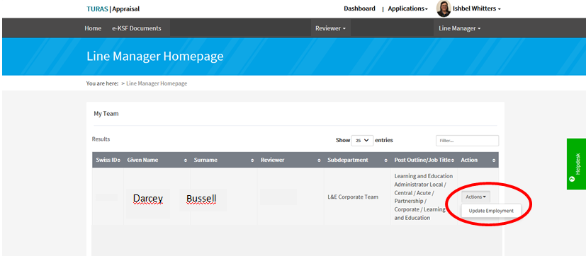

To assign a KSF Post Outline enter the start of the title and then select the appropriate KSF Post Outline from the drop down list
Please note that you will not be able to view the contents of the KSF Post Outline until it has been assigned therefore please refer to the Turas Appraisal pages on HR Connect for details of all KSF Post Outlines available including dimensions and levels
To assign a Reviewer enter the name of the reviewer and select from the drop down list.
When KSF Post Outline or Reviewer has been selected click on the Submit button and you will be asked to confirm this. Click the Submit Form button

