Name: _________________________________________
SCREEN TIME TRACKING Example

Day of the week | TV SCREEN TIME | COMPUTER TIME: Gaming, social media, iPad, WhatsApp, text messages etc. | DAILY TOTAL ENTERTAINMENT SCREEN TIME
Monday | 2 hours | 3 ½ hours | 5 ½ hours
Wednesday | 1 hours | 6 hours | 7 hours
Saturday | 4 hours | 8 hours | 12 hours

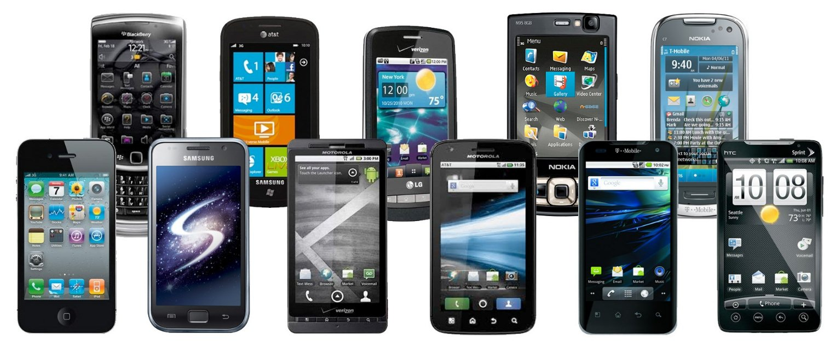
Comment:

Are you surprised by the results? Yes or no

Do you think the results are a concern? Why or why not?

What do you think you should do now?

