[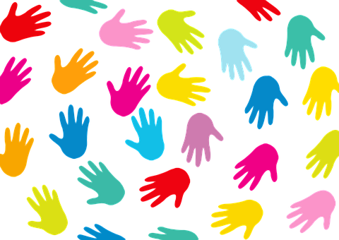](https://pixabay.com/en/hands-background-black-colorful-communic-565603/)**

**Be Screen  
Smart**

**Certificate of Achievement**

________________________________________________________

**Great Job! You did it!**

**By reducing time in front of the TV, computer, smart phones, iPads and video games you have made a great change towards a healthy lifestyle.**

**CONGRATULATIONS**

_____________________________

Teacher

[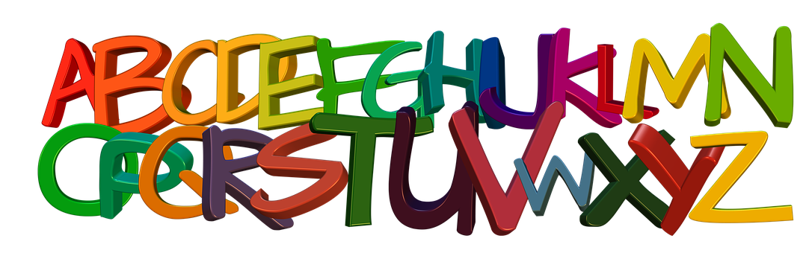](https://pixabay.com/en/banner-header-abc-alphabet-letters-read--916669/)

